Assignment 1 – Tree Based Search

Table of contents:

Instructions:

Introduction:

Search Algorithms:

BFS Tree Based Search:

Path Taken: 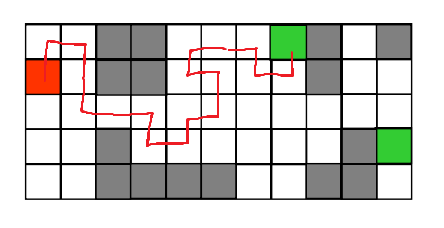

Implementation:

Features/Bugs/Missing:

Research:

Conclusion:

Acknowledgements/Resources:

References: