**INTRODUCTION**

## A Brief History of The Atom

Matter is composed of indivisible building blocks. This idea was recorded as early as the fifth century BCE by Leucippus and Democritus. The Greeks called these particles “Atomos”, meaning indivisible, and the modern word “atom” is derived from this term.

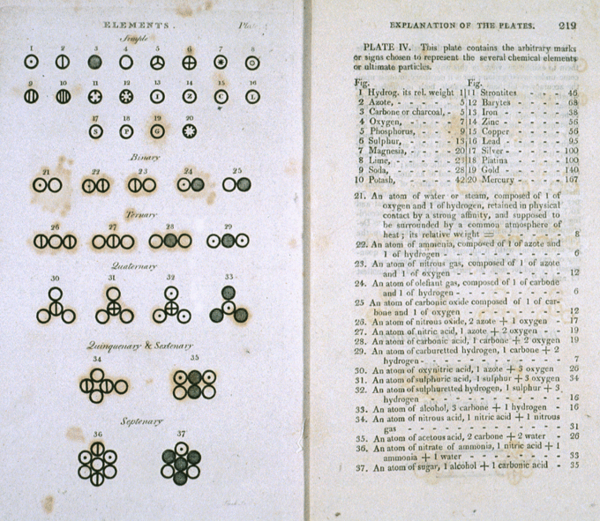The concept of the atom was revisited and elaborated upon by many scientists and philosophers, including Galileo, Newton, Boyle, and Lavoisier however the English chemist and meteorologist John Dalton is credited with the first modern atomic theory.

**PARTICLE NATURE OF ELECTRONS**

Rutherford’s Alpha Particle Experiment

The method used by Rutherford included the following experimental steps and procedure. He bombarded a thin gold foil of thickness approximately 8.6 x 10-6 cm with a beam of alpha particles in a vacuum. (Alpha particles are positively charged particles with a mass of about four times that of a hydrogen atom and are found in radioactive natural substances). He used gold since it is highly malleable, producing sheets that can be only a few atoms thick, thereby ensuring smooth passage of the alpha particles. A circular screen coated with zinc sulfide (ZnS) surrounded the foil. Since the positively charged alpha particles possess mass and move very fast, it was hypothesized that they would penetrate the thin gold foil and land themselves on the screen, producing fluorescence in the part they struck.

Rutherford’s Atomic Model

Rutherford model, also called Rutherford atomic model, nuclear atom, or planetary model of the atom, description of the structure of atoms proposed (1911) by the New Zealand-born physicist Ernest Rutherford. The model described the atom as a tiny, dense, positively charged core called a nucleus, in which nearly all the mass is concentrated, around which the light, negative constituents, called electrons, circulate at some distance, much like planets revolving around the Sun.

Drawbacks Of Rutherford’s Atomic model

1. Rutherford proposed that electrons revolve at a high speed in circular orbits around the positively charged nucleus. When a charged particle i. e. electron revolves around positively charge nucleus, it needs to be accelerated to keep it moving in circular orbits. However, according to electromagnetic theory, whenever a charged particle such as an electron is accelerated around another charged center ( nucleus ) which are under force of attraction, there will be continuous radiation of energy. This loss of energy would slow down the speed of the electron. This would reduce the radius of the electron–orbit. Eventually the electron would fall into the nucleus. The result would be that the atom would collapse. But this does not happen. Thus, Rutherford’s Diagram

   Description automatically generatedatom could not explain the stability of the atom. Failure of Rutherford’s model.
2. Rutherford proposed that electrons revolve around the nucleus in the ﬁxed orbits. However, he did not specify the orbits and the number of electrons in each orbit.

Bohr’s Atomic Model

In atomic physics, the Bohr model or Rutherford–Bohr model, presented by Niels Bohr and Ernest Rutherford in 1913, is a system consisting of a small, dense nucleus surrounded by orbiting electrons—like the structure of the Solar System, but with attraction provided by electrostatic forces in place of gravity. Rutherford could not explain the structural stability of an atom he proposed that the electrons rotate around the nucleus but could not state which electron rotated in which manner around the nucleus. Bohr explained the stability of the atom by assigning energy level to each electron and cleaning out the concept of shells. He named the shells as K, L, M, N and so on. He said that the electrons have certain amount of energy assigned to them, and all the shells have a certain energy level. Every electron containing the same energy level as that of a shell can only travel in it.

Bohr proposed his atomic model as Rutherford could not explain the structural stability. According to Rutherford theory an electron would rotate around the nucleus which is a direct violation of the classical theory of Electromagnetism, which says that any charge body moving around another oppositely charge body with variable acceleration continuously radiates energy and ultimately falls on the static charged body. In this case electron constantly radiates energy and ultimately falls on the nucleus within around 10-15 s. Therefore, the atomic structure collapses. To overcome this poor proposed some amends atomic theory.

1. The electron can revolve in certain stable orbits around the nucleus without radiating any energy, contrary to what classical electromagnetism suggests. These stable orbits are called stationary orbits and are attained at certain discrete distances from the nucleus. The electron cannot have any other orbit in between the discrete ones.
2. The stationary orbits are attained at distances for which the angular momentum of the revolving electron is an integer multiple of the reduced Planck constant: mevr=nℏ, where n = 1, 2, 3, ... is called the principal quantum number, and ħ = h/2π. The lowest value of n is 1; this gives the smallest possible orbital radius of 0.0529 nm known as the Bohr radius. Once an electron is in this lowest orbit, it can get no closer to the proton. Starting from the angular momentum quantum rule, Bohr was able to calculate the energies of the allowed orbits of the hydrogen atom and other hydrogen-like atoms and ions. These orbits are associated with definite energies and are also called energy shells or energy levels. In these orbits, the electron's acceleration does not result in radiation and energy loss. The Bohr model of an atom was based upon Planck's quantum theory of radiation.
3. Electrons can only gain and lose energy by jumping from one allowed orbit to another, absorbing or emitting electromagnetic radiation with a frequency ν determined by the energy difference of the levels according to the Planck relation: ΔE=E2−E1=hν, where h is Planck's constant.

Bohr's condition, that the angular momentum is an integer multiple of ħ was later reinterpreted in 1924 by de Broglie as a standing wave condition: the electron is described by a wave and a whole number of wavelengths must fit along the circumference of the electron's orbit:

Drawbacks Of Bohr’s Model

1. Much of the spectra of larger atoms. At best, it can make predictions about the K-alpha and some L-alpha X-ray emission spectra for larger atoms, if two additional ad hoc assumptions are made. Emission spectra for atoms with a single outer-shell electron (atoms in the lithium group) can also be approximately predicted. Also, if the empiric electron–nuclear screening factors for many atoms are known, many other spectral lines can be deduced from the information, in similar atoms of differing elements, via the Ritz–Rydberg combination principles (see Rydberg formula). All these techniques essentially make use of Bohr's Newtonian energy-potential picture of the atom.
2. The relative intensities of spectral lines; although in some simple cases, Bohr's formula, or modifications of it, was able to provide reasonable estimates.
3. The existence of fine structure and hyperfine structure in spectral lines, which are known to be due to a variety of relativistic and subtle effects, as well as complications from electron spin.
4. The model also violates the uncertainty principle in that it considers electrons to have known orbits and locations, two things which cannot be measured simultaneously.

**WAVE NATURE OF ELECTRONS**

de Broglie’s wave particle duality

When physical entities have both wave and particle nature, they are said to possess a duality. Based on experimental evidence German physicist Albert Einstein showed that light which had been considered as a form of electromagnetic waves, must also be thought of as particle-like, localized in packets of discrete energy. The observations of the Compton effect (1922) by American physicist Arthur Holly Compton could be explained only if light had a wave-particle duality. French physicist Louis de Broglie proposed (1924) that electrons and other discrete bits of matter, which until then had been conceived only as material particles, also have wave properties such as wavelength and frequency.

E=mc2

* E = energy,
* m = mass,
* c = speed of light

E=hν

* E = energy,
* h = Plank's constant (6.62607 x 10-34 J s),
* ν= frequency

Since de Broglie believed particles and wave have the same traits, he hypothesized that the two energies would be equal. Because real particles do not travel at the speed of light, De Broglie submitted velocity (v) for the speed of light (c). Through the equation λ, de Broglie substituted v/λ for ν and arrived at the final expression that relates wavelength and particle with speed.

$$λ = \frac{h}{mv}$$

What are atomic spectra?

The spectrum of the electromagnetic radiation emitted or absorbed by an electron during transitions between different energy level within an atom. When an electron gets excited from one energy level to another, it either emits or absorbs light of a specific wavelength. The collection of all these specific wavelengths of the atom in a given set of conditions like pressure, temperature, etc is the atomic spectra of atoms. There are three types of atomic spectra and they are emission spectra, absorption spectra, and continuous spectra.

Origin of atomic Spectra?

When the electrons in the atom are excited, for example by being heated, the additional energy pushes the electrons to higher energy orbitals. When the electrons fall back down and leave the excited state, energy is re-emitted in the form of a photon. The wavelength (or equivalently, frequency) of the photon is determined by the difference in energy between the two states. These emitted photons form the element's spectrum.

The fact that only certain colours appear in an element's atomic emission spectrum means that only certain frequencies of light are emitted. Each of these frequencies are related to energy by the formula: E = hν

Types of Atomic Spectra

* 1. When energy is absorbed by electrons of an atom, electrons move from lower energy levels to higher energy levels. These excited electrons must radiate energy to return to ground states from the excited state, which is unstable. The emission spectrum is formed by the frequencies of these emitted light.
  2. an absorption spectrum is constituted by the frequencies of light transmitted with dark bands when energy is absorbed by the electrons in the ground state to reach higher energy states.

Difference between the two types of atomic spectra

|  |  |
| --- | --- |
| **Emission Spectra** | **Absorption Spectra** |
| Produced when atoms release energy | Produced when atoms absorb energy |
| Comprise coloured lines in the spectrum | Comprise dark lines or gaps in the spectrum |
| It is helpful in figuring out the composition of a certain matter | Can be used to figure out the ability of certain objects to retain heat and its absorption level |
| The type of photons emitted is helpful in figuring out the kind of elements the substance is made of as each element radiates a different amount of energy and has a unique emission level | The wavelengths of light absorbed is helpful in figuring out the number of substances in the sample |

What is continuous and discontinuous spectra?

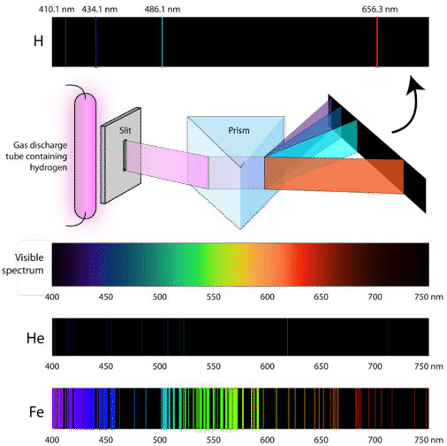If the light emitted from the excited atoms is viewed through a prism, then individual patterns of lines will be produced. These lines are called spectra and correspond to fingerprint wavelengths for a specific element. The specific elements produce wavelengths within the visible spectrum (between 400-700 nm) and can be seen by the naked eye. To obtain the numerical wavelengths, one would need to employ some type of detector.

Atomic Spectroscopy

Atomic spectroscopy is the study of the electromagnetic radiation absorbed or emitted by the atoms. There are three types of atomic spectroscopy, and they are:

Atomic emission spectroscopy: This involves the transfer of energy from the ground state to an excited state. The electronic transition can be explained in atomic emission.

Atomic absorption spectroscopy: For absorption to take place there should be identical energy difference between the lower and higher energy levels. The atomic absorption spectroscopy principle uses the fact that the free electrons generated in an atomizer can absorb radiation at specific frequency. It quantifies the absorption of ground-state atoms in the gaseous state.

Atomic fluorescence spectroscopy: This is a combination of atomic emission and atomic absorption as it involves radiation of both excitation and de-excitation.

Uses of Atomic Spectroscopy

1. It is used for identifying the spectral lines of materials used in metallurgy.
2. It is used in pharmaceutical industries to find the traces of materials used.
3. It can be used to study multidimensional elements.