**ANTACIDS**

**What are antacids?**

An antacid is a substance which neutralizes stomach acidity and is used to relieve heartburn, indigestion, or an upset stomach. Some antacids have been used in the treatment of constipation and diarrhea. Currently most of the antacids contain salts of aluminum, calcium, magnesium, or sodium. Some preparations contain a combination of two salts, such as magnesium carbonate and aluminum hydroxide.

**What are the uses of antacids?**

Antacids are available OTC (over the counter) and are taken by mouth to quickly relieve occasional heartburn, the major symptom of gastroesophageal reflux disease and indigestion. Treatment with antacids alone is symptomatic and only justified for minor symptoms. Alternative uses for antacids include constipation, diarrhea, hyperphosphatemia, and urinary alkalization. Some antacids are also used as an adjunct to pancreatic enzyme replacement therapy in the treatment of pancreatic insufficiency. Antacids (sodium citrate, magnesium trisilicate) increase gastric pH with little or no effect on gastric volume, and therefore may see some limited use in pre-operative procedures.

**What are the side effects of antacids?**

Antacids can either cause constipation or have a laxative effect. Some people have had allergic reactions. Antacids might also increase the risk of developing sensitivities to certain foods.

Many of the side effects of antacids come from not taking them as directed. Many antacids — including Maalox, Mylanta, Rolaids, and Tums — contain calcium. If taken too much or taken for longer than directed, one could get an overdose of calcium. Too much calcium can cause:

1. nausea
2. vomiting
3. mental status changes
4. kidney stones

Excess calcium can also lead to alkalosis. In this condition, the body does not make enough acid to function properly.

**How do antacids work?**

When an excess amount of acid is produced in the stomach, the natural mucous barrier that protects the lining of the stomach can degrade, leading to pain and irritation. There is also potential for the development of acid reflux, which can cause pain and damage to the esophagus. Antacids contain alkaline ions that chemically neutralize stomach gastric acid, reducing damage to the stomach lining and esophagus, and relieving pain.

Acid + Alkali 🡪 Salt + Water

**What are the types of antacids?**

1. Liquid.
2. Chewable gummy or tablet.
3. Tablet that can be dissolved in water to drink.

Some of the most popular antacid manufacturers are :-

1. Rantac
2. Zintac
3. Digene
4. Milk of magnesia

**What are the precautions before using antacids?**

Antacids are typically safe for most people. However, people with certain medical conditions should talk with their doctors before taking certain antacids that contain aluminum hydroxide and magnesium carbonate.

For example, people with heart failure may have sodium restrictions to help decrease fluid buildup. However, antacids often contain a lot of sodium.

People with kidney failure may develop a buildup of aluminum after using antacids. This can lead to aluminum toxicity. People with kidney failure also tend to have problems with electrolyte balance. All antacids contain electrolytes, which could make electrolyte balance problems worse.

**Compositions of some of the most widely used antacids: -**

**Rantac 150**

**Uses of Rantac tablet**

1. Heartburn
2. Gastroesophageal reflux disease (Acid reflux)
3. Peptic ulcer disease

**Benefits of Rantac tablet**

Rantac 150 Tablet belongs to a group of medicines called histamine 2 antagonists. It works by reducing the amount of acid your stomach makes and relieves the pain associated with heartburn and indigestion.

**Side effect of Rantac tablet**

1. Sleepiness
2. Headache
3. Tiredness
4. Constipation

**Working of Rantac tablet**

Rantac 150 Tablet is a histamine H2 receptor antagonist. It works by reducing the acid produced in the stomach. This helps to relieve acid-related indigestion and heartburn.

**Precautions while taking Rantac tablets: -**

1. It is unsafe to consume alcohol with Rantac 150 Tablet.
2. Rantac 150 Tablet should be used with caution in patients with kidney disease.
3. Rantac 150 Tablet should be used with caution in patients with liver disease.

**Chemical structure of Rantac tablet**

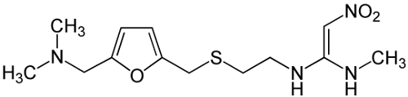

**Nexpro 40**

Uses of Nexpro 40

1. Gastroesophageal reflux disease (Acid reflux)
2. Peptic ulcer disease

Benefits of Nexpro 40

Nexpro 40 Tablet belongs to a group of medicines called proton pump inhibitors. It reduces the amount of acid your stomach makes and relieves the pain associated with heartburn and acid reflux. You should take it exactly as it is prescribed for it to be effective.

**Side effects of Nexpro 40 tablet**

1. Headache
2. Dizziness
3. Dryness in mouth
4. Nausea
5. Abdominal pain
6. Constipation
7. Flatulence
8. Diarrheal

**Precautions of using Nexpro 40 tablets: -**

1. Caution is advised when consuming alcohol with Nexpro 40 Tablet. Please consult your doctor.
2. Nexpro 40 Tablet should be used with caution in patients with severe liver disease.

**Chemical structure of Nexpro 40 tablet**

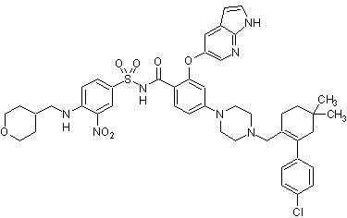

**Comparative study of the different types of antacids (Through graphs and statistical means)**

**ANTISEPTIC**

**What are antiseptics?**

are antimicrobial substances that are applied to living tissue/skin to reduce the possibility of infection, sepsis, or putrefaction. Antiseptics are generally distinguished from antibiotics by the latter's ability to safely destroy bacteria within the body, and from disinfectants, which destroy microorganisms found on non-living objects.

**What is the difference between antiseptics and skin disinfectants?**

There is a big difference between antiseptics and disinfectants. An antiseptic is applied to the body, while disinfectants are applied to nonliving surfaces, such as countertops and handrails. In a surgical setting, for example, a doctor will apply an antiseptic to the surgical site on a person’s body and use a disinfectant to sterilize the operating table. Both antiseptics and disinfectants contain chemical agents that are sometimes called biocides. Hydrogen peroxide is an example of a common ingredient in both antiseptics and disinfectants. However, antiseptics usually contain lower concentrations of biocides than disinfectants do.

**What are the uses of antiseptics?**

The uses of antiseptics include :-

1. Hand washing. Medical professionals use antiseptics for hand scrubs and rubs in hospitals.
2. Disinfecting mucous membranes. Antiseptics can be applied to the urethra or bladder to clean the area before inserting a catheter. They can also help to treat an infection in these areas.
3. Cleaning skin before an operation. Antiseptics are applied to the skin before any kind of surgery to protect against any harmful microorganisms that might be on the skin.
4. Treating skin infections. One can buy OTC antiseptics to reduce the risk of infection in minor cuts, burns, and wounds. Examples include hydrogen peroxide and rubbing alcohol.
5. Treating throat and mouth infections. Some throat lozenges contain antiseptics to help with sore throats due to a bacterial infection.

**What are the types of Antiseptics?**

Common types with varied uses include:

1. **Chlorhexidine and other biguanides.** These are used on open wounds and for bladder irrigation.
2. **Antibacterial dye.** These help to treat wounds and burns.
3. **Peroxide and permanganate.** These are often used in antiseptic mouthwashes and on open wounds.
4. **Halogenated phenol derivative.** This is used in medical-grade soaps and cleaning solutions.

**What are some of the side effects of antiseptics?**

**Some of the common side effects are: -**

1. Blanching of skin
2. Skin inflammation

**Some other more serious and rare types of side effects include: -**

1. Methemoglobinemia, a Type of Blood Disorder
2. A Toxic Effect on The Central Nervous System, Which Consists of The Brain And Spinal Cord
3. Accumulation Of Fluid in The Tissues of The Eyelid
4. Slow Heartbeat
5. Abnormal Heart Rhythm
6. Low Blood Pressure
7. Lung Failure Causing Loss of Breath
8. Decreased Lung Function
9. Bronchospasm
10. Unconsciousness
11. Seizures
12. A Bluish Discoloration of The Skin
13. Headache
14. A Significant Type of Allergic Reaction Called Anaphylaxis
15. A Type of Allergic Reaction Called Angioedema

**Some common Antiseptics in India are: -**

1. Dettol
2. Betadine
3. Boroline

**Uses of Dettol: -**

1. Kills bacteria.
2. Provides protection against germs which can cause infection and illness.
3. Kills germs on skin.
4. Protects against infection from cuts, scratches, and insect bites.

**Benefits of Dettol antiseptic: -**

Chloroxylenol is a substituted phenol which has been widely used for many years as an ingredient of antiseptic/disinfectant products intended for external use. It is known to be bactericidal in low concentration to a wide range of Gram positive and Gram-negative bacteria. Chloroxylenol is well-absorbed when applied to the skin. It is extensively metabolised in the body, probably by the liver, and rapidly excreted, mainly in the urine, as sulphate and glucuronide conjugates. Chloroxylenol has a low systemic toxicity, even at dosage levels many times higher than those likely to be absorbed during normal usage of Dettol Liquid.

**Uses of Dettol liquid: -**

1. **Medical uses**

For cuts, bites, abrasions, and insect stings: wash the area with one tablespoonful of Dettol diluted in a half pint of water and cover with dry gauze or lint.

For urgent application, Dettol may be used undiluted, but not on sensitive skins.

1. **Personal hygiene**

For douching (when medically advised): two teaspoonfuls of Dettol diluted in two pints of warm water.

For dandruff: one tablespoonful of Dettol diluted in one pint of warm water. Saturate hair and scalp for 10 minutes, then shampoo.

For spots and pimples: bathe the affected area daily with one tablespoonful of Dettol diluted in half a pint of warm water (not for eczematous conditions).

**Side effects of using Dettol antiseptic liquid: -**

Excessive exposure to Dettol has the potential for causing death. It can be poisonous when swallowed and even when it is unintentionally inhaled.

**Structure of Dettol antiseptic liquid: -**

**Uses of Boroline antibacterial cream: -**

1. Used for cuts.
2. Cracked lips.
3. Rough skin.
4. Treat infections.

**Benefits of Boroline cream: -**

1. Contains protective properties, does not wear off in extremely dry and chilly conditions.
2. In case of deep cuts, apply Boroline when the wound is closed and dry.
3. Softens rough hands and elbows.
4. Heals cracked heels, sunburns, and scars.
5. Protects against rashes.

**Key Ingredients in Boroline antiseptic cream: -**

1. Boric Acid
2. Zinc Oxide
3. Anhydrous Lanolin

**Structure of Boroline antiseptic cream: -**

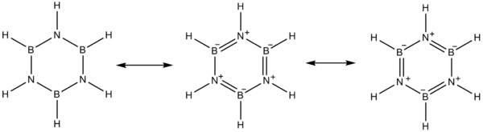

**Uses of Betadine Solution**

* Prevention of Wound infection

**Benefits of Betadine solution**

Betadine 10% Solution is a versatile antiseptic that is used for the treatment and prevention of infection. Betadine 10% Solution kills and prevents the growth of infection-causing microbes, thereby preventing abrasions, cuts and wounds, or any break in the skin from getting infected. The antiseptic effect is caused due to the slow release of iodine.

**Side effects of Betadine solution: -**

* Application site reactions (burning, irritation, itching and redness)

**How does the betadine solution work?**

Betadine 10% Solution is an antiseptic applied on skin, which is infected or is likely to get infected. It works by slowly releasing iodine which kills or prevents the growth of infectious microorganisms.

**Structure of Betadine solution: -**

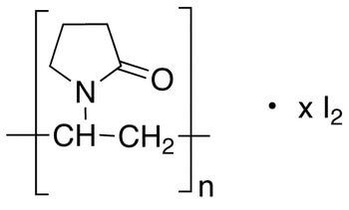

**ANTIBIOTICS**

**What are Antibiotics?**

An antibiotic is a type of antimicrobial substance active against bacteria. It is the most important type of antibacterial agent for fighting bacterial infections, and antibiotic medications are widely used in the treatment and prevention of such infections. They may either kill or inhibit the growth of bacteria. A limited number of antibiotics also possess antiprotozoal activity. Antibiotics are not effective against viruses such as the common cold or influenza; drugs which inhibit viruses are termed antiviral drugs or antivirals rather than antibiotics.

**Uses of Antibiotics: -**

Antibiotics are used to treat or prevent bacterial infections, and sometimes protozoan infections. When an infection is suspected of being responsible for an illness, but the responsible pathogen has not been identified, an empiric therapy is adopted. This involves the administration of a broad-spectrum antibiotic based on the signs and symptoms presented and is initiated pending laboratory results that can take several days.

**Some common side effects of Antibiotics are: -**

1. vomiting
2. nausea (feeling like you may vomit)
3. diarrhoea
4. bloating and indigestion
5. abdominal pain
6. loss of appetite

**How do antibiotics work?**

Antibiotics work by blocking vital processes in bacteria, killing the bacteria or stopping them from multiplying. This helps the body's natural immune system to fight the bacterial infection. Different antibiotics work against different types of bacteria.

Antibiotics that affect a wide range of bacteria are called broad spectrum antibiotics (e.g., amoxicillin and gentamicin).

Antibiotics that affect only a few types of bacteria are called narrow spectrum antibiotics (e.g., penicillin).

Different types of antibiotics work in different ways. For example, penicillin destroys bacterial cell walls, while other antibiotics can affect the way the bacterial cell works.

**Some commonly used antibiotics in India: -**

1. amoxicillin.
2. doxycycline.
3. cephalexin.

**Amoxicillin**

**Uses of Amoxicillin: -**

Amoxicillin is used to treat a wide variety of bacterial infections. This medication is a penicillin-type antibiotic. It works by stopping the growth of bacteria. This antibiotic treats only bacterial infections. It will not work for viral infections (such as common cold, flu). Using any antibiotic when it is not needed can cause it to not work for future infections. Amoxicillin is also used with other medications to treat stomach/intestinal ulcers caused by the bacteria H. pylori and to prevent the ulcers from returning.

**Side effects of Amoxicillin: -**

1. feeling sick (nausea)
2. diarrhoea

**Some serious side effects of Amoxicillin: -**

1. diarrhoea (possibly with stomach cramps)
2. pale poo with dark pee, yellowing of the skin or the whites of your eyes (warning signs of liver or gallbladder problems)
3. bruising or skin discolouration
4. joint or muscle pain that comes on after 2 days of taking the medicine.
5. a skin rash with circular red patches

**Uncommon allergic side effect of Amoxicillin: -**

1. a raised, itchy skin rash
2. coughing
3. wheezing

**Structure of Amoxicillin: -**

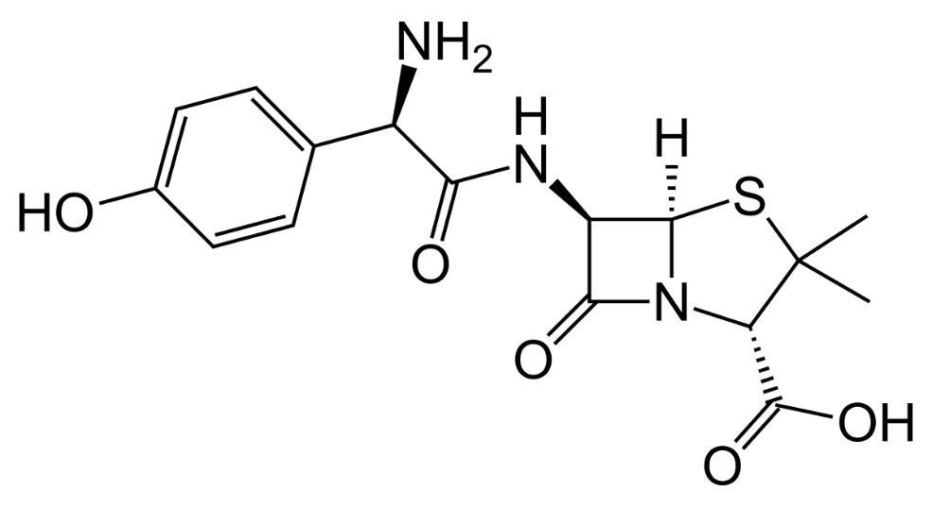

**Uses of Doxycycline: -**

Doxycycline is a tetracycline antibiotic that fights bacteria in the body. Doxycycline is used to treat many different bacterial infections, such as acne, urinary tract infections, intestinal infections, respiratory infections, eye infections, gonorrhea, chlamydia, syphilis, periodontitis (gum disease), and others. Doxycycline is also used to treat blemishes, bumps, and acne-like lesions caused by rosacea. It will not treat facial redness caused by rosacea.

**Precautions before taking Doxycycline : -**

1. Liver disease
2. Kidney disease
3. Asthma or sulfite allergy
4. Increased pressure inside your skull
5. If you also take isotretinoin, seizure medicine, or a blood thinner.

Doxycycline should not be taken with iron supplements, multivitamins, calcium supplements, antacids, or laxatives within 2 hours before or after taking doxycycline. Avoid taking any other antibiotics with doxycycline unless told by a doctor. Avoid exposure to sunlight or tanning beds. Doxycycline can make you sunburn more easily.

**Side effects of Doxycycline: -**

Common doxycycline side effects may include:

1. nausea, vomiting, upset stomach, loss of appetite.
2. mild diarrhoea.
3. skin rash or itching.
4. darkened skin colour.
5. vaginal itching or discharge.

**Severe side effects of** **Doxycycline: -**

1. severe stomach pain, diarrhoea that is watery or bloody.
2. throat irritation, trouble swallowing.
3. chest pain, irregular heart rhythm, feeling short of breath.
4. little or no urination.
5. **low white blood cell counts** - fever, chills, swollen glands, body aches, weakness, pale skin, easy bruising, or bleeding.
6. severe headaches, ringing in your ears, dizziness, nausea, vision problems, pain behind your eyes.
7. loss of appetite, upper stomach pain (that may spread to your back), tiredness, nausea or vomiting, fast heart rate, dark urine, jaundice (yellowing of the skin or eyes).

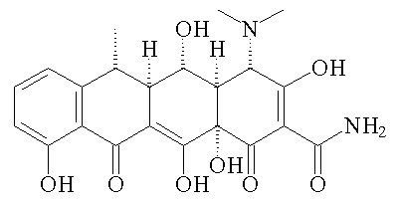

**Structure of Doxycycline: -**

**\*\* All structures will be drawn and statistical data will be given via pie charts and graphs in the original paper, samples of all the medicines used for the case studies will be given.**