Name: Manju

Date: 30/5/2025

This document includes the list of SQL queries used for database creation, data insertion, and task completion as part of the assigned task. Each query is accompanied by a brief explanation of its purpose.

**Data base creation:**

CREATE DATABASE StudentManagement;

USE StudentManagement;

**Purpose**: It is used to create and select the StudentManagement database for storing all student-related tables and data.

**Table creation:**

CREATE TABLE Students (StudentID INT PRIMARY KEY AUTO_INCREMENT, Name VARCHAR(50), Gender VARCHAR(1), Age INT, Grade VARCHAR(10), MathScore INT, ScienceScore INT, EnglishScore INT);

**Purpose**: This “ CREATE TABLE Students” is used to define the structure of the Students table, including fields for student ID, name, gender, age, grade, and scores for three subjects.

**Data insertion:**

INSERT INTO Students (Name, Gender, Age, Grade, MathScore, ScienceScore, EnglishScore) VALUES ('Arjun', 'M', 16, 'A', 92, 88, 90);

INSERT INTO Students (Name, Gender, Age, Grade, MathScore, ScienceScore, EnglishScore) VALUES ('Swetha', 'F', 15, 'B', 76, 82, 78);

INSERT INTO Students (Name, Gender, Age, Grade, MathScore, ScienceScore, EnglishScore) VALUES ('Sagar', 'M', 17, 'C', 65, 70, 68);

INSERT INTO Students (Name, Gender, Age, Grade, MathScore, ScienceScore, EnglishScore) VALUES ('Krithika', 'F', 16, 'A', 91, 94, 89);

INSERT INTO Students (Name, Gender, Age, Grade, MathScore, ScienceScore, EnglishScore) VALUES ('Mohith', 'M', 15, 'B', 80, 75, 85);

INSERT INTO Students (Name, Gender, Age, Grade, MathScore, ScienceScore, EnglishScore) VALUES ('Shreya', 'F', 17, 'C', 60, 65, 70);

INSERT INTO Students (Name, Gender, Age, Grade, MathScore, ScienceScore, EnglishScore) VALUES ('Karan', 'M', 16, 'B', 78, 81, 79);

INSERT INTO Students (Name, Gender, Age, Grade, MathScore, ScienceScore, EnglishScore) VALUES ('Darshini', 'F', 15, 'A', 93, 90, 92);

INSERT INTO Students (Name, Gender, Age, Grade, MathScore, ScienceScore, EnglishScore) VALUES ('Rohith', 'M', 17, 'B', 84, 79, 83);

INSERT INTO Students (Name, Gender, Age, Grade, MathScore, ScienceScore, EnglishScore) VALUES ('Kamali', 'F', 16, 'C', 67, 72, 69);

**Purpose**: This “ INSERT INTO Students” add sample student data to the table so that we can analyze it like real-life student records.

**Display all the students and their details:**

SELECT * FROM Students;

**Purpose**: This query is used to view all student records with their details for checking and reference.

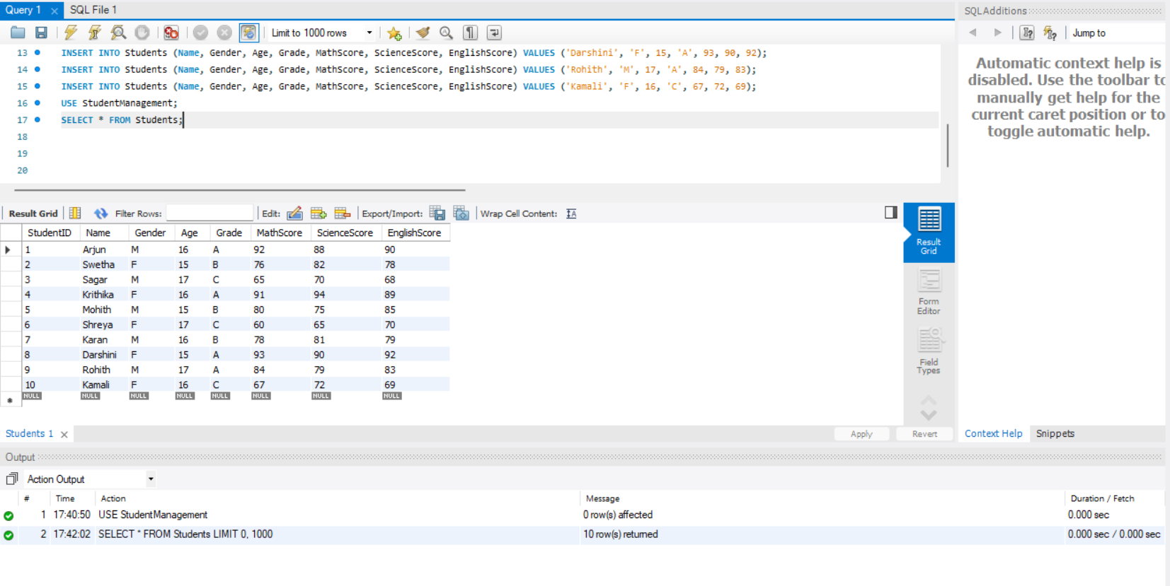**Output**:

**Calculating average scores of each subject:**

SELECT AVG(MathScore) AS AvgMathScore, AVG(ScienceScore) AS AvgScienceScore, AVG(EnglishScore) AS AvgEnglishScore FROM Students**;**

**Purpose**: This query is to find out the average marks of all students in Math, Science, and English

**Output:**

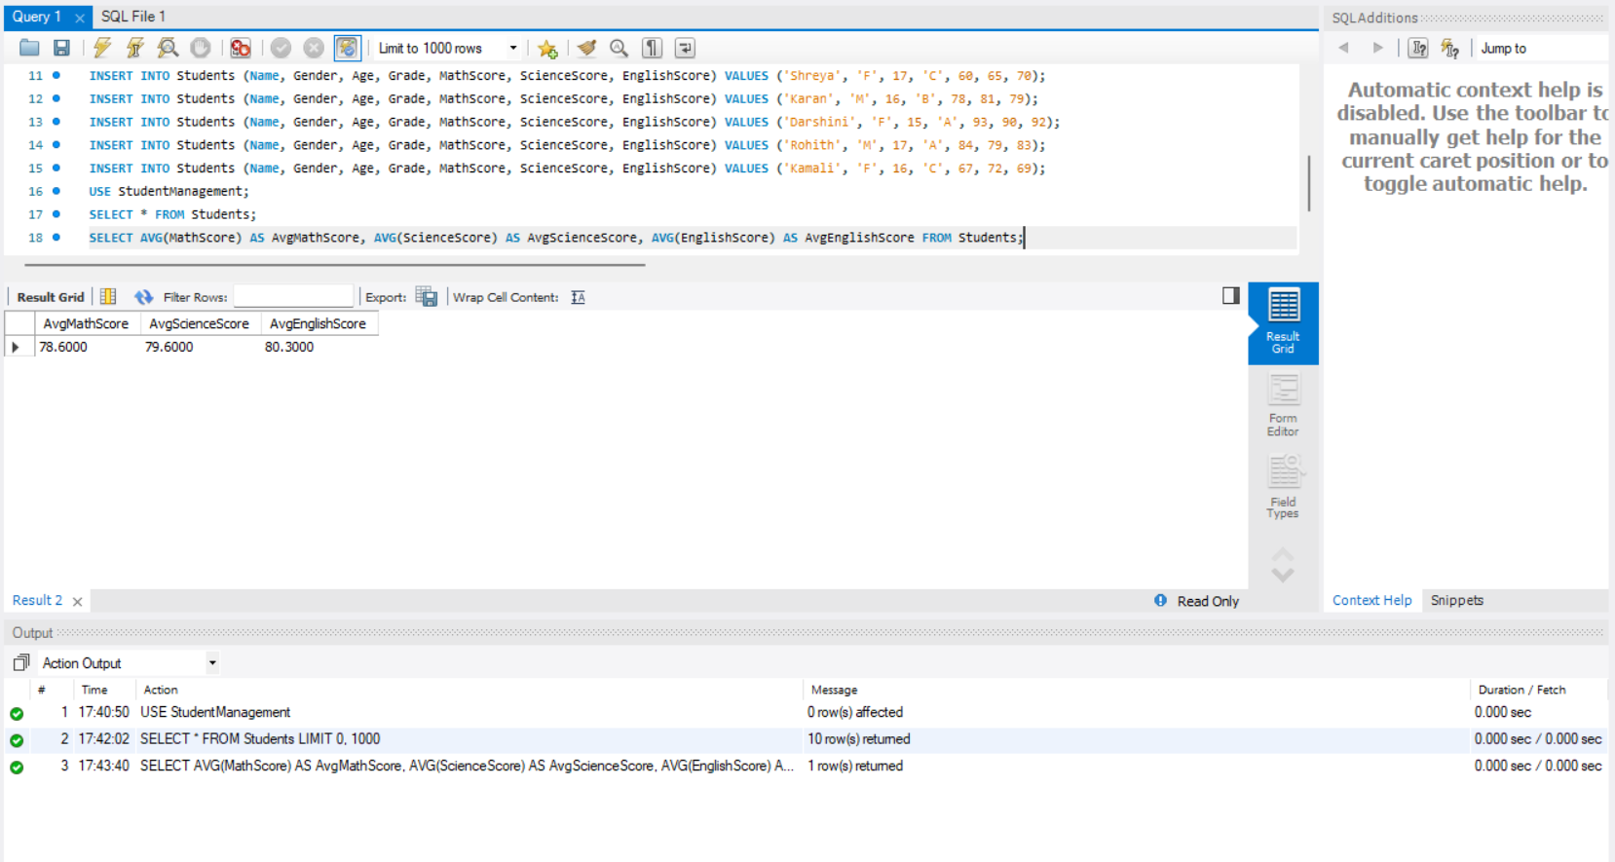

**Students with the highest total score:**

SELECT StudentID, Name, Gender, Age, Grade, MathScore, ScienceScore, EnglishScore, (MathScore + ScienceScore + EnglishScore) AS TotalScore FROM Students WHERE (MathScore + ScienceScore + EnglishScore) = (SELECT MAX(MathScore + ScienceScore + EnglishScore) FROM Students);

**Purpose**: This query is used to find the students with the highest total score across all subjects.

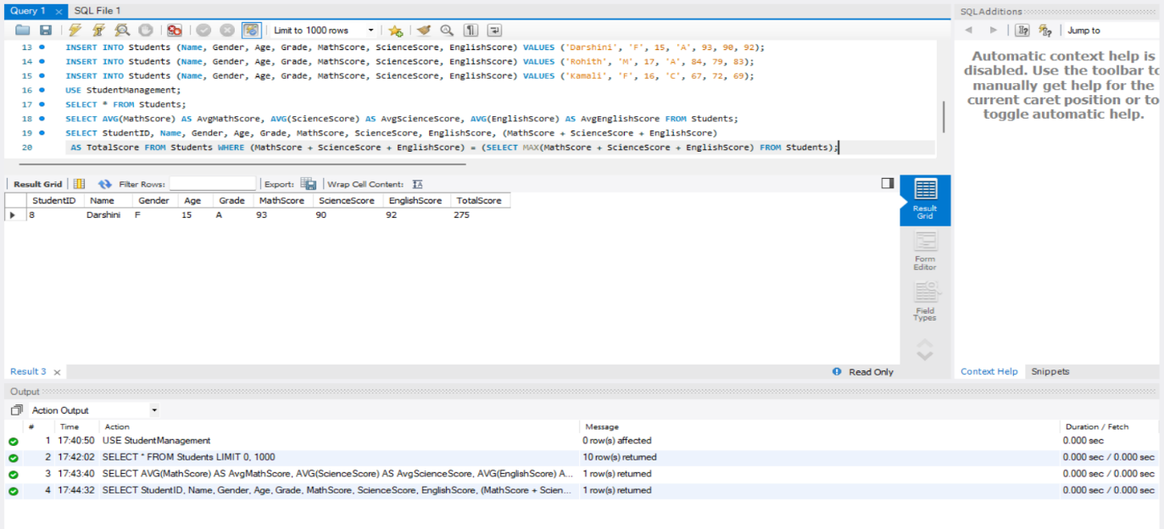**Output:**

**Number of students with each grade:**

SELECT Grade, COUNT(*) AS NumberOfStudents FROM Students GROUP BY Grade;

**Purpose**: This query is to see how many students fall under each grade(A,B,C).

**Output:**

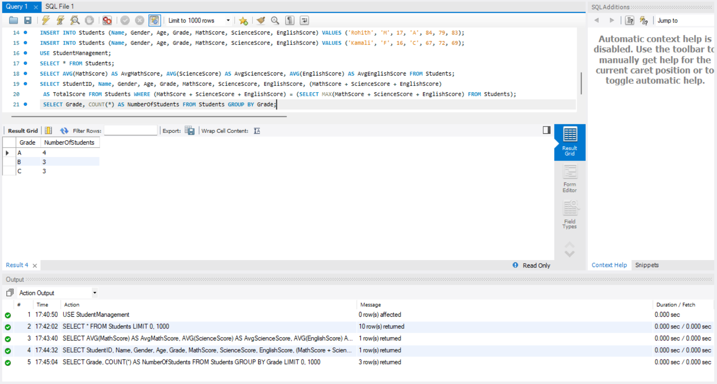

**Average score of male and female students:**

SELECT Gender, AVG(MathScore) AS AvgMathScore, AVG(ScienceScore) AS AvgScienceScore, AVG(EnglishScore) AS AvgEnglishScore FROM Students GROUP BY Gender;

**Purpose**:This query is to compare the average marks of boys and girls in each subject.

**Output:**

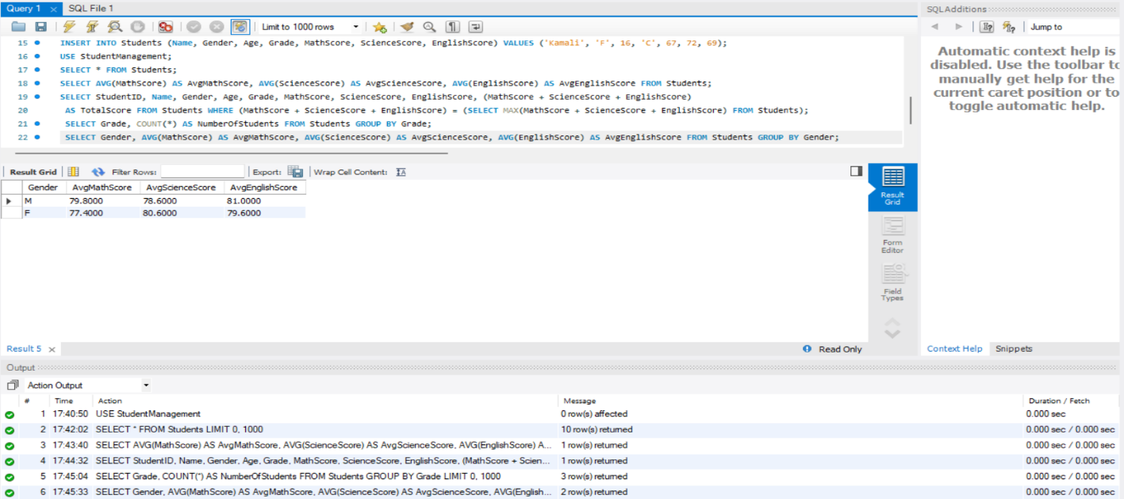

**Students who’s maths score is above 80:**

SELECT StudentID, Name, Gender, Age, Grade, MathScore, ScienceScore, EnglishScore FROM Students WHERE MathScore > 80;

**Purpose**: To identify students who scored high in Maths, so they can be recognized or better understood.

**Output:**

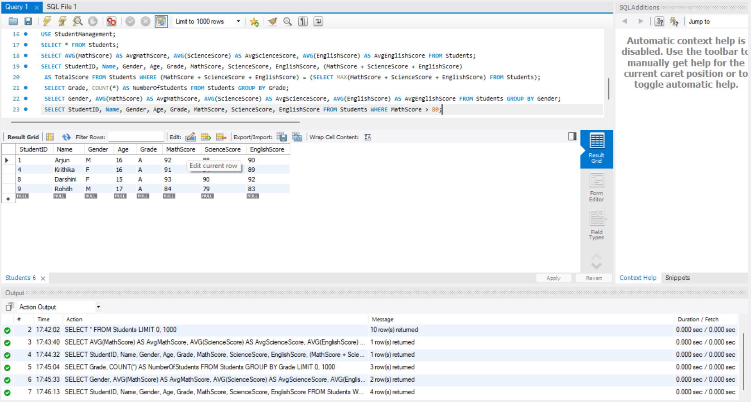

**Updated grade of student with a specific studentID:**

UPDATE Students SET Grade = 'B' WHERE StudentID = 9;

**Purpose**: This query is to modify the grade of the students.

**Output:**

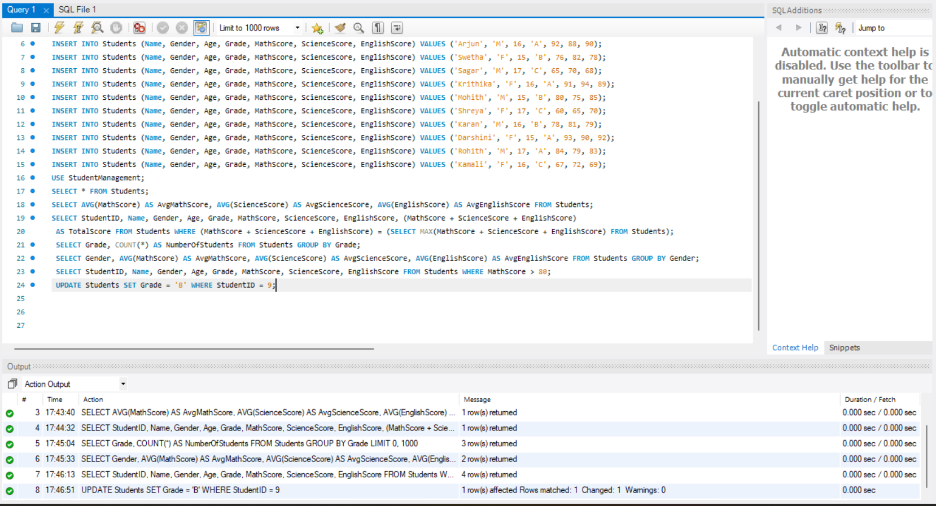

**Display all the students and their details:**

SELECT * FROM Students;

**Purpose**: This query is used to view all student records with their details for checking and reference, after the modification.

**Output:**

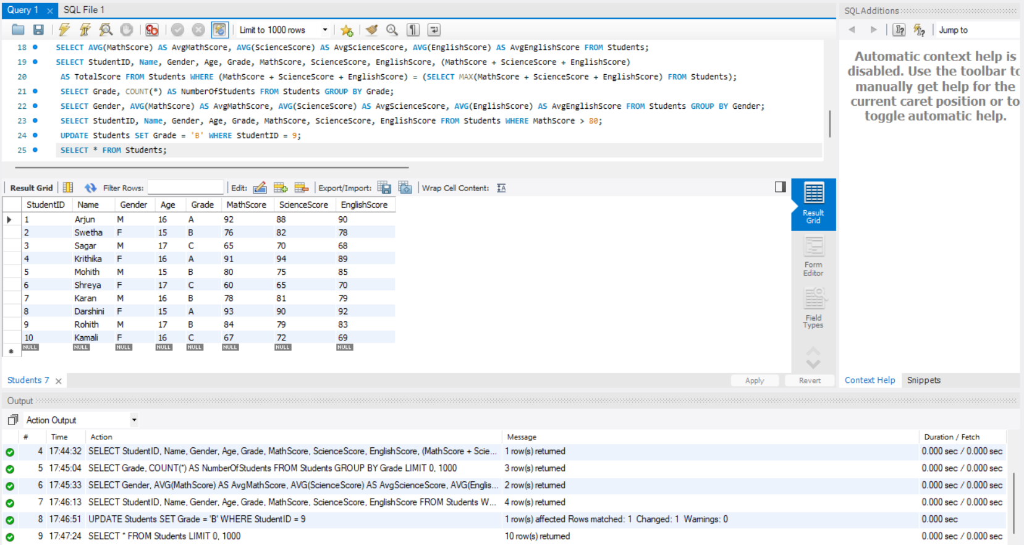

**Observations and insights derived from the data:**

1. Top performer: The student with the highest total score across Math, Science, and English achieved a total score of 275. This student demonstrates consistent excellence in all subjects.
2. Average subject scores: Math, the average score is moderately high, suggesting balanced performance. Science and English also show competitive average scores, indicating no significant weaknesses overall.
3. Gender-Based Performance:

Female students slightly ourperform in Science and English on average.

Male students have a marginal edge in Math.

This can help in tailoring subject-specific support or motivation programs.

1. Grade Disttribution:

The number of students in each grade:

Grade A: Only few students, suggesting hign standards on academic performance

Grade B: Most students get this grade, showing average to good performance.

Grade C: Least students, but they may require academic assistance.

1. High performers in Math: Studens scoring above 80 in Math also tend to have good scores in other subjects. These students could be considered for advanced learning opportunities.
2. Update Query: The grade of a student who’s studentID=9 was successfully updated to grade B. This reflects the change, which can be used in further analysis or reporting.
3. Overall Dataset Review: The data structure and analysis provide a strong base for generating reports, identifying top/bottom performers and understanding demographic-based trends like gender or grade-wise differences.