**Name:** Manju  
**Date:** 07/05/2025  
**Batch:** May 25th Batch

This document includes a set of SQL queries executed as part of the assigned **Week 3 task**.  
The queries demonstrate the use of subqueries and aggregate functions to analyze student performance data.  
Each query is accompanied by a brief explanation and its corresponding output screenshot, as required in the assignment guidelines.

**SQL Queries**

**Top Students by Total Scores**

SELECT Name, (MathScore + ScienceScore + EnglishScore) AS TotalScore FROM Students ORDER BY TotalScore DESC LIMIT 5;

**Output:**

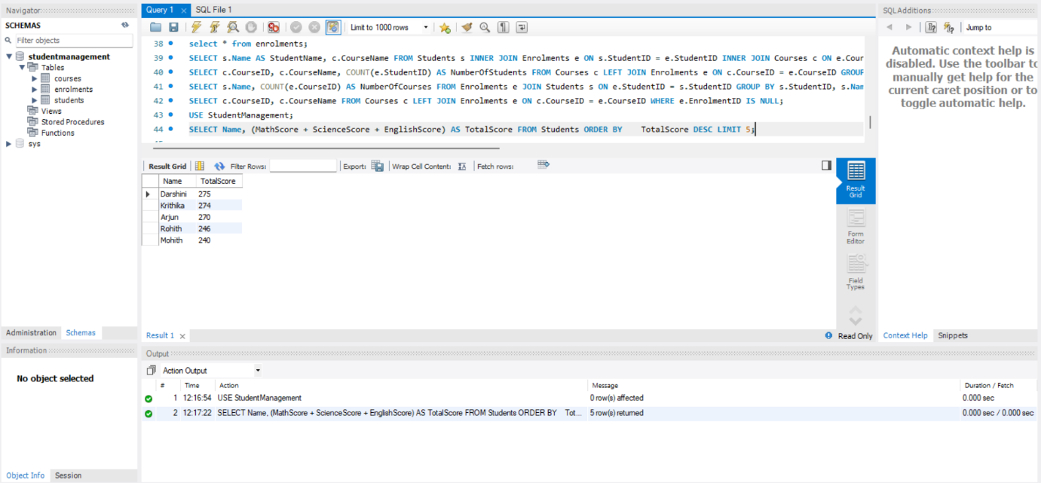

**Purpose:** Identifies the top 5 performing students based on total scores across Math, Science, and English.

**Explanation:** This query ranks students based on their total score (sum of Math, Science, and English). It helps identify the top 5 academic performers.

**Calculate Averages Based on Specific Conditions**

SELECT AVG(MathScore) AS AverageMathScore FROM Students WHERE MathScore > 70;

**Output:**

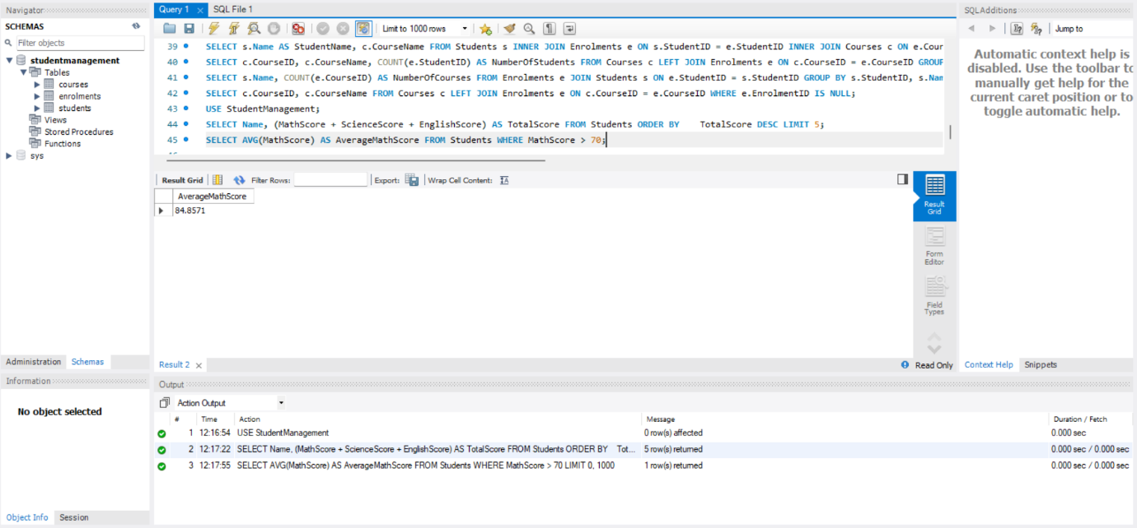 **Purpose:** To determine the average Math score among students who have scored **above 70**, indicating relatively stronger performers in Math.

**Explanation:** This calculates the average Math score, but only for students who scored more than 70 in Math.

SELECT AVG(MathScore + ScienceScore + EnglishScore) AS AverageTotalScore FROM Students WHERE (MathScore + ScienceScore + EnglishScore) BETWEEN 200 AND 250;

**Output:**

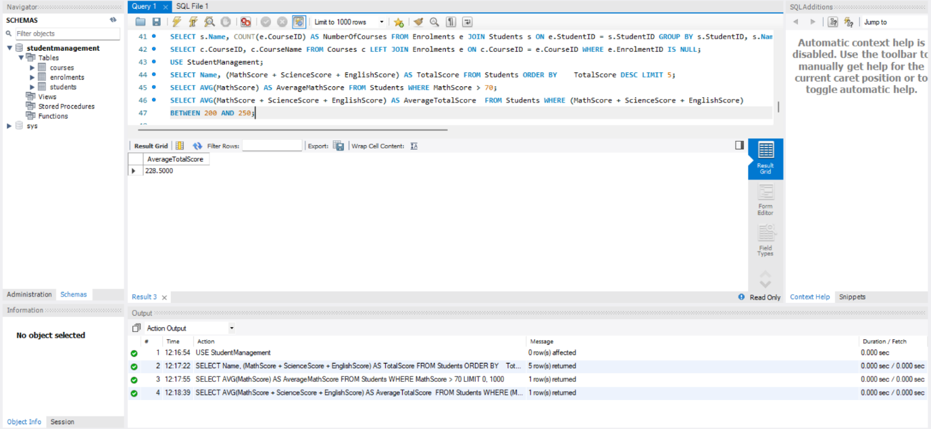

**Purpose:** This query calculates the average total score (i.e., the sum of Math, Science, and English scores) only for those students whose total score falls between 200 and 250.

**Explanation:** This gives the average *total* score for students whose combined score is in the range of 200–250.

**Second-Highest Math Scores**SELECT MAX(MathScore) AS SecondHighestMathScore FROM Students WHERE MathScore < (SELECT MAX(MathScore) FROM Students);

**Output:**

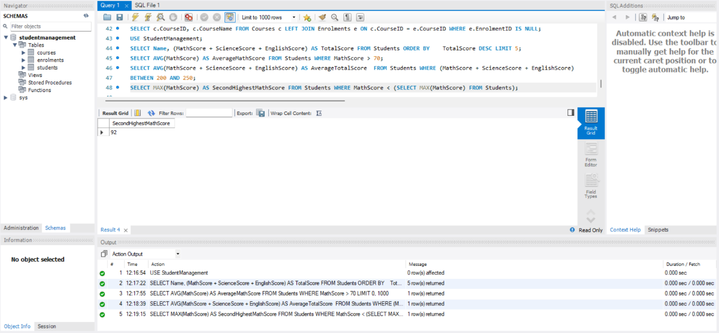

**Purpose:** Determines the second-highest Math score in the dataset**.**

**Subquery**: (SELECT MAX(MathScore) FROM Students) finds the **highest** Math score in the dataset.

Filters out that score to find the **next highest (second)** using MAX() again. The outer query then gets the **maximum score that is less than that value**, which effectively gives the **second highest Math score**.

**Explanation:** This query finds the second highest Math score by excluding the highest one using a subquery.

**Summary of Findings**

**1.Top-Performing Students:**

We found the top 5 students with the highest combined scores in Math, Science, and English. These students consistently did well in all subjects, showing they are strong academically overall.

**2.Math Performance Trends:**

We looked at the average Math scores of students who scored more than 70. It turns out that these students had a much higher average, indicating a clear group of top performers in Math.

**3.Overall Academic Performance:**

We calculated the average total scores for students who scored between 200 and 250. This gaveus a better idea of how students in the upper-middle performance range are doing academically.

**4.Second Highest Math Score:**

Using a subquery, we found the second highest Math score among all students. This helps us not only rank the top performers but also recognize students who came very close to being the best.