**Name:** Manju  
**Date:** 01/07/2025  
**Batch:** May 25th Batch

This document includes a set of SQL queries executed as part of the assigned **Week 5 task**.  
The queries demonstrate the use of **SQL CASE statements** to perform **conditional transformations** on student performance data. Specifically, the queries categorize total scores into grades and evaluate individual subject scores to determine pass/fail status.

Each query is followed by a short explanation of the logic used in the CASE statements and is supported with screenshots showing the executed queries and their respective outputs, as required in the assignment guidelines.

**SQL Queries**

1. **Assign Grades Based on Total Scores**

SELECT StudentID,Name,(MathScore + ScienceScore + EnglishScore) AS TotalScore,CASE WHEN (MathScore + ScienceScore + EnglishScore) >= 270 THEN 'A'WHEN (MathScore + ScienceScore + EnglishScore) >= 240 THEN 'B' WHEN (MathScore + ScienceScore + EnglishScore) >= 210 THEN 'C' ELSE 'D (Fail)' END AS AssignedGrade FROM Students;

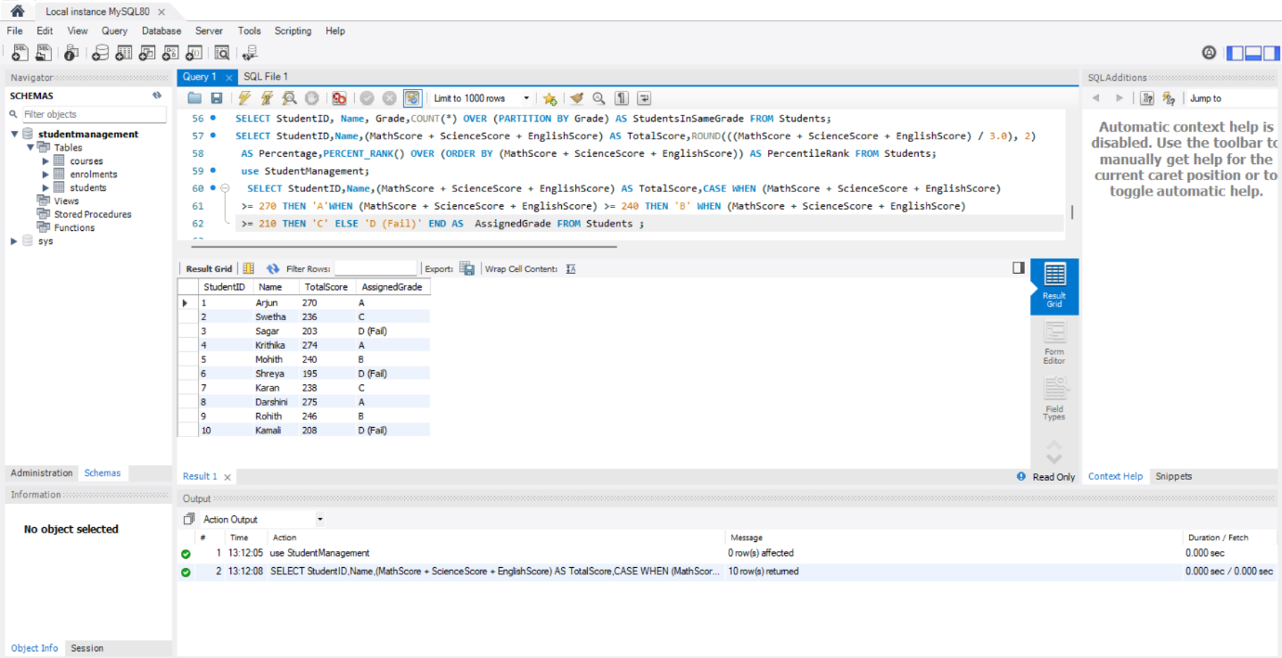**Output:**

**Purpose**: To assign grades to students based on their total scores from Math, Science, and English.

**Explanation**: The query adds the scores of all three subjects and uses a CASE statement to classify the total into grade categories: A for ≥270, B for ≥240, C for ≥210, and D (Fail) for scores below 210.

1. **Determine Pass or Fail Status in Each Subject**

SELECT StudentID,Name,MathScore,CASE WHEN MathScore >= 40 THEN 'Pass' ELSE 'Fail' END AS MathStatus,ScienceScore, CASE WHEN ScienceScore >= 40 THEN 'Pass' ELSE 'Fail' END AS ScienceStatus, EnglishScore, CASE WHEN EnglishScore >= 40 THEN 'Pass' ELSE 'Fail' END AS EnglishStatus FROM Students;

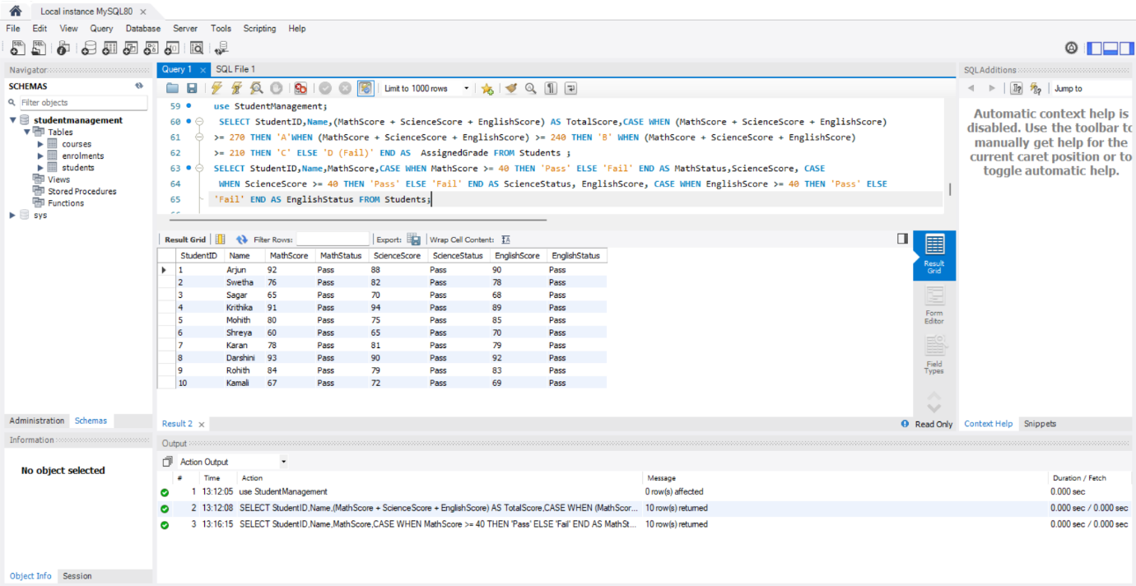**Output:**

**Purpose**: To determine each student’s pass or fail status in individual subjects based on a threshold score.

**Explanation**: The query uses CASE statements to check if scores in Math, Science, and English are ≥40; if so, it returns 'Pass', otherwise 'Fail' for each subject.

**Summary of Findings**

**1.Grades Based on Total Scores:**Students were grouped into four categories—A, B, C, and D—depending on their combined scores in Math, Science, and English.

This made it easy to see overall performance levels:

Grade A students scored 270 or above, showing excellent results.

Grade B students had good scores between 240 and 269.

Grade C students performed satisfactorily with scores between 210 and 239.

Grade D (Fail) indicated students who scored below 210 and need extra help.

This grading helps teachers quickly spot who is excelling and who may need support.

**2.Pass or Fail in Each Subject:**

Each subject was also checked separately to see if students passed the minimum score of 40.

The results clearly showed whether a student passed or failed in Math, Science, and English individually.

This detailed view helps pinpoint specific subjects where a student may be struggling, so teachers can focus support where it’s most needed.

Overall, these queries provided a clear picture of how students are doing both overall and in each subject. This information is helpful for planning targeted support and recognizing strong performers.