Name: Manju

Date: 16/07/2025

Batch: May 25th Batch

This document contains SQL queries performed for Week 7, focusing on creating and using SQL Views for organizing and analyzing

student score data.

Two views were created from the existing Students table to improve query efficiency and reusability:

Studentscores: Displays student names and their scores in individual subjects using a vertical format.

passedstudents: Lists students who passed all subjects with a minimum score of 40 in each.

Queries were executed to validate both views and verify the expected output. These views enable simplified analysis such as

identifying passed students and retrieving subject-wise scores from a single source.

1. **Studentscores view**

CREATE VIEW Studentscores AS SELECT StudentID, Name,'Math' AS Subject, MathScore AS Score FROM Students UNION SELECT StudentID, Name,'Science' AS Subject, ScienceScore AS Score FROM Students UNION SELECT StudentID, Name,'English' AS Subject, EnglishScore AS Score FROM Students;

**Output:**

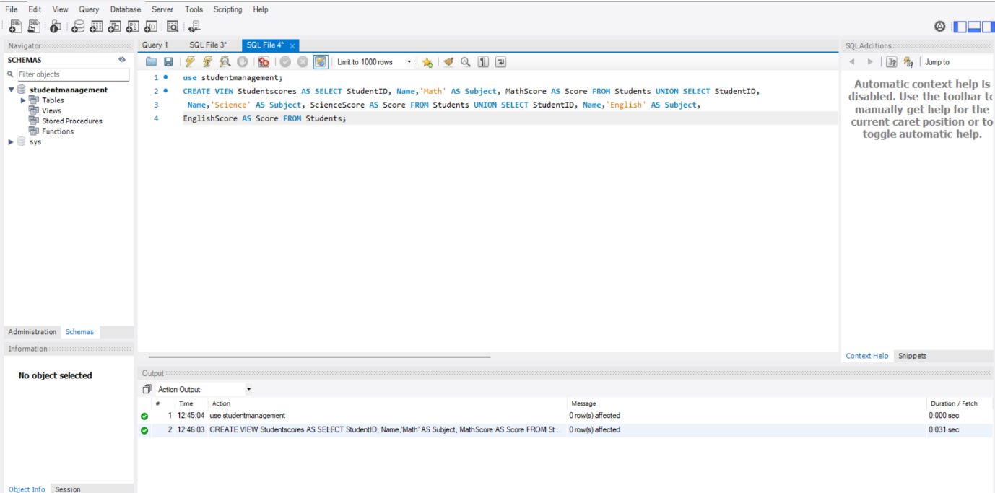

**Purpose:** This query is used to organize student scores in a subject-wise format.

**Explanation:** This view turns each student’s subject scores into separate rows, making it easier to view and analyze scores subject-wise instead of in columns.

SELECT * FROM Studentscores;

**Output:**

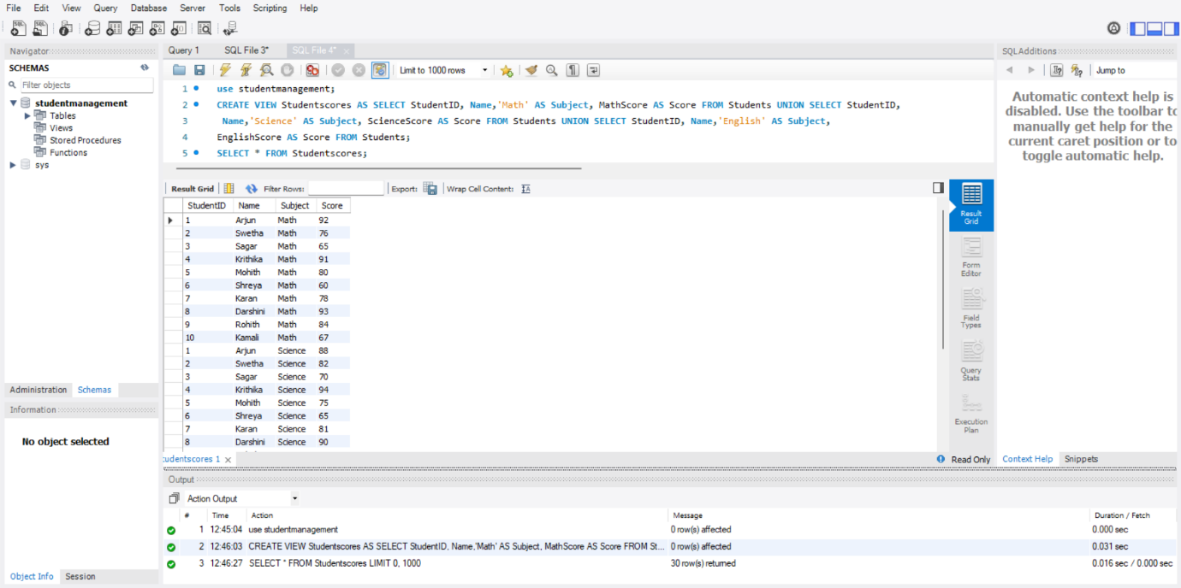

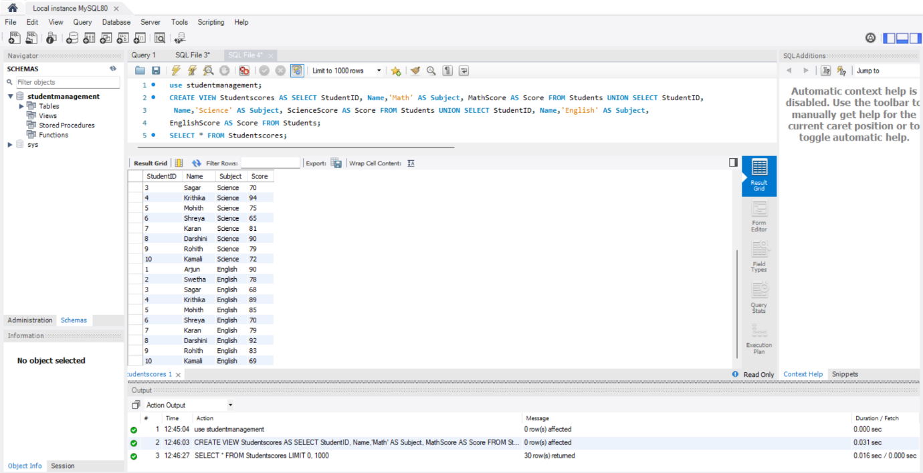

**Purpose:** This is used to see all the data from the Studentscores view you just created.

**Explanation:** It simply shows each student’s subject name along with their score. This makes it easier to filter or sort based on subject or score.

1. **passedstudents View (Students Who Passed All Subjects)**

CREATE VIEW passedstudents AS SELECT StudentID, Name FROM Students WHERE MathScore >= 40 AND ScienceScore >= 40 AND EnglishScore >= 40;

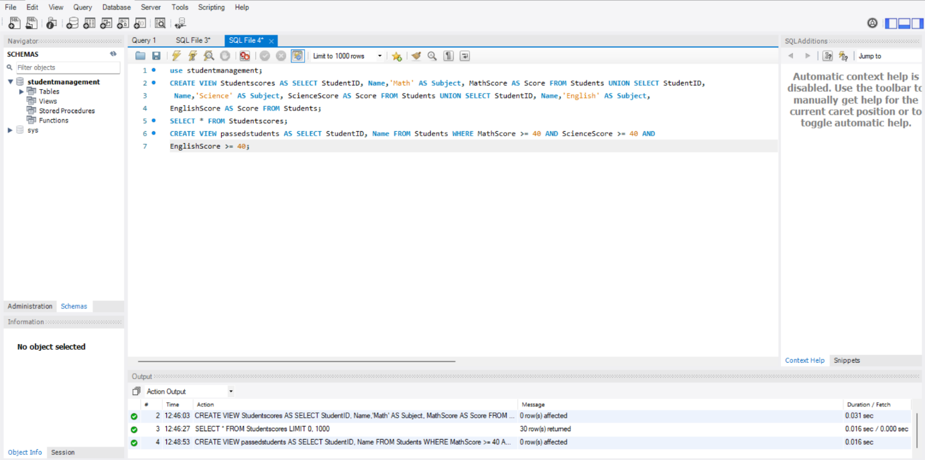**Output:**

**Purpose:** This view is created to list students who have passed in all subjects.

**Explanation:** Only students who have scored 40 or more in Math, Science, and English will be shown in this view. It's useful when you want to find out who has passed everything without checking each subject individually.

SELECT * FROM passedstudents;

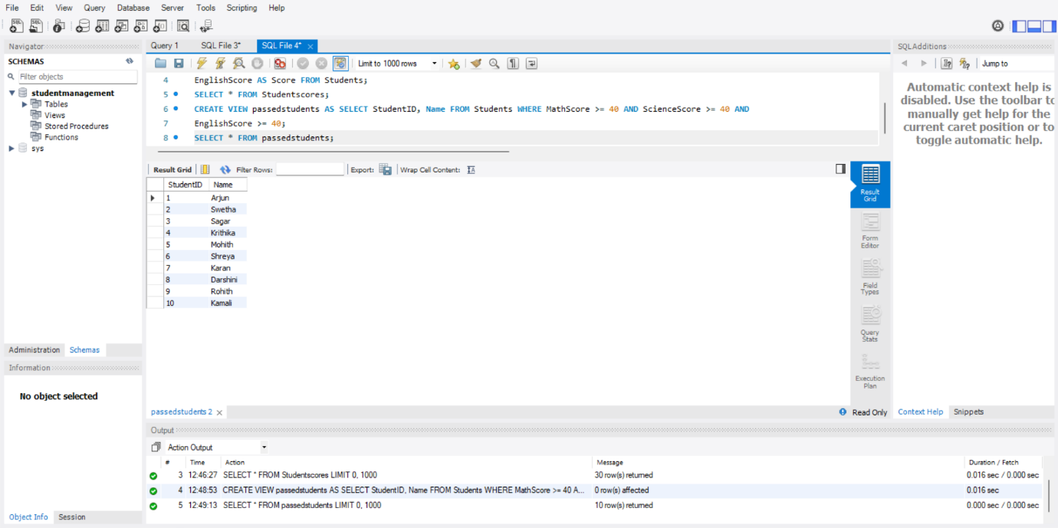**Output:**

**Purpose:**This is used to display the list of students who passed all subjects from the view you just created.

**Explanation:**Once the view is created, this query helps you quickly get the names and IDs of all students who met the pass criteria (≥ 40 in all subjects) no need to repeat the logic each time.

**Summary of findings**

In this task, two SQL views were created to simplify the way student data is analyzed and accessed.

The Studentscores view helps in organizing each student’s subject scores in a clear, subject-wise format. Instead of having all marks in columns, this view shows each subject and score as a separate row. This makes it easier to filter, sort, or analyze performance based on specific subjects.

The passedstudents view lists all students who have passed all three subjects — Math, Science, and English — by scoring at least 40 marks in each. This view makes it easy to quickly identify students who have successfully cleared all subjects without writing lengthy conditions again.

Overall, these views reduce repetition, simplify queries, and are very useful for reporting and performance analysis.