**Wine Quality Analysis Documentation**

**Mukul Sagar**

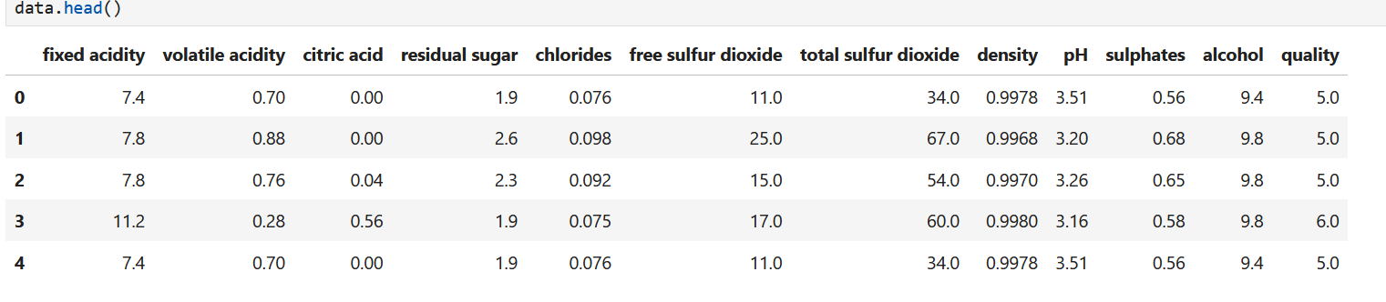1. **Introduction:**  
 - This project aims to predict the quality of wine based on physicochemical attributes. The dataset contains various features such as fixed acidity, volatile acidity, citric acid, residual sugar, chlorides, free sulfur dioxide, total sulfur dioxide, density, pH, sulphates, and alcohol, which are used to predict the quality of wine represented by a score between 0 and 10.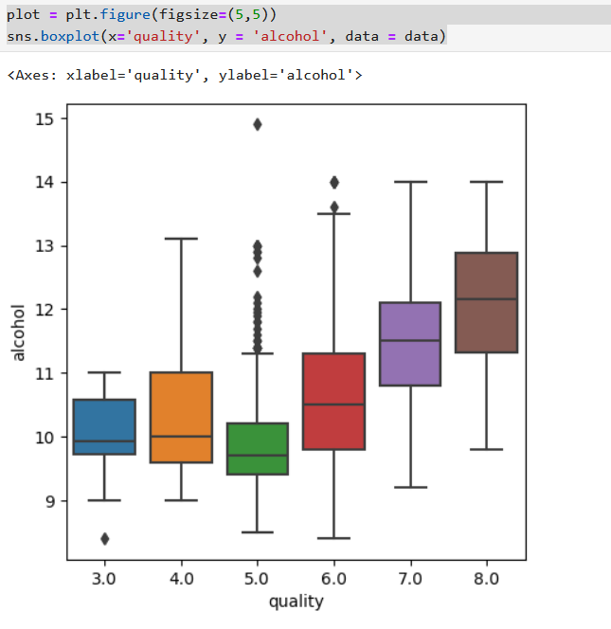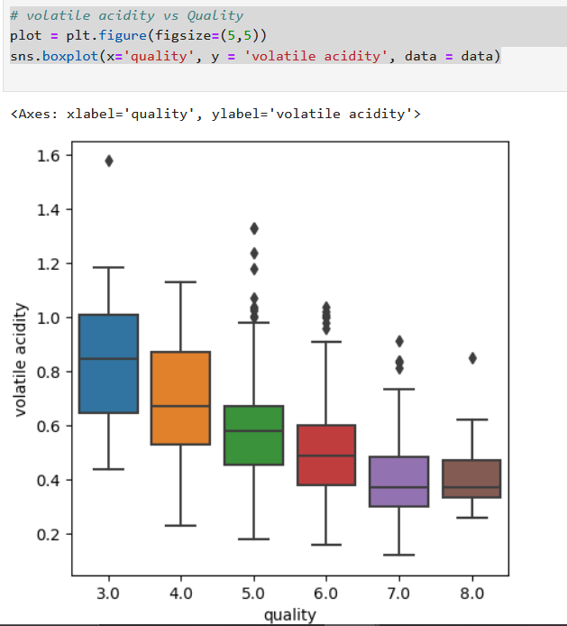  
  
2. **Data Pre-processing:**  
 - The dataset is loaded and analyzed.   
 - Correlation analysis is performed to understand the relationship between different features using a heatmap.  
 - A scatter plot is created to visualize the relationship between density, alcohol, and wine quality.  
 - Data is split into input features (X) and the target variable (y).  
 - Standardization is applied to scale the input features.

3. **Outlier Detection:**  
 - Isolation Forest algorithm is utilized to detect outliers in the dataset, which could potentially be excellent or poor quality wines.

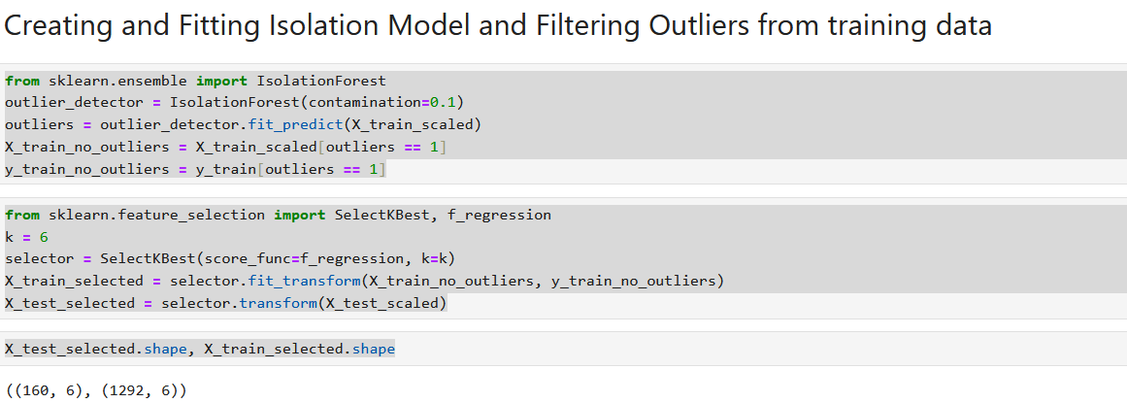4. **Feature Selection:**  
 - SelectKBest method with f_regression score function is employed to select the top k features that are most relevant for predicting wine quality.  
  
5. **Model Building and Evaluation (Classification):**  
 -RandomForestClassifier is trained on the selected features and evaluated on the test set using accuracy score.

-Classification report and confusion matrix are generated to analyze the performance of the classification model. Precision, recall, and F1-score metrics are provided for each class to understand the model's predictive capabilities.

6. **Model Building and Evaluation (Regression):**  
 - RandomForestRegressor is trained on the selected features and evaluated using mean squared error.  
 - An accuracy function is defined to calculate the accuracy of the regression model. Mean squared error and R-squared metrics are provided to assess the model's performance in predicting wine quality scores.   
  
7. **Additional Models:**  
 - Linear Regression and another RandomForestRegressor model with different parameters are trained and evaluated.

-The performance metrics including RMSE and R-squared are provided for each model to compare their predictive accuracy.   
  
8. **Predictive System:**  
 - A predictive system is developed to predict the quality of wine based on user input of physicochemical attributes.  
 - The model predicts whether the wine quality is good or bad based on the predicted quality score.  
  
9. **Conclusion:**  
 -This project illustrates the application of machine learning techniques for wine quality prediction, showcasing the significance of physicochemical attributes in determining wine quality. Through rigorous data preprocessing, including outlier detection and feature selection, we ensured the robustness and relevance of the input data for model training.

-Several machine learning models, including RandomForestClassifier and RandomForestRegressor, were trained and evaluated for both classification and regression tasks, respectively. The performance of each model was assessed using a variety of metrics, such as accuracy, precision, recall, F1-score, mean squared error, RMSE, and R-squared.

- The predictive system developed in this project provides a practical tool for users to predict the quality of wine based on their input of physicochemical attributes. This system can be valuable for wine producers, distributors, and enthusiasts in assessing and enhancing wine quality.

- Moving forward, further exploration can be conducted to improve the predictive accuracy of the models. This may involve exploring advanced machine learning techniques, conducting more extensive feature engineering, and optimizing model parameters. Additionally, the inclusion of domain knowledge and expert insights could enhance the interpretability and effectiveness of the predictive models.

- Overall, this project contributes to the understanding and utilization of machine learning in the wine industry, facilitating informed decision-making and quality improvement efforts.

10. **Dataset Description:**  
 - The dataset consists of physicochemical attributes of wine samples along with their quality scores.  
 - Features include fixed acidity, volatile acidity, citric acid, residual sugar, chlorides, free sulfur dioxide, total sulfur dioxide, density, pH, sulphates, and alcohol.  
  
11. **Visualizations:**  
 -**Correlation Heatmap:** A heatmap is constructed to visualize the correlation between different physicochemical attributes. This heatmap provides insights into the relationships between features, highlighting potential correlations that can influence wine quality prediction.

**-Scatter Plot:** A scatter plot is generated to illustrate the relationship between density and alcohol content, with the wine quality represented by different colors. This visualization helps identify any discernible patterns or clusters in the data based on these attributes.

**-Box Plots:** Box plots of quality versus various physicochemical attributes are created to explore the distribution and variability of each feature across different quality categories. These visualizations offer a comprehensive overview of how each attribute may contribute to wine quality and help identify any potential outliers or anomalies in the dataset.

12. **Future Work:**  
 While the code provided lays a solid foundation for wine quality prediction, there are several shortcomings and areas for improvement:  
  
1. Limited Model Evaluation: The code evaluates the models using basic metrics such as accuracy for classification and mean squared error for regression. While these metrics provide some insights into model performance, they may not capture the nuances of wine quality prediction adequately.  
  
2. Imbalanced Classes: The classes in the dataset are imbalanced, with significantly more normal wines than excellent or poor ones. This can bias the models towards predicting the majority class and may lead to suboptimal performance, especially for rare classes.  
  
3. Feature Selection: The code uses a simple feature selection method (SelectKBest with f_regression) to select the top k features. However, more advanced feature selection techniques, such as recursive feature elimination or Lasso regularization, could potentially improve model performance by identifying the most relevant features.  
  
4. Limited Model Diversity: The code primarily utilizes RandomForestClassifier and RandomForestRegressor for prediction. While random forests are versatile and robust models, exploring a broader range of algorithms, such as gradient boosting machines (e.g., XGBoost, LightGBM) or neural networks, could offer better performance and generalization.  
  
5. Model Interpretability: The code lacks interpretability in model outputs. Understanding how the models make predictions and which features contribute most to the predictions is crucial for practical applications, especially in domains like wine quality prediction where domain expertise is valuable.  
  
To address these shortcomings, a possible model that could better suit this kind of task is a gradient boosting machine (GBM), specifically XGBoost or LightGBM. These models offer several advantages:  
  
- Handle Imbalanced Data: GBMs naturally handle imbalanced data through techniques like weighted sampling or class-weighted loss functions, which can improve performance on rare classes.  
- Feature Importance: GBMs provide feature importance scores, allowing for better interpretation of model predictions and identifying the most influential features for wine quality prediction.  
- High Performance: GBMs often outperform random forests and other traditional machine learning algorithms in terms of predictive accuracy and generalization.  
- Model Flexibility: GBMs can capture complex relationships between features and the target variable, which may be beneficial in a task like wine quality prediction where the underlying factors influencing quality can be intricate.  
  
In summary, leveraging more advanced evaluation metrics, addressing class imbalance, employing sophisticated feature selection methods, exploring diverse model architectures, and enhancing model interpretability can all contribute to building a more robust and accurate wine quality prediction system.