FraudScreen: Hard-Coded Rule Evaluation Flow
Pre-dynamic-engine architecture and function-call reference
Scope: This document records the earlier production path where SignalContext was calculated centrally, but fraud interpretation remained in three hard-coded Python rule functions. The dynamic rule engine may run in shadow mode, but it does not control the decision in this flow.

1. End-to-End Runtime Flow
A transaction is created, flushed so it has a database ID, evaluated against historical activity, scored by the hard-coded rules, and then persisted with its rule-level results.
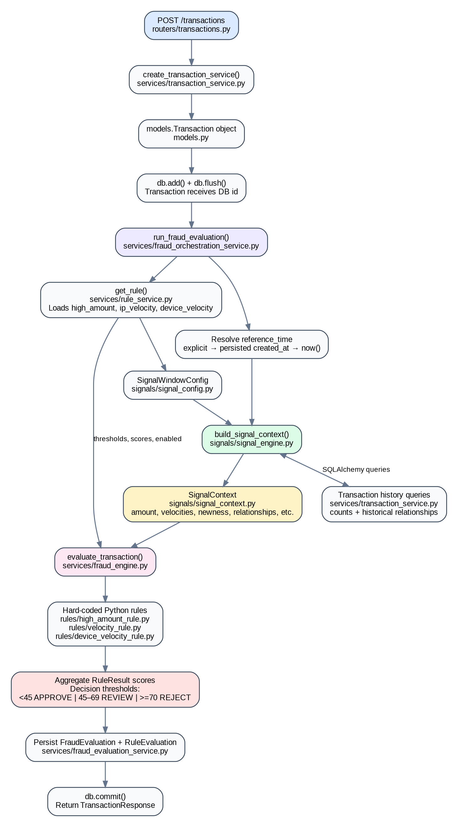

2. Hard-Coded Rule Evaluation Sequence
All three rules receive the same SignalContext. Each rule contains its own Python comparison logic and produces a RuleResult. The fraud engine aggregates those scores and applies the fixed decision thresholds.
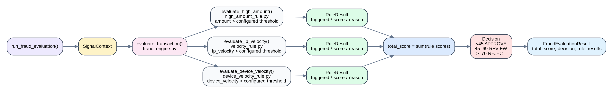
APPROVE  score < 45 | REVIEW  score 45–69 | REJECT  score >= 70

3. Detailed Function Call Path
Step | File / Layer | Function | Responsibility
1 | routers/transactions.py | create_transaction(...) | Receives TransactionCreate from POST /transactions and starts the transaction workflow.
2 | services/transaction_service.py | create_transaction_service(...) | Maps TransactionCreate fields to models.Transaction, applies optional synthetic created_at, calls db.add(), and flushes the row.
3 | services/fraud_orchestration_service.py | run_fraud_evaluation(...) | Resolves reference_time, loads active rule configuration, builds SignalWindowConfig, builds SignalContext, and invokes the hard-coded fraud engine.
4 | services/rule_service.py | get_rule(...) | Loads high_amount, ip_velocity, and device_velocity FraudRule records from the fraud_rules table.
5 | signals/signal_engine.py | build_signal_context(...) | Calls transaction-history helpers and produces the internal SignalContext dataclass.
6 | services/transaction_service.py | count_* / has_* helpers | Runs SQLAlchemy queries for velocity, distinct relationships, prior customer usage, country history, and decline/session behavior.
7 | services/fraud_engine.py | evaluate_transaction(...) | Passes SignalContext values and DB rule configuration to each hard-coded Python rule function.
8 | rules/high_amount_rule.py | evaluate_high_amount(...) | Compares amount with the configured high-amount threshold and returns RuleResult.
9 | rules/velocity_rule.py | evaluate_ip_velocity(...) | Compares SignalContext.ip_velocity with the configured IP threshold and returns RuleResult.
10 | rules/device_velocity_rule.py | evaluate_device_velocity(...) | Compares SignalContext.device_velocity with the configured device threshold and returns RuleResult.
11 | services/fraud_engine.py | score aggregation + decision | Sums rule scores and maps the total to APPROVE, REVIEW, or REJECT.
12 | services/fraud_evaluation_service.py | create_fraud_evaluation(...) | Persists one FraudEvaluation and its child RuleEvaluation rows.
13 | transaction orchestration / router | db.commit() | Commits the Transaction, FraudEvaluation, and RuleEvaluation records as one unit of work.

4. Core Objects and Data Passed Between Layers
Object | Type | Purpose
TransactionCreate | Pydantic API input schema | Validated transaction payload received from API or synthetic data generator.
models.Transaction | SQLAlchemy ORM model | Persisted transaction row. A persisted instance also carries created_at and database id.
SignalWindowConfig | Frozen dataclass | Central window settings. Existing IP/device values may be populated from FraudRule.window_minutes.
SignalContext | Internal dataclass | Calculated facts such as amount, velocities, new-device/card/IP flags, country mismatches, and decline/session counts.
models.FraudRule | SQLAlchemy ORM model | Stores enabled state, threshold, score, window, and later signal_key/operator. Earlier hard-coded functions still interpret these records.
RuleResult | Pydantic/internal result schema | One rule outcome: rule_name, triggered, score, and human-readable reason.
FraudEvaluationResult | Pydantic result schema | Aggregated total_score, final decision, and list of RuleResult objects.
FraudEvaluation / RuleEvaluation | SQLAlchemy ORM models | Persisted evaluation header and rule-level audit trail.

5. Simplified Pseudocode of the Earlier Flow
create_transaction(transaction):
db_transaction = create_transaction_service(db, transaction)
fraud_result = run_fraud_evaluation(db, db_transaction)
create_fraud_evaluation(db, db_transaction.id, fraud_result)
db.commit()
return db_transaction
run_fraud_evaluation(db, transaction):
reference_time = resolve_reference_time(transaction)
high_amount_rule = get_rule("high_amount")
ip_rule = get_rule("ip_velocity")
device_rule = get_rule("device_velocity")
window_config = SignalWindowConfig(...)
signal_context = build_signal_context(...)
return evaluate_transaction(signal_context, rule configuration)
evaluate_transaction(signal_context, ...):
results = [
evaluate_high_amount(...),
evaluate_ip_velocity(...),
evaluate_device_velocity(...),
]
total_score = sum(result.score for result in results)
decision = APPROVE / REVIEW / REJECT
return FraudEvaluationResult(...)

6. Main Limitation of the Hard-Coded Design
The Signal Engine is reusable, but each new fraud rule still requires a new Python function or explicit call inside fraud_engine.py. A rule cannot be fully authored from the UI because Python contains the interpretation logic. The dynamic rule engine removes this limitation by resolving signal_key from SignalContext and applying a DB-configured operator, threshold, and score.

