

**The Experiment Report of**

***Machine Learning***

**College Software College**

**Subject Software Engineering**

**Members**   **麦栋铖**

**Student ID 201536612525**

**E-mail** [379857334@qq.com](mailto:379857334@qq.com)

**Tutor**   **Qingyao Wu**

**Date submitted** **2017.12.8**

# 1. Topic: Linear Regression, Linear Classification and Gradient Descent

**2. Time: 2017.12.8**

**3. Reporter:Dongcheng Mai**

**4. Purposes:**

1. Further understand of linear regression and gradient descent.
2. Conduct some experiments under small scale dataset.
3. Realize the process of optimization and adjusting parameters.
4. **Data sets and data analysis:**

Linear Regression uses Housing in LIBSVM Data, including 506 samples and each sample has 13 features. You are expected to download scaled edition. After downloading, you are supposed to divide it into training set, validation set.   
Linear classification uses australian in LIBSVM Data, including 690 samples and each sample has 14 features. You are expected to download scaled edition. After downloading, you are supposed to divide it into training set, validation set.

1. **Experimental steps:**

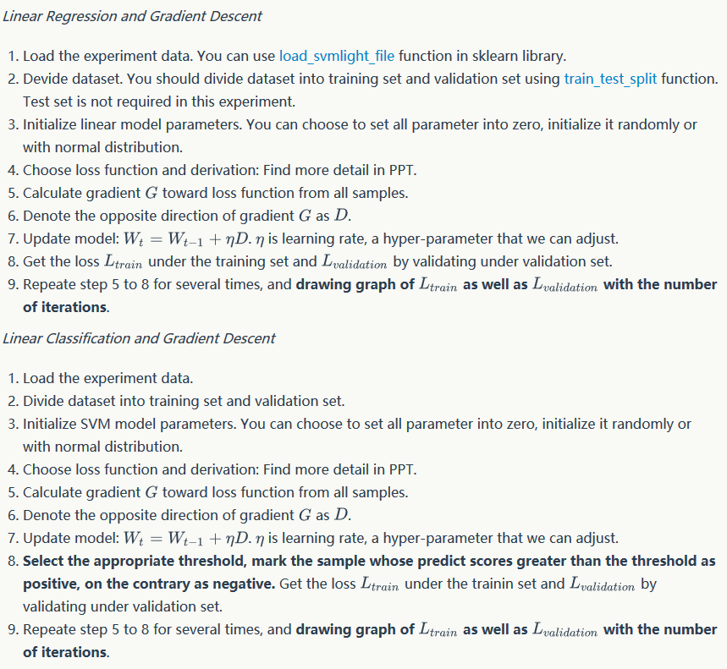

1. **Code:**

Linear Regression:

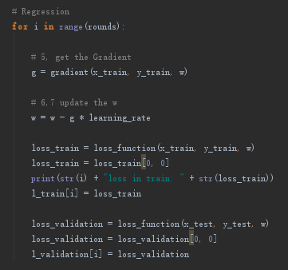

Linear Classification:

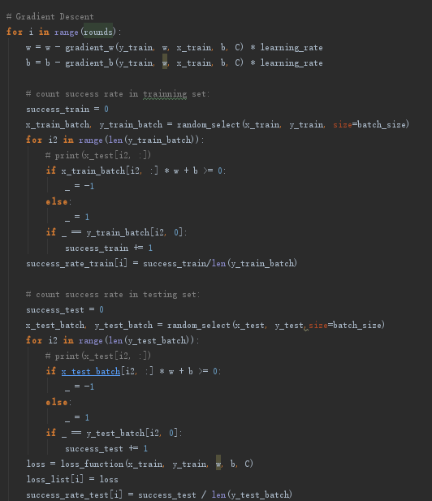

1. **Selection of validation:**

**hold-out**

1. **The initialization method of model parameters:**

set all parameter into zero

1. **The selected loss function and its derivatives:**

Regression:

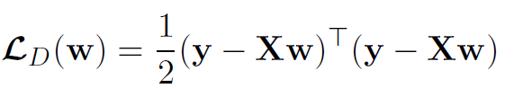

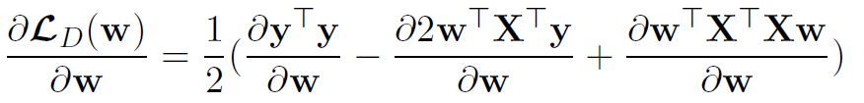

Classification:

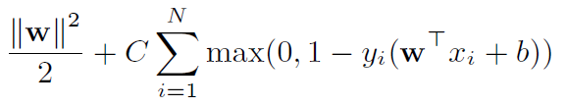

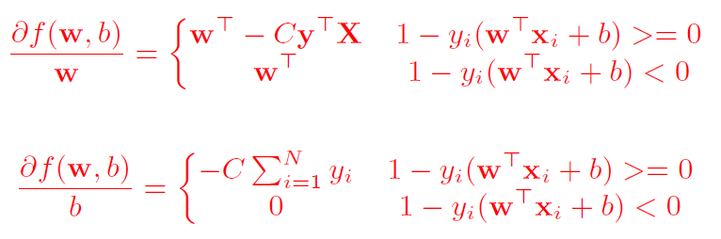

**11. Experimental results and curve:**

## Hyper-parameter selection (η, epoch, etc.):

η:0.0005,0.05

## Assessment Results (based on selected validation):

Merged with the next one

## Predicted Results (Best Results):

Regression:

loss function：

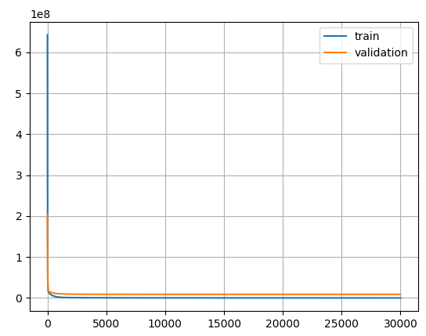

Classification:

accuracy(batch size = 50):

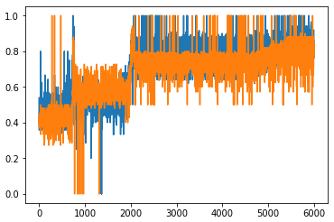

## Loss curve:

Regression: Classification:

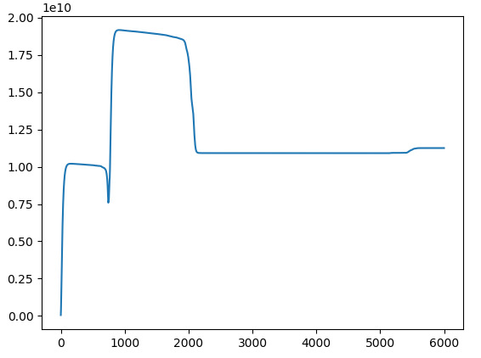

**12. Results analysis:**

Gradient drops converge to a certain value or oscillate as the number of iterations increases.  
Reference is very important

**13. Similarities and differences between linear regression and linear classification:**

The same point: the purpose is to fit a hyperplane

Differences: The regression is to keep the points as close as possible to the hyperplane, and the classification is to make the points as far away from the hyperplane as possible and divided into two categories, in different positions in the hyperplane.

**14. Summary:**

Machine learning is a very effective method of fitting data  
 Tuning and optimization require very patient attempts.