Curriculum vitae of Makanaka Thabeth Farasi 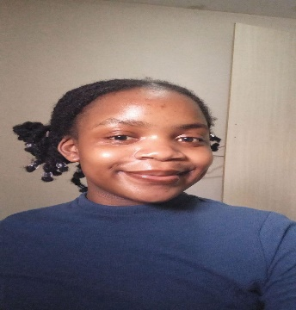

**My Information**

**Names: Makanaka Thabeth**

**Surname: Farasi**

**Date of birth: 14 August 2003**

**Gender: Female**

**Marital status: Single**

**Address: Vincent Dickenson RD**

**Cottonlands**

**Verulam**

**4345**

**Home Language: English**

**Phone Number: 0621456002**

**Email Address:** [**makanakafarasi6@gmail.com**](mailto:makanakafarasi6@gmail.com)

**GitHub profile:** [**https://github.com/Maka180**](https://github.com/Maka180)

**LinkedIn profile:** [**www.linkedin.com/in/makanaka-farasi-048429338**](http://www.linkedin.com/in/makanaka-farasi-048429338)

**Virtual CV: https://github.com/Maka180/Virtual_CV_MT_Farasi/blob/main/CV.html**

**Objective**

I am a highly motivated final-year Information Technology and management student with a strong foundation in software development, network administration, data analysis and furthermore. Eager to apply the theoretical knowledge and practical project experience to contribute to a dynamic team and grow within a challenging IT environment. Looking for an entry level position that leverages my problem-solving skills, technical proficiency, and passion for innovation.

**Education**

Degree: Bachelor of Science in Information Technology and Management|

University Name: Northwest University

Location: Potchefstroom, South Africa

Expected Graduation: 2026

Coursework: Data structures & algorithms, object Oriented programming, User Interface Programming, System analysis and Design, Information Security, Data analytics, Artificial intelligence, Database management systems, computer networks, operating systems, decision support systems.

**Skills**

**Programming Languages:** Python, Java, C++, JavaScript, SQL

**Web Technologies:** HTML, Node.js

**Databases:** MySQL

**Networking:** TCP/IP, DNS, DHCP, Routing, Switching

**Software/Applications:** Microsoft Office Suite

**Soft Skills:** Problem-Solving, Critical Thinking, Teamwork, Communication, Adaptability, Time Management, Self-Learning

**Achievements**

* Certification Name: Computer hardware basics,
* Issuing Body: Cisco
* Date issued: April 08, 2024

**Projects**

* Project name 1: Tawanda home of love
* Date: February 2024-September 2024
* Description: Tawanda home of love is a system for an orphanage. It is an automated system that maintains children, staff, sponsors and volunteers.
* Technologies: MySQL database, Visual studio (C#), GitHub.
* Outcomes: This project equipped with these following skills:
* Soft skills**:** Team collaboration, communication and critical thinking.
* Analytical and problem-solving skills**:** Requirement analysis, problem identification and process modelling.
* Technical skills: Database design, user interface design, system design and programming basics in C#.
* Contribution: I was part of the planning, Requirement analysis documentation, System design and system development.
* Project link in GitHub: https://github.com/CMPG223-GROUP19/CMPG223-DEMO-PROJECT
* Project name 2: Clinic Patient Management System
* Date: March 2025-May 2025
* Description: This is a clinic management system that automates a clinic paper system. It facilitates the management of patients, medical staff, events, campaigns as well as its appointments.
* Technologies: Oracle database management environment.
* Outcomes: This project helped me sharpen various skills further, such as:
* Soft skills: Team collaboration, communication and critical thinking.
* Analytical and problem-solving skills: Problem identification and process modelling
* Technical skills: Database design, SQL
* Contribution/role: I got an opportunity to be the group leader of the project. I was also part of planning and creation of the database system.
* Project link to GitHub: https://github.com/neohlm/Patient-Management-Database-System