Vertex Studio — Premium Brand Identity Package
This document serves as the master brand specification for Claude when redesigning and extending the Vertex Studio brand.

Visual Brand Concept
Reference concept for the premium logo and visual identity.
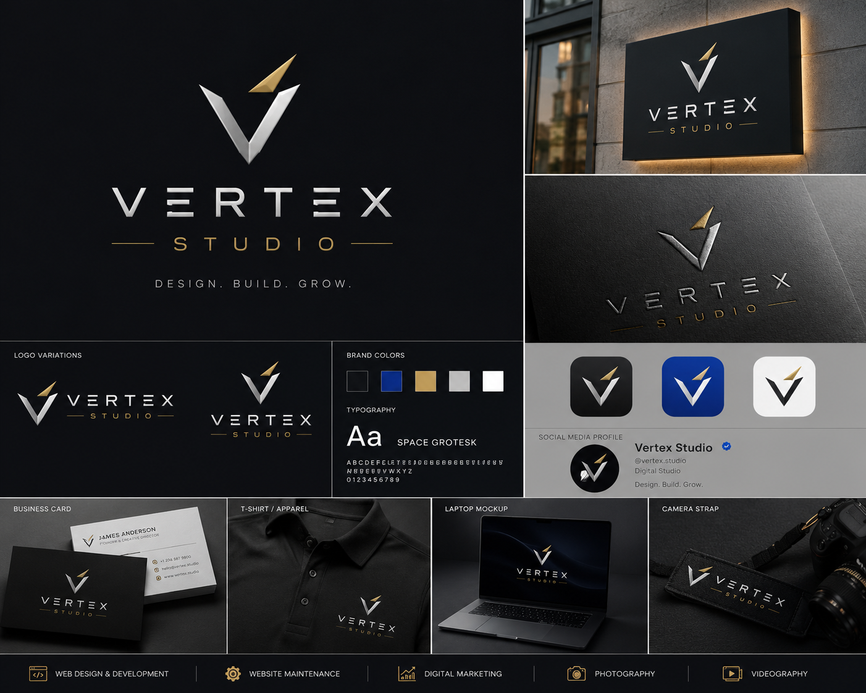

Primary Logo Concept
A geometric 'V' representing:
• Vertex (highest point)
• Upward growth
• Excellence
• Precision
• Premium technology
Style:
• Minimal
• Luxury
• Timeless
• Flat first, with optional metallic presentation
• Works in black, white, gold, and blue.

Brand Colors
Midnight Black #0F172A
Royal Blue #1E40AF
Luxury Gold #C8A45D
White #FFFFFF
Slate #64748B
Silver #D1D5DB

Master Claude Prompt
Use the visual logo shown above as the primary inspiration for every design.
Maintain the same geometric 'V' language, premium typography, luxury spacing, and minimalist aesthetic.
Design a complete brand ecosystem including website, logo system, business cards, proposals, pricing guide, social media kit, motion graphics, icons, favicon, UI kit, and brand guidelines. Keep every asset visually consistent with the supplied logo concept.

