Whiteboard workshop 3

A) 18 x 900 = 16200

B) 1/18 = 1:0.055

C) The demand for South African platinum would increase because buyers could purchase more,this is because international buyers can now purchase more rounds with every dollar.

D) The demand for South African exports will decrease, as they will now be more expensive for international buyers

E) There would be an increase in sales due to the exports effects, where a lower exchange rate makes buyers more likely to buy goods from the country.This will increase revenue.

2

1. Since the exchange rate is too high, the Japanese will demand less rands than are suplied therefore resulting in a surplus.This will cause the exchange rate to drop till it reaches equilibrium.
2. Now there is a shortage which will cause japanes to exhange their xen for Rand then the exchange rate goes back to equilibrium

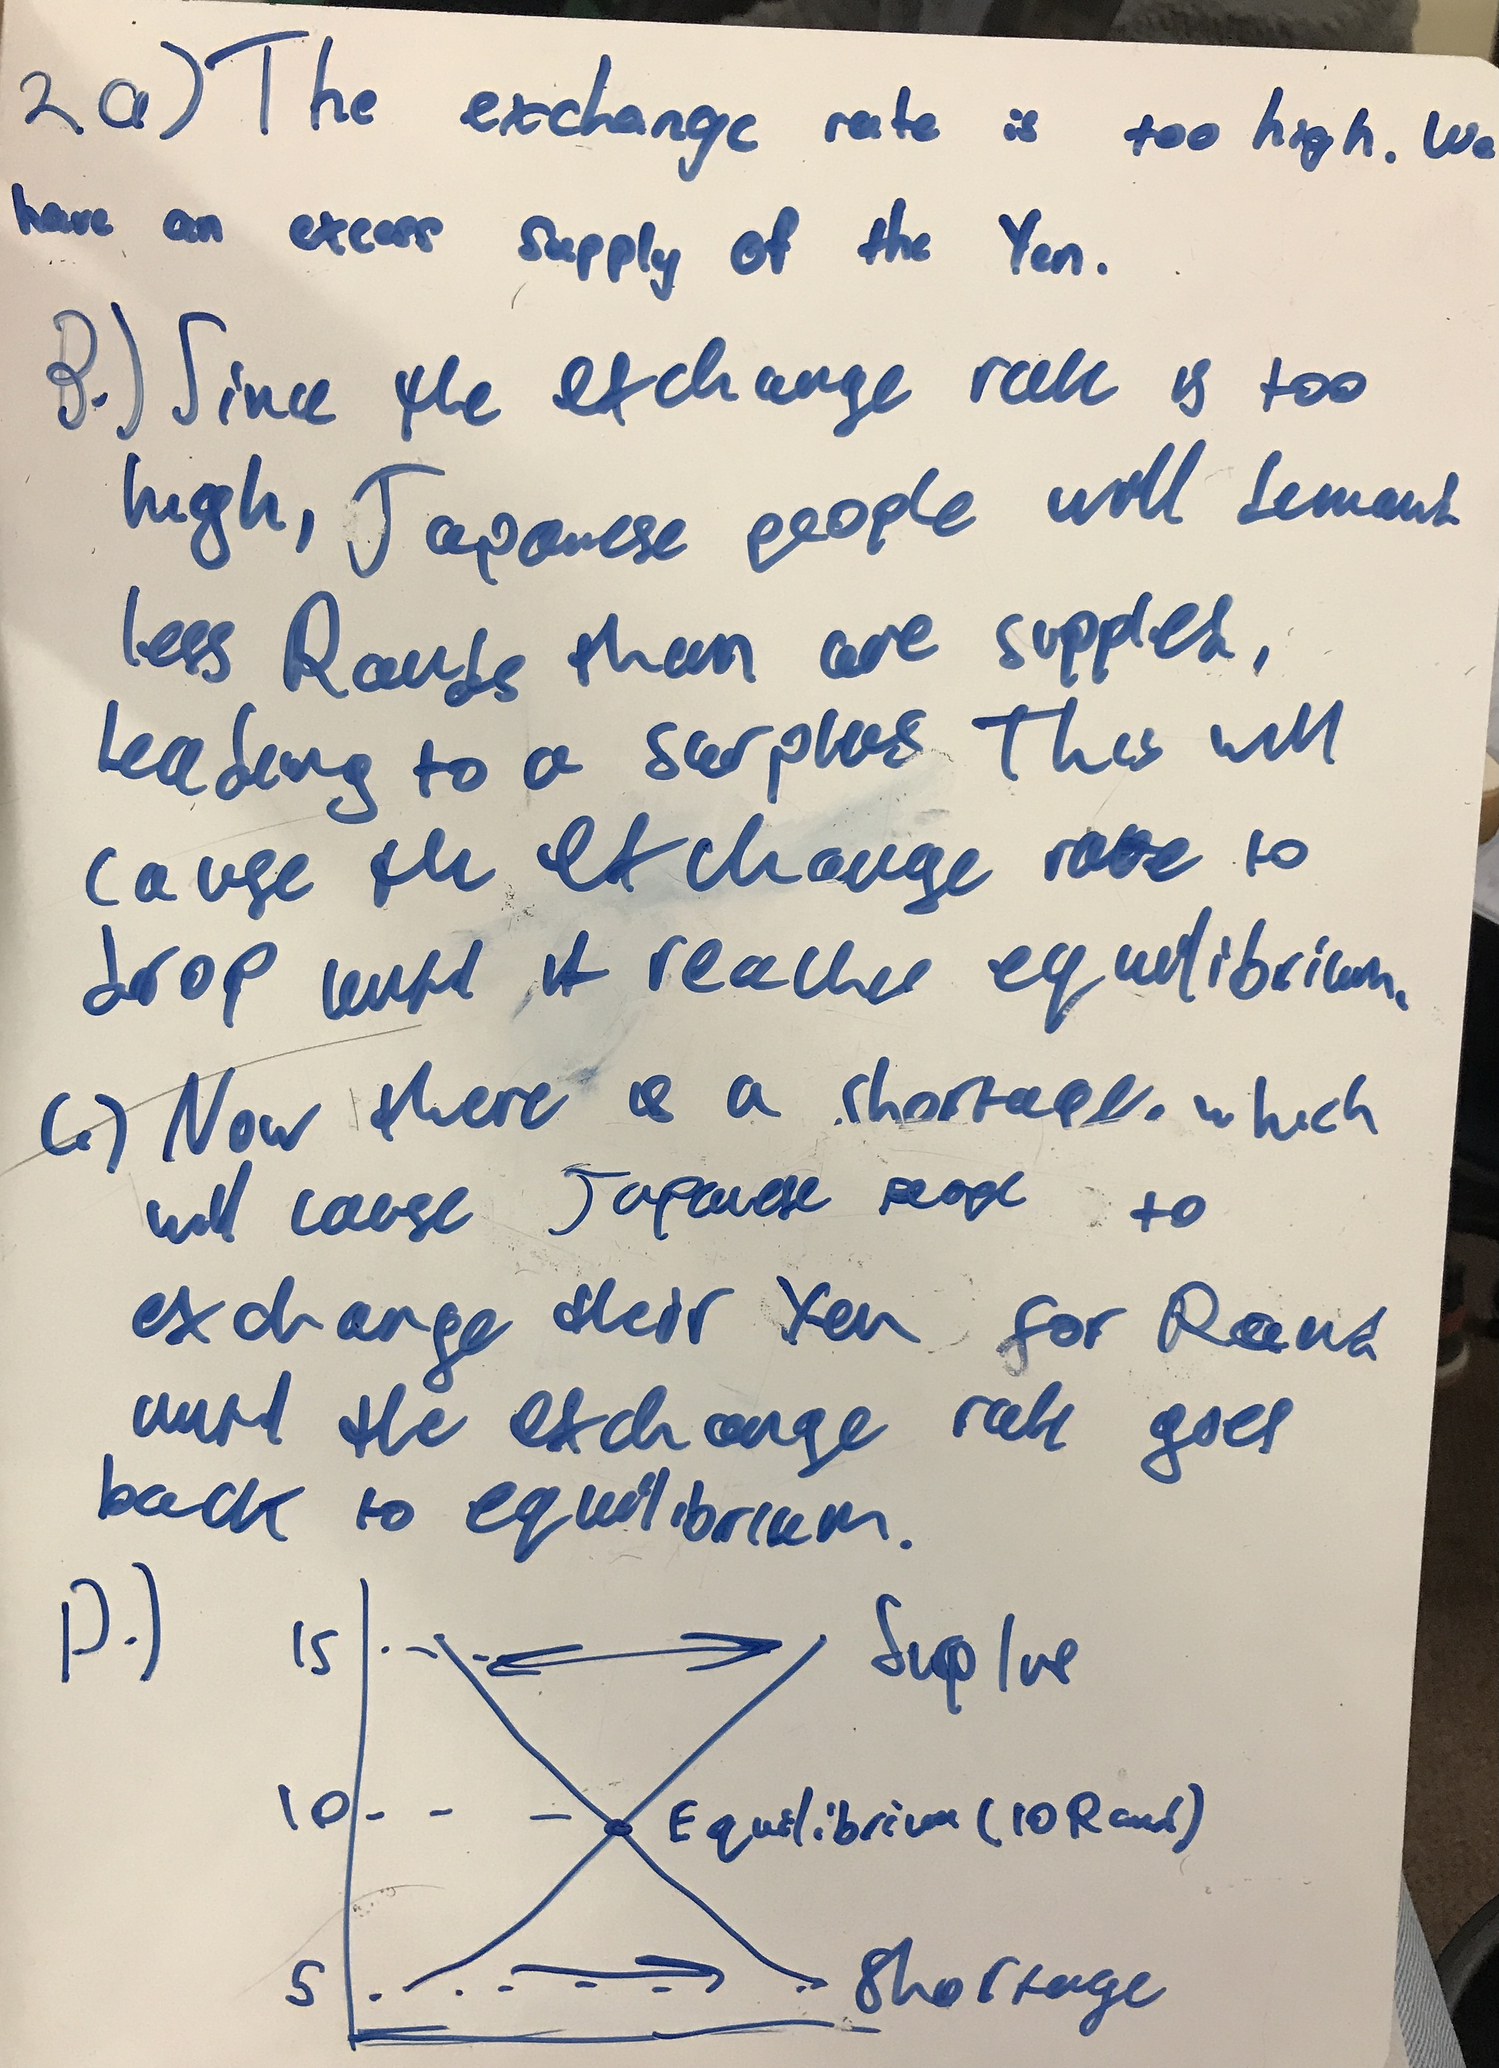

3