**MY TOURS**

**A PROJECT REPORT**

Submitted by

**MAKANESHA V**

**(REGISTER NO 22ISR023)**

**22VC003- INTRODUCTION TO TAILWIND CSS**

**DEPARTMENT OF COMPUTER TECHNOLOGY-PG**



**KONGU ENGINEERING COLLEGE**

**(Autonomous)**

**PERUNDURAI**

**ERODE–638060**

**OCTOBER 2023**

ii

**DEPARTMENT OF COMPUTER TECHNOLOGY- PG**

**KONGU ENGINEERING COLLEGE**

**(Autonomous)**

**PERUNDURAI ERODE–638060**

**OCTOBER2023**

**BONAFIDE CERTIFICATE**

This is to certify that the Project report entitled “**MY TOURS**” is the bonafide record of one credit Project (22VC003-Introduction to Tailwind CSS) done by **MAKANESHA V** (Register. no 22SR023), during the year 2023-2024

FACULTY INCHARGE

iii

**ABSTRACT**

Discover a world of adventure with our premier tourism website! Immerse yourself in captivating destinations, from exotic beaches to vibrant cityscapes. Our user-friendly platform offers a seamless travel experience, providing comprehensive information on accommodations, attractions, and local culture. Whether you seek a relaxing getaway or thrilling escapades, we cater to every traveler’s desires. Browse curated itineraries, uncover hidden gems, and plan your dream vacation effortlessly. Embrace the joy of exploration with our interactive maps and insightful travel guides. Your journey begins here—where every click opens doors to new horizons. Embark on unforgettable adventures with our tourism website, your gateway to endless possibilities!

# TABLE OF CONTENTS

|  |  |  |
| --- | --- | --- |
| **CHAPTER NO** | **TITLE** | **PAGE NO** |
|  | **ABSTRACT** | iii |
| **1** | **INTRODUCTION** | **1** |
|  | 1.1 OVERVIEW OF THE PROJECT | 1 |
| **2** | **SYSTEM ANALYSIS** | **2** |
|  | 2.1 EXISTING SYSTEM  2.2 PROPOSED SYSTEM  2.3 PROBLEM ANALYSIS | 2  2  3 |
|  | 2.3.1 PROBLEM DESCRIPTION | 3 |
|  | 2.3.2 DATA FLOW DIAGRAM | 4 |
| **3** | **SYSTEM REQUIREMENTS** | **4** |
|  | 3.1 HARDWARE REQUIREMENTS | 4 |
|  | 3.2 SOFTWARE REQUIREMENTS | 5 |
|  | 3.3 SOFTWARE DESCRIPTION | 5 |
| **4** | **SYSTEM DESIGNS** | **8** |
|  | 4.1 INPUT DESIGN | 8 |
|  | 4.2 MODULE DESIGN | 9 |
|  | 4.3 OUTPUT DESIGN | 11 |
| **5** | **CONCLUSION AND FUTURE WORK** | **12** |
| 6 | **APPENDICES** | **13** |
|  | APPENDIX 1: SAMPLE CODE | 13 |
|  | APPENDIX 2: SCREEN SHOTS | 18 |

**CHAPTER 1 INTRODUCTION**

# 1.1 OVERVIEW OF PROJECT

“MY TOURS” The tourism website project aims to create a captivating online platform that promotes and facilitates travel experiences. Focused on user-friendly navigation, the site will feature destination guides, curated itineraries, and immersive multimedia content. Integrating interactive maps and a booking system will enhance user engagement. Emphasizing responsive design for seamless accessibility across devices, the website will prioritize visually appealing aesthetics to inspire wanderlust. Social media integration will amplify reach and user interaction. Robust backend infrastructure ensures reliable performance. With a commitment to showcasing diverse destinations, the tourism website strives to be a go-to resource for travelers seeking inspiration and practical information.

**CHAPTER 2**

**SYSTEM ANALYSIS**

# 2.1 EXISTING SYSTEM

* The existing tourism website lacks real-time updates on attractions and accommodations, leading to outdated information .

Drawbacks for existing system

* Limited user interactivity hampers engagement, and the absence of personalized recommendations hinders user satisfaction.
* Additionally, the site's navigation is cumbersome, impeding a seamless user experience.

# 2.2 PROPOSED SYSTEM

The proposed system is to provide the information regarding their respective locations with plenty of place suggestion.

Advantages of proposed system

* User-friendly interface for seamless navigation.
* Dynamic content showcasing diverse travel destinations.
* Personalized user profiles for tailored recommendations.
* Integrated booking system for flights, hotels, and activities.
* Real-time weather updates and travel advisories.

# 2.3 PROBLEM ANALYSIS

The tourism website faces issues with slow page loading, outdated content, and limited mobile responsiveness, hindering user experience. Ineffective SEO strategies contribute to low visibility. Insufficient integration of booking features and social media limits user engagement.

## 2.3.1 Problem description

## Inadequate user engagement and outdated content plague our tourism website, diminishing its appeal. Visitors struggle to find relevant information, hindering their travel planning experience. Revitalizing the site's design, updating content regularly, and enhancing navigation are imperative for fostering a user-friendly platform that inspires exploration and boosts tourism engagement.

## 2.3.2 Data flow diagram

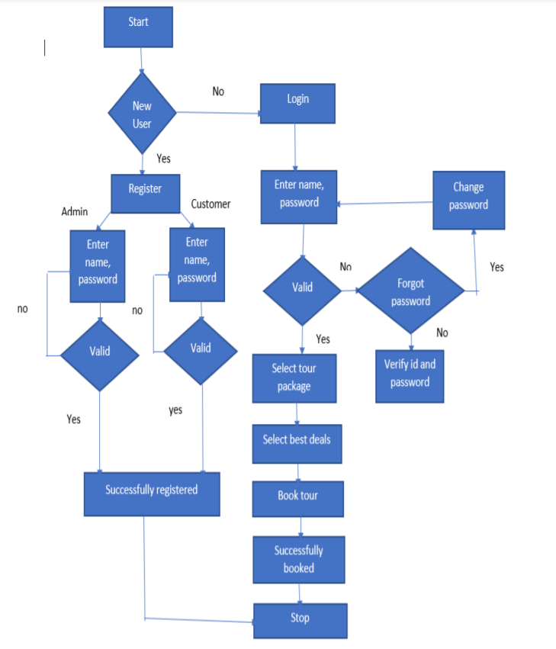

# 2.4 SYSTEM SPECIFICATION

# 

## 2.4.1 Hardware requirements

Processor: Intel core i5

RAM: 4GB or higher

Keyboard: Standard 104 keyboard (enhanced)

Mouse: Local PS/2

System type: 64-bit operating system

## 2.4.2 Software requirements

Operating System: Windows 11

Web Browser: Internet Explorer 10 or higher, Chrome

Front-end: HTML, Tailwind CSS

Client-Side Script: JavaScript

## 2.4.3 Software description

# HTML

HTML (Hypertext Markup Language) is the standard language for creating and structuring web pages. It uses a markup system with tags to define the elements and content of a webpage. HTML is a markup language used to create web pages and web content. It consists of a set of elements, each represented by tags enclosed in angle brackets (<tag>). These elements define the structure, content, and presentation of a webpage.

The feature of HTML includes:

* HTML is used to build websites.
* It is supported by all browsers.
* It can be integrated with other languages like CSS, JavaScript, etc.
* It is easy to learn and easy to use.
* It is platform-independent.
* Images, videos, and audio can be added to a web page.
* Hypertext can be added to the text.
* It is a mark-up language.
* You can display HTML documents on any platforms such as Macintosh, Window and Linux etc.
* Graphics, videos and sounds can also be added to the web pages which give an extra attractive look to your web pages.

# TAILWIND CSS (Cascading style sheets)

Tailwind CSS is a utility-first CSS framework that streamlines web development by providing a set of pre-designed, low-level utility classes. It focuses on efficiency and flexibility, allowing developers to rapidly build responsive and visually appealing user interfaces.

Tailwind's approach encourages a "design in the markup" philosophy, where styles are applied directly in the HTML, eliminating the need for custom CSS. With a comprehensive set of utility classes covering layout, typography, colors, and more, Tailwind enables developers to create consistent and customizable designs with minimal effort, making it a popular choice for modern web development.

# JAVASCRIPT

JavaScript (JS) is a high-level, dynamic, interpreted programming language that is commonly used to add interactivity and functionality to web pages. It is one of the three core technologies used in web development, alongside HTML and CSS. JavaScript code can be embedded directly into HTML documents, or it can be included as a separate filet hat is referenced by an HTML document.

JavaScript has a syntax that is similar to other programming languages, such as C++and Java, but it also has some unique features that set it apart. JavaScript has become an essential skill for web developers, and there are many resources available for learning the language, including online tutorials, books, and courses.

# CHAPTER 3

# SYSTEM DESIGN

# 3.1 INPUT DESIGN

Create an engaging tourism website with a user-friendly interface. Feature stunning visuals of destinations, ensuring quick loading times for seamless navigation. Implement a clear and intuitive menu for easy exploration of travel packages, accommodation options, and activities. Allowing users to filter results based on preferences. Prioritize mobile responsiveness for on-the-go access. Integrate user reviews and ratings to build trust. Provide a secure booking system and highlight exclusive deals. Incorporate social media links for community engagement. Utilize vibrant and inviting colors, evoking the spirit of travel. Overall, strive for a visually appealing, informative, and efficient design to enhance the user experience..

# LOGIN FORM

The login form provides authentication to enter into the application through login name and password and selecting the role of the user and service provider. After entering the login name and password the input is verified and validated.

**SIGN UP FORM**:

The signup form is a basic online form where users provide their unique username or email, create a secure password, and confirm it. This form allows users to register and access the website or platform.

# 3.2 MODULE DESIGN

The modules and its functionalities involved in are,

➢ Authentication Module

* Sign up
* Login
* User defined module
  + - Login
    - Main page
    - Destinations
    - Help
    - About
    - Contact
* Main page
  + Offers
  + Locations
  + Categories
* Destination page
  + Locations
  + Booking
* Category page
  + Beaches
  + Hills

# AUTHENTICATION MODULE

This module allow user to ensuring secure access by verifying user identities. These modules employ methods like name, email, passwords, authentication to confirm user authenticity.

# USER DATA MANAGEMENT

This module enable user to login if they have their account otherwise, they need to create an account. The user needs to choose desired location and can book their slots.

# E-BOOKING PLATFORM

The description of each places in a location is given in a clear way and booking can be done using the forms by giving an appropriate data.

# 3.4 OUTPUT DESIGN

The tourism website's design will feature a vibrant and user-friendly interface, harmonizing enticing visuals with intuitive navigation. A dynamic homepage carousel will showcase diverse destinations, inviting users to explore. The menu will streamline access to key sections, such as 'Explore Destinations,' 'Categories,' and 'Special Offers.' Responsive design ensures seamless browsing on various devices.

Integration of high-quality imagery, and concise, engaging content will enhance user experience. Booking functionality will be prominently displayed, with clear calls-to-action. Social media integration and user reviews will foster community engagement. The overall aesthetic will convey excitement, reliability, and a sense of adventure.

# CHAPTER 4

# CONCLUSION AND FUTURE ENHANCEMENTS

# 4.1 CONCLUSION

Discover the world with us! “MY TOURS” website is your gateway to unforgettable experiences. From breathtaking landscapes to vibrant cultures, we invite you to explore, connect, and create memories that last a lifetime. Start your journey today and let the adventure begin!

# 4.1 FUTURE ENHANCEMENT

* Personalized Experiences: Implement AI-driven recommendations for tailored travel itineraries based on user preferences, enhancing user engagement.
* Augmented Reality (AR) Integration: Enable virtual exploration of destinations through AR, providing users with immersive previews and enhancing trip planning.
* Blockchain for Security: Utilize blockchain technology to secure and streamline transactions, ensuring trust, transparency, and data integrity for users booking accommodations and activities on the platform.

# APPENDICES

# APPENDIX 1:

# SAMPLE CODING

# index.html

<!DOCTYPE html>

<html lang="en">

<head>

<meta charset="UTF-8">

<meta name="viewport" content="width=device-width, initial-scale=1.0">

<title>Tourism Website</title>

<link href="https://cdn.jsdelivr.net/npm/tailwindcss@2.2.15/dist/tailwind.min.css" rel="stylesheet">

</head>

<body class="bg-black">

<!-- Navigation Bar -->

<nav class="bg-black p-4">

<div class="container mx-auto">

<div class="flex justify-between items-center">

<a href="#" class="text-white text-2xl font-semibold">My Tours</a>

<ul class="flex space-x-4">

<li><a href="index.html" class="text-white text-black">Home</a></li>

<li><a href="destinations.html" class="text-white text-black">Destinations</a></li>

<li><a href="help.html" class="text-white text-black">Help</a></li>

<li><a href="about.html" class="text-white text-black">About</a></li>

<li><a href="contact.html" class="text-white text-black">Contact</a></li>

<li><a href="login.html" class="text-white text-black">Logout</a></li>

</ul>

</div>

</div>

</nav>

<!-- Hero Section -->

<div class="bg-cover bg-center h-80 bg-gray-900 text-black bg-image-url flex items-center" style="background-image: url('pic1.jpg');">

<div class="container mx-auto text-center">

<h1 class="text-4xl font-semibold">Discover Your Next Adventure</h1>

<p class="text-lg mt-2">Explore amazing destinations around the world.</p>

<a href="destinations.html" class="mt-4 bg-black hover:bg-gray-700 text-white font-semibold px-6 py-2 rounded-full inline-block">Get Started</a>

</div>

</div>

<!-- Featured Destinations -->

<div class="container mx-auto mt-8">

<h2 class="text-2xl font-semibold mb-4">Featured Destinations</h2>

<div class="grid grid-cols-1 md:grid-cols-2 lg:grid-cols-3 gap-4">

<!-- Destination Card (Repeat as needed) -->

<div class="bg-white rounded-lg shadow-md">

<img src="pic2.jpg" alt="Destination 1" class="w-full h-48 object-cover rounded-t-lg">

<div class="p-4">

<h3 class="text-xl font-semibold">Special offers on 2 week trip</h3>

<p class="text-gray-600">Explore exciting offers for world tourist day.</p>

<a href="destinations.html" class="mt-2 text-blue-500 hover:underline">Book Now</a>

</div>

</div>

<div class="bg-white rounded-lg shadow-md">

<img src="fcity.jpg" alt="Destination 2" class="w-full h-48 object-cover rounded-t-lg">

<div class="p-4">

<h3 class="text-xl font-semibold">Categories</h3>

<p class="text-gray-600">Explore the beauty of various places on your choices.</p>

<a href="category.html" class="mt-2 text-blue-500 hover:underline">See Places</a>

</div>

</div>

<div class="bg-white rounded-lg shadow-md">

<img src="pep.jpg" alt="Destination 3" class="w-full h-48 object-cover rounded-t-lg">

<div class="p-4">

<h3 class="text-xl font-semibold">Gallery</h3>

<p class="text-gray-600">Explore the beauty of this amazing range of picutres.</p>

<a href="gallery.html" class="mt-2 text-blue-500 hover:underline">View More</a>

</div>

</div>

<!-- End of Destination Card -->

</div>

</div>

<!-- Footer -->

<footer class="bg-gray-900 text-white p-4 mt-8">

<div class="container mx-auto text-center">

<p>&copy; 2023 Tourism Site. All rights reserved.</p>

</div>

</footer>

</body>

</html>

# APPENDIX II – SAMPLE SCREENSHOT

MAIN PAGE

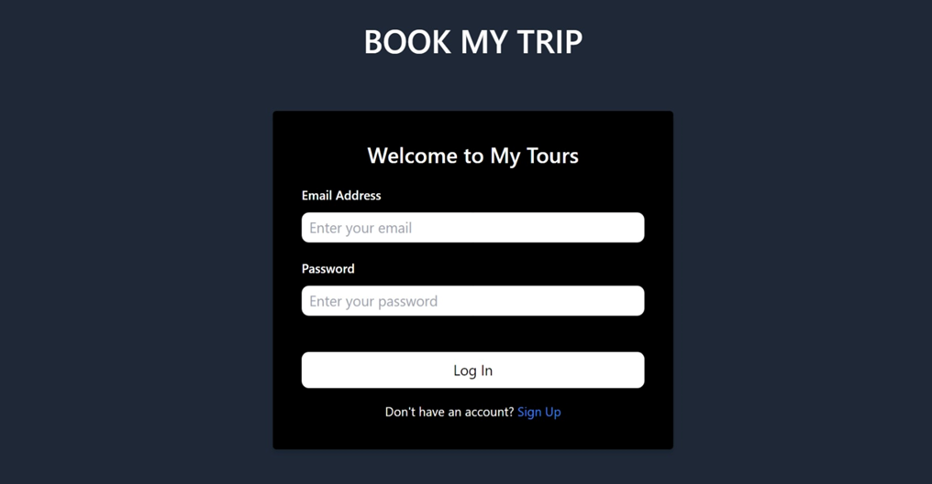

LOGIN PAGE

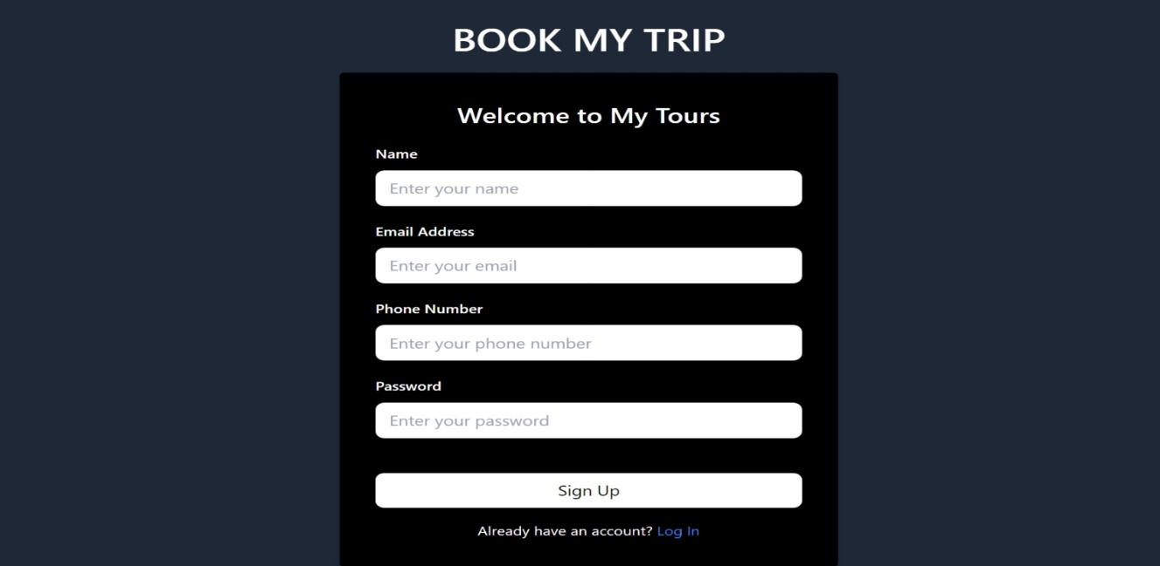

SIGN UP PAGE

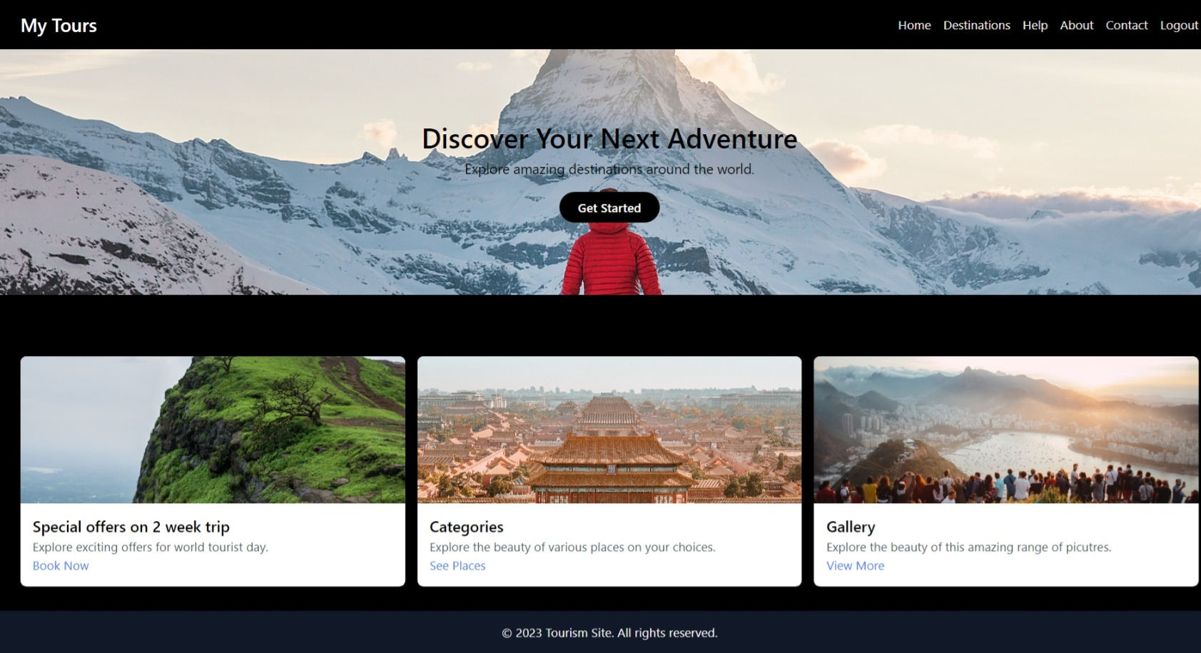

MAIN PAGE

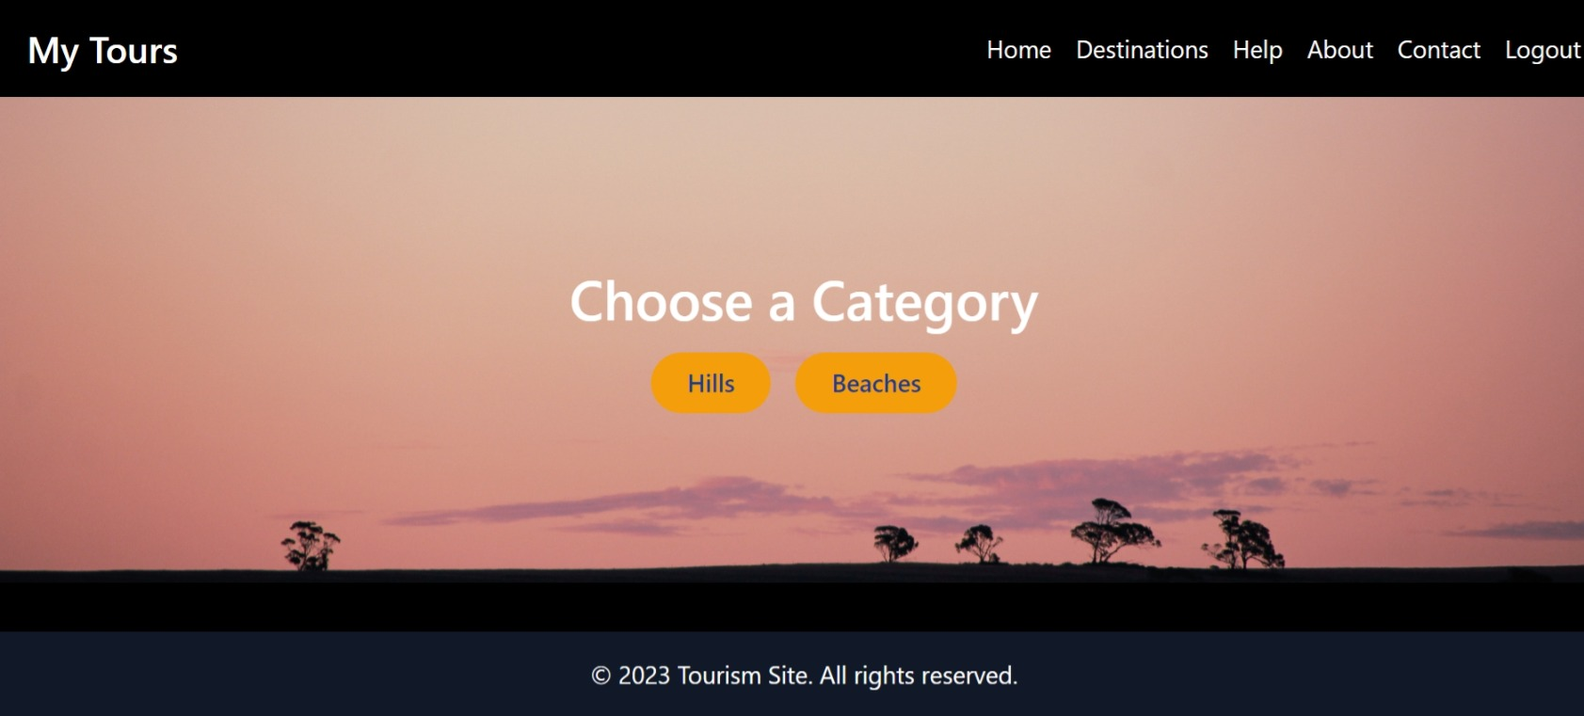

CATEGORY PAGE

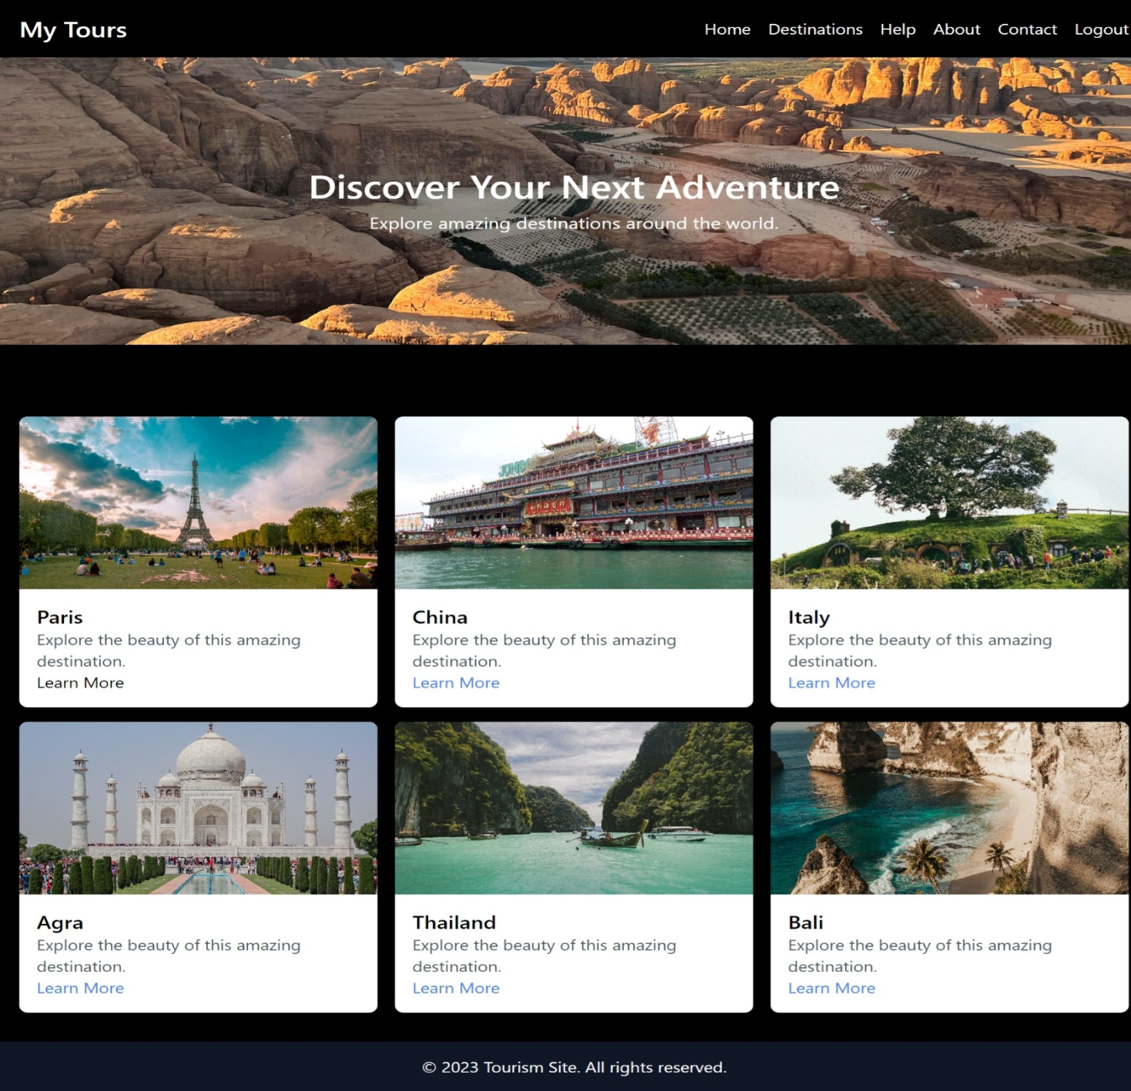

DESTINATION PAGE

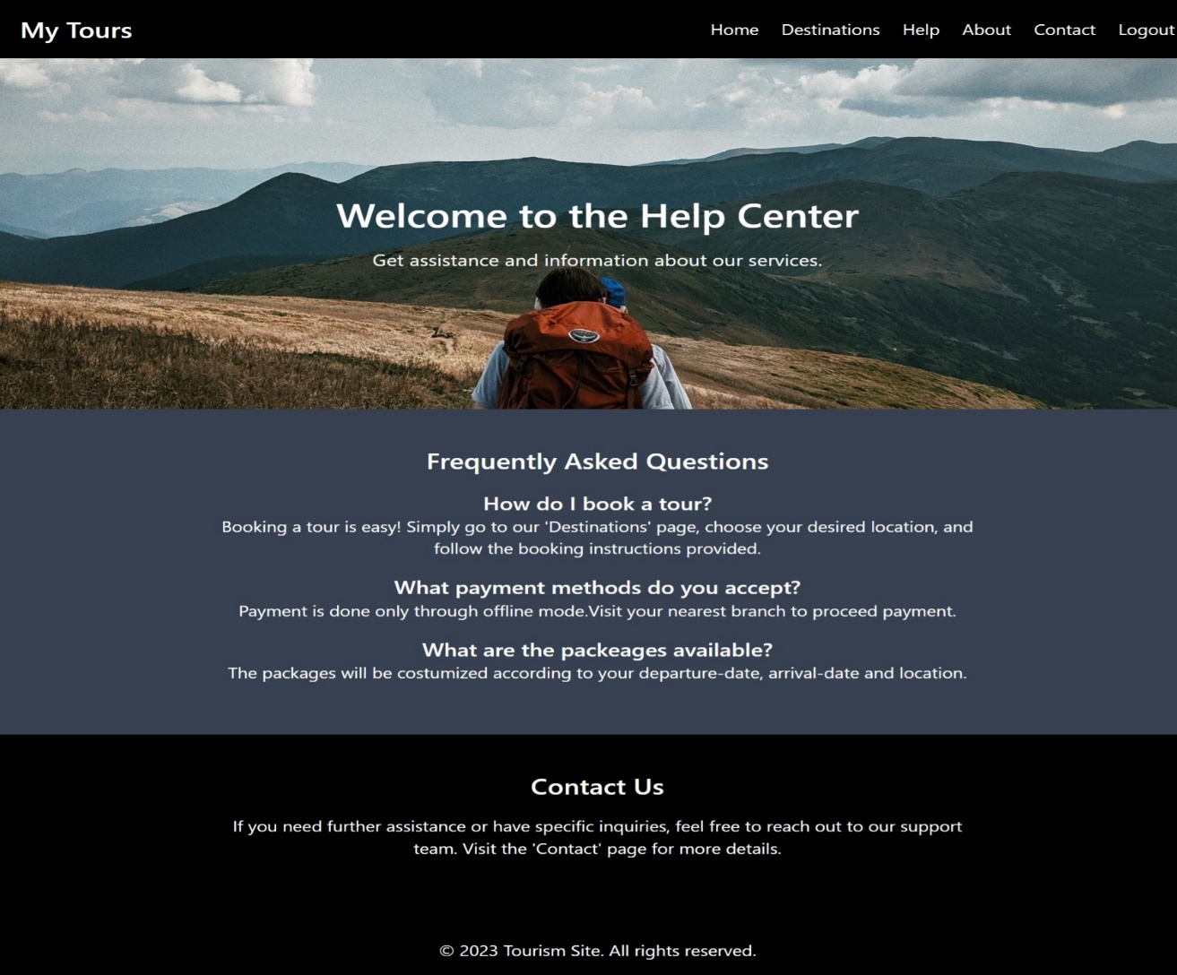

HELP PAGE

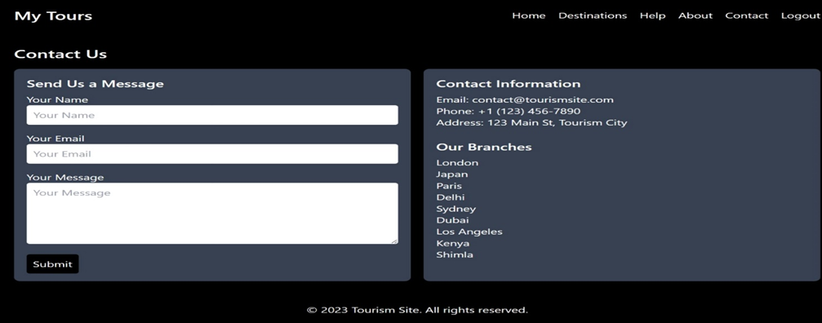

CONTACT PAGE

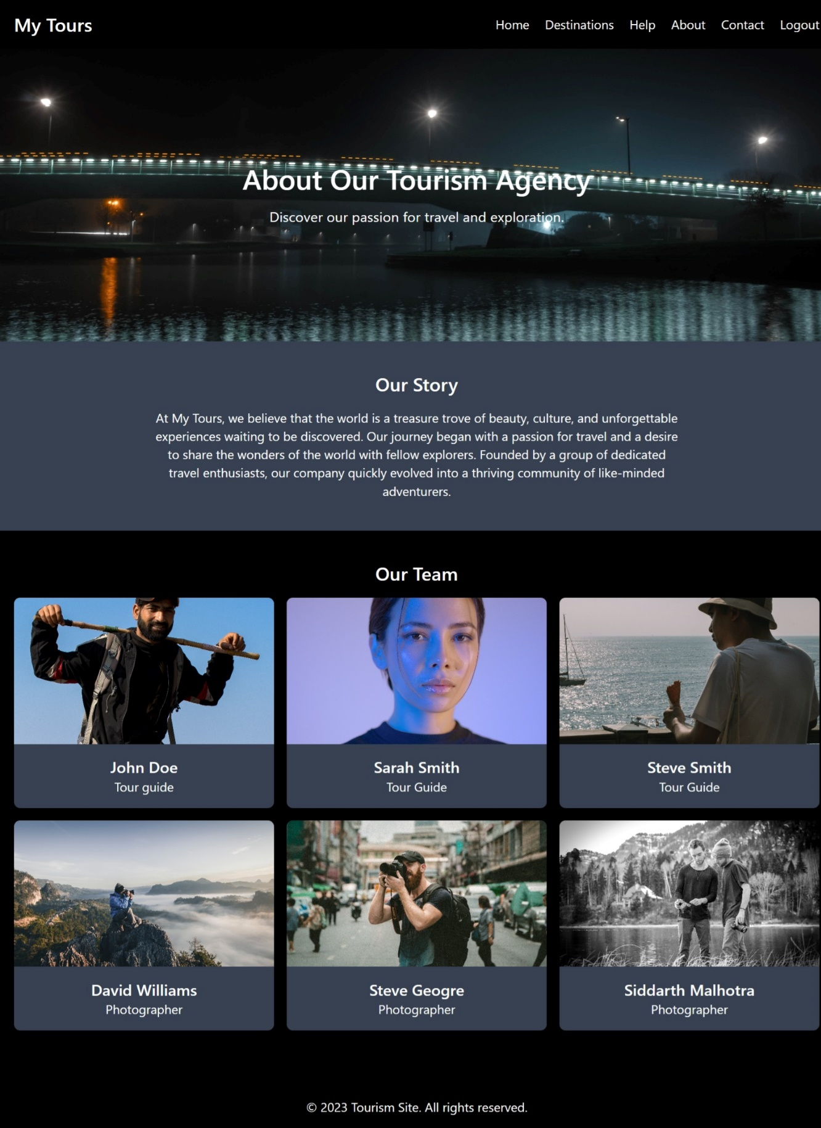

ABOUT PAGE

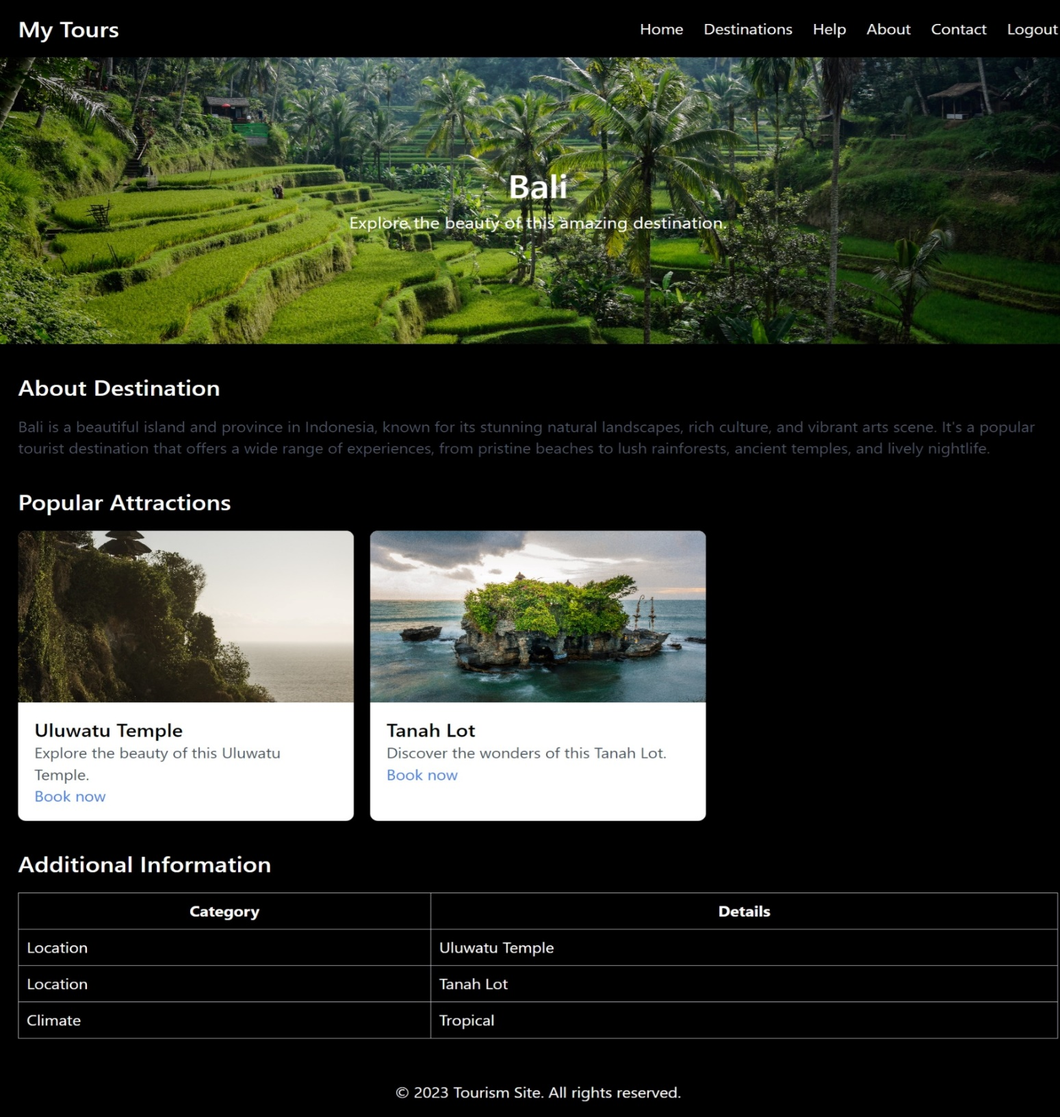SAMPLE LOCATION 1

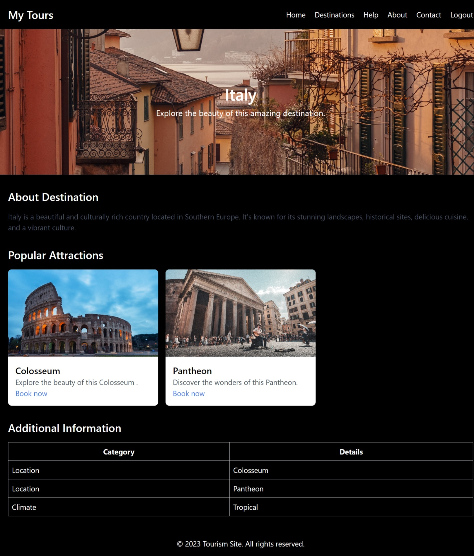

SAMPLE LOCATION 2

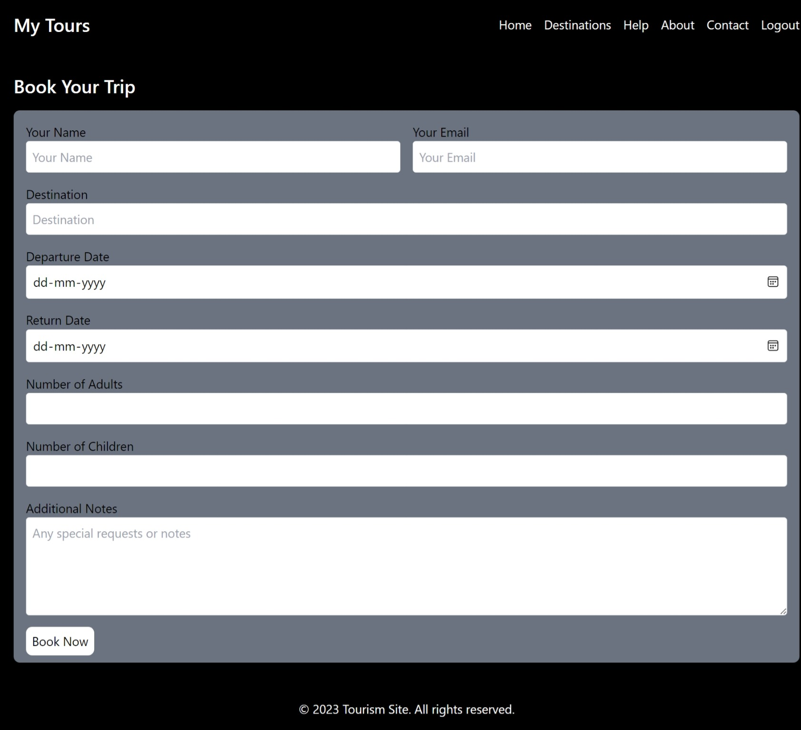

BOOKING FORM