DS Lab Programs

NAME: Tirkala Rishitha
Class: CSE-AI-B
Roll-no: 160724754067

Date: 03/02/2026(week 1)

- Create an account in github and link the repository with the google colab
https://github.com/rishithatirkala-byte/RishithaTirkala-ai-2025-2026-Even-AI-DS-4067.git

- Write the code to implement the following data structures
  - List
  - Tuples
  - Sets and
  - Dictionaries
#implementation of list
fruits=["apple","banana","cherry"]
print(fruits)
fruits.append("orange")
fruits.insert(1,"mango")
print(fruits)
fruits.remove("banana")
print(fruits)
print(fruits[0])
print("Total fruits:",len(fruits))

OUTPUT:

['apple', 'banana', 'cherry']
['apple', 'mango', 'banana', 'cherry', 'orange']
['apple', 'mango', 'cherry', 'orange']
apple
Total fruits: 4
---------------------------------------------------------
#implementation of tuples
fruits=("apple","banana","cherry",1,5)
print(fruits)
print(fruits[0])
print(fruits[2])
print(fruits[-1])
print("Total fruits:",len(fruits))

OUTPUT:

('apple', 'banana', 'cherry', 1, 5)
apple
cherry
5
Total fruits: 5
---------------------------------------------------
#implementation of sets
fruits={"apple","banana","cherry"}
print(fruits)
fruits.add("orange")
fruits.update(["mango","grapes"])
fruits.remove("banana")
print(fruits)
print("Total fruits:", len(fruits))
set1={1,2,3,4,5}
set2={4,5,6,7,8}
#union
print("Union:",set1|set2)
#intersection
print("Intersection:",set1&set2)
#difference
print("Difference:",set1-set2)
#symmetric difference
print("Symmetric Difference:",set1^set2)

OUTPUT:

{'apple', 'cherry', 'banana'}
{'cherry', 'mango', 'orange', 'grapes', 'apple'}
Total fruits: 5
Union: {1, 2, 3, 4, 5, 6, 7, 8}
Intersection: {4, 5}
Difference: {1, 2, 3}
Symmetric Difference: {1, 2, 3, 6, 7, 8}
--------------------------------------------------------------------------
#implementation of dictionaries
student={"Name":"Sara","RollNo":42,"Course":"DS"}
print("Dictionary items:")
for key,value in student.items():
print(key,":",value)
print("Total keys:",len(student))

OUTPUT:

Dictionary items:
Name : Sara
RollNo : 42
Course : DS
Total keys: 3

- Write the code to download, save and transform the data sets from the URL
# Download and save the dataset to local drive
import pandas as pd

# Correct URL of dataset (sample CSV dataset)
url = "https://raw.githubusercontent.com/mwaskom/seaborn-data/master/iris.csv"

# Read dataset from URL
df = pd.read_csv(url)

# Display first few rows
print(df.head())

# Save dataset to local drive
df.to_csv("iris.csv", index=False)

print("Dataset saved successfully")

OUTPUT:-

sepal_length sepal_width petal_length petal_width species
0 5.1 3.5 1.4 0.2 setosa
1 4.9 3.0 1.4 0.2 setosa
2 4.7 3.2 1.3 0.2 setosa
3 4.6 3.1 1.5 0.2 setosa
4 5.0 3.6 1.4 0.2 setosa
Dataset saved successfully

Date: 10/02/2026(week 2)
- Write the code to implement the following searching algorithms
  - Linear search
  - Binary search
# linear search
n = int(input("Enter number of elements: "))
arr = []

# input elements
for i in range(n):
arr.append(int(input(f"Enter element {i+1}: ")))

key = int(input("Enter element to search: "))

found = False

for i in range(n):
if arr[i] == key:
print(f"{key} found at index {i}")
found = True
break

if not found:
print("Element not found")

OUTPUT:

Enter number of elements: 6
Enter element 1: 12
Enter element 2: 23
Enter element 3: 34
Enter element 4: 5
Enter element 5: 1
Enter element 6: 3
Enter element to search: 5
5 found at index 3
# binary search
n = int(input("Enter number of elements: "))
arr = []

for i in range(n):
arr.append(int(input(f"Enter element {i+1}: ")))

arr.sort()
print("\nSorted list:", arr)

key = int(input("Enter the key: "))

low = 0
high = n - 1
found = False

while low <= high:
mid = (low + high) // 2

if arr[mid] == key:
print(f"Element {key} found at index {mid}")
found = True
break
elif key < arr[mid]:
high = mid - 1
else:
low = mid + 1

if not found:
print("Element not found")

OUTPUT:-

Enter number of elements: 5
Enter element 1: 6
Enter element 2: 8
Enter element 3: 4
Enter element 4: 4
Enter element 5: 8

Sorted list: [4, 4, 6, 8, 8]
Enter the key: 8
Element 8 found at index 3

- Write the code to implement the following sorting algorithms
  - Bubble sort
  - Selection sort
  - Insertion sort
# Bubble sort
n = int(input("Enter number of elements: "))
arr = []

for i in range(n):
arr.append(int(input(f"Enter element {i+1}: ")))

print("\nOriginal array:", arr)

#bubble sort logic
for i in range(n-1):
for j in range (n-1-1):
if arr[j] > arr[j+1]:
arr[j], arr[j+1]= arr[j+1], arr[j]
print("sorted array:", arr)

OUTPUT:-
Enter number of elements: 5
Enter element 1: 56
Enter element 2: 34
Enter element 3: 76
Enter element 4: 88
Enter element 5: 45

Original array: [56, 34, 76, 88, 45]
sorted array: [34, 56, 76, 88, 45]

# selection sort
n = int(input("Enter number of elements: "))
arr = []

for i in range(n):
arr.append(int(input(f"Enter element {i+1}: ")))

print("\nOriginal array:", arr)

# selection sort logic
for i in range(n - 1):
min_index = i
for j in range(i + 1, n):
if arr[j] < arr[min_index]:
min_index = j

# swap after finding minimum
arr[i], arr[min_index] = arr[min_index], arr[i]

print("Sorted array:", arr)

OUTPUT:-

Enter number of elements: 5
Enter element 1: 66
Enter element 2: 88
Enter element 3: 886
Enter element 4: 12
Enter element 5: 6

Original array: [66, 88, 886, 12, 6]
Sorted array: [6, 12, 66, 88, 886]

#INSERTION SORT

def insertion_sort(arr):
n = len(arr)
for i in range(1, n):
key = arr[i]
j = i - 1
while j >= 0 and arr[j] > key:
arr[j + 1] = arr[j]
j -= 1
arr[j + 1] = key
return arr
numbers = [12, 11, 13, 5, 6]
print("Original List:", numbers)
sorted_numbers = insertion_sort(numbers)
print("Sorted List:", sorted_numbers)

OUTPUT:-

Original List: [12, 11, 13, 5, 6]
Sorted List: [5, 6, 11, 12, 13]

- Perform the data filtering operations any data frame using logical operators and condition based
# filtering data
import pandas as pd

data = {
"ID": [101, 102, 103],
"Name": ["Alice", "Bob", "Charlie"]
}

df = pd.DataFrame(data)

print("Original DataFrame")
print(df)

print(df[df["Name"] == "Alice"])
print(df[df["Name"] == "Charlie"])

OUTPUT:

Original DataFrame
ID Name
0 101 Alice
1 102 Bob
2 103 Charlie
ID Name
0 101 Alice
ID Name
- 103 Charlie
- Perform the following data manipulation operations
  - Adding columns
  - Updating the values
  - Conditional updates
  - Renaming columns
import pandas as pd

# data manipulation operations
data = {
"Name": ['A', 'B', 'C'],
"Age": [20, 21, 22],
"Marks": [70, 80, 90]
}

df = pd.DataFrame(data)

print("Original Data:")
print(df)

# adding a new column
df["Bonus"] = 5
print("\nAfter adding bonus:")
print(df)

# increase marks
df["Marks"] = df["Marks"] + 2
print("\nAfter increasing marks:")
print(df)

# create new column from existing columns
df["Total"] = df["Marks"] + df["Bonus"]
print("\nAfter adding total:")
print(df)

# change value
df.loc[0, "Age"] = 21
print("\nAfter changing Age of first student:")
print(df)

# rename column
df.rename(columns={"Total": "Final"}, inplace=True)
print("\nAfter renaming Total to Final:")
print(df)

# remove a column
df.drop("Bonus", axis=1, inplace=True)
print("\nAfter removing Bonus column:")
print(df)

OUTPUT:

Original Data:
Name Age Marks
0 A 20 70
1 B 21 80
2 C 22 90

After adding bonus:
Name Age Marks Bonus
0 A 20 70 5
1 B 21 80 5
2 C 22 90 5

After increasing marks:
Name Age Marks Bonus
0 A 20 72 5
1 B 21 82 5
2 C 22 92 5

After adding total:
Name Age Marks Bonus Total
0 A 20 72 5 77
1 B 21 82 5 87
2 C 22 92 5 97

After changing Age of first student:
Name Age Marks Bonus Total
0 A 21 72 5 77
1 B 21 82 5 87
2 C 22 92 5 97

After renaming Total to Final:
Name Age Marks Bonus Final
0 A 21 72 5 77
1 B 21 82 5 87
2 C 22 92 5 97

After removing Bonus column:
Name Age Marks Final
0 A 21 72 77
1 B 21 82 87
2 C 22 92 97

#SELECTING DATA

import pandas as pd

data = {
"ID": [101, 102, 103],
"Name": ['abc', 'xyz', 'pqr']
}

df = pd.DataFrame(data)

print(df)
print(df[["Name"]])
print("location 0\n", df.iloc[0])
print("location to 3\n", df.iloc[0:3, 1:2])

OUTPUT:

ID Name
0 101 abc
1 102 xyz
2 103 pqr
Name
0 abc
1 xyz
2 pqr
location 0
ID 101
Name abc
Name: 0, dtype: object
location to 3
Name
0 abc
1 xyz
- pqr

- Perform the grouping operations on any of the data frames

# Grouping
import pandas as pd

# Simple Dataframe
data = {
"Department": ["IT", "IT", "HR", "HR", "Finance"],
"Name": ["A", "B", "C", "D", "E"],
"Marks": [80, 85, 75, 90, 88]
}

df = pd.DataFrame(data)

print("Original Data:")
print(df)

print("\n Average Marks by department:")
print(df.groupby("Department")["Marks"].mean())

print("\nTotal marks by department:")
print(df.groupby("Department")["Marks"].sum())

OUTPUT:

Original Data:
Department Name Marks
0 IT A 80
1 IT B 85
2 HR C 75
3 HR D 90
4 Finance E 88

Average Marks by department:
Department
Finance 88.0
HR 82.5
IT 82.5
Name: Marks, dtype: float64

Total marks by department:
Department
Finance 88
HR 165
IT 165
Name: Marks, dtype: int64

# Rearrange

import pandas as pd

data = {
"Name": ["A", "B", "C"],
"Age": [22, 21, 23],
"Marks": [85, 90, 80]
}

df = pd.DataFrame(data)

print("Original DataFrame:")
print(df)

# Rearranging rows by Marks (ascending)
df_sorted = df.sort_values(by="Marks")

print("\nAfter rearranging rows by marks (ascending):")
print(df_sorted)

# Rearranging rows by Marks (descending)
df_sorted_desc = df.sort_values(by="Marks", ascending=False)

print("\nAfter rearranging rows by marks (descending):")
print(df_sorted_desc)

# Rearranging columns
df_rearranged_cols = df[["Marks", "Name", "Age"]]

print("\nAfter rearranging columns:")
print(df_rearranged_cols)

OUTPUT:

Original DataFrame:
Name Age Marks
0 A 22 85
1 B 21 90
2 C 23 80

After rearranging rows by marks (ascending):
Name Age Marks
2 C 23 80
0 A 22 85
1 B 21 90

After rearranging rows by marks (descending):
Name Age Marks
1 B 21 90
0 A 22 85
2 C 23 80

After rearranging columns:
Marks Name Age
0 85 A 22
1 90 B 21
- 80 C 23

- Write the code to implement the ranking operations
# Ranking
import pandas as pd
data = {
"Name": ["A", "B", "C", "D"],
"Marks": [85, 92, 78, 80]
}
df = pd.DataFrame(data)
print("Original Data:")
print(df)
df["Rank"] = df["Marks"].rank(ascending=False)
print("\nAfter ranking:")
print(df)

Output:

Original Data:
Name Marks
0 A 85
1 B 92
2 C 78
3 D 80

After ranking:
Name Marks Rank
0 A 85 2.0
1 B 92 1.0
2 C 78 4.0
- D 80 3.0

- Write the code to implement following visualization graphs
  - Line graph
#plotting
import matplotlib.pyplot as plt

x=[1,2,3,4,5]
y=[2,4,6,8,10]
plt.plot(x,y)
plt.xlabel("x-axis")
plt.ylabel("y-axis")
plt.title("x-y graph")
plt.show()

OUTPUT:-

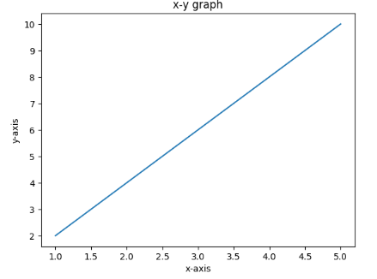
  - Bar graph
import matplotlib.pyplot as plt
subjects=["math","physics","chemistry"]
marks=[90,85,95]
plt.bar(subjects,marks)
plt.xlabel("subjects")
plt.ylabel("marks")
plt.title("Bar chart")
plt.show()

OUTPUT:-
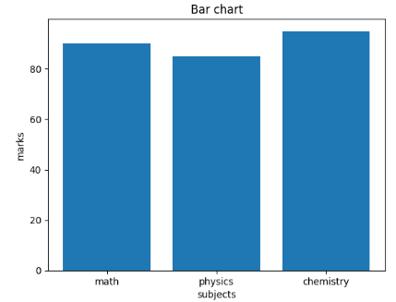

  - Scattered graph
#scatter plot
import matplotlib.pyplot as plt
x = [5, 7, 8, 7, 2, 17]
y = [99, 86, 87, 88, 100, 86]
plt.scatter(x, y, color='blue', marker='o')
plt.title("Scatter Plot Example")
plt.xlabel("X Values")
plt.ylabel("Y Values")

OUTPUT:-

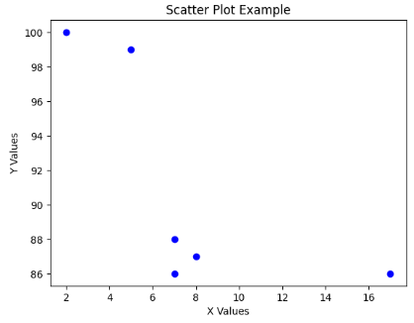
  - Histogram
#histogram
import matplotlib.pyplot as plt
marks = [85, 90, 78, 92, 88, 76, 95, 89, 73, 84,
91, 87, 79, 82, 94, 77, 86, 88, 90, 83]
plt.hist(marks, bins=5, color='green', edgecolor='black')
plt.title("Histogram of Marks")
plt.xlabel("Marks Range")
plt.ylabel("Frequency")
plt.show()

OUTPUT:-
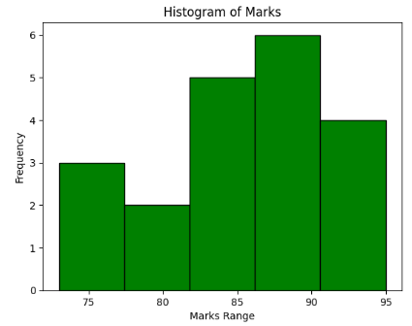

  - Pie chart
#pie chart
import matplotlib.pyplot as plt
subjects = ['Math', 'Science', 'English', 'Computer']
marks = [30, 25, 20, 25]
plt.pie(marks, labels=subjects, autopct='%1.1f%%', startangle=90)
plt.title("Subject Distribution")
plt.axis('equal')
plt.show()

OUTPUT:-

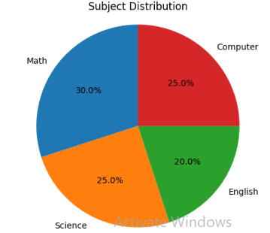
--------------------------------------------------------------------------------------------------------------------------------------

Week 3 : 17.02.2026
12. Write the code to implement the following operations on any data set reading from URL
  - Data filtering
  - Data Manipulation
  - Data ranking

# Import libraries
import pandas as pd
import numpy as np
import matplotlib.pyplot as plt

# Load Iris dataset (working public CSV link)
url = "https://raw.githubusercontent.com/mwaskom/seaborn-data/master/iris.csv"
df = pd.read_csv(url)

print("Dataset (first 10 rows):")
print(df.head(10))

# Select the sepal length column
data = df["sepal_length"]

print("\nSummary Statistics:")
print(data.describe())

print("\nVariance:", np.var(data))
print("Standard Deviation:", np.std(data))

# Plot histogram
plt.figure(figsize=(8,5))
plt.hist(data, bins=10, color='skyblue', edgecolor='black')

# Mean line
plt.axvline(np.mean(data), color='red', linestyle='dashed',
linewidth=2, label=f"Mean: {np.mean(data):.2f}")

# Median line
plt.axvline(np.median(data), color='green', linestyle='dashed',
linewidth=2, label=f"Median: {np.median(data):.2f}")
plt.xlabel("Sepal Length (cm)")
plt.ylabel("Frequency")
plt.title("Distribution of Sepal Length")
plt.legend()
plt.show()

# Skewness inference
mean_value = np.mean(data)
median_value = np.median(data)

print("\nInference:")
print("Mean value:", mean_value)
print("Median value:", median_value)

if mean_value > median_value:
print("Data is slightly right-skewed")
elif mean_value < median_value:
print("Data is slightly left-skewed")
else:
print("Data is symmetric")

OUTPUT:

Dataset (first 10 rows):
sepal_length sepal_width petal_length petal_width species
0 5.1 3.5 1.4 0.2 setosa
1 4.9 3.0 1.4 0.2 setosa
2 4.7 3.2 1.3 0.2 setosa
3 4.6 3.1 1.5 0.2 setosa
4 5.0 3.6 1.4 0.2 setosa
5 5.4 3.9 1.7 0.4 setosa
6 4.6 3.4 1.4 0.3 setosa
7 5.0 3.4 1.5 0.2 setosa
8 4.4 2.9 1.4 0.2 setosa
9 4.9 3.1 1.5 0.1 setosa

Summary Statistics:
count 150.000000
mean 5.843333
std 0.828066
min 4.300000
25% 5.100000
50% 5.800000
75% 6.400000
max 7.900000
Name: sepal_length, dtype: float64

Variance: 0.6811222222222222
Standard Deviation: 0.8253012917851409
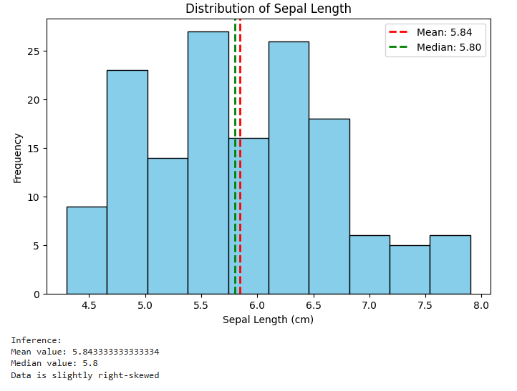
13. Write the code to implement the following descriptive statistics operations any of the created data frame
  - Mean, Median and mode
  - Standard Deviations
  - Variance
  - Kurtosis
  - Skewness
import pandas as pd
import numpy as np
import matplotlib.pyplot as plt

# Create data
data = [10, 12, 15, 18, 20, 22, 25, 30, 35, 40]

# Create DataFrame
df = pd.DataFrame(data, columns=["Values"])

print("Dataset:")
print(df)

print("\nSummary Statistics:")
print(df.describe())

print("\nVariance:", np.var(data))
print("Standard Deviation:", np.std(data))

# Plot histogram
plt.hist(data, bins=5, color='skyblue', edgecolor='black')
plt.xlabel("Values")
plt.ylabel("Frequency")
plt.title("Data Distribution")
plt.show()

# Calculate mean and median
mean_value = np.mean(data)
median_value = np.median(data)
print("\nInference")
print("Mean Value:", mean_value)
print("Median Value:", median_value)
if mean_value > median_value:
print("Data is slightly right-skewed")

elif mean_value < median_value:
print("Data is slightly left-skewed")

else:
print("Data is symmetric")

OUTPUT:

Dataset:
Values
0 10
1 12
2 15
3 18
4 20
5 22
6 25
7 30
8 35
9 40

Summary Statistics:
Values
count 10.000000
mean 22.700000
std 9.855061
min 10.000000
25% 15.750000
50% 21.000000
75% 28.750000
max 40.000000

Variance: 87.41
Standard Deviation: 9.34933152690608

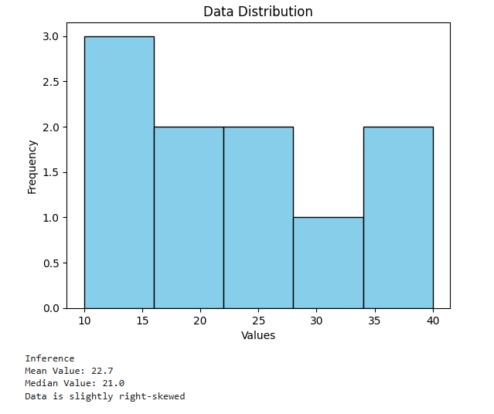

14. Read any of the data set from URL and perform the descriptive statistics functions
#14 EDA using dataset URL

import pandas as pd
import numpy as np
import matplotlib.pyplot as plt

url = "https://raw.githubusercontent.com/dataprofessor/data/master/BostonHousing.csv"
df = pd.read_csv(url)

print("First 10 rows of dataset")
print(df.head(10))

data = df['rm']

print("\nSummary statistics")
print(data.describe())

print("\nVariance:", np.var(data))
print("Standard deviation:", np.std(data))

plt.hist(data, bins=10)
plt.xlabel("RM (number of rooms)")
plt.ylabel("Frequency")
plt.title("Distribution of RM values")
plt.show()

mean_val = np.mean(data)
median_val = np.median(data)

print("\nMean:", mean_val)
print("Median:", median_val)

if mean_val > median_val:
print("Data is slightly right skewed")
elif mean_val < median_val:
print("Data is slightly left skewed")
else:
print("Data is symmetric")
Output:

First 10 rows of dataset
crim zn indus chas nox rm age dis rad tax ptratio \
0 0.00632 18.0 2.31 0 0.538 6.575 65.2 4.0900 1 296 15.3
1 0.02731 0.0 7.07 0 0.469 6.421 78.9 4.9671 2 242 17.8
2 0.02729 0.0 7.07 0 0.469 7.185 61.1 4.9671 2 242 17.8
3 0.03237 0.0 2.18 0 0.458 6.998 45.8 6.0622 3 222 18.7
4 0.06905 0.0 2.18 0 0.458 7.147 54.2 6.0622 3 222 18.7
5 0.02985 0.0 2.18 0 0.458 6.430 58.7 6.0622 3 222 18.7
6 0.08829 12.5 7.87 0 0.524 6.012 66.6 5.5605 5 311 15.2
7 0.14455 12.5 7.87 0 0.524 6.172 96.1 5.9505 5 311 15.2
8 0.21124 12.5 7.87 0 0.524 5.631 100.0 6.0821 5 311 15.2
9 0.17004 12.5 7.87 0 0.524 6.004 85.9 6.5921 5 311 15.2

b lstat medv
0 396.90 4.98 24.0
1 396.90 9.14 21.6
2 392.83 4.03 34.7
3 394.63 2.94 33.4
4 396.90 5.33 36.2
5 394.12 5.21 28.7
6 395.60 12.43 22.9
7 396.90 19.15 27.1
8 386.63 29.93 16.5
9 386.71 17.10 18.9

Summary statistics
count 506.000000
mean 6.284634
std 0.702617
min 3.561000
25% 5.885500
50% 6.208500
75% 6.623500
max 8.780000
Name: rm, dtype: float64

Variance: 0.49269521612976347
Standard deviation: 0.7019225143345692
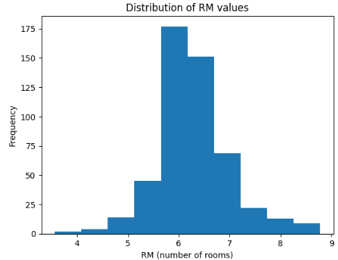
Mean: 6.284634387351779
Median: 6.2085
Data is slightly right skewed

15. Read any of the data set from URL and perform the Data visualization methods
#15 Data Visualization

import pandas as pd
import matplotlib.pyplot as plt

url = "https://raw.githubusercontent.com/mwaskom/seaborn-data/master/iris.csv"
df = pd.read_csv(url)

print("First 5 rows")
print(df.head())

print("\nDataset info")
df.info()

plt.plot(df['sepal_length'])
plt.title("Sepal Length")
plt.xlabel("Index")
plt.ylabel("Value")
plt.show()

plt.hist(df['petal_length'], bins=20)
plt.title("Petal Length Histogram")
plt.xlabel("Petal Length")
plt.ylabel("Frequency")
plt.show()

plt.scatter(df['sepal_length'], df['petal_length'])
plt.title("Sepal vs Petal Length")
plt.xlabel("Sepal Length")
plt.ylabel("Petal Length")
plt.show()

df['species'].value_counts().plot(kind='bar')
plt.title("Species Count")
plt.xlabel("Species")
plt.ylabel("Count")
plt.show()

counts = df['species'].value_counts()
plt.pie(counts, labels=counts.index)
plt.title("Species Distribution")
plt.show()
Output:

First 5 rows
sepal_length sepal_width petal_length petal_width species
0 5.1 3.5 1.4 0.2 setosa
1 4.9 3.0 1.4 0.2 setosa
2 4.7 3.2 1.3 0.2 setosa
3 4.6 3.1 1.5 0.2 setosa
4 5.0 3.6 1.4 0.2 setosa

Dataset info
<class 'pandas.core.frame.DataFrame'>
RangeIndex: 150 entries, 0 to 149
Data columns (total 5 columns):
# Column Non-Null Count Dtype
--- ------ -------------- -----
0 sepal_length 150 non-null float64
1 sepal_width 150 non-null float64
2 petal_length 150 non-null float64
3 petal_width 150 non-null float64
4 species 150 non-null object
dtypes: float64(4), object(1)
memory usage: 6.0+ KB
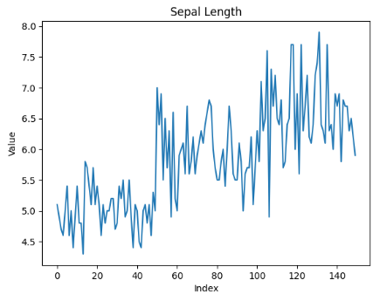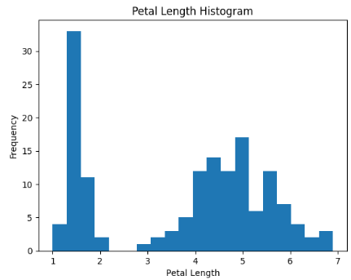

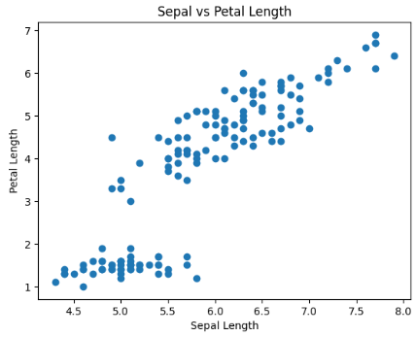

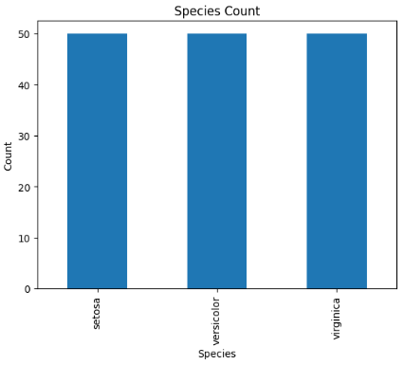

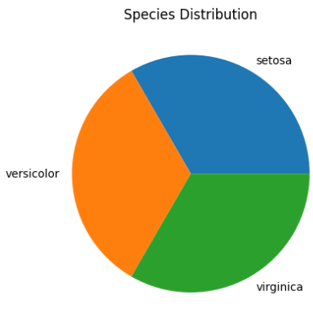

WEEK 4: 24/02/26
16. write a python code to perform the following database operations using SQlite
import sqlite3
conn = sqlite3.connect("example.db")
cursor = conn.cursor()
cursor.execute("""
CREATE TABLE IF NOT EXISTS users (
id INTEGER PRIMARY KEY AUTOINCREMENT,
name TEXT NOT NULL,
age INTEGER,
email TEXT UNIQUE
)
""")
print("Table created successfully.")
cursor.execute("INSERT INTO users (name, age, email) VALUES (?, ?, ?)",
("raju", 25, "raju@example.com"))
cursor.execute("INSERT INTO users (name, age, email) VALUES (?, ?, ?)",
("ravi", 30, "ravi@example.com"))
conn.commit()
print("Data inserted successfully.")
cursor.execute("SELECT * FROM users")
rows = cursor.fetchall()
print("\nUsers in database:")
for row in rows:
print(row)
cursor.execute("UPDATE users SET age = ? WHERE name = ?", (28, "raju"))
conn.commit()
print("\nRecord updated successfully.")
cursor.execute("DELETE FROM users WHERE name = ?", ("ravi",))
conn.commit()
print("Record deleted successfully.")
cursor.execute("SELECT * FROM users")
rows = cursor.fetchall()
print("\nFinal data:")
for row in rows:
print(row)
conn.close()
print("\nDatabase connection closed.")

Output:

Table created successfully.
Data inserted successfully.

Users in database:
(1, 'raju', 25, 'raju@example.com')
(2, 'ravi', 30, 'ravi@example.com')

Record updated successfully.
Record deleted successfully.

Final data:
(1, 'raju', 28, 'raju@example.com')

Database connection closed.

17.Write the python code to perform the following operations to clean the data
- Missing values
- Sum of missing values
- Replace with mean of the column
import pandas as pd
data = {
'Name': ['Alice', 'Bob', 'Charlie', 'David', 'Eve'],
'Age': [25, None, 35, 40, 28],
'Salary': [50000, 60000, None, 70000, 62000],
'Allowances': [2000, None, 2000, 2000, 2500]
}
df = pd.DataFrame(data)
print("Missing Values Count:\n", df.isnull().sum())
df_cleaned = df.dropna()
print("\nDataFrame after dropping missing values:\n", df_cleaned)
df_filled = df.fillna({'Age': df['Age'].mean(), 'Salary': df['Salary'].mean(), 'Allowances': 2000})
print("\nDataFrame after filling missing values:\n", df_filled)

Output:

Missing Values Count:
Name 0
Age 1
Salary 1
Allowances 1
dtype: int64

DataFrame after dropping missing values:
Name Age Salary Allowances
0 Alice 25.0 50000.0 2000.0
3 David 40.0 70000.0 2000.0
4 Eve 28.0 62000.0 2500.0

DataFrame after filling missing values:
Name Age Salary Allowances
0 Alice 25.0 50000.0 2000.0
1 Bob 32.0 60000.0 2000.0
2 Charlie 35.0 60500.0 2000.0
3 David 40.0 70000.0 2000.0
4 Eve 28.0 62000.0 2500.0

18. Implement the data cleaning operations on any data set using URL
import pandas as pd
url = "https://raw.githubusercontent.com/datasciencedojo/datasets/master/titanic.csv"
df = pd.read_csv(url)
print(" Original Dataset Info ")
print(df.info())
print("\n Missing Values Before Cleaning:")
print(df.isnull().sum())
print("\nFirst 5 rows:\n", df.head())
df['Age'] = df['Age'].fillna(df['Age'].median())
df['Embarked'] = df['Embarked'].fillna(df['Embarked'].mode()[0])
print("\nMissing Values After Filling:")
print(df.isnull().sum())
df = df.drop(columns=['Cabin'])
print("\n Columns After Dropping 'Cabin' ")
print(df.columns)
before_duplicates = df.shape[0]
df = df.drop_duplicates()
after_duplicates = df.shape[0]
print(f"\nRemoved {before_duplicates - after_duplicates} duplicate rows")
df['Survived'] = df['Survived'].astype('category')
df['Pclass'] = df['Pclass'].astype('category')
print("\n Data Types After Conversion ")
print(df.dtypes)
df.columns = df.columns.str.lower()
print("\n Columns After Renaming ")
print(df.columns)
Q1 = df['age'].quantile(0.25)
Q3 = df['age'].quantile(0.75)
IQR = Q3 - Q1
lower_bound = Q1 - 1.5 * IQR
upper_bound = Q3 + 1.5 * IQR
before_outliers = df.shape[0]
df = df[(df['age'] >= lower_bound) & (df['age'] <= upper_bound)]
after_outliers = df.shape[0]
print(f"\nRemoved {before_outliers - after_outliers} outlier rows based on Age")
df.to_csv("cleaned_titanic.csv", index=False)
print("\nData Cleaning Completed Successfully!")
print("Cleaned file saved as: cleaned_titanic.csv")
print("\n First 5 rows of Cleaned Dataset ")
print(df.head())
Output:
Original Dataset Info
<class 'pandas.core.frame.DataFrame'>
RangeIndex: 891 entries, 0 to 890
Data columns (total 12 columns):
# Column Non-Null Count Dtype
--- ------ -------------- -----
0 PassengerId 891 non-null int64
1 Survived 891 non-null int64
2 Pclass 891 non-null int64
3 Name 891 non-null object
4 Sex 891 non-null object
5 Age 714 non-null float64
6 SibSp 891 non-null int64
7 Parch 891 non-null int64
8 Ticket 891 non-null object
9 Fare 891 non-null float64
10 Cabin 204 non-null object
11 Embarked 889 non-null object
dtypes: float64(2), int64(5), object(5)
memory usage: 83.7+ KB
None

Missing Values Before Cleaning:
PassengerId 0
Survived 0
Pclass 0
Name 0
Sex 0
Age 177
SibSp 0
Parch 0
Ticket 0
Fare 0
Cabin 687
Embarked 2
dtype: int64

First 5 rows:
PassengerId Survived Pclass \
0 1 0 3
1 2 1 1
2 3 1 3
3 4 1 1
4 5 0 3

Name Sex Age SibSp \
0 Braund, Mr. Owen Harris male 22.0 1
1 Cumings, Mrs. John Bradley (Florence Briggs Th... female 38.0 1
2 Heikkinen, Miss. Laina female 26.0 0
3 Futrelle, Mrs. Jacques Heath (Lily May Peel) female 35.0 1
4 Allen, Mr. William Henry male 35.0 0

Parch Ticket Fare Cabin Embarked
0 0 A/5 21171 7.2500 NaN S
1 0 PC 17599 71.2833 C85 C
2 0 STON/O2. 3101282 7.9250 NaN S
3 0 113803 53.1000 C123 S
4 0 373450 8.0500 NaN S

Missing Values After Filling:
PassengerId 0
Survived 0
Pclass 0
Name 0
Sex 0
Age 0
SibSp 0
Parch 0
Ticket 0
Fare 0
Cabin 687
Embarked 0
dtype: int64

Columns After Dropping 'Cabin'
Index(['PassengerId', 'Survived', 'Pclass', 'Name', 'Sex', 'Age', 'SibSp',
'Parch', 'Ticket', 'Fare', 'Embarked'],
dtype='object')

Removed 0 duplicate rows

Data Types After Conversion
PassengerId int64
Survived category
Pclass category
Name object
Sex object
Age float64
SibSp int64
Parch int64
Ticket object
Fare float64
Embarked object
dtype: object

Columns After Renaming
Index(['passengerid', 'survived', 'pclass', 'name', 'sex', 'age', 'sibsp',
'parch', 'ticket', 'fare', 'embarked'],
dtype='object')

Removed 66 outlier rows based on Age

Data Cleaning Completed Successfully!
Cleaned file saved as: cleaned_titanic.csv

First 5 rows of Cleaned Dataset
passengerid survived pclass \
0 1 0 3
1 2 1 1
2 3 1 3
3 4 1 1
4 5 0 3

name sex age sibsp \
0 Braund, Mr. Owen Harris male 22.0 1
1 Cumings, Mrs. John Bradley (Florence Briggs Th... female 38.0 1
2 Heikkinen, Miss. Laina female 26.0 0
3 Futrelle, Mrs. Jacques Heath (Lily May Peel) female 35.0 1
4 Allen, Mr. William Henry male 35.0 0

parch ticket fare embarked
0 0 A/5 21171 7.2500 S
1 0 PC 17599 71.2833 C
2 0 STON/O2. 3101282 7.9250 S
3 0 113803 53.1000 S
4 0 373450 8.0500 S

- Write the python code to detect the outliers
#IQR meethod
import pandas as pd
data={
"name":['A','B','C','D','E','F'],
"age":[13,24,25,120,23,22]

}

df=pd.DataFrame(data)
q1=df['age'].quantile(0.25)
q3=df['age'].quantile(0.75)
iqr=q3-q1
lower_bound=q1-1.5*iqr
upper_bound=q3+1.5*iqr
outliners=df[(df['age']upper_bound)]
print("outliners using IQR method")
print(outliners)
Output:
outliners using IQR method
name age
0 A 13
3 D 120

20.Perform the following operations on data distributions
- Normal distributions
- Left skewness
- Right skewness
# Data Distribution

import numpy as np
import pandas as pd
import matplotlib.pyplot as plt
normal_data = np.random.normal(loc=70, scale=5, size=1000)
right_skewed = np.random.exponential(scale=2, size=1000)
left_skewed = -np.random.exponential(scale=2, size=1000)
plt.hist(normal_data, bins=30)
plt.title("Normal Distribution")
plt.show()
plt.hist(right_skewed, bins=30)
plt.title("Right Skewed Distribution")
plt.show()
plt.hist(left_skewed, bins=30)
plt.title("Left Skewed Distribution")
plt.show()
print("Normal Data Mean:", np.mean(normal_data))
print("Normal Data Median:", np.median(normal_data))

print("Right Skewed Mean:", np.mean(right_skewed))
print("Right Skewed Median:", np.median(right_skewed))

print("Left Skewed Mean:", np.mean(left_skewed))
print("Left Skewed Median:", np.median(left_skewed))
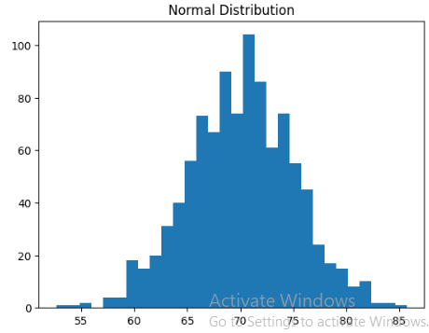

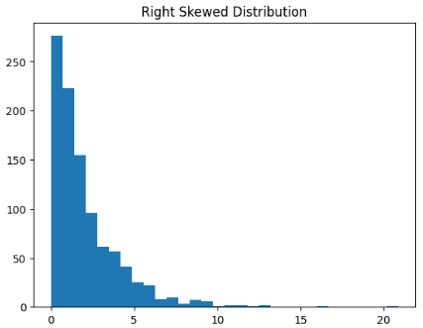
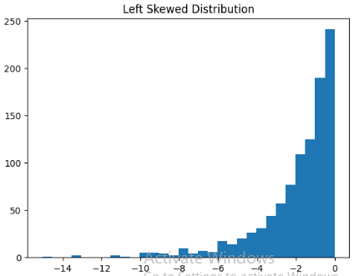

Normal Data Mean: 70.11128462827989
Normal Data Median: 70.29968677048613
Right Skewed Mean: 2.0730665484706994
Right Skewed Median: 1.3947625496295668
Left Skewed Mean: -1.925496961505998
Left Skewed Median: -1.2688244275112757

WEEK 5: 10/03/26

21.Write the code to perform the following operations
- Z-score
- Statistical inference
- random variable model
- Central limit theorem
- Standardizations
#21
import numpy as np
import math
population=np.array([10,20,30,40,50,60,70])
N=len (population)
print("population size(N):",N)
mu=np.mean(population)
print("population mean(u):",mu)
sigma2=np.var(population,ddof=0)
print("population variance(sigma^2):",sigma2)
sigma=np.sqrt(sigma2)
print("population standard deviation:",sigma2)
sample=np.array([20,30,40,50])
n=len(sample)
print("\n sample size(n):",n)
x_bar=np.mean(sample)
print("sample mean:",x_bar)
s2=np.var(sample,ddof=1)
print("sample variance:",s2)
s=np.sqrt(s2)
print("sample standard deviation(s):",s)
SE=sigma/math.sqrt(n)
print("\n standard error:",SE)
z=(x_bar-mu)/SE
print("z-score:",z)
Output:
population size(N): 7
population mean(u): 40.0
population variance(sigma^2): 400.0
population standard deviation: 400.0

sample size(n): 4
sample mean: 35.0
sample variance: 166.66666666666666
sample standard deviation(s): 12.909944487358056

standard error: 10.0
z-score: -0.5

22. Write a code to test the hypothesis, if test for Z is accepted or rejected
import math
n=100
x=60
p_hat=x/n
SE=math.sqrt(p_hat*(1-p_hat)/n)
z=1.96
lower=p_hat-z*SE
upper=p_hat+z*SE
print("Sample proportion=",p_hat)
print("Confidence Interval=",(lower,upper))
p0=0.50
z_test=(p_hat-p0)/math.sqrt(p0*(1-p0)/n)
print("z value=",z_test)
if abs(z_test)>1.96:
print("Reject Ho")
else:
print("Do not reject Ho")
Output:
Sample proportion= 0.6
Confidence Interval= (0.5039800020828994, 0.6960199979171006)
z value= 1.9999999999999996
Reject Ho

WEEK 6: 24/03/26

23. Write a code to implement linear regression on any sample dataset
#23 linear regression on any sample dataset
import numpy as np
import matplotlib.pyplot as plt
from sklearn.linear_model import LinearRegression
X=np.array([1,2,3,4,5]).reshape(-1,1)
Y=np.array([30,35,50,55,65])
model=LinearRegression()
model.fit(X,Y)
predictions=model.predict(X)
print("Slope:",model.coef_)
print("Intercept:",model.intercept_)
plt.scatter(X,Y)
plt.plot(X,predictions)
plt.xlabel("experience")
plt.ylabel("salary")
plt.title("Linear Regression")
plt.show()

Output:

Slope: [9.]
Intercept: 19.999999999999993
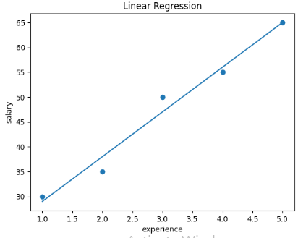
24. Write a code to implement linear regression with example url
#24 linear regression with an example URL
import matplotlib.pyplot as plt
import pandas as pd
from sklearn.linear_model import LinearRegression
from sklearn.metrics import mean_squared_error
url=("https://raw.githubusercontent.com/ybi-foundation/dataset/main/Salary%20Data.csv")
data=pd.read_csv(url)
print("Data preview")
print(data.head())
X=data[['Experience Years']]
Y=data['Salary']
model.fit(X,Y)
print("model prediction")
print("slope:",model.coef_[0])
print("intercept:",model.intercept_)
years=[[5]]
predicted_salary=model.predict(years)
print ("\n predict salary for 5 years experience:",predicted_salary[0])
Y_pred=model.predict(X)
mse=mean_squared_error(Y,Y_pred)
print("\n Mean Squared Error:",mse)
plt.scatter(X,Y)
plt.plot(X,Y_pred)
plt.xlabel("Experience years")
plt.ylabel("Salary")
plt.title("Linear Regression")
plt.show()

Output:
Data preview
Experience Years Salary
0 1.1 39343
1 1.2 42774
2 1.3 46205
3 1.5 37731
4 2.0 43525
model prediction
slope: 9523.650507417704
intercept: 25673.01576053028

predict salary for 5 years experience: 73291.26829761881

Mean Squared Error: 28960383.65377621

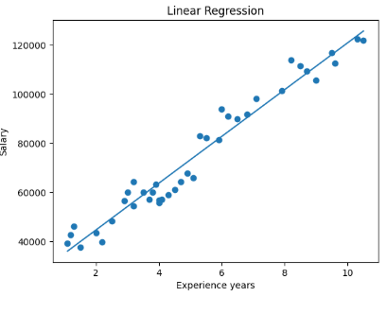
25. Write a code to implement logistic regression to find the following—
- spam or not spam
#25.a logistic regression spam or no spam
import pandas as pd
from sklearn.linear_model import LogisticRegression
from sklearn.model_selection import train_test_split
from sklearn.metrics import accuracy_score,confusion_matrix
data = {
"links": [0, 2, 1, 3, 0, 4],
"spam": [0, 1, 0, 1, 0, 1]
}
df = pd.DataFrame(data)
X = df[["links"]]
y = df["spam"]
X_train, X_test, y_train, y_test = train_test_split(X, y, test_size=0.2, random_state=42)
model = LogisticRegression()
model.fit(X_train, y_train)
y_pred = model.predict(X_test)
accuracy = accuracy_score(y_test, y_pred)
print("Accuracy:", accuracy)
Output:
Accuracy: 0.5

- disease or no disease
#25.b logistic regression disease or no disease

import pandas as pd
from sklearn.linear_model import LogisticRegression
from sklearn.model_selection import train_test_split
from sklearn.metrics import accuracy_score,confusion_matrix
data = {
"BP": [120, 140, 130, 150, 110, 160],
"disease": [0, 1, 0, 1, 0, 1]
}
df = pd.DataFrame(data)
X = df[["BP"]]
y = df["disease"]
X_train, X_test, y_train, y_test = train_test_split(X, y, test_size=0.2, random_state=42)
model = LogisticRegression()
model.fit(X_train, y_train)
y_pred = model.predict(X_test)
accuracy = accuracy_score(y_test, y_pred)
print("Accuracy:", accuracy)
Output:
Accuracy: 1.0

- sentiment analysis positive or negative
#25.c logistic regression sentimental analysis positive or negative
import pandas as pd
from sklearn.linear_model import LogisticRegression
from sklearn.model_selection import train_test_split
from sklearn.metrics import accuracy_score,confusion_matrix
data = {
"length": [5, 20, 15, 30, 10, 25],
"sentiment": [0, 1, 0, 1, 0, 1]
}
df = pd.DataFrame(data)
X = df[["length"]]
y = df["sentiment"]
X_train, X_test, y_train, y_test = train_test_split(X, y, test_size=0.2, random_state=42)
model = LogisticRegression()
model.fit(X_train, y_train)
y_pred = model.predict(X_test)
accuracy = accuracy_score(y_test, y_pred)
print("Accuracy:", accuracy)
Output:
Accuracy: 1.0

WEEK 7: 31/03/26

26.Write a code to implement logistic regression work with url to find the given patients are having diabetes or not
#26logistic regression with URL
import pandas as pd
from sklearn.model_selection import train_test_split
from sklearn.linear_model import LogisticRegression
from sklearn.metrics import accuracy_score,confusion_matrix
url="https://raw.githubusercontent.com/jbrownlee/Datasets/master/pima-indians-diabetes.data.csv"
columns=[
"Pregnancies",
"Glucose",
"BloodPressure",
"SkinThickness",
"Insulin","BMI","DiabetesPedigreeFunction","Age","Outcome"
]
data=pd.read_csv(url,names=columns)
print("Dataset Preview")
print(data.head())
X=data.drop("Outcome",axis=1)
y=data["Outcome"]
X_train,X_test,y_train,y_test=train_test_split(X,y,test_size=0.2,random_state=42)
model=LogisticRegression(max_iter=1000)
model.fit(X_train,y_train)
y_pred=model.predict(X_test)
accuracy=accuracy_score(y_test,y_pred)
print("Accuracy:",accuracy)
print("Confusion Matrix:")
print(confusion_matrix(y_test,y_pred))
sample=[[2,120,70,20,85,30,0.5,25]]
prediction=model.predict(sample)
print("\n Diabetes Prediction (0=No,1=Yes):",prediction)
Output:
Dataset Preview
Pregnancies Glucose BloodPressure SkinThickness Insulin BMI \
0 6 148 72 35 0 33.6
1 1 85 66 29 0 26.6
2 8 183 64 0 0 23.3
3 1 89 66 23 94 28.1
4 0 137 40 35 168 43.1

DiabetesPedigreeFunction Age Outcome
0 0.627 50 1
1 0.351 31 0
2 0.672 32 1
3 0.167 21 0
4 2.288 33 1
Accuracy: 0.7467532467532467
Confusion Matrix:
[[78 21]
[18 37]]

Diabetes Prediction (0=No,1=Yes): [0]

WEEK8: 21.04.2026

#Confusion matrix
from sklearn.metrics import confusion_matrix
from sklearn.metrics import precision_score,recall_score,f1_score,roc_curve,auc
import matplotlib.pyplot as plt
y_true = [1,0,1,0,1,0,1,0]
y_pred = [1,1,1,0,0,0,1,0]
cm=confusion_matrix(y_true,y_pred)
print("Confusion Matrix:\n", cm)
print("Precsion:", precision_score(y_true,y_pred))
print("Recall:", recall_score(y_true,y_pred))
print("F1 score:", f1_score(y_true,y_pred))
y_score=[0.9,0.6,0.8,0.3,0.4,0.2,0.85,0.1]
fpr, tpr,_=roc_curve(y_true,y_score)
roc_auc=auc(fpr,tpr)
print("Auc:",roc_auc)
plt.plot(fpr,tpr)
plt.xlabel("FPR")
plt.ylabel("TPR")
plt.title("ROC curve")
plt.show()

OUTPUT:

Confusion Matrix:
[[3 1]
[1 3]]
Precsion: 0.75
Recall: 0.75
F1 score: 0.75
Auc: 0.9375

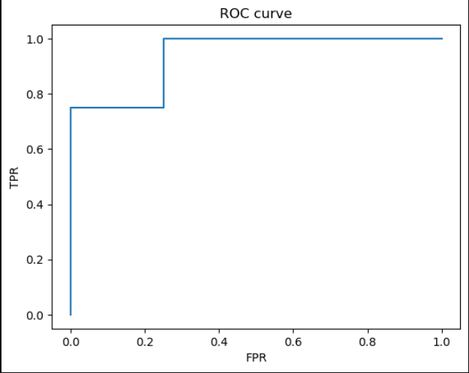

#support vector machine
from sklearn import svm
X = [[2,2],[4,4],[2,0],[0,2]]
Y = [1,1,-1,-1]
model=svm.SVC(kernel='linear')
model.fit(X,Y)
print(model.predict([[0,0]]))

OUTPUT:

[-1]

#Polynomial Regression
import numpy as np
import matplotlib.pyplot as plt
from sklearn.preprocessing import PolynomialFeatures
from sklearn.linear_model import LinearRegression
X = np.array([1,2,3,4]).reshape(-1,1)
Y = np.array([1,4,9,16])
poly = PolynomialFeatures(degree=2)
X_poly=poly.fit_transform(X)
model=LinearRegression()
model.fit(X_poly,Y)
Y_pred=model.predict(X_poly)
plt.scatter(X,Y)
plt.plot(X,Y_pred)
plt.show()

OUTPUT:

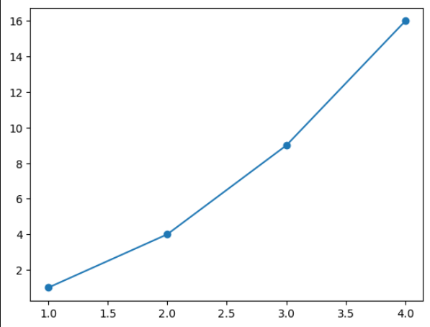

#Decision Tree
from sklearn.tree import DecisionTreeClassifier
X=[[1,1],[1,0],[0,1],[0,0]]
y=[0,1,1,0]
model=DecisionTreeClassifier()
model.fit(X,y)
print(model.predict([[1,0]]))

OUTPUT:

[1]

#Decision Tree
from sklearn.tree import DecisionTreeClassifier
X=[[1,1],[1,0],[0,1],[0,0]]
y=[1,1,0,0]
model=DecisionTreeClassifier()
model.fit(X,y)
print(model.predict([[1,0]]))

OUTPUT: [1]

------------------------------------------------------------------------------------------------------------------------------------------------------------------------------------------------------------------------------------------------------------------------------------------------------------------------------------------------------------------------------------------------------------------
WEEK 9: 28.04.2026

#LASSO Model
from sklearn.linear_model import Lasso
import numpy as np
X = np.array([[1,25,160],[2,30,165],[3,35,170]])
Y = np.array([30000,40000,50000])
model = Lasso(alpha=0.1)
model.fit(X,Y)
print(model.coef_)

OUTPUT:

[9.99973000e+03 4.80000000e-02 3.33066907e-18]

#Similarity and distances
from scipy.spatial import distance
from scipy.stats import pearsonr
import numpy as np
p1 = np.array([2,3])
p2 = np.array([5,7])
euc = distance.euclidean(p1,p2)
mh = distance.cityblock(p1,p2)
cb = distance.chebyshev(p1,p2)
hm = distance.cosine(p1,p2)
cs = 1-cb
set1,set2=set(p1), set(p2)
js = len(set1 & set2) / len(set1 | set2)
r = pearsonr(p1, p2)
print("Euclidean Distance: ", euc)
print("Manhatten distance: ", mh)
print("chebyshev Distance: ", cb)
print("Hamming Distance: ", hm)
print("Cosine similarity: ", cs)
print("Jaccord distance: ", js)
print("Pearsonrs coefficent", r)

OUTPUT:
Euclidean Distance: 5.0
Manhatten distance: 7
chebyshev Distance: 4
Hamming Distance: 0.0005198856603004787
Cosine similarity: -3
Jaccord distance: 0.0
Pearsonrs coefficent PearsonRResult(statistic=1.0, pvalue=1.0)

#K-means clustering(Unsupervised learning)
import numpy as np
A = np.array([[2,3],[3,4],[4,2]])
B = np.array([[8,7],[9,6],[10,8]])
P = np.array([5,5])
cA = A.mean(axis=0)
cB = B.mean(axis=0)
dA=np.linalg.norm(P-cA)
dB=np.linalg.norm(P-cB)
if dA<dB:
print("Point belongs to cluster A")
else:
print("Point belongs to cluster B")

OUTPUT:
Point belongs to cluster A

