Student Performance Analysis
Project README

Project Overview
This project analyzes student academic performance data across three core subjects — Math, Science, and English — along with attendance records. The pipeline covers data ingestion, cleaning, exploratory analysis, and visualization to uncover patterns and correlations in student outcomes.

Dataset
The raw dataset (Student_data.csv) includes:
- Student names and marks in Math, Science, and English
- Attendance percentages per student
- Missing values handled during the cleaning phase (cleaned_data.csv)

Project Pipeline
- Data Loading: Read raw CSV data into a DataFrame
- Data Cleaning: Impute missing values, compute average scores
- Exploratory Analysis: Correlation analysis and descriptive statistics
- Visualization: Bar chart, line chart, and heatmap generated via Matplotlib/Seaborn

Visualizations

1. Average Marks — Bar Chart
Compares the class average marks across Math (~81), Science (~80), and English (~85), showing English as the highest-performing subject on average.
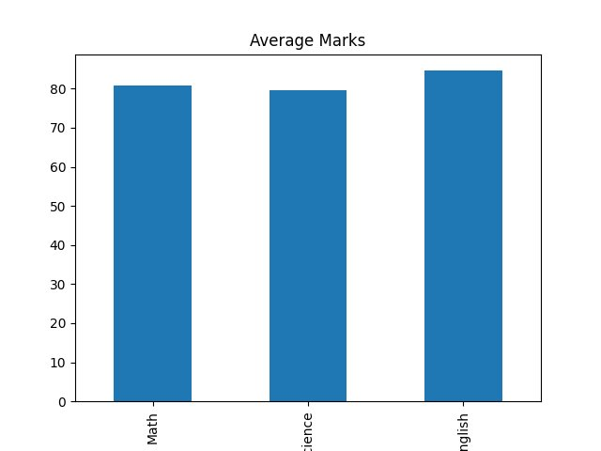

2. Marks Trend — Line Chart
Tracks individual student performance across the three subjects, revealing students with consistent performance versus those with high variance between subjects.
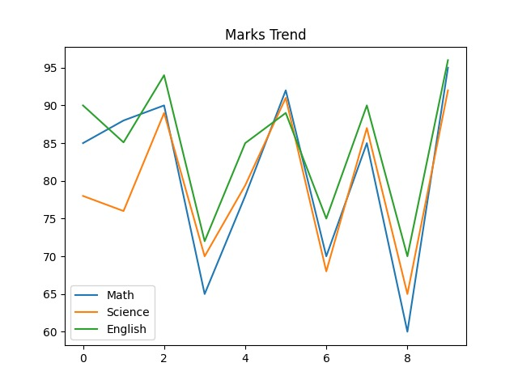

3. Correlation Heatmap
Displays Pearson correlation coefficients between all numeric features. Key insight: Math and Average are highly correlated (0.98), and Attendance shows strong correlation with English (0.94) and Math (0.93), suggesting attendance is a significant predictor of academic performance.
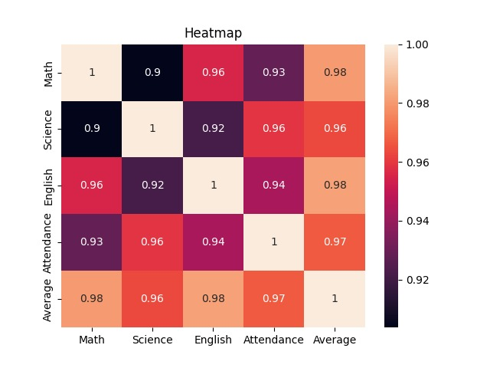

Project Files
- Student_data.csv — Raw input data
- cleaned_data.csv — Processed data with imputed values and averages
- project_code.py — Main analysis and visualization script
- app.py — Application entry point
- bar_chart.png, Line_Chart.jpeg, Heatmap.jpeg — Generated visualizations

Key Findings
- All subjects are strongly correlated with each other (r > 0.90)
- Attendance is positively correlated with performance across all subjects
- English shows the highest average marks among the three subjects
- Average score is the strongest overall predictor of subject-wise performance

Tech Stack
- Python (pandas, numpy, matplotlib, seaborn)
- CSV data files for input/output

