**TrafficTelligence: Advanced Traffic Volume Estimation with Machine Learning**

**AI/ML Project Documentation Format**

**1. Introduction**

* **Project Title:** TrafficTelligence: Advanced Traffic Volume Estimation with Machine Learning
* **Team Members:**
  + Makasi Sri Lakshmi – Developer / Data Scientist / UI Designer

**2. Project Overview**

* **Purpose:**  
  TrafficTelligence is built to predict traffic volume based on weather and temporal features. It assists commuters, traffic analysts, and city planners by forecasting road traffic to optimize travel decisions, planning, and traffic management.
* **Features:**
  + Predict traffic volume using historical and live weather/time inputs
  + Display results on a simple web interface
  + Maintain prediction history logs
  + Data visualization of trends
  + Downloadable traffic logs

**3. Architecture**

* **Frontend:**  
  Web-based UI developed using HTML/CSS/JavaScript or Flask for forms, charts (Chart.js), and logs display.
* **Backend:**  
  Python Flask framework used to handle ML prediction API, input preprocessing, and log handling.
* **Database:**  
  SQLite or CSV-based local storage for prototype (can scale to MySQL or MongoDB for cloud use).

**4. Setup Instructions**

* **Prerequisites:**
  + Python 3.10+
  + Flask
  + pandas, scikit-learn, matplotlib
* **Installation:**
  + Clone the repository
  + git clone https://github.com/makasi/traffic-telligence.git
  + Install dependencies
  + pip install -r requirements.txt
  + Run the Flask app:
  + python app.py

**5. Folder Structure**

* **/model**: Trained ML models (Pickle format)
* **/templates**: HTML files for UI
* **/static**: CSS, JS, and image assets
* **/logs**: Prediction history CSVs

**6. Running the Application**

* Run the Flask app locally:
* python app.py
* Open in browser: http://127.0.0.1:5000

**7. API Documentation**

* **POST /predict**
  + Request JSON: { "temperature": 294.26, "rain": 0, "snow": 0, "weather": "Clear", "hour": 9 }
  + Response: { "predicted_volume": 5210 }
* **GET /logs**
  + Returns stored prediction records

**8. Authentication**

Currently not implemented. The prototype is open access. Future plans may include role-based user login (Admin, Analyst)

**9. User Interface**

* Form for inputting weather/time data
* Traffic volume output displayed clearly
* Line chart or bar chart of traffic trends
* Table log of all predictions

**10. Testing**

* **Tools Used:** Postman for API, manual UI validation
* **Tests Performed:**
  + Input edge cases (extreme temperature, rare weather)
  + Consistency of predictions
  + Responsiveness of UI

**11. Screenshots or Demo**

**Demo : https://youtu.be/IuEKecKAwMc**

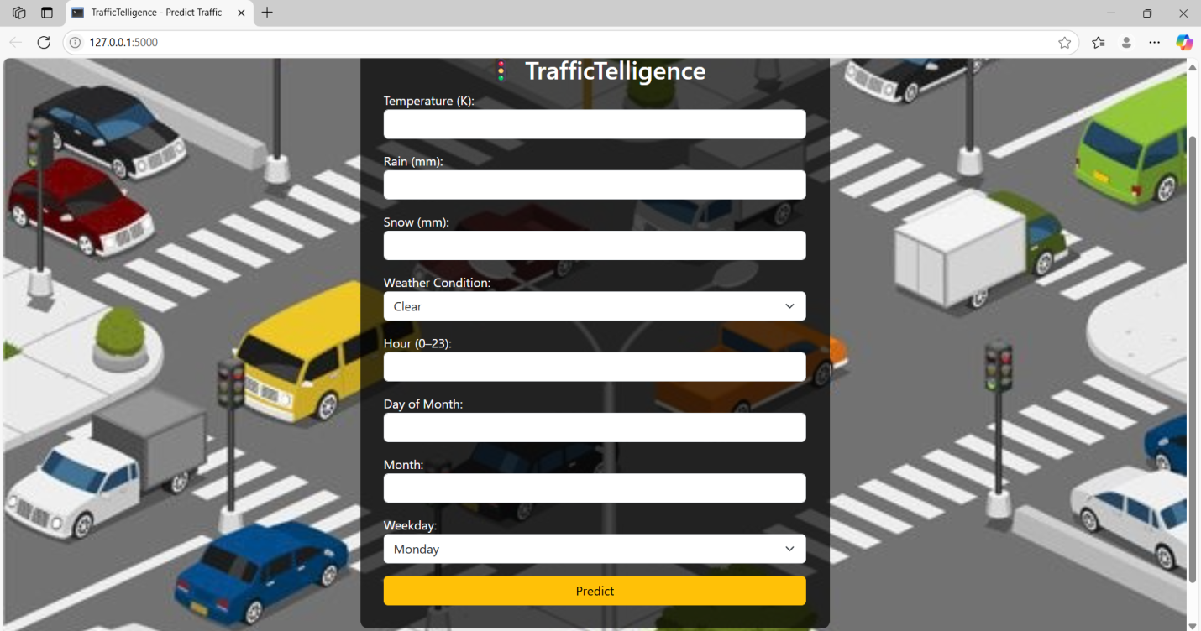

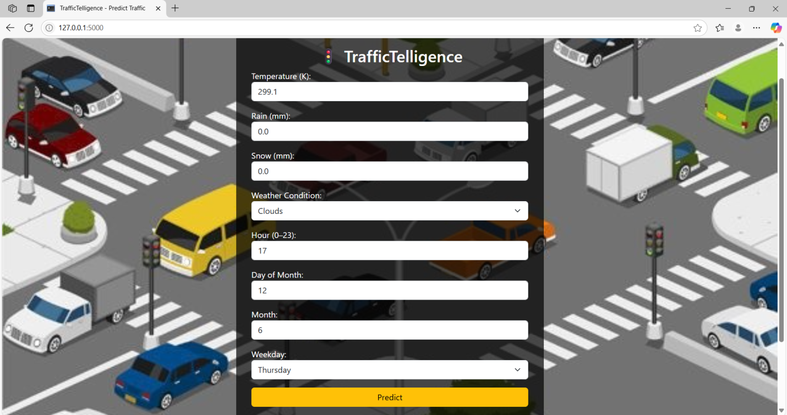



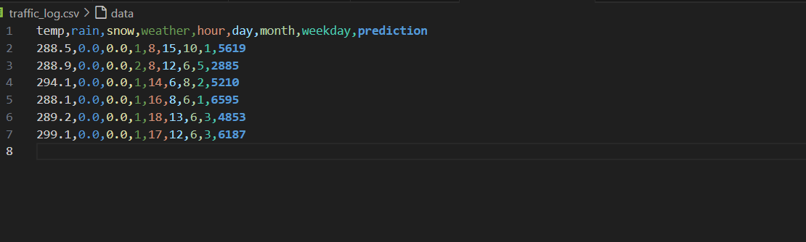

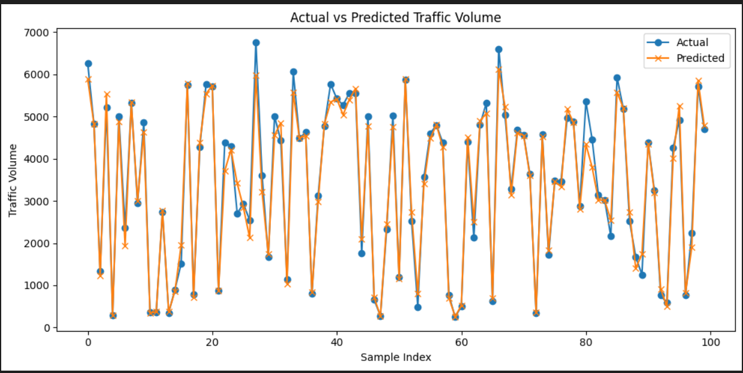

**12. Known Issues**

* No live weather API integration yet
* Basic form validation only (no weather input verification)

**13. Future Enhancements**

* Integrate live weather APIs (e.g., OpenWeatherMap)
* Add user authentication and dashboards
* Host on Render/AWS/GCP
* Add feature to export reports as PDF/CSV
* Real-time map-based congestion prediction (using GPS data)

**GitHub Repo:** <https://github.com/makasi/traffic-telligence>  
**Dataset:** https://drive.google.com/file/d/1iV5PfYAmI6YP0_0S4KYy1ZahHOqMgDbM/view