Module 1 Activity – Configure a Development Environment

Makayla Pierce

Rasmussen College

Author’s note

This research is being submitted on October 4, 2018, for Fundamentals of Mobile Web Application Development.

http://fundwebappdevsvm.centralus.cloudapp.azure.com/mod1_activity.html

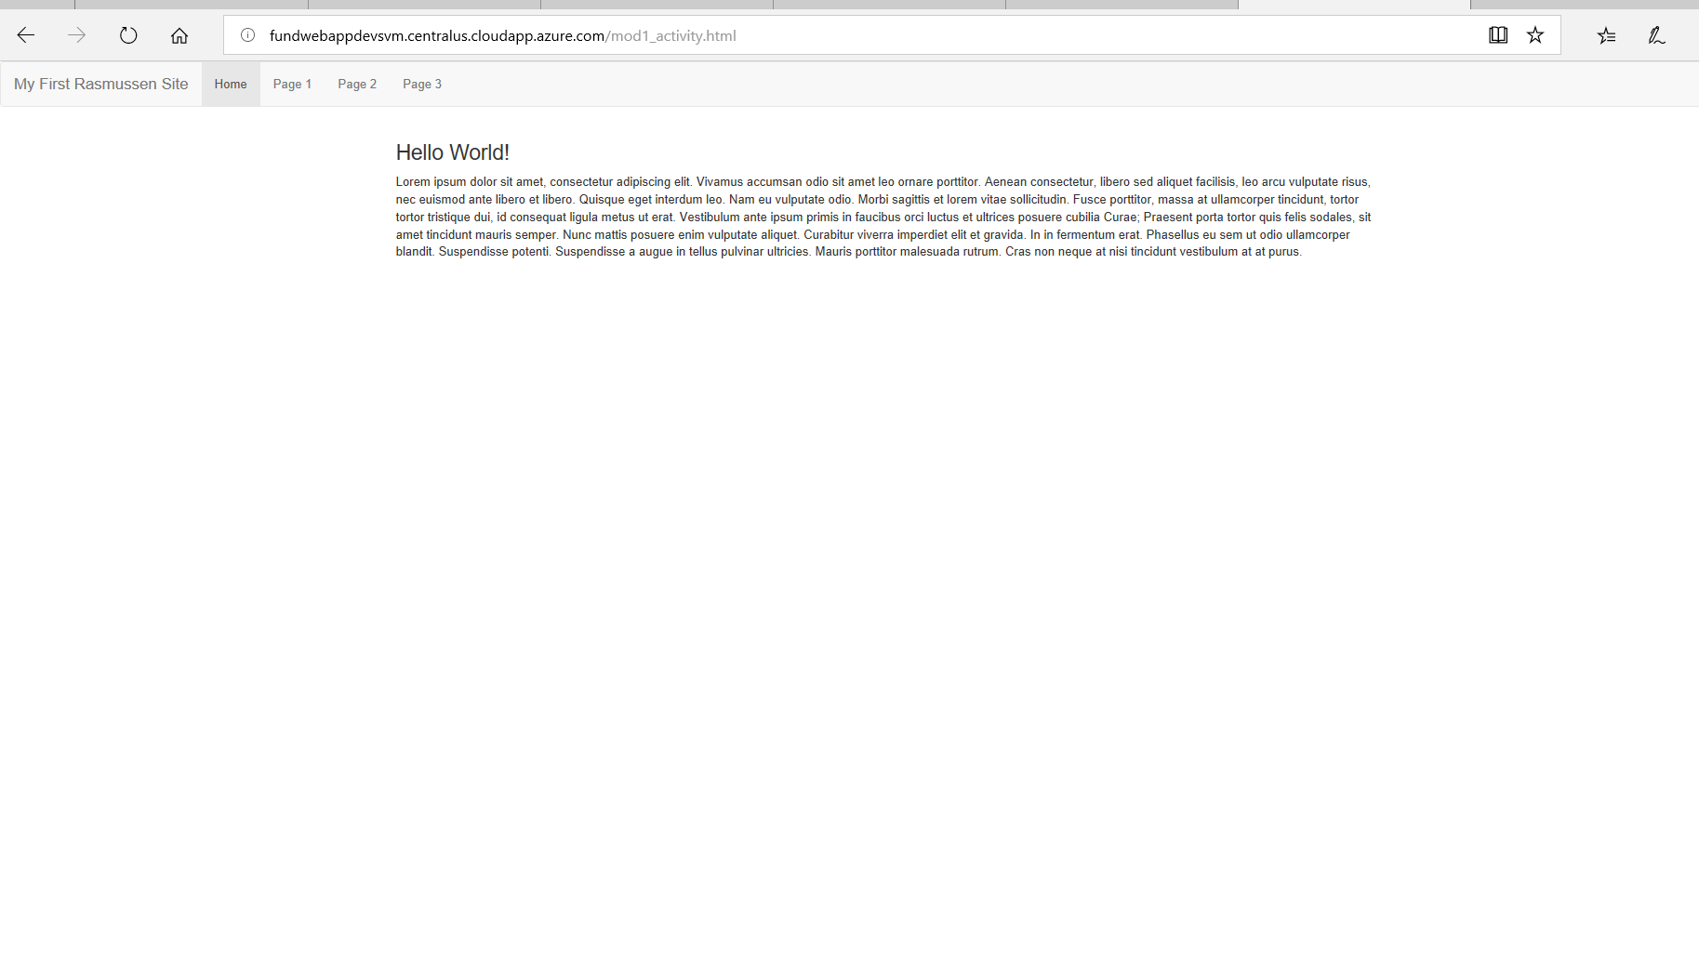

<https://github.com/MakaylaPierce/FundWebAppDevs/>

