Module 2 Activity – Create a Wireframe of a Home Page

Makayla Pierce

Rasmussen College

Author’s note

This research is being submitted on October 11, 2018, for Fundamentals of Mobile Web Application Development.

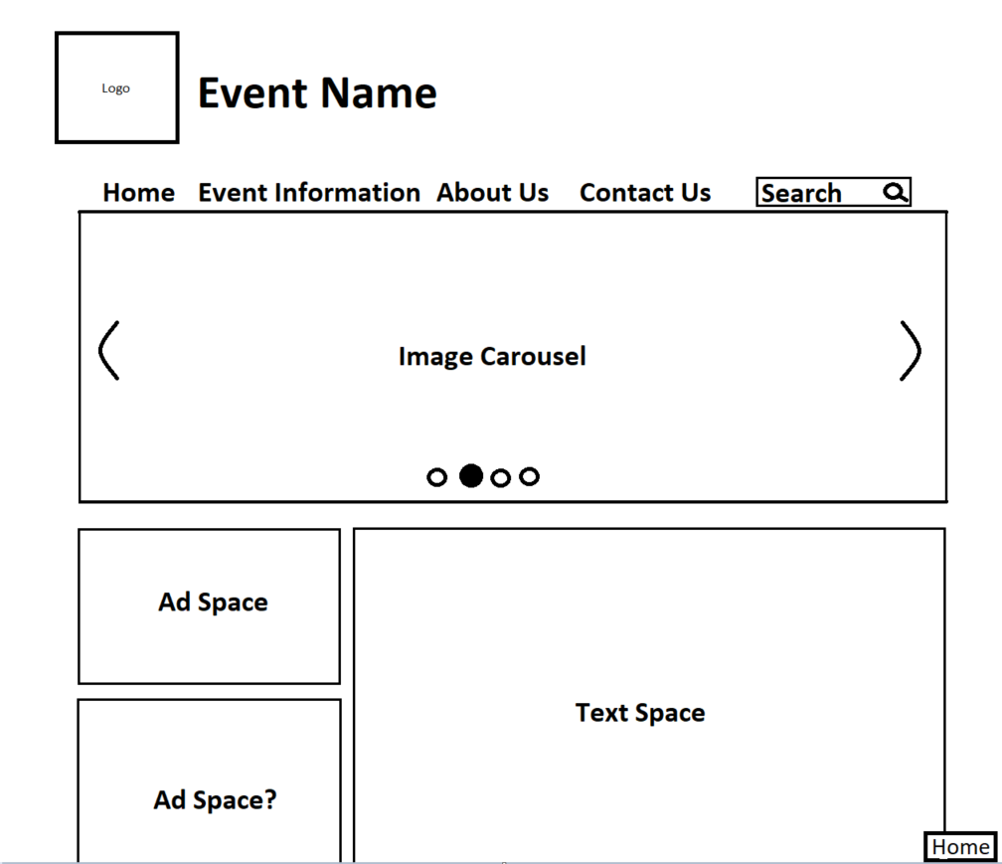

(If you are asking yourself “Did they make this in Paint?” Yes, I did this in Paint. It felt easier for me to do it in Paint rather than the sites that were given as examples to use such as Wireframecc, Word, Visio, etc.)

This is the home page for my site, I would like to create an image carousel for it. Currently, it already has the logo and event name in place, as well as a fitting background, navigation bar, search bar, and text space.

My site is based on the yearly event called TwitchCon which is a convention for gamers and content creators.