Module 5 Assignment – Testing Screen Display Sizes

Makayla Pierce

Rasmussen College

Author’s note

This research is being submitted on November 3, 2018, for Fundamentals of Mobile Web Application Development.

I feel that I could make this page better and more attractive by center-aligning the text. (Pixel 2)

There is also this odd issue of the bottom bar getting put in the center of the screen in landscape mode. (all mobile resolutions)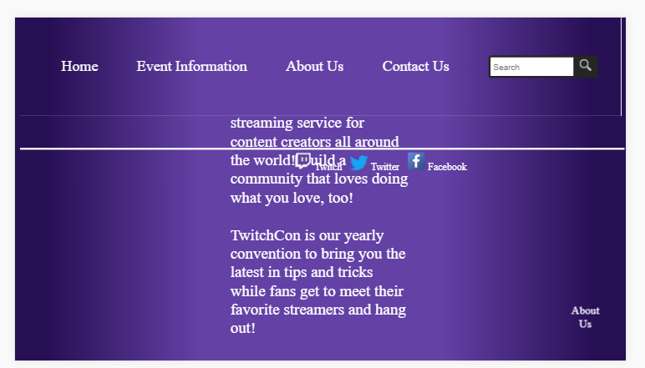

The social media bar also isn’t at the bottom of the page on the Home page in portait orientation. (galaxy S5)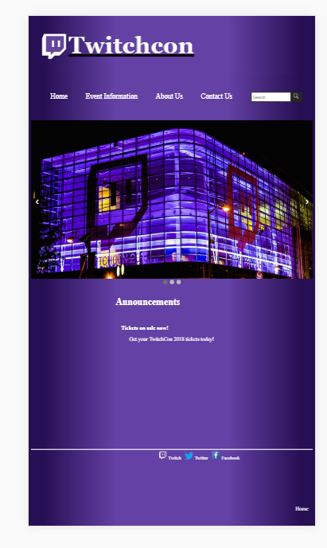

It seems the social media bar has an issue staying at the bottom of the page in landscape mode in every page except the Home Page. Perhaps I changed it for the HomePage file and forgot to change it in the rest of them?