
MINISTRY OF EDUCATION, CULTURE AND RESEARCH
OF THE REPUBLIC OF MOLDOVA
Technical University of Moldova
Faculty of Computers, Informatics and Microelectronics
Department of Software Engineering and Automation

Bruma Cristian FAF-242

Report
Laboratory Work No. 1
Computer Architecture
Topic: Caesar cipher and Caesar cipher with a permutation

Checked by:
Olga Grosu, university assistant
DISA, FCIM, UTM

Chișinău – 2026
Table of Contents
1 AIM OF THE WORK 3
1.1 Purpose of laboratory work 3
1.2 Problem statement 3
2 THEORETICAL BACKGROUND 4
2.1 Caesar cipher 4
2.2 Caesar cipher with a permutation 4
2.3 Key space and cryptanalysis 5
3 IMPLEMENTATION 6
3.1 Structure of the programs 6
3.2 Letter encoding 6
3.3 Normalization of the text 7
3.4 Input and validation 8
3.5 Permuted alphabet, encryption and decryption 9
3.6 Main functions 10
4 RESULTS 12
4.1 Task 1.1: Caesar cipher 12
4.2 Task 1.2: Caesar cipher with two keys 13
4.3 Verification of the results 14
CONCLUSIONS 16
SOURCE CODE 17
REFERENCES 18

1 AIM OF THE WORK

1.1 Purpose of laboratory work
The purpose of the laboratory work is to study the operating principle of the Caesar cipher, to identify the reasons for which its small key space makes it insecure, to strengthen it by means of a keyword-based permutation of the alphabet and to implement both versions of the algorithm for the Romanian alphabet [1].
Achieving this purpose requires the following activities:
- study of the encryption and decryption formulas of the Caesar cipher;
- analysis of the key space and of the exhaustive search attack;
- construction of a permuted alphabet starting from a keyword;
- implementation of both ciphers in C++ for the Romanian alphabet of 31 letters;
- verification of the programs on correct and incorrect input data.

1.2 Problem statement
Task 1.1 requires the implementation of the Caesar cipher for the Romanian alphabet, which has n = 31 letters [1]. The conditions of the task are the following:
- the letters are encoded only by their positions in the alphabet, from A = 0 to Z = 30, without the use of built-in character codes;
- the key is an integer from 1 to 30 inclusive;
- the text contains only Romanian letters, uppercase or lowercase, and spaces, which are removed before encryption;
- an invalid key or an invalid character produces a message that states the allowed range and asks for the value again;
- the user chooses the operation, enters the key and the message, and receives the result.
Task 1.2 extends the previous task with a second key, which is a keyword of at least 7 Romanian letters. The keyword is used to permute the alphabet before the shift is applied, the permuted alphabet must be displayed by the program, and invalid values of either key must produce a message that states the allowed values [1].

2 THEORETICAL BACKGROUND

2.1 Caesar cipher
In the Caesar cipher, every letter of the plaintext is replaced by the letter found a fixed number of positions further along the alphabet. The secret key k is the shift value and is the same for encryption and decryption, so the cipher is symmetric. The key belongs to the set {1, 2, ..., n − 1}, where n is the length of the alphabet, and the value k = 0 is excluded because it leaves the text unchanged [1], [2]. According to formula (2.1), the encryption of a letter is performed as follows:
c = e_{k}(x) = (x + k) mod n (2.1)
where c is the ciphertext letter, e_{k} is the encryption function with key k, x is the numeric code of the plaintext letter (its position in the alphabet, starting from 0), k is the key and n is the length of the alphabet.
Decryption is the inverse operation, described by formula (2.2):
m = d_{k}(y) = (y − k) mod n (2.2)
where m is the recovered plaintext letter, d_{k} is the decryption function with key k, y is the numeric code of the ciphertext letter, and k and n have the same meaning as in formula (2.1).
The modulo operation returns the remainder of the division of two integers. When the difference y − k is negative, the result must be brought back into the range 0, ..., n − 1 by adding n; for example, (1 − 3) mod 26 = 24. Some programming languages return negative remainders, so this case must be handled explicitly [1]. For the English alphabet (n = 26) and k = 3, the letter S with code 18 is encrypted as (18 + 3) mod 26 = 21, which is the letter V.
The method is named after Julius Caesar, who is said to have used it with the key k = 3 in the communication with his generals [1]. The cipher is very easy to break, since a cryptanalyst can recover the plaintext by trying all possible keys. This property is the motivation for the strengthened version described in the next subchapter.

2.2 Caesar cipher with a permutation
The low cryptographic strength of the Caesar cipher is caused mainly by the small key space: there are only 25 different keys for the English alphabet. Such a cipher is broken by an exhaustive search, in which every key is tried in turn and exactly one of them produces readable text in the language of the message. For example, the message BRUTEFORCEATTACK encrypted with the key k = 17 gives the ciphertext SILKVWFITVRKKRTB, and among the 25 candidates obtained by trying all keys only the key 17 produces meaningful English text [1].
To increase the strength, the alphabet is permuted using a keyword, called the second key k₂, which is not to be confused with the numeric key k. The keyword is any sequence of letters of the alphabet, either a real word or a meaningless one. The new order is built by writing the letters of the keyword first, followed by the remaining letters of the alphabet in their natural order, and each letter appears only once: if a letter occurs several times in the keyword, only its first occurrence is kept [1]. For the keyword CRYPTOGRAPHY and the English alphabet, the permuted alphabet is CRYPTOGAHBDEFIJKLMNQSUVWXZ.
The Caesar shift is then applied on the permuted alphabet, so the numeric code of a letter is its position in the new order. With the key k = 3 and the keyword CRYPTOGRAPHY, the plaintext CIFRULCEZAR is encrypted as PLKTXQPJYDT, whereas the plain Caesar cipher with the same shift gives FLIUXOFHCDU [1]. Formulas (2.1) and (2.2) remain valid, but the codes x and y are positions in the permuted alphabet.

2.3 Key space and cryptanalysis
The number of keys of the Caesar cipher is given by formula (2.3):
K_{C} = n − 1 (2.3)
where K_{C} is the number of keys of the Caesar cipher and n is the length of the alphabet. For the Romanian alphabet, n = 31 and there are only 30 keys.
For the version with a permutation, every ordering of the alphabet combined with every shift gives a different pair of keys, so the number of keys is calculated with formula (2.4):
K_{P} = n! · (n − 1) (2.4)
where K_{P} is the number of key pairs (k, k₂) of the version with a permutation, n! is the number of possible orderings of the alphabet and n − 1 is the number of possible shifts. The values obtained for the English and the Romanian alphabets are given in table 2.1.
Table 2.1 Number of keys of the two versions of the cipher
Version | Key | Number of keys, n = 26 | Number of keys, n = 31
Caesar cipher | k | 25 | 30
Caesar cipher with a permutation | (k, k₂) | 26! × 25 = 10 082 286 528 165 140 889 600 000 000 | 31! × 30 = 246 685 159 625 337 684 531 766 886 400 000 000
Distinct substitutions (upper bound) | – | 26! ≈ 4.03 × 10²⁶ | 31! ≈ 8.22 × 10³³

According to the data in table 2.1, the number of keys of the version with a permutation makes the exhaustive search impracticable. However, the cipher is still not protected against frequency analysis: each plaintext letter is always replaced by the same ciphertext letter, so the letter frequencies of the language remain visible in the ciphertext [2], [3]. In addition, different key pairs can produce the same substitution, so the number of distinct encryptions can never exceed n!.

3 IMPLEMENTATION

3.1 Structure of the programs
Both tasks are solved by two C++ programs, task1.cpp and task2.cpp, which share three auxiliary source files. The files have the following roles:
- format.cpp contains the conversion between UTF-8 and UTF-32 and the normalization of the text;
- reading.cpp contains the console input and the validation of the operation, of the keys and of the text;
- encrypt.cpp contains the construction of the permuted alphabet and the encryption and decryption function;
- task1.cpp and task2.cpp contain the alphabet constant and the main function of each task.
Each task file includes the auxiliary files with the #include directive, so that a task is compiled as a single translation unit. The alphabet constant is declared before the inclusion of reading.cpp and encrypt.cpp, because the functions from these files use it. The programs use C++14 digit separators in binary literals and the Windows console functions (windows.h), therefore they are intended for the Windows platform. The correspondence between the requirements of the laboratory work and the code is given in table 3.1.
Table 3.1 Requirements of the tasks and their implementation
Requirement | Implementation
Letter encoding A = 0, ..., Z = 30 | ALPHABET, position found with find
Key from 1 to 30 | read_key
Uppercase conversion, removal of spaces | normalize
Cedilla variants treated as comma-below letters | cedilla_to_comma, fuse
Message about the invalid character | find_invalid, describe
Keyword of at least 7 letters | read_key2
Permuted alphabet | build_alphabet
Encryption and decryption | caesar_encrypt, negative key

3.2 Letter encoding
The Romanian alphabet is stored in a constant string of 31 characters, in the order required by the laboratory work:
static const u32string ALPHABET =
U"A\u0102\u00C2BCDEFGHI\u00CEJKLMNOPQRS\u0218T\u021AUVWXYZ";

The characters Ă, Â and Î are written with their Unicode escape sequences, and Ș and Ț are the letters with comma below. The shift is never computed from ASCII or Unicode values: the escape sequences only define which letters belong to the alphabet, while the numeric code of a letter is its position in the string, obtained with the find method. The codes resulting from this definition are given in table 3.2.
Table 3.2 Letter encoding of the Romanian alphabet (n = 31)
Letter | A | Ă | Â | B | C | D | E | F | G | H | I | Î | J | K | L | M
Code | 0 | 1 | 2 | 3 | 4 | 5 | 6 | 7 | 8 | 9 | 10 | 11 | 12 | 13 | 14 | 15
Letter | N | O | P | Q | R | S | Ș | T | Ț | U | V | W | X | Y | Z
Code | 16 | 17 | 18 | 19 | 20 | 21 | 22 | 23 | 24 | 25 | 26 | 27 | 28 | 29 | 30

3.3 Normalization of the text
The input is received as a UTF-8 string and converted to UTF-32 by the function utf8to32, which decodes the bytes of each character according to the UTF-8 rules [4]; the function utf32to8 performs the reverse conversion before the output. Working with 32-bit code points allows every Romanian letter to be handled as a single element. The normalization is a composition of functions, written in normalize:
u32string normalize_letters(const u32string& s) {
u32string result = s;
for (char32_t& c : result) {
c = to_upper_ro(cedilla_to_comma(c));
}
return result;
}

u32string normalize(const string& s) {
return fuse(normalize_letters(remove_spaces(utf8to32(s))));
}

The function remove_spaces deletes spaces, tabulations, carriage returns and non-breaking spaces. The function cedilla_to_comma replaces the cedilla variants Ş, ş, Ţ, ţ with the comma-below letters Ș, ș, Ț, ț [5], and to_upper_ro converts lowercase letters, including ă, â, î, ș and ț, to uppercase. Some keyboards produce a letter with a separate combining mark instead of a single code point, therefore the function fuse merges such pairs, using the table of the function fuse_pair:
char32_t fuse_pair(char32_t base, char32_t mark) {
struct Fuse { char32_t base, mark, result; };

static const Fuse FUSES[] = {
{U'S', 0x0326, 0x0218},
{U'T', 0x0326, 0x021A},
{U'A', 0x0302, 0x00C2},
{U'A', 0x0306, 0x0102},
{U'I', 0x0302, 0x00CE},
};

for (const Fuse& f : FUSES)
if (f.base == base && f.mark == mark)
return f.result;
return 0;
}

The table contains five pairs. For example, the letter S followed by the combining comma below (U+0326) is replaced by the single letter Ș, so that all the typing variants are accepted as the same letter.

3.4 Input and validation
The console is read by the function read_line_utf8. When the input comes from the Windows console, the line is read with ReadConsoleW and converted to UTF-8 [6], which allows the Romanian letters to be typed correctly; when the input is redirected, the function falls back to getline.
bool read_line_utf8(string& out) {
HANDLE h = GetStdHandle(STD_INPUT_HANDLE);
DWORD mode;
if (!GetConsoleMode(h, &mode))
return (bool)getline(cin, out);

wstring wline;
wchar_t buf[512];
DWORD n;
while (true) {
if (!ReadConsoleW(h, buf, 512, &n, nullptr) || n == 0)
return false;
wline.append(buf, n);
if (wline.back() == L'\n') break;
}
...

The operation is read by read_operation, which accepts only the characters e and d. The numeric key is validated by the function read_key:
int read_key() {
const int max_key = (int)ALPHABET.size() - 1;
while (true) {
cout << "Enter key [1," << max_key << "]: ";
string line;
if (!read_line_utf8(line)) exit(1); // input closed

size_t b = line.find_first_not_of(" \t\r");
size_t e = line.find_last_not_of(" \t\r");
string s = (b == string::npos) ? "" : line.substr(b, e - b + 1);

bool ok = !s.empty() && s.size() <= 3;
for (char ch : s)
if (ch < '0' || ch > '9') ok = false;

if (ok) {
int key = stoi(s);
if (key >= 1 && key <= max_key) return key;
}
cout << "Invalid key, key must be a whole number in the interval [1,"
<< max_key << "].\n";
}
}

The line is trimmed, and it is accepted only if it is not empty, has at most three characters and contains only digits; the value is then compared with the interval [1, 30]. In the case of an error, the program displays the allowed interval and requests the value again, as required by the task. The keyword and the text are validated with the help of find_invalid, which returns the distinct characters that are not in the alphabet, and read_key2:
u32string find_invalid(const u32string& normalized) {
u32string bad;
for (char32_t c : normalized) {
if (ALPHABET.find(c) == u32string::npos && // not a letter
bad.find(c) == u32string::npos) // not already reported
bad += c;
}
return bad;
}

u32string read_key2() {
const size_t min_len = 7;
while (true) {
cout << "Enter second key (Romanian letters only, at least " << min_len <<
" letters): ";
string line;
if (!read_line_utf8(line)) exit(1);

u32string k = normalize(line); // uppercase, no spaces,
comma-below fixed

u32string bad = find_invalid(k);
if (!bad.empty()) {
cout << "These characters are not in the Romanian alphabet:\n "
<< describe(bad) << "\nTry again.\n";
continue;
}
if (k.size() < min_len) {
cout << "Second key is too short (" << k.size() << " letters), need at
least "
<< min_len << ".\n";
continue;
}
return k;
}
}

The keyword is normalized first, then the rejected characters are reported together with their Unicode code points, and finally the length is checked against the minimum of 7 letters. The function read_text works in the same way, with the additional check that the normalized text is not empty.

3.5 Permuted alphabet, encryption and decryption
The permuted alphabet is built by the function build_alphabet, and the cipher is implemented by caesar_encrypt:
u32string build_alphabet(const u32string& k2, const u32string& base) {
u32string result;
for (char32_t c : k2)
if (result.find(c) == u32string::npos) result += c;
for (char32_t c : base)
if (result.find(c) == u32string::npos) result += c;
return result;
}

u32string caesar_encrypt(const u32string& s, int key, const u32string& alphabet) {
u32string result = s;
const int n = (int)alphabet.size();
for (char32_t& c : result) {
size_t pos = alphabet.find(c);
if (pos == u32string::npos) continue;
c = alphabet[((int)pos + key + n) % n];
}
return result;
}

The function build_alphabet copies the letters of the keyword that were not yet added, and then the letters of the base alphabet that were not yet added, which gives the order described in subchapter 2.2. The function caesar_encrypt finds the position of every letter in the given alphabet and replaces it with the letter at the position (pos + key + n) mod n, which corresponds to formula (2.1). Decryption uses the same function with the negative key, which corresponds to formula (2.2); since the absolute value of the key is at most 30 and n = 31, the added term n guarantees a non-negative argument of the modulo operation. The same function serves for Task 1.1 when the base alphabet is passed.

3.6 Main functions
The main function of Task 1.1 reads the operation, the key and the text, displays the alphabet and prints the result:
int main() {
SetConsoleOutputCP(CP_UTF8);
SetConsoleCP(CP_UTF8);
char type = read_operation();
int key = read_key();
string text = read_text();

cout<<"The alphabet: "<<utf32to8(ALPHABET)<<'\n';

if (type == 'd') key = -key;
cout <<"Result: "<<utf32to8(caesar_encrypt(normalize(text), key, ALPHABET)) <<
'\n';
}

The main function of Task 1.2 additionally reads the keyword, builds the permuted alphabet and displays it, so that the result can be checked by hand:
int main() {
SetConsoleOutputCP(CP_UTF8);
SetConsoleCP(CP_UTF8);
char type = read_operation();
int key = read_key();
u32string key2 = read_key2();
string text = read_text();

u32string alphabet = build_alphabet(key2, ALPHABET);
cout<<"The new built alphabet: "<<utf32to8(alphabet)<<'\n';

if (type == 'd') key = -key;
cout <<"Result: "<<utf32to8(caesar_encrypt(normalize(text), key, alphabet)) <<
'\n';
}

In both programs, the first two statements set the console code pages to UTF-8, and the decryption is obtained by changing the sign of the key.

4 RESULTS

4.1 Task 1.1: Caesar cipher
Figure 4.1 shows the encryption of the text "Ștefan cel Mare" with the key 3. The spaces are removed, the letters are converted to uppercase and the result is UVHIBQFHOPBTH.
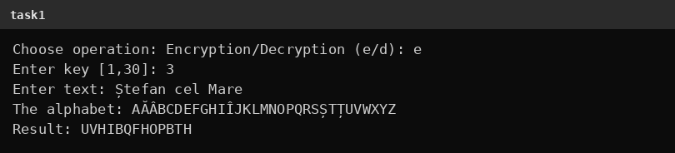
Figure 4.1 Encryption in Task 1.1 (key 3)
According to figure 4.2, the decryption of the obtained ciphertext with the same key returns the original message ȘTEFANCELMARE.
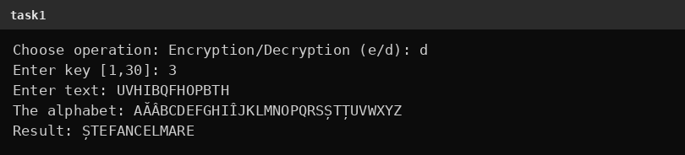
Figure 4.2 Decryption in Task 1.1 (key 3)
The text typed with the cedilla variants of the letters and with lowercase diacritics is accepted and processed as the same letters, as shown in figure 4.3.
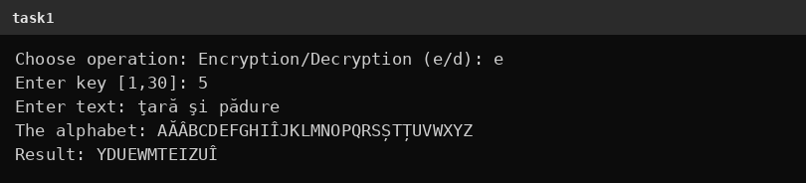
Figure 4.3 Input with cedilla letters in Task 1.1 (key 5)
The messages displayed for invalid data are shown in figure 4.4. The invalid operation x, the keys 0, 31 and abc, and the texts that contain the characters 5 and ! are rejected, and the program requests the value again each time.
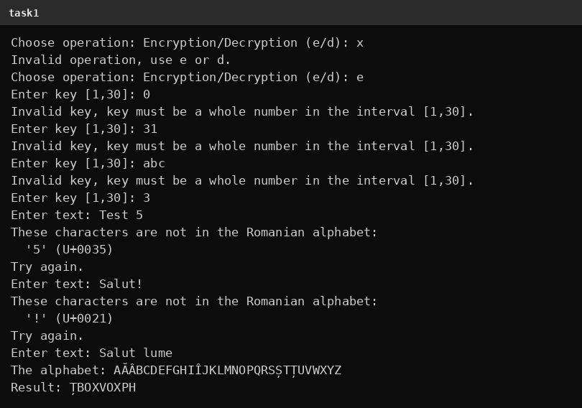
Figure 4.4 Messages for invalid input in Task 1.1

4.2 Task 1.2: Caesar cipher with two keys
Figure 4.5 shows the encryption of the same text with the key 3 replaced by the key 7 and with the keyword BIBLIOTECA. The repeated letters B, I and A of the keyword are used only once, and the displayed alphabet is BILOTECAĂÂDFGHÎJKMNPQRSȘȚUVWXYZ.
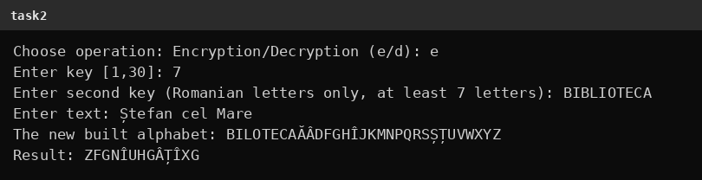
Figure 4.5 Encryption in Task 1.2 (key 7, keyword BIBLIOTECA)
The decryption of the ciphertext with the same keys is presented in figure 4.6.
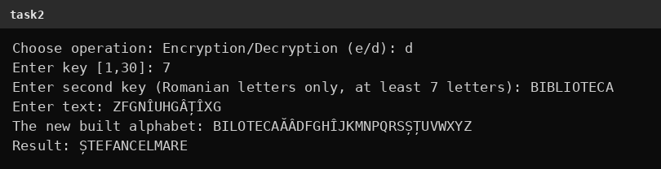
Figure 4.6 Decryption in Task 1.2 (key 7, keyword BIBLIOTECA)
Figure 4.7 contains the messages displayed for invalid input of Task 1.2: the key 35 outside the interval, the keyword scurt which is too short, the keyword abc123xyz which contains digits, and an empty text.
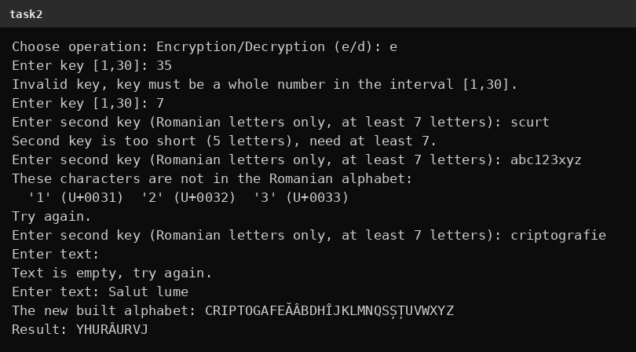
Figure 4.7 Messages for invalid input in Task 1.2

4.3 Verification of the results
The results were checked by hand with formulas (2.1) and (2.2). In figure 4.1, the letter Ș has the code 22, and (22 + 3) mod 31 = 25 is the code of the letter U, which is the first letter of the ciphertext. In figure 4.5, the letter Ș has the position 23 in the permuted alphabet, and (23 + 7) mod 31 = 30 corresponds to the letter Z, which is the first letter of the ciphertext. In addition, all the results were compared with the output of an independent implementation, and the values coincided in every case. The test cases are summarized in table 4.1.
Table 4.1 Summary of the test cases
No. | Task | Operation | Keys | Input text | Result | Figure
1 | 1.1 | Encryption | 3 | Ștefan cel Mare | UVHIBQFHOPBTH | 4.1
2 | 1.1 | Decryption | 3 | UVHIBQFHOPBTH | ȘTEFANCELMARE | 4.2
3 | 1.1 | Encryption | 5 | ţară şi pădure | YDUEWMTEIZUÎ | 4.3
4 | 1.1 | Encryption | 3 | Salut lume (after errors) | ȚBOXVOXPH | 4.4
5 | 1.2 | Encryption | 7, BIBLIOTECA | Ștefan cel Mare | ZFGNÎUHGÂȚÎXG | 4.5
6 | 1.2 | Decryption | 7, BIBLIOTECA | ZFGNÎUHGÂȚÎXG | ȘTEFANCELMARE | 4.6
7 | 1.2 | Encryption | 7, criptografie | Salut lume (after errors) | YHURÂURVJ | 4.7

CONCLUSIONS
The laboratory work achieved its purpose: the Caesar cipher and the Caesar cipher with a permutation were implemented for the Romanian alphabet of 31 letters, and both programs were verified on correct and incorrect data. The letters are encoded by their positions in the alphabet, the input is validated with clear messages, and the typing variants of the letters Ș and Ț are handled correctly.
From the point of view of security, the Caesar cipher has only 30 keys for the Romanian alphabet, so it is broken immediately by an exhaustive search. The permutation with a keyword increases the number of keys to 31! × 30, which is approximately 2.5 × 10³⁵ and excludes the exhaustive search. Nevertheless, the cipher remains a monoalphabetic substitution, so the letter frequencies of the language are preserved and the cipher is vulnerable to frequency analysis. In addition, a keyword with few distinct letters moves only the beginning of the alphabet, and the rest keeps the natural order, as can be seen at the end of the alphabets in figures 4.5 and 4.7.
During the work, the following aspects were learned: the correct handling of negative remainders in modular arithmetic, the representation of Romanian letters in Unicode and the difference between the cedilla and comma-below variants, and the importance of validating every input value. The full source code is available in the GitHub repository [7].

SOURCE CODE
The complete source code of the programs (format.cpp, reading.cpp, encrypt.cpp, task1.cpp and task2.cpp) is published in the GitHub repository [7]: https://github.com/Makday/CS_labs

REFERENCES
[1] Laboratory Work No. 1. Caesar cipher and Caesar cipher with a permutation: task description. Technical University of Moldova, 2026.
[2] Stallings W. Cryptography and Network Security: Principles and Practice. 7th ed. Harlow: Pearson, 2017. 767 p.
[3] Menezes A., van Oorschot P., Vanstone S. Handbook of Applied Cryptography. Boca Raton: CRC Press, 1996. 780 p.
[4] Yergeau F. UTF-8, a transformation format of ISO 10646. RFC 3629, 2003. Available: https://www.rfc-editor.org/rfc/rfc3629
[5] Unicode Consortium. The Unicode Standard: Latin Extended-B (U+0180-U+024F). Available: https://www.unicode.org/charts/PDF/U0180.pdf
[6] Microsoft. ReadConsole function. Windows Console documentation. Available: https://learn.microsoft.com/en-us/windows/console/readconsole
[7] Source code of the laboratory work. Available: https://github.com/Makday/CS_labs

