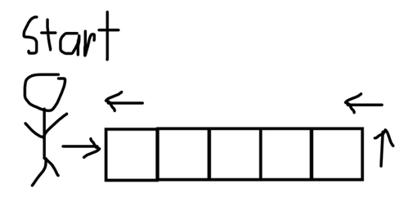
Variant I ( bot places blocks starting from its current position, code focuses on movement and correct block placement)

-- define house size
size = 5
height = 3

-- build floor (5x5)
repeat size times
repeat size times
place wood -- place block in front
move forward 1 -- step onto it
-- return to start of row
turn left
turn left
move forward size + 1 -- go back to row start
-- move to next row
turn right
move forward 1
turn right

-- after loop, we are at far corner facing backward the block
-- reposition to original corner for walls
turn right
move forward size
turn right

-- build walls
repeat 4 times -- 4 walls
repeat size times -- length of wall
repeat height times
place wood
move up 1
move down height -- return to ground
move forward 1 -- move to next wall position
turn left -- turn at corner

print "House complete!"

Variant II (Blocks are placed using coordinates, does not involve a bot)
size = 5
height = 3

# floor
repeat x from 0 to size - 1
repeat z from 0 to size - 1
place wood at (x, 0, z)

# walls
repeat y from 1 to height

repeat x from 0 to size - 1
place wood at (x, y, 0)
place wood at (x, y, size - 1)

repeat z from 0 to size - 1
place wood at (0, y, z)
place wood at (size - 1, y, z)

print "House complete!"

