
MINISTRY OF EDUCATION, CULTURE AND RESEARCH
OF THE REPUBLIC OF MOLDOVA
Technical University of Moldova
Faculty of Computers, Informatics and Microelectronics
Department of Software Engineering and Automation

Cristian Bruma FAF-242
Andrei Uzun FAF-242
Report
Laboratory work n.1
of Network Programming

Checked by:
Fiștic Cristofor, university assistant
DISA, FCIM, UTM

Chișinău – 2026
Table of Contents
1 AIM OF THE WORK 3
1.1 Purpose of practical work 3
1.2 Problem statement 3
2 THEORETICAL BACKGROUND 4
2.1 Threads, CPU-bound and I/O-bound work 4
2.2 Physical cores, logical processors and speed-up 4
2.3 Race conditions and synchronisation 4
2.4 Producer–consumer with a bounded queue 4
2.5 Peak memory of a process 5
3 DESCRIPTION OF EXERCISES 6
3.1 Exercise 1: Counting with threads over one file 8
3.2 Exercise 2: Three ways to count in memory 11
3.3 Exercise 3: Producer and consumers 14
3.4 Exercise 4: Many files on a USB flash drive 19
CONCLUSION 24
REFERENCES 25

1 AIM OF THE WORK

1.1 Purpose of practical work
The purpose of the work is to measure how the number of threads, and the way the work is divided among them, change the running time and the memory of a real workload [1]. The measurements are used to decide when the work is CPU-bound and when it is I/O-bound, to observe a race condition and the cost of fixing it, and to find where the parallel speed-up stops.

1.2 Problem statement
A text file numbers.txt with 50 000 000 random integers from −1 000 000 to 1 000 000, one number per line, must be processed in several ways, and in every case the numbers of negative, positive and zero values must be counted [1]. The following parts were solved:
- count the signs with 1, 2, 4, 8, 16, 32 and 64 threads, each thread reading and parsing only its own part of the file;
- compare three ways of counting in memory: unsynchronised shared counters, lock-protected shared counters and per-thread counters;
- count the signs with one reader thread and several worker threads connected by a bounded queue;
- count the signs in eight files read from a USB flash drive with 1, 2 and 4 threads;
- decide from the measurements which work is CPU-bound and which is I/O-bound.
In every task the numbers of negative, positive and zero values must add up to 50 000 000 and must be the same in all tasks.

2 THEORETICAL BACKGROUND

2.1 Threads, CPU-bound and I/O-bound work
A thread is an independent flow of execution inside a process, and the threads of one program execute code that operates on values and objects residing in a shared main memory [2]. Work is called CPU-bound when its running time is determined by the speed of the processor, so adding processors shortens it. Work is called I/O-bound when its running time is determined by waiting for a device such as a disk, a USB drive or a network. The handout asks to decide from measurements which of the two cases applies to each task [1].
Concurrency helps CPU-bound work only while free processors are available. It helps I/O-bound work only when the waiting of one thread can be overlapped with useful work of another thread, or when independent devices can serve requests at the same time.

2.2 Physical cores, logical processors and speed-up
A physical core is a complete processing unit. With Hyper-Threading, one physical core appears to the operating system as two logical processors, which keep a separate architectural state but share the execution resources and the caches of the core [3]. Two threads running on the same core therefore progress more slowly than two threads running on different cores.
The speed-up on n threads is the ratio of the time with one thread to the time with n threads, and its ideal value is n. Amdahl's law states that the speed-up of a task is limited by the part of the work that cannot be parallelised [4]. In practice the creation of threads, the waiting for shared resources and the scheduling of more threads than processors reduce the speed-up further.

2.3 Race conditions and synchronisation
Incrementing a counter with counter++ is not one step: the value is read, increased by one and written back. If two threads read the same value before either writes it back, both write the same result and one increment is lost, which is a race condition. Java associates a monitor with every object, and a synchronized block lets only one thread at a time execute the protected code, while the behaviour of threads that are not correctly synchronised can be confusing and counterintuitive [2].
A lock makes the result correct but forces the threads to take turns. The alternative is to avoid sharing: every thread counts in its own variables, and the partial results are added after all threads have finished.

2.4 Producer–consumer with a bounded queue
In the producer–consumer pattern, one thread puts items into a queue and other threads take them out. A BlockingQueue is thread-safe, may be capacity bounded and is designed primarily for producer–consumer queues [5]. When a bounded queue is full the producer waits, and when it is empty the consumers wait, so the amount of queued data stays bounded. The interface has no built-in close operation, so the end of the input is signalled by a special element, called a poison object, put into the queue once for every consumer [5].

2.5 Peak memory of a process
The resident set size of a process is the part of its memory that is held in RAM. The Linux kernel records the highest value reached by it in the VmHWM field of /proc/pid/status, called the peak resident set size [6]. This value covers the Java heap and also the thread stacks, the code of the virtual machine and native buffers, so it is larger than the heap alone. The maximum heap size of the virtual machine is limited with the option -Xmx.

3 DESCRIPTION OF EXERCISES
All measurements were made on the machine described in table 3.1. The program is written in Java and built with the Maven wrapper.
Table 3.1 – Hardware and software configuration
Component | Description
Processor | Intel(R) Core(TM) i5-10300H CPU @ 2.50GHz
Physical cores | 4
Logical processors | 8
RAM | 32 GB
Internal disk | SPCC M.2 PCIe SSD, 1.8 TB, NVMe (ROTA 0, not rotational)
USB drive | Silicon Motion Flash Drive (090c:1000), USB 2.0 (480 Mbit/s)
Operating system | CachyOS, Linux kernel 7.2.11-1-cachyos
Language and runtime | OpenJDK 25.0.4.1 (2026-08-18)
The program is one executable in which every task is selected by command-line parameters, for example run --task 1a --threads 8. Every task implements the Task interface with the methods prepare(), run() and cleanup(). Work that must not be measured, such as loading the array in Task 1b, is done in prepare(). The class Runner measures only the call of run() with System.nanoTime(), and right after it reads the peak memory from the VmHWM line of /proc/self/status [6]. Every run is a separate process and appends one row to results.csv with the task, the number of threads, the time in milliseconds, the peak memory in kilobytes, the three counts, their total and a timestamp.
The reference counts of the generated file are given in table 3.2. All tasks, except the deliberately incorrect unsynchronised version of Task 1b, returned exactly these values in every run, which was checked by the chart script described below.
Table 3.2 – Reference counts of the generated file
Sign | Count
Negative | 25 003 915
Positive | 24 996 059
Zero | 26
Total | 50 000 000
The results of Tasks 1a, 1b and 1c were obtained with the script script.sh, which is shown below. The script performs the following steps:
- the project is built with ./mvnw -q clean compile;
- the file numbers.txt with 50 000 000 numbers is generated and then split into eight files of 6 250 000 numbers in the directory parts;
- every task of 1a and 1c is run for 1, 2, 4, 8, 16, 32 and 64 threads, first once as a warm-up run whose output is discarded and then three times with the results appended to results.csv;
- every version of Task 1b is run with 8 threads, which is the number of logical processors, in the same way, with one discarded warm-up run and three recorded runs;
- every run is a separate Java process started with the option -Xmx512m, so that the same heap limit is used everywhere and the peak memory of one run cannot influence the next one.
#!/usr/bin/env bash
set -euo pipefail
JAVA_FLAGS="-Xmx512m"
CP="target/classes/"
RUNS="3"
THREADS="1 2 4 8 16 32 64"
MAX_PROCESSORS="8"
OUT="results.csv"
run() { java $JAVA_FLAGS -cp "$CP" org.example.lab1.Main "$@"; }
./mvnw -q clean compile
run generate && echo "generated"
run split && echo "divided"
for task in 1a 1c; do
for t in $THREADS; do
run run --task "$task" --threads "$t" --output /dev/null # warm-up, discarded
for ((i = 1; i <= RUNS; i++)); do
run run --task "$task" --threads "$t" --output "$OUT"
done
done
done
for task in 1b_unsync 1b_locked 1b_local; do
run run --task "$task" --threads "$MAX_PROCESSORS" --output /dev/null
for ((i = 1; i <= RUNS; i++)); do
run run --task "$task" --threads "$MAX_PROCESSORS" --output "$OUT"
done
done
The operating system file cache was not cleared between the runs of Tasks 1a, 1b and 1c. The warm-up run therefore loads numbers.txt into memory, and the recorded runs read it from the file cache, which is possible because the machine has 32 GB of RAM. Task 2 is not part of the script, because the USB drive had to be ejected, unplugged and plugged in again before every run, so that no data came from the file cache. Task 2 was run once for 1, 2 and 4 threads, and its rows were appended to the same results.csv.
The charts were generated from results.csv by the Python script make_charts.py with pandas and matplotlib and are stored in the directory charts. Every point is the mean of the recorded runs, the bars show the minimum and the maximum, and the speed-up is the mean time with one thread divided by the mean time with n threads. The dotted vertical lines mark the 4 physical cores and the 8 logical processors. The script also compared the counts of every row with the most frequent counts, and only the three rows of the unsynchronised version of Task 1b differed.

3.1 Exercise 1: Counting with threads over one file
Objective: to measure how the running time and the peak memory of a CPU-bound counting task change with the number of threads when every thread reads and parses only its own part of one file
Commands used: Task 1a was started once per recorded run with the command below, where n is one of 1, 2, 4, 8, 16, 32 and 64.
java -Xmx512m -cp target/classes/ org.example.lab1.Main run --task 1a --threads n
Description: The file is divided by byte offsets: thread i processes the range from size·i/n to size·(i+1)/n, where size is the length of the file. The class ThreadedCounter creates the threads and adds their results after join(), and the class RangeCounter does the work of one thread. A thread that starts in the middle of a line skips the partial line and a thread processes every line that starts inside its range, finishing the last line even when it crosses the boundary, so no line is counted twice or skipped. The last line of the file has no newline, which is handled after the end of the data is reached. Every thread opens the file with RandomAccessFile, reads it through its own buffer of 1 MB, converts the bytes to numbers without creating strings and keeps three local counters.
The mean values of the three recorded runs are given in table 3.3.
Table 3.3 – Task 1a results, mean of three runs
Threads | Time, ms | Speed-up | Peak memory, MB
1 | 1359 | 1.00 | 67.0
2 | 725 | 1.87 | 72.0
4 | 383 | 3.55 | 78.1
8 | 339 | 4.01 | 92.2
16 | 340 | 4.00 | 120.6
32 | 401 | 3.39 | 168.3
64 | 418 | 3.25 | 255.6
The execution time against the number of threads is shown in figure 3.1. It falls from 1359 ms with one thread to 725 ms with two and 383 ms with four threads, and then stays near 340 ms for 8 and 16 threads before rising again for 32 and 64 threads.
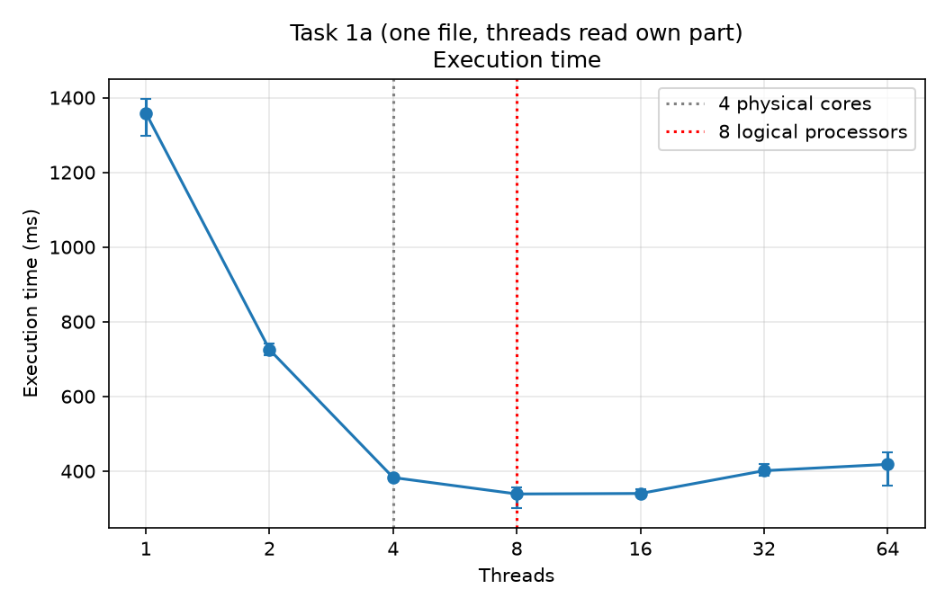
Figure 3.1 – Task 1a, execution time against the number of threads
The speed-up relative to one thread is shown in figure 3.2. The curve follows the ideal line up to 2 threads, reaches 3.55 with 4 threads and its maximum of 4.01 with 8 threads, and decreases to 3.39 and 3.25 with 32 and 64 threads.
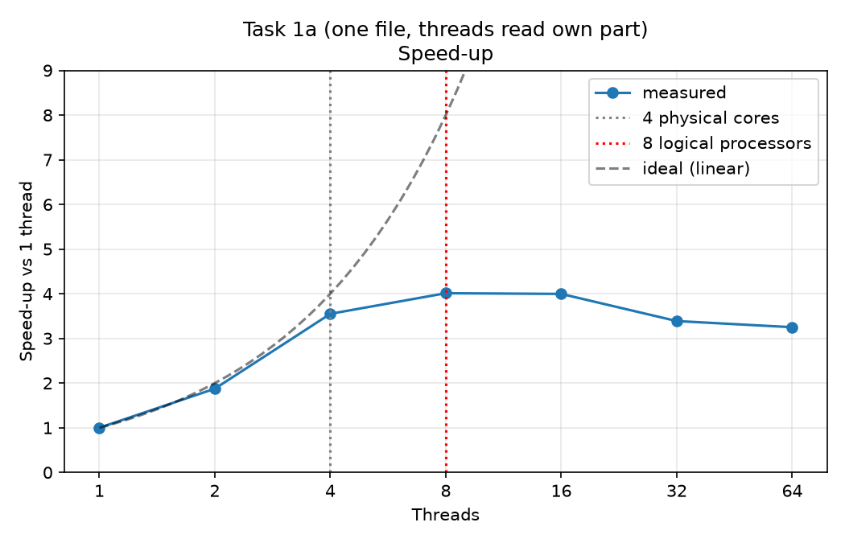
Figure 3.2 – Task 1a, speed-up against the number of threads
The peak memory against the number of threads is shown in figure 3.3. It grows from 67 MB with one thread to 256 MB with 64 threads, roughly in a straight line.
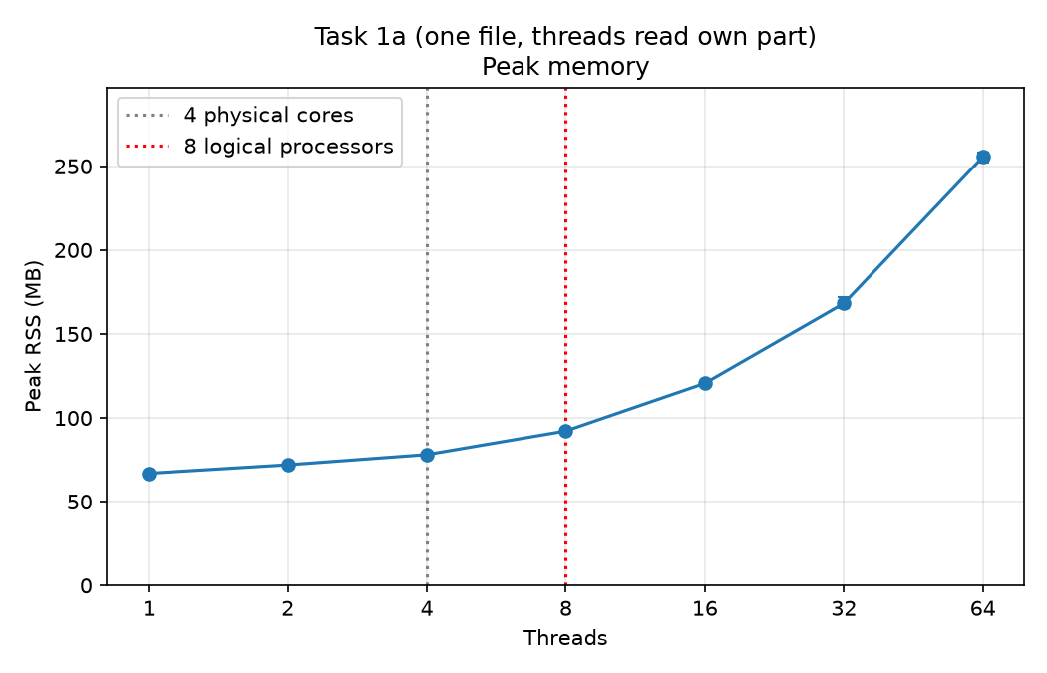
Figure 3.3 – Task 1a, peak memory against the number of threads
Question 1: At which number of threads does the speed-up stop growing? The speed-up grows almost linearly up to 4 threads, with the values 1.87 for 2 threads and 3.55 for 4 threads, which are efficiencies of 94 % and 89 %. It reaches its maximum of 4.01 with 8 threads and stays the same with 16 threads (4.00), so the growth stops at 8 threads. This matches the processor, which has 4 physical cores and 8 logical processors (table 3.1). Up to 4 threads every thread can use a physical core of its own. The second logical processor of a core shares the execution resources of that core [3], so the step from 4 to 8 threads adds only about 13 % (from 3.55 to 4.01) instead of the doubling that eight full cores would give. Above 8 threads there is no free logical processor left, and the dotted lines in figure 3.2 show the two thresholds.
Question 2: Why do 32 and 64 threads not help? Are they slower, and why? They are slower: 401 ms with 32 threads and 418 ms with 64 threads, which is 18 % and 23 % more than the 339 ms with 8 threads, and the speed-up falls to 3.39 and 3.25. Only 8 threads can run at the same moment, so the additional threads share the same processors by time slicing. Every additional thread also has to be created and scheduled, opens the file and allocates its own buffer, and its part of the file is smaller, so this fixed cost becomes a larger share of the work. The runs with 64 threads also differ more from each other (from 360 to 451 ms), as the bars in figure 3.1 show. The time with 16 threads (340 ms) is equal to the time with 8 threads, so the first threads above the number of logical processors cost almost nothing, and the loss appears only when the number of threads is several times larger.

3.2 Exercise 2: Three ways to count in memory
Objective: to compare unsynchronised shared counters, shared counters protected by a lock and per-thread counters, and to observe a race condition and the cost of fixing it
Commands used: Each version of Task 1b was started with 8 threads, which is the number of logical processors, using the commands below.
java -Xmx512m -cp target/classes/ org.example.lab1.Main run --task 1b_unsync --threads 8
java -Xmx512m -cp target/classes/ org.example.lab1.Main run --task 1b_locked --threads 8
java -Xmx512m -cp target/classes/ org.example.lab1.Main run --task 1b_local --threads 8
Description: The class NumberLoader loads all 50 000 000 numbers into an int array in prepare(), so the loading is not measured. The class Parallel divides the indices of the array into equal ranges and starts one thread per range. In Task1bUnsynchronized all threads increment the same three shared counters without any protection. In Task1bLocked every increment is placed inside a synchronized block with one lock shared by all threads. In Task1bLocal every thread counts in its own local variables and writes its result into its own slot of an array, and the results are added after all threads have finished. The unsynchronised version was run three times, as required.
The results are given in table 3.4. The total counted by the unsynchronised version is the mean of three runs, which counted 12 072 697, 10 783 115 and 10 680 822 numbers.
Table 3.4 – Task 1b results with 8 threads, mean of three runs
Version | Time, ms | Total counted | Correct | Peak memory, MB
No synchronisation | 110 | 11 178 878 | no | 261.9
Lock (mutex) | 2315 | 50 000 000 | yes | 261.9
Per-thread counters | 57 | 50 000 000 | yes | 265.9
The execution times are compared in figure 3.4. The vertical axis is logarithmic, because the locked version is about 40 times slower than the version with per-thread counters.
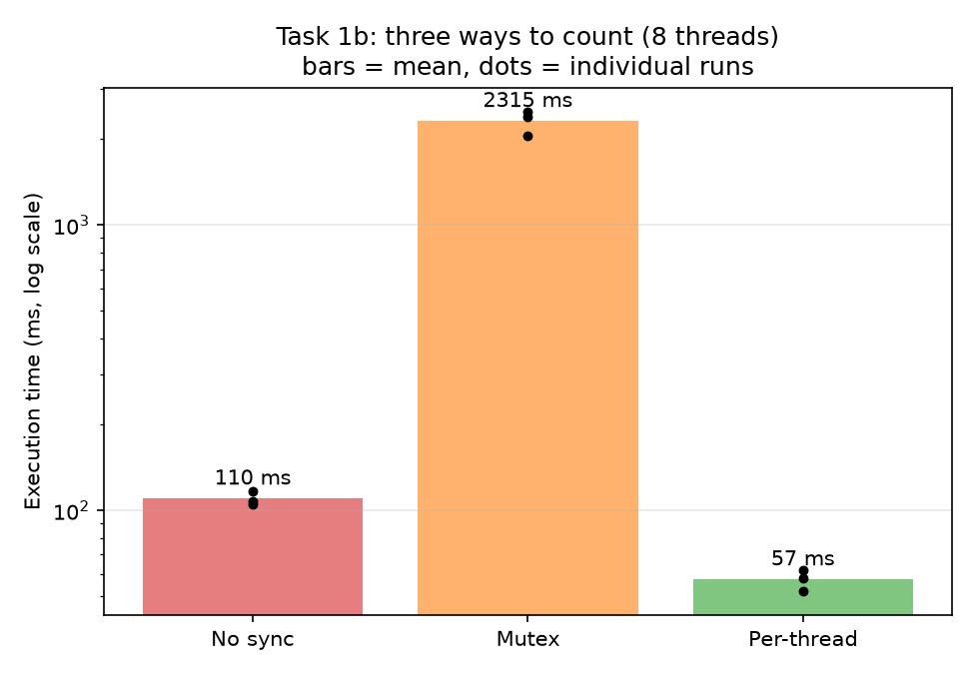
Figure 3.4 – Task 1b, execution time of the three versions with 8 threads
The totals counted in every run are shown in figure 3.5 together with the expected value of 50 000 000. Only the unsynchronised version misses it.
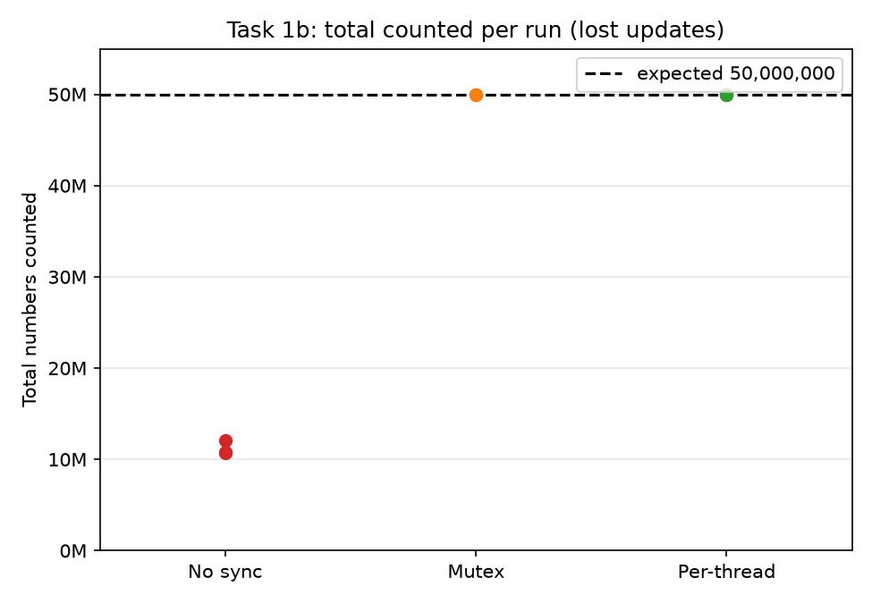
Figure 3.5 – Task 1b, total counted in every run
The peak memory of the three versions is shown in figure 3.6. It is practically the same, about 262 to 266 MB, because the array of 50 000 000 int values occupies 200 MB in all of them.
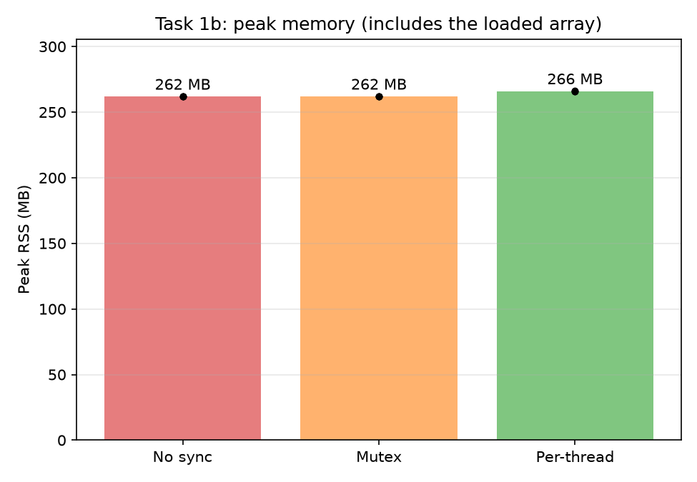
Figure 3.6 – Task 1b, peak memory of the three versions
Question 4: Rank the three versions of Task 1b by time. Which of them are correct? Explain each result. By time the order is the per-thread counters (57 ms), the unsynchronised counters (110 ms) and the lock (2315 ms). The versions with the lock and with per-thread counters are correct, while the unsynchronised version is not.
The unsynchronised version counted only between 10.7 and 12.1 million of the 50 million numbers, so about 78 % of the updates were lost. The statement shared.negative++ is a read, an addition and a write, and when two threads read the same value before either writes, both write the same result and one increment disappears. Eight threads update the same three variables all the time, so such collisions are very frequent, and the total differs from run to run. Without synchronisation the specification also gives no guarantee about the order in which the writes of one thread are seen by another [2]. The version is faster than the locked one because it never waits, but it is about twice as slow as the per-thread version, most likely because all cores keep writing to the same memory location and its cache line moves between them.
The version with the lock is correct, because only one thread at a time can be inside the synchronized block, but this makes the 8 threads take turns for each of the 50 000 000 increments. It took 2315 ms, which is about 21 times more than the unsynchronised version and about 41 times more than the per-thread version, so the price of correctness here is the loss of almost all parallelism and the cost of acquiring the lock for every number.
The version with per-thread counters is correct and the fastest. Every thread increments private local variables and writes to shared memory only once, at the end, so no thread waits for another and the threads do not disturb each other's caches. The correctness is obtained by removing the sharing, not by paying for protecting it.

3.3 Exercise 3: Producer and consumers
Objective: to measure how a reader thread that fills a bounded queue and several worker threads that count the signs scale with the number of workers
Commands used: Task 1c was started once per recorded run with the command below, where n is the number of workers.
java -Xmx512m -cp target/classes/ org.example.lab1.Main run --task 1c --threads n
Description: One reader thread reads numbers.txt line by line with BufferedReader and puts the lines in batches of 10 000 into an ArrayBlockingQueue with the capacity of 100 batches [5]. The workers take a batch, parse every line with Integer.parseInt and keep three local counters. When the file ends, the reader puts one special empty batch, the poison object, into the queue for every worker, and a worker stops when it takes it. After all threads have finished, the counts of the workers are added. The reader waits when the queue is full and the workers wait when it is empty.
The mean values of the three recorded runs are given in table 3.5.
Table 3.5 – Task 1c results, mean of three runs
Workers | Time, ms | Speed-up | Peak memory, MB
1 | 2048 | 1.00 | 382.0
2 | 1759 | 1.16 | 386.6
4 | 1822 | 1.12 | 383.6
8 | 2125 | 0.96 | 382.4
16 | 1883 | 1.09 | 381.0
32 | 1982 | 1.03 | 387.7
64 | 1842 | 1.11 | 388.4
The execution time against the number of workers is shown in figure 3.7. It stays between about 1760 and 2130 ms for every number of workers, and the differences between the points are of the same size as the differences between the repeated runs.
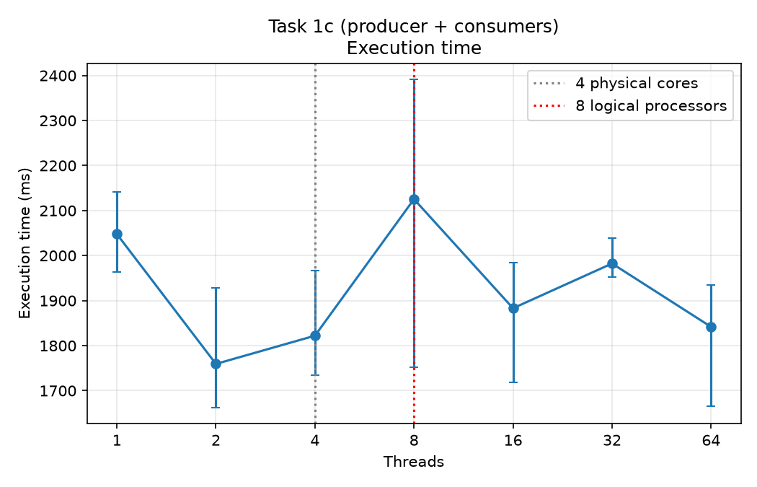
Figure 3.7 – Task 1c, execution time against the number of workers
The speed-up is shown in figure 3.8. It reaches at most 1.16 with two workers and does not grow afterwards.
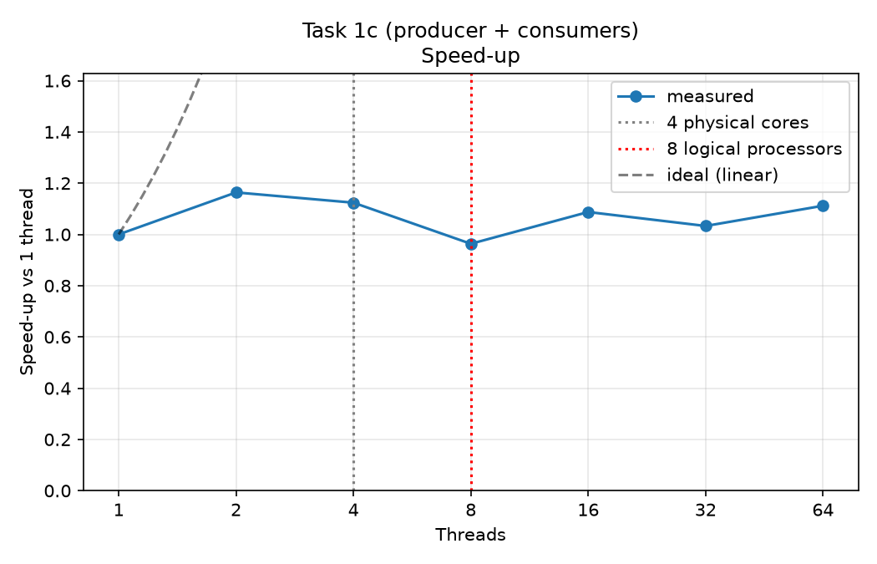
Figure 3.8 – Task 1c, speed-up against the number of workers
The peak memory is shown in figure 3.9. It stays near 385 MB for every number of workers.
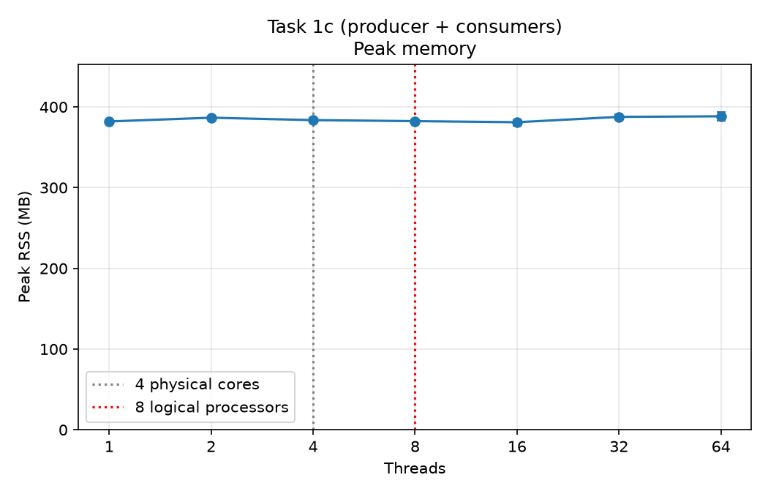
Figure 3.9 – Task 1c, peak memory against the number of workers
Tasks 1a and 1c are compared directly in figures 3.10, 3.11 and 3.12. In all of them the number of threads of Task 1a and the number of workers of Task 1c are placed on the same axis, and the reader of Task 1c is not counted.
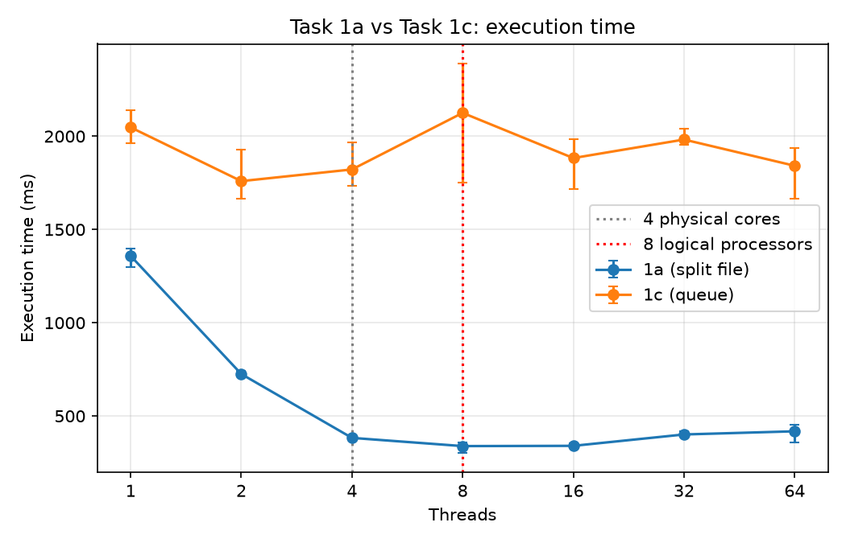
Figure 3.10 – Execution time of Task 1a and Task 1c
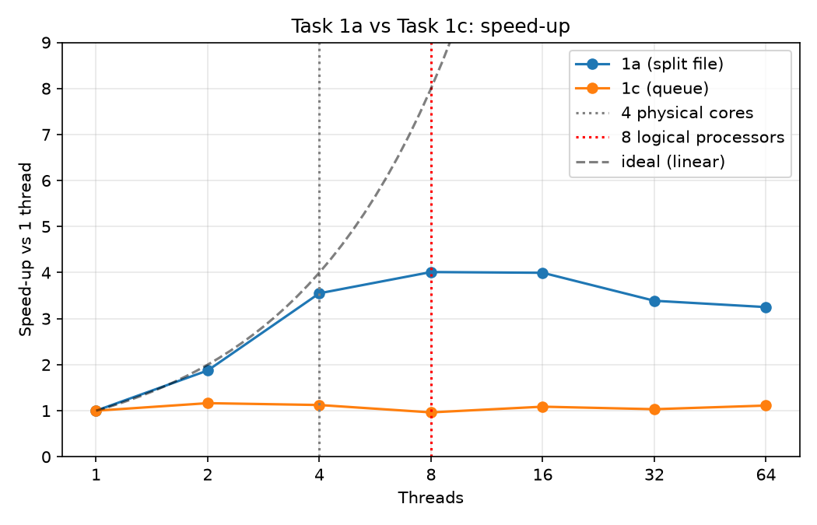
Figure 3.11 – Speed-up of Task 1a and Task 1c
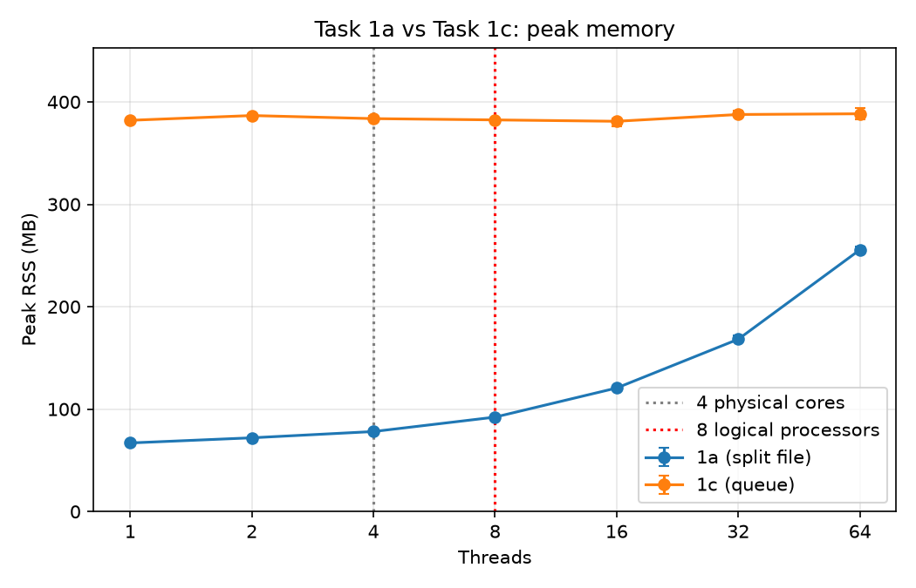
Figure 3.12 – Peak memory of Task 1a and Task 1c
Question 3: Does the peak memory depend on the number of threads? Why? In Task 1a it does. The peak memory in figure 3.12 grows from 67 MB with one thread to 256 MB with 64 threads, which is about 3 MB for every additional thread. Every thread allocates its own read buffer of 1 MB and holds it until it finishes, so all the buffers exist at the same time. The rest of the 3 MB is attributed to other per-thread costs, such as the stack and the temporary memory of the read calls, which were not measured separately.
In Task 1c it does not in any visible way. The values lie between 381 and 388 MB for every number of workers, and the growth of about 6 MB from 1 to 64 workers, which is roughly 0.1 MB per worker, is smaller than the differences between repeated runs of the same configuration (up to 11 MB with 64 workers). The workers keep only three counters and take batches that already exist, and the amount of queued data is limited by the queue to 100 batches whatever the number of workers. The large absolute value, which is higher than in Task 1a, comes from the reader, which creates a string for each of the 50 000 000 lines. These strings become garbage that the virtual machine frees only when the heap approaches the limit of 512 MB, so the peak memory depends on the heap limit and not on the number of workers. The same holds for Task 1b, in which the peak of about 262 to 266 MB is determined by the array of 200 MB and the number of threads was fixed.
Question 5: Compare Task 1c with Task 1a. Which one is faster, and why? At which number of workers does Task 1c stop getting faster? Task 1a is faster. Its best time is 339 ms with 8 threads, and the best mean time of Task 1c is 1759 ms with 2 workers, which is about 5.2 times more (figure 3.10). Even with one thread, Task 1a takes 1359 ms and Task 1c takes 2048 ms. In Task 1a every thread performs the whole work for its own part of the file in parallel: reading, parsing and counting. In Task 1c the reading of lines and the creation of strings are done by a single reader, and the workers only convert the strings to numbers, which is the cheaper part. The reader is therefore a sequential bottleneck, and by Amdahl's law the speed-up is limited by this part [4]. Applying the law to the points with 2 and 4 workers gives a sequential share of roughly 70 to 90 % of the work.
Task 1c stops getting faster at 2 workers, where the speed-up is 1.16. With more workers it stays between 0.96 and 1.12 (figure 3.11), and the differences between 2 and 64 workers are not larger than the differences between repeated runs. The worker count does not matter, because the workers wait for the reader.
Question 6: What would happen with batches of a single line? And with a queue that has no size limit? These two cases were not run, so the answers follow from the implementation. With batches of a single line every one of the 50 000 000 lines would pass through the queue separately. Every put and every take acquires the lock of the queue and may wake another thread, so the cost of the synchronisation per line would become comparable to or larger than the cost of parsing the number, and all workers would compete for the same lock. The queue would also hold at most 100 lines, so the reader and the workers would wait for each other all the time, and the time would be much longer than the measured one and would get worse with more workers.
With a queue without a size limit the reader would never wait. If the workers were slower than the reader, the queue would grow until it held a large part of the file as strings, which needs several gigabytes and would exceed the heap limit of 512 MB and end with an out-of-memory error. The bounded queue stops the reader when it is full and so keeps the memory constant [5]. In the measurements the reader was the slower side with two or more workers, so the queue was probably almost empty and an unbounded queue would not have filled up in these runs, but the limit is what guarantees this for any speed of the workers.

3.4 Exercise 4: Many files on a USB flash drive
Objective: to decide from measurements whether the work is CPU-bound or I/O-bound when the files are read from a slow USB flash drive
Commands used: The eight files part-00.txt to part-07.txt were copied to the USB drive, and Task 2 was started with the command below, where n is 1, 2 or 4 and the path is the mount point of the drive.
java -Xmx512m -cp target/classes/ org.example.lab1.Main run --task 2 --threads n --input /run/media/user/MYUSB/parts/
Description: The files are listed and sorted in prepare() and are assigned to the threads in turn, so with 8 files every thread gets 8, 4 or 2 files for 1, 2 or 4 threads. A thread reads a file with a single call of Files.readAllBytes into one byte array, and then scans the array once and counts the numbers without creating any strings. The last number of a file has no newline, so the end of the array is treated as a line end. Before every run the drive was ejected, unplugged and plugged in again, so that no data came from the file cache. One run per configuration was made.
The results are given in table 3.6.
Table 3.6 – Task 2 results on the USB drive, one run per configuration
Threads | Time, ms | Speed-up | Peak memory, MB
1 | 18 567 | 1.00 | 297.1
2 | 17 443 | 1.06 | 343.3
4 | 17 362 | 1.07 | 435.9
The execution time is shown in figure 3.13. It decreases only from 18 567 ms to 17 362 ms when the number of threads grows from 1 to 4.
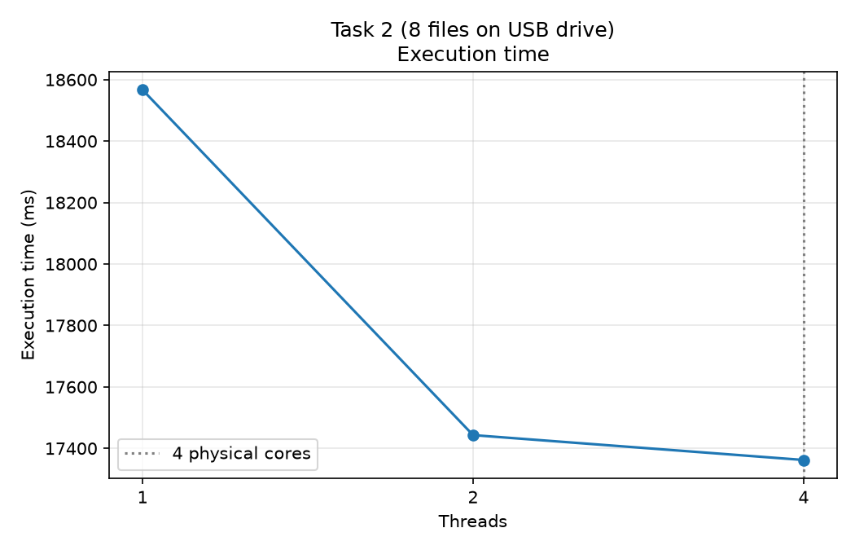
Figure 3.13 – Task 2, execution time against the number of threads
The speed-up is shown in figure 3.14. It is 1.06 with two threads and 1.07 with four threads, which is far below the ideal line.
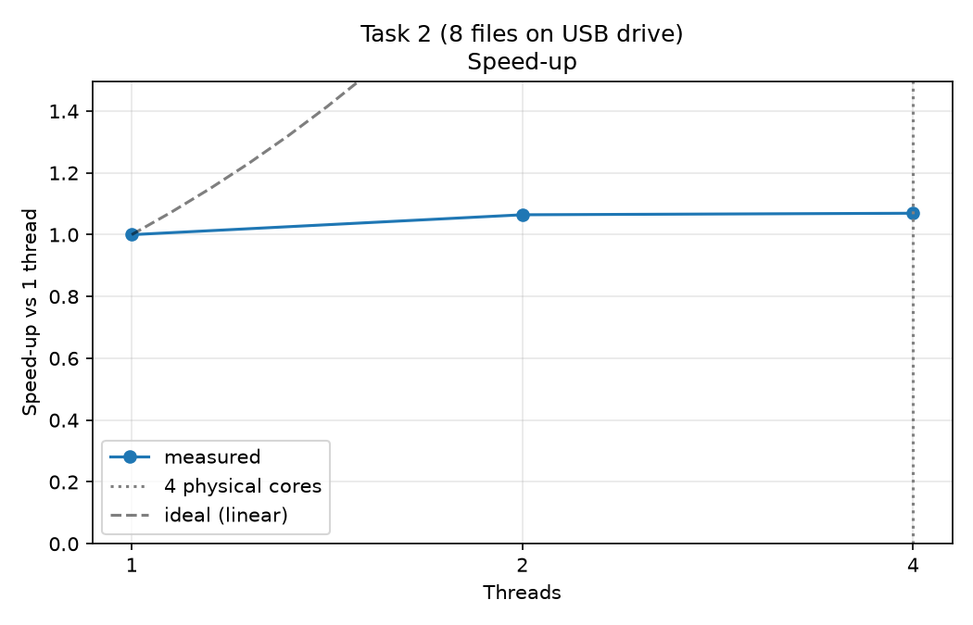
Figure 3.14 – Task 2, speed-up against the number of threads
The peak memory is shown in figure 3.15. Unlike the time, it grows with every thread added.
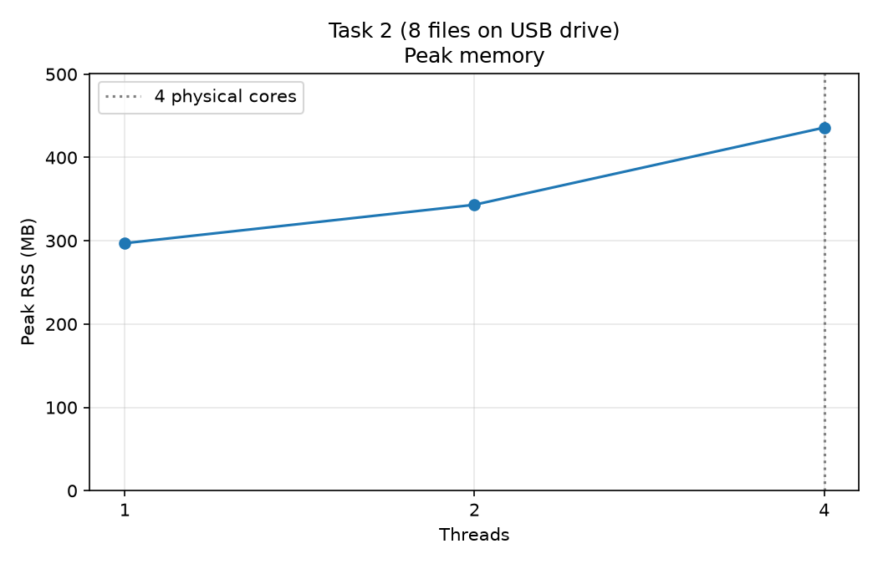
Figure 3.15 – Task 2, peak memory against the number of threads
The comparison with Task 1a on one thread is shown in figure 3.16. Both tasks parse the same 50 000 000 numbers with one thread, the first from the internal disk through the file cache and the second from the USB drive.
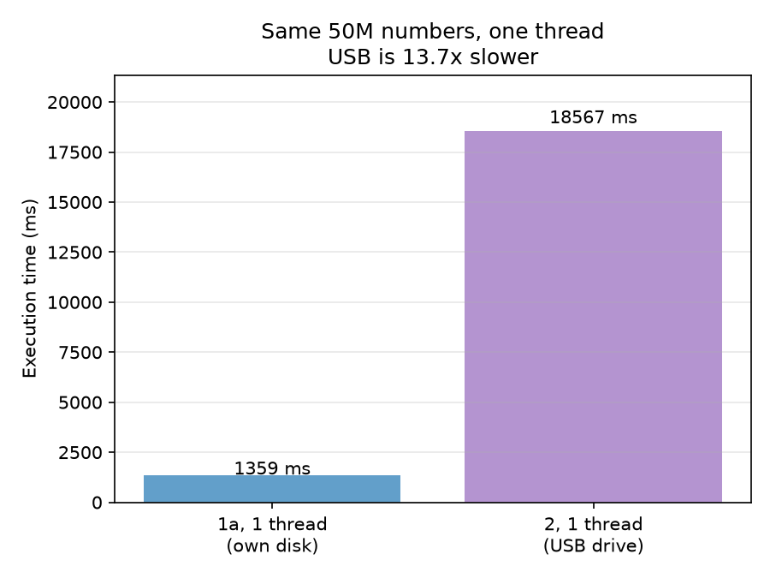
Figure 3.16 – Task 2 on the USB drive and Task 1a on the internal disk with one thread
Question 1: Compare the time on one thread with Task 1a on one thread. On the USB drive, is the work CPU-bound or I/O-bound? Support the answer with numbers. The work is I/O-bound. On one thread Task 2 took 18 567 ms and Task 1a took 1359 ms, so the same numbers took 13.7 times longer to process from the USB drive. The time of Task 1a is the cost of reading from the file cache and parsing, so the parsing cannot take more than about 1.4 s, which is at most 7 % of the time on the drive. At least 93 % of the time, about 17 s, was spent waiting for the drive. The size of numbers.txt is estimated at about 370 MB from the range of the values, which gives a throughput of roughly 20 MB/s. The USB 2.0 link has a nominal speed of 480 Mbit/s, that is 60 MB/s (table 3.1), and the measured throughput is lower than this limit. These measurements do not show whether the link or the flash memory of the drive is the slower part.
Question 2: On the USB drive, do more threads help? Why not, when lecture 1 showed that I/O-bound work benefits from concurrency? They help very little: 17 443 ms with two threads and 17 362 ms with four threads, which are speed-ups of 1.06 and 1.07. The gain of about 1.2 s is close to the parsing time of 1.4 s, so the only thing that was gained is that one thread parses while another waits for the drive. The time of reading itself does not shrink. Concurrency helps I/O-bound work when the waiting can be overlapped with other useful work, or when requests go to independent devices that can serve them at the same time, for example a server waiting for many network clients. Here there is one drive behind one USB 2.0 link, which a single sequential reader already keeps busy, so the requests of additional threads only wait in line behind each other. The additional threads also cost memory, because each of them holds a whole file of about 46 MB in a byte array, and the peak memory grows from 297 MB to 343 MB and 436 MB, that is by about 46 MB for the first additional thread and 93 MB for the next two (figure 3.15). Even with one thread the peak is high, because the eight buffers read one after another become garbage that is freed only when needed.

CONCLUSION
In the work, a Java program was written in which the tasks are selected by command-line parameters, and the counting of negative, positive and zero numbers in a file of 50 000 000 integers was measured with different numbers of threads, different ways of dividing the work and different storage [1]. The main findings are the following:
- the counting of one file that is read from the file cache is CPU-bound, because its time falls from 1359 ms to 339 ms as threads are added up to the number of logical processors;
- the speed-up of Task 1a stops growing at 8 threads with the value 4.01, which corresponds to 4 physical cores with 2 logical processors each [3];
- the threads above the number of logical processors do not help and are slower, 401 ms with 32 threads and 418 ms with 64 threads, and every additional thread of Task 1a adds about 3 MB of peak memory;
- unsynchronised shared counters lost about 78 % of the updates, the lock made the counting about 41 times slower than per-thread counters, and per-thread counters were both correct and the fastest at 57 ms;
- the producer–consumer version is limited by its single reader, so its speed-up never exceeds 1.16 and its peak memory of about 385 MB does not depend on the number of workers;
- the same numbers read from a USB 2.0 flash drive took 18 567 ms with one thread, 13.7 times longer than from the file cache, so this work is I/O-bound and more threads gave a speed-up of only 1.07.
On this machine the work of Tasks 1a and 1b was CPU-bound, which is shown by the time falling with the number of threads until the logical processors are used up. The work of Task 1c was limited by the sequential reader, and the work of Task 2 on the USB drive was I/O-bound, which is shown by the time on the drive being 13.7 times the time of the same parsing from the file cache and by the almost unchanged time with more threads. The limit of the parallel speed-up was set by the 4 physical cores and 8 logical processors in the CPU-bound case [4], by the sequential part in the producer–consumer case and by the bandwidth of the drive in the I/O-bound case.

REFERENCES
1. Laboratory Work 1: Concurrency in Practice. Course laboratory handout (PDF).
2. The Java Language Specification, Java SE 24 Edition. Chapter 17: Threads and Locks. Oracle. Available at: https://docs.oracle.com/javase/specs/jls/se24/html/jls-17.html
3. Hyper-threading. Wikipedia. Available at: https://en.wikipedia.org/wiki/Hyper-threading
4. Amdahl's law. Wikipedia. Available at: https://en.wikipedia.org/wiki/Amdahl%27s_law
5. Java Platform, Standard Edition 17 API Specification. Interface BlockingQueue. Oracle. Available at: https://docs.oracle.com/en/java/javase/17/docs/api/java.base/java/util/concurrent/BlockingQueue.html
6. proc_pid_status(5), Linux manual page. The Linux man-pages project. Available at: https://man7.org/linux/man-pages/man5/proc_pid_status.5.html

