
MINISTRY OF EDUCATION, CULTURE AND RESEARCH
OF THE REPUBLIC OF MOLDOVA
Technical University of Moldova
Faculty of Computers, Informatics and Microelectronics
Department of Software Engineering and Automation

Bruma Cristian FAF-242

Report
Laboratory Work No. 1
Software Design Techniques and Mechanisms
Topic: SOLID Principles in a Scalable Workflow Engine

Checked by:
Istrati Daniel, university assistant
DISA, FCIM, UTM

Chișinău – 2026
Table of Contents
1 AIM OF THE WORK 3
1.1 Purpose of laboratory work 3
1.2 Problem statement 3
2 THEORETICAL BACKGROUND 4
2.1 The SOLID principles and scalability 4
2.2 Single Responsibility Principle 4
2.3 Open/Closed Principle 4
2.4 Liskov Substitution Principle 5
2.5 Interface Segregation Principle 5
2.6 Dependency Inversion Principle 5
3 IMPLEMENTATION 6
3.1 Project overview 6
3.2 Project structure 6
3.3 Application of the Single Responsibility Principle 7
3.4 Application of the Open/Closed Principle 8
3.5 Application of the Liskov Substitution Principle 9
3.6 Application of the Interface Segregation Principle 9
3.7 Application of the Dependency Inversion Principle 10
3.8 Runtime behaviour and growth scenarios 10
4 RESULTS 11
4.1 Execution of the project 11
4.2 Verification of extensibility 11
4.3 Assessment of the principles 12
4.4 Limitations and possible improvements 13
CONCLUSIONS 14
SOURCE CODE 15

1 AIM OF THE WORK

1.1 Purpose of laboratory work
The purpose of the laboratory work is to study the SOLID principles of object-oriented design and to acquire practical skills in applying them while developing a software system that remains easy to extend and maintain as its functionality grows [1].
The following objectives are pursued within the work:
- to study the meaning, the motivation and the typical violations of the five SOLID principles;
- to select a problem domain in which new behaviour must be added frequently;
- to design and implement a Java project in which at least three SOLID principles are respected;
- to verify by an extension experiment that new functionality is added without modifying the existing classes;
- to assess critically the degree to which each principle is satisfied and to identify the remaining weaknesses.

1.2 Problem statement
The problem statement of the laboratory work is the implementation of a project with respect to at least 3 SOLID principles.
For this purpose, a minimal workflow automation engine named FlowForge was selected. The engine executes a configured sequence of steps whenever a named event occurs. The set of steps and of event consumers is open-ended, which makes the domain suitable for checking whether a design is scalable. The solution is required to satisfy the criteria listed below, which are verified in chapter 4:
a) at least three SOLID principles are applied and justified with concrete fragments of code;
b) a new action is introduced without modifying any existing class of the engine;
c) a new event consumer is introduced without modifying the event bus;
d) every class has a clearly defined responsibility and depends on abstractions where variation is expected.

2 THEORETICAL BACKGROUND

2.1 The SOLID principles and scalability
SOLID is an acronym that groups five principles of object-oriented design: Single Responsibility, Open/Closed, Liskov Substitution, Interface Segregation and Dependency Inversion. The principles were formulated and popularised by Robert C. Martin [1], [2]. Their shared goal is to keep the cost of changing a system low while the system grows.
A design that ignores the principles usually degrades in three ways: it becomes rigid, because one change forces many others; fragile, because a change breaks seemingly unrelated parts; and immobile, because useful parts cannot be reused outside their original context [1]. A scalable project avoids this degradation by adding functionality through new code instead of editing code that already works. The SOLID principles describe how classes have to be organized to make such growth possible, and they are summarized in table 2.1.
Table 2.1 – Summary of the SOLID principles
Principle | Formulation | Typical symptom of violation
SRP – Single Responsibility | A class has only one reason to change. | One class is edited for several unrelated requirements.
OCP – Open/Closed | Entities are open for extension and closed for modification. | A conditional on the object type is edited for every new variant.
LSP – Liskov Substitution | A subtype can be used wherever its supertype is expected. | Overriding methods throw “not supported” or callers test the concrete type.
ISP – Interface Segregation | Clients do not depend on methods they do not use. | Implementations contain empty or artificial methods.
DIP – Dependency Inversion | High-level and low-level modules depend on abstractions. | Business rules instantiate concrete low-level classes directly.

2.2 Single Responsibility Principle
The Single Responsibility Principle states that a class should have only one reason to change [1]. A responsibility is understood as a reason for change that originates from a single concern. When one class combines several concerns, for example data storage, business rules and output formatting, a modification of any of them requires editing and retesting the same class, and the risk of side effects grows with every change. Classes with a single responsibility are small, cohesive and easy to test, and they can be replaced independently of each other.

2.3 Open/Closed Principle
The Open/Closed Principle was introduced by Bertrand Meyer, who stated that software entities should be open for extension but closed for modification [3]. In the form adopted by modern object-oriented languages, the principle is realized through abstraction: client code is written against an interface or an abstract class, and new behaviour is supplied by writing a new implementation of that abstraction [1]. The client then remains unchanged and does not have to be retested. A frequent symptom of violation is a conditional statement that selects behaviour according to the type of an object and has to be extended each time a new variant appears.

2.4 Liskov Substitution Principle
The Liskov Substitution Principle requires that objects of a subtype can be used wherever objects of the supertype are expected, without altering the desirable properties of the program [4]. In practice this means behavioural compatibility and not only matching method signatures: a subtype must not strengthen the preconditions of the supertype, must not weaken its postconditions and must preserve its invariants. Typical violations are overriding methods that throw an exception such as “operation not supported” and client code that checks the concrete type of an object before using it.

2.5 Interface Segregation Principle
The Interface Segregation Principle states that clients should not be forced to depend on methods that they do not use [1]. Large interfaces that serve several kinds of clients are therefore split into small interfaces, each oriented to one role. Besides lowering coupling, small interfaces keep implementations simple, because no class has to provide empty or artificial methods. In Java, an interface with exactly one abstract method is a functional interface and can be implemented by a lambda expression, which removes the need for a separate named class [5].

2.6 Dependency Inversion Principle
The Dependency Inversion Principle has two parts: high-level modules should not depend on low-level modules, as both should depend on abstractions, and abstractions should not depend on details, as details should depend on abstractions [1]. High-level modules contain the rules of the application, whereas low-level modules perform concrete work such as printing, storing or sending data. When the rules refer only to abstractions, the concrete work can be exchanged without touching the rules. Concrete objects are created and connected in a single place near the entry point of the program, usually by passing them to constructors [2].
The five principles complement each other: the Open/Closed Principle states the goal, while the Liskov Substitution, Interface Segregation and Dependency Inversion Principles provide the means to reach it.

3 IMPLEMENTATION

3.1 Project overview
The project developed in the laboratory work is named FlowForge and represents a minimal workflow automation engine. The engine follows the rule “when an event occurs, execute a configured sequence of steps”, which is the idea behind commercial automation services. The domain was selected because the set of steps and of event consumers is open-ended: at present the engine prints a message, but later it may write a file or call a web service. A design that requires editing the engine for every new step does not scale, so the domain is a suitable test for the SOLID principles.
The engine is built from five concepts:
- an action is a single executable step;
- a workflow is a named and ordered sequence of actions;
- a context is a collection of key-value data shared by the actions of one run;
- an event listener is a consumer of events;
- an event bus stores the listeners and delivers published events to them.
The project is written in Java 17 and built with Apache Maven [6], and JUnit 5 is declared as a test dependency in the file pom.xml. The code base contains seven source files with about one hundred lines, so every principle can be examined directly in the code. In the listings of this chapter, the package and import declarations are omitted.

3.2 Project structure
The classes are grouped by role into three packages, actions, core and events, located under com.example.FlowForge. The role of each type is presented in table 3.1.
Table 3.1 – Types of the project
Package | Type | Kind | Role
actions | Action | interface | Contract of a single executable step
actions | LogAction | class | Prints a message to the standard output
core | Workflow | class | Named and ordered sequence of actions
core | Context | class | Key-value data shared during one run
events | EventListener | interface | Contract of an event consumer
events | EventBus | class | Stores listeners and delivers published events
root | App | class | Entry point that creates and connects the objects

The relations between the types are shown in figure 3.1. The engine classes communicate through two abstractions, Action and EventListener, while the concrete class LogAction is referenced only by the class App.
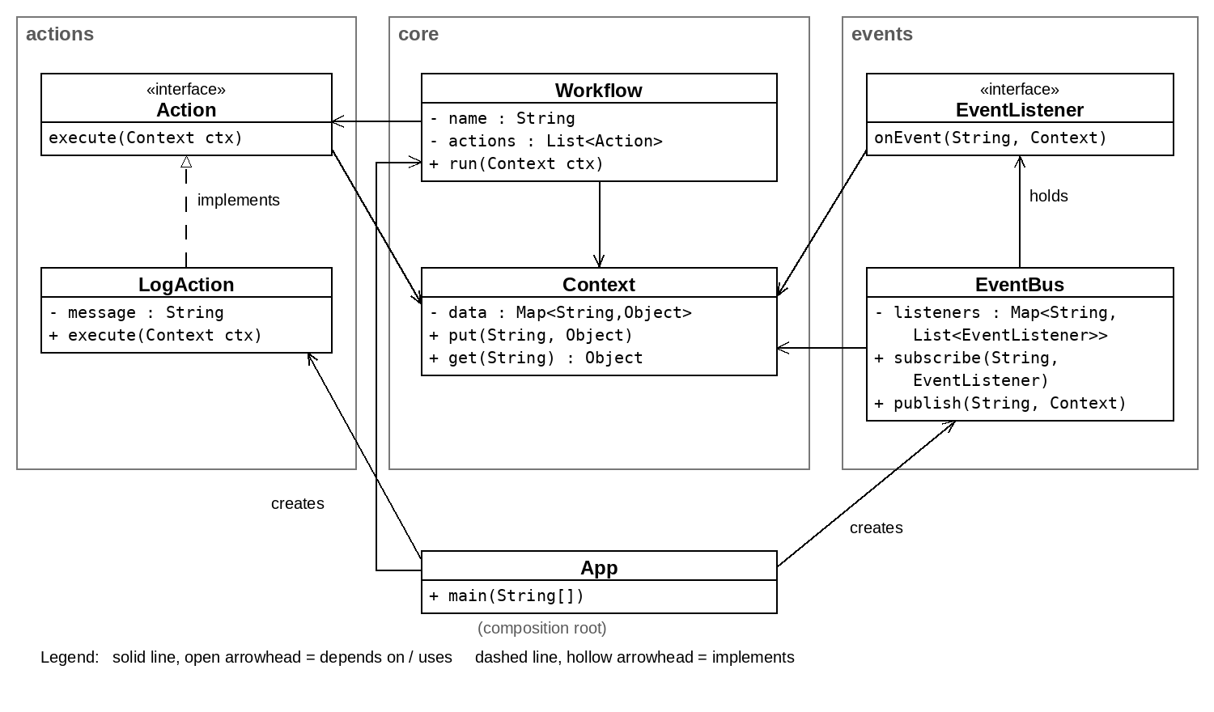
Figure 3.1 – Class diagram of the project

3.3 Application of the Single Responsibility Principle
Each class of the project was given one reason to change. The responsibilities are listed in table 3.2.
Table 3.2 – Responsibilities of the classes
Class | Responsibility | Reason to change
Context | Holds the data shared by the actions of one run | The way shared data is stored or accessed changes
Workflow | Executes its actions in the given order | The rule of execution changes
LogAction | Writes one message | The format or destination of the message changes
EventBus | Maintains subscriptions and delivers events | The rule of event delivery changes
App | Creates the objects and starts the program | The configuration of the application changes

The class Context is the simplest example. It stores and returns values and contains no logic related to actions or events:
public class Context {
private final Map<String, Object> data = new HashMap<>();
public void put(String k, Object v) { data.put(k, v); }
public Object get(String k) { return data.get(k); }
}
Because the storage is isolated in this class, a change of the storage mechanism affects no other class. In the same way, EventBus does not know what a listener does, and Workflow does not know what an action does; both only coordinate. The class Workflow additionally prints the line “Running …” to the standard output, which is a minor deviation from the principle analysed in section 4.4.

3.4 Application of the Open/Closed Principle
The Open/Closed Principle is applied at two extension points of the engine. The first one is the interface Action, which is implemented by LogAction:
public interface Action {
void execute(Context ctx);
}

public class LogAction implements Action{
private final String message;

public LogAction(String message) {
this.message = message;
}

@Override
public void execute(Context ctx) {
System.out.println("[LOG]" + message);
}
}
The class Workflow stores a list of Action objects and calls the method execute of each of them, without knowing their concrete types:
public class Workflow {
private final String name;
private final List<Action> actions;

public Workflow(String name, List<Action> actions) {
this.name = name;
this.actions = actions;
}

public void run(Context ctx) {
System.out.println("Running " + name);
actions.forEach(a -> a.execute(ctx));
}
}
Since Workflow refers only to the interface, a new kind of step is added by writing a new class that implements Action, and Workflow is neither modified nor recompiled for this purpose. The second extension point is the interface EventListener. The class EventBus keeps the listeners in a map indexed by the event name and calls them when an event is published:
public class EventBus {
private final Map<String, List<EventListener>> listeners = new HashMap<>();

public void subscribe(String type, EventListener l) {
listeners.computeIfAbsent(type, k -> new ArrayList<>()).add(l);
}

public void publish(String type, Context ctx) {
listeners.getOrDefault(type, List.of()).forEach(l -> l.onEvent(type, ctx));
}
}
A new consumer of an event is added by calling subscribe with a new listener, and the class EventBus remains unchanged.

3.5 Application of the Liskov Substitution Principle
The contract of the interface Action can be stated as follows: the method execute receives a non-null context, performs one step and returns normally. The class LogAction respects this contract, because it accepts any context, does not require particular keys to be present, does not modify the context and declares no additional checked exceptions. For this reason, the loop in the method run of Workflow treats every action uniformly and contains no check of the concrete type.
The same reasoning holds for listeners: any implementation of EventListener, including a lambda expression, can be registered in the bus and is called in the same way. The contract is currently implicit, because it is not documented in the interfaces. Documenting it is recommended in section 4.4, so that future implementations can be verified against it.

3.6 Application of the Interface Segregation Principle
Both abstractions of the project are narrow: Action declares a single method, execute, and EventListener declares a single method, onEvent:
public interface EventListener {
void onEvent(String eventType, Context ctx);
}
A class that takes part in a workflow implements one method and nothing else. The benefit becomes visible in comparison with a hypothetical interface that would combine execution, subscription and serialization of steps, because every action would then be obliged to implement methods that are irrelevant to it. Since EventListener has exactly one abstract method, it is a functional interface [5], and a consumer can be written as a lambda expression, as in the class App presented in the next section.

3.7 Application of the Dependency Inversion Principle
The classes that contain the rules of the engine depend on abstractions: Workflow depends on Action, and EventBus depends on EventListener. The concrete class LogAction is referenced only in the entry point of the program, which creates the objects and connects them:
public class App {
public static void main(String[] args) {
EventBus bus = new EventBus();
Workflow wf = new Workflow("hello-flow",
List.of(new LogAction("Step 1"), new LogAction("Step 2")));

bus.subscribe("USER_SIGNUP", (type, ctx) -> wf.run(ctx));
bus.publish("USER_SIGNUP", new Context());
}
}
The class App is the single place where concrete classes are chosen. The workflow receives its actions through the constructor, and the listener, written as a lambda expression, receives the workflow from the surrounding code. As a result, replacing LogAction with another implementation of Action requires a change in App only. The inversion of dependencies is not complete: Workflow and EventBus still depend on the concrete class Context, as discussed in section 4.4.

3.8 Runtime behaviour and growth scenarios
At run time the engine behaves as follows. The class App creates the event bus and the workflow and subscribes a listener to the event USER_SIGNUP. When this event is published together with a context, the bus calls every listener registered for that event name. The listener passes the context to the workflow, and the workflow calls the method execute of each action in the order of the list. All actions of one run receive the same context object, which makes it possible for an action to read data written by a previous one.
The described structure allows the engine to grow in several independent directions, which are listed in table 3.3. None of them requires a change in the classes Workflow, EventBus, Action or EventListener. The first two scenarios were realized in the experiment of section 4.2, and the remaining ones were not implemented in the project and are presented as an analysis of the design.
Table 3.3 – Growth scenarios of the engine
Scenario | Required change | Classes modified
New kind of step, for example writing a file | New class that implements Action | App only
New consumer of an event | New lambda expression or class that implements EventListener | App only
New source of events | New code that calls the method publish of the bus | None of the engine classes
Different order of steps | Different list passed to Workflow | App only

4 RESULTS

4.1 Execution of the project
The project was compiled and executed from its unmodified sources. The program creates an event bus and a workflow named hello-flow that contains two LogAction objects, subscribes the workflow to the event USER_SIGNUP and publishes this event. The console output is presented in figure 4.1.
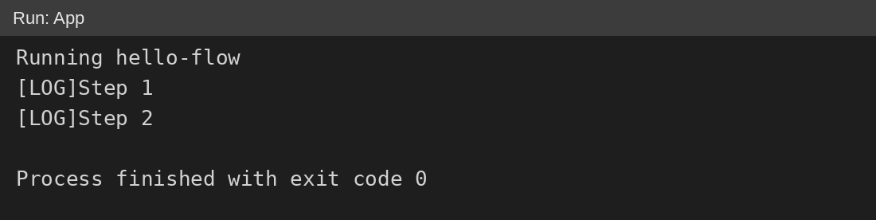
Figure 4.1 – Console output of the project
The first line is produced by the method run of Workflow, and the next two lines are produced by the two LogAction objects in the order in which they were passed to the workflow. The output shows that the event published to the bus reached the workflow through the listener and that the actions were executed in sequence.

4.2 Verification of extensibility
To verify the Open/Closed and Liskov Substitution principles experimentally, an experimental copy of the project was extended with a new action and a new event consumer. The new action, UppercaseLogAction, implements the interface Action:
public class UppercaseLogAction implements Action {
private final String message;

public UppercaseLogAction(String message) {
this.message = message;
}

@Override
public void execute(Context ctx) {
System.out.println("[LOG-UPPER] " + message.toUpperCase());
}
}
In the class App, the new action replaced the second action of the workflow, and a second listener that prints an audit line was subscribed to the same event:
List.of(new LogAction("Step 1"), new UppercaseLogAction("Step 2")));

bus.subscribe("USER_SIGNUP", (type, ctx) -> wf.run(ctx));
bus.subscribe("USER_SIGNUP", (type, ctx) -> System.out.println("[AUDIT] event received: " + type));
The result of the execution is shown in figure 4.2.
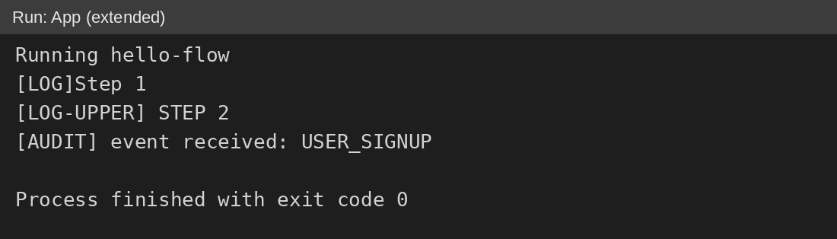
Figure 4.2 – Console output of the extended project
The output contains the line produced by the new action in the second position and the audit line of the new listener, which is printed after the lines of the workflow because listeners are called in the order of subscription. Both extensions work, and Workflow treats the new action exactly as LogAction. The source files before and after the extension were compared by their SHA-256 hashes, and the results are given in table 4.1.
Table 4.1 – Files affected by the extension
File | Package | Result
Action.java | actions | Identical
LogAction.java | actions | Identical
Workflow.java | core | Identical
Context.java | core | Identical
EventListener.java | events | Identical
EventBus.java | events | Identical
App.java | root | Modified (entry point)
UppercaseLogAction.java | actions | Added

Only the entry point was modified, which corresponds to the dependency structure of the project: the classes Workflow, EventBus, Action, EventListener, Context and LogAction remained unchanged.

4.3 Assessment of the principles
The results were compared with the criteria a)–d) of section 1.2. Criteria b) and c) were confirmed experimentally in section 4.2, criterion a) by the analysis of chapter 3, and criterion d) by table 3.2 and figure 3.1. The assessment of each principle is summarized in table 4.2.
Table 4.2 – Assessment of the SOLID principles
Principle | Evidence in the project | Assessment
SRP | Every class has one reason to change (table 3.2), but Workflow also prints a status line. | Largely satisfied
OCP | A new action and a new listener were added without modifying Workflow or EventBus (table 4.1). | Satisfied
LSP | LogAction and UppercaseLogAction are interchangeable in Workflow, but the contract is implicit. | Satisfied
ISP | Action and EventListener declare one method each. | Satisfied
DIP | Workflow and EventBus depend on abstractions, but both depend on the concrete Context. | Partially satisfied

Consequently, all four criteria are met, with the limitations listed in section 4.4.

4.4 Limitations and possible improvements
The analysis revealed several weaknesses that do not prevent the project from meeting the requirements, but that should be corrected before the project grows:
- the method run of Workflow writes directly to the standard output, which mixes orchestration with presentation;
- Workflow, EventBus and the actions depend on the concrete class Context instead of an abstraction;
- the packages core and actions depend on each other, because Workflow imports Action and Action imports Context;
- the method get of Context returns Object, so callers must cast the result;
- the contract of Action and EventListener, including the expected behaviour in case of an error, is not documented.
The following improvements would raise the Dependency Inversion and Single Responsibility principles from partial to full compliance:
- to introduce an interface for the context and place it in a separate package;
- to pass an output abstraction to Workflow through its constructor;
- to document the contract of both interfaces with Javadoc comments.

CONCLUSIONS
In the laboratory work, the FlowForge project, a minimal workflow automation engine, was implemented with respect to the SOLID principles. The project consists of seven source files grouped into three packages, and the engine classes communicate through two narrow abstractions, Action and EventListener.
The analysis showed that the Open/Closed, Liskov Substitution and Interface Segregation principles are satisfied, the Single Responsibility Principle is largely satisfied, and the Dependency Inversion Principle is satisfied partially, because the concrete class Context is still referenced directly. The requirement of the problem statement, which is the respect of at least three SOLID principles, is therefore fulfilled.
The extension experiment confirmed the scalability of the design: a new action and a new event consumer were added by writing one new class and changing two lines of the entry point, while the six remaining source files stayed identical. The cost of adding new behaviour is thus limited to the new class and the entry point, and this property is the main practical result of the work.
The limitations identified in section 4.4 define the direction of further development. The most valuable step is to hide the context behind an interface, which would also remove the cyclic dependency between the packages.
The sources used in the work are listed below.
[1] R. C. Martin, Agile Software Development, Principles, Patterns, and Practices. Upper Saddle River, NJ, USA: Prentice Hall, 2003.
[2] R. C. Martin, Clean Architecture: A Craftsman’s Guide to Software Structure and Design. Boston, MA, USA: Prentice Hall, 2017.
[3] B. Meyer, Object-Oriented Software Construction, 2nd ed. Upper Saddle River, NJ, USA: Prentice Hall, 1997.
[4] B. H. Liskov and J. M. Wing, “A behavioral notion of subtyping,” ACM Transactions on Programming Languages and Systems, vol. 16, no. 6, pp. 1811–1841, Nov. 1994.
[5] Oracle, “Lambda Expressions,” The Java Tutorials. [Online]. Available: https://docs.oracle.com/javase/tutorial/java/javaOO/lambdaexpressions.html
[6] Apache Software Foundation, “Apache Maven Project.” [Online]. Available: https://maven.apache.org/

SOURCE CODE
The complete source code of the project is available in the GitHub repository:
https://github.com/Makday/TMPS_labs

