Ministerul Educaţiei și Cercetării al Republicii Moldova Universitatea Tehnică a Moldovei
Facultatea Calculatoare, Informatică și Microelectronică

Laboratory work 2:

Study and empirical analysis of sorting algorithms.

Elaborated:
st. gr. FAF-242 Bruma Cristian

Verified:
asist. univ. Fiștic Cristofor

Chişinău - 2026
TABLE OF CONTENTS

ALGORITHM ANALYSIS 3

Objective 3
Tasks 3
Theoretical Notes: 3
Introduction: 4
Comparison Metric 4
Input Format: 4

IMPLEMENTATION 5

QuickSort: 5
MergeSort: 6
HeapSort: 8
RadixSort: 11

CONCLUSION 13

ALGORITHM ANALYSIS

Objective
Study and analyze different algorithms for sorting, particularly quickSort, mergeSort, heapSort, radixSort.

Tasks:
- Implement the algorithms listed above in a programming language
- Establish the properties of the input data against which the analysis is performed;
- Choose metrics for comparing algorithms;
- Perform empirical analysis of the proposed algorithms;
- Make a graphical presentation of the data obtained;
- Make a conclusion on the work done.

Theoretical Notes:

An alternative to mathematical analysis of complexity is empirical analysis. This may be useful for: obtaining preliminary information on the complexity class of an algorithm; comparing the efficiency of two or more algorithms solving the same problem; comparing the efficiency of several implementations of the same algorithm; and obtaining information on the efficiency of implementing an algorithm on a particular computer.

In the empirical analysis of an algorithm, the following steps are usually followed:

- The purpose of the analysis is established.
- An efficiency metric is chosen — either the number of executions of a key operation or the execution time of all or part of the algorithm.
- The properties of the input data in relation to which the analysis is performed are established (data size or specific properties such as order, distribution, or repetition of elements).
- The algorithm is implemented in a programming language.
- Multiple sets of input data are generated.
- The program is run for each input data set.
- The obtained data are analyzed.

The choice of efficiency measure depends on the purpose of the analysis. If the aim is to obtain information on the complexity class or to verify the accuracy of a theoretical estimate, then counting key operations (such as comparisons or swaps) is appropriate. If the goal is to assess the behavior of a concrete implementation, then execution time is the more suitable metric.

After executing the program with the test data, the results are recorded and, for the purpose of the analysis, either synthetic quantities (mean, standard deviation, etc.) are calculated, or a graph with appropriate pairs of points — that is, problem size versus efficiency measure — is plotted.

Introduction:

Sorting is one of the most fundamental problems in computer science. It consists of rearranging a collection of elements into a defined order — most commonly ascending or descending — according to a comparison criterion. Due to its central role in data processing, database management, search optimization, and algorithm design, sorting has been extensively studied, and a wide variety of algorithms have been developed to address it.

Among the most significant comparison-based sorting algorithms are QuickSort, MergeSort, and HeapSort — all three of which belong to the class of algorithms with an average or worst-case time complexity of O(n log n). Despite sharing this theoretical bound, their behavior in practice differs considerably depending on the nature of the input data, the implementation strategy, and the hardware environment.

QuickSort, introduced by Tony Hoare in 1959, operates by selecting a pivot element and partitioning the array into two sub-arrays, recursively sorting each. It is widely used due to its excellent average-case performance and cache efficiency, though its worst-case complexity degrades to O(n²) on certain input configurations.

MergeSort, rooted in the divide-and-conquer paradigm, splits the array into halves, sorts each recursively, and then merges the sorted halves. It guarantees O(n log n) performance in all cases and is inherently stable, but requires additional memory proportional to the input size.

HeapSort leverages the heap data structure to repeatedly extract the maximum element and build the sorted array in-place. It guarantees O(n log n) in all cases and operates with O(1) auxiliary space, though its practical speed is often slower than QuickSort due to poor cache locality.

In contrast to these comparison-based algorithms stands RadixSort — a fundamentally different approach that does not compare elements against each other at all. Instead, RadixSort sorts integers by processing their digits one at a time, from least significant to most significant, grouping elements into buckets at each pass. Originally described by Herman Hollerith in the context of punch card machines in the late 19th century, it achieves a time complexity of O(n·k), where k is the number of digits in the largest value. When k is small relative to log n, RadixSort can outperform all comparison-based algorithms. However, it is limited in applicability — it requires integer or fixed-length key types, does not naturally handle negative values or floating point numbers, and exhibits poor cache behavior due to its bucket-based memory access pattern.

As mentioned previously, the performance of an algorithm can be analyzed mathematically — derived through formal reasoning — or empirically, based on experimental observations. Within this laboratory work, we will be analyzing these three algorithms empirically across multiple input data configurations.

Comparison Metric:

The comparison metric for this laboratory work will be considered the time of execution of each algorithm (T(n)) for different sizes of arrays.

Input Format:

As input, each algorithm will receive 3 sets of 30 arrays of integers with sizes equally distributed in the range [100_000, 1_000_000]. The 3 sets of arrays have different properties, more precisely:
- The first set of arrays has random elements to measure average time complexity;
- The second set of arrays has every array already sorted in an ascending order to measure the best time complexity;
- The third set of arrays has every array sorted in a descending order to measure the worst time complexity;

IMPLEMENTATION

All four algorithms will be implemented in their naïve form in C++ and analyzed empirically based on the time required for their completion. The performance graphs will be generated using Python.

QuickSort:

QuickSort was developed by Tony Hoare in 1959 and remains one of the most widely used sorting algorithms in practice. Despite having an O(n²) worst-case complexity, its average-case performance of O(n log n) combined with excellent cache locality makes it faster than most alternatives on random data. It is the basis for the default sorting implementation in many standard libraries.

Algorithm Description:

QuickSort is a divide-and-conquer algorithm. It selects a pivot element and partitions the array into two sub-arrays — elements less than the pivot and elements greater than the pivot — then recursively sorts each sub-array. The key steps are:
- Choose a pivot element (e.g. first element, random, or median-of-three)
- Partition the array so all elements smaller than the pivot are to its left, all larger to its right
- Recursively apply steps 1–2 to the left and right sub-arrays
- Base case: sub-array of size 0 or 1 is already sorted time.
Implementation:

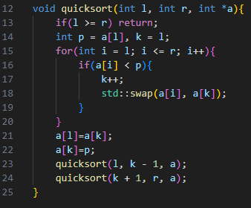
Figure 1 naive quicksort implementation in C++
In Figure 1 is represented the naive implementation of quicksort which takes a pivot the leftmost element. On a sorted or nearly sorted array, it will yield O(n²) runtime as each iteration of sorting will have to sort all of the remaining elements.

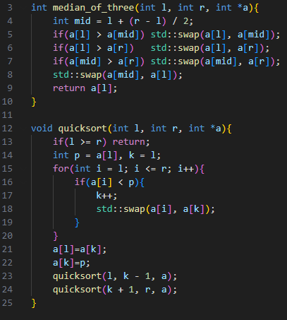
Figure 2 median of three quicksort implementation in C++
In Figure 2 is represented a better implementation of quicksort which takes a pivot the median element out of the leftmost, rightmost and middle elements. This variant improves the runtime and increases the likelihood of an O(n log n) runtime, including for sorted arrays.

Results:

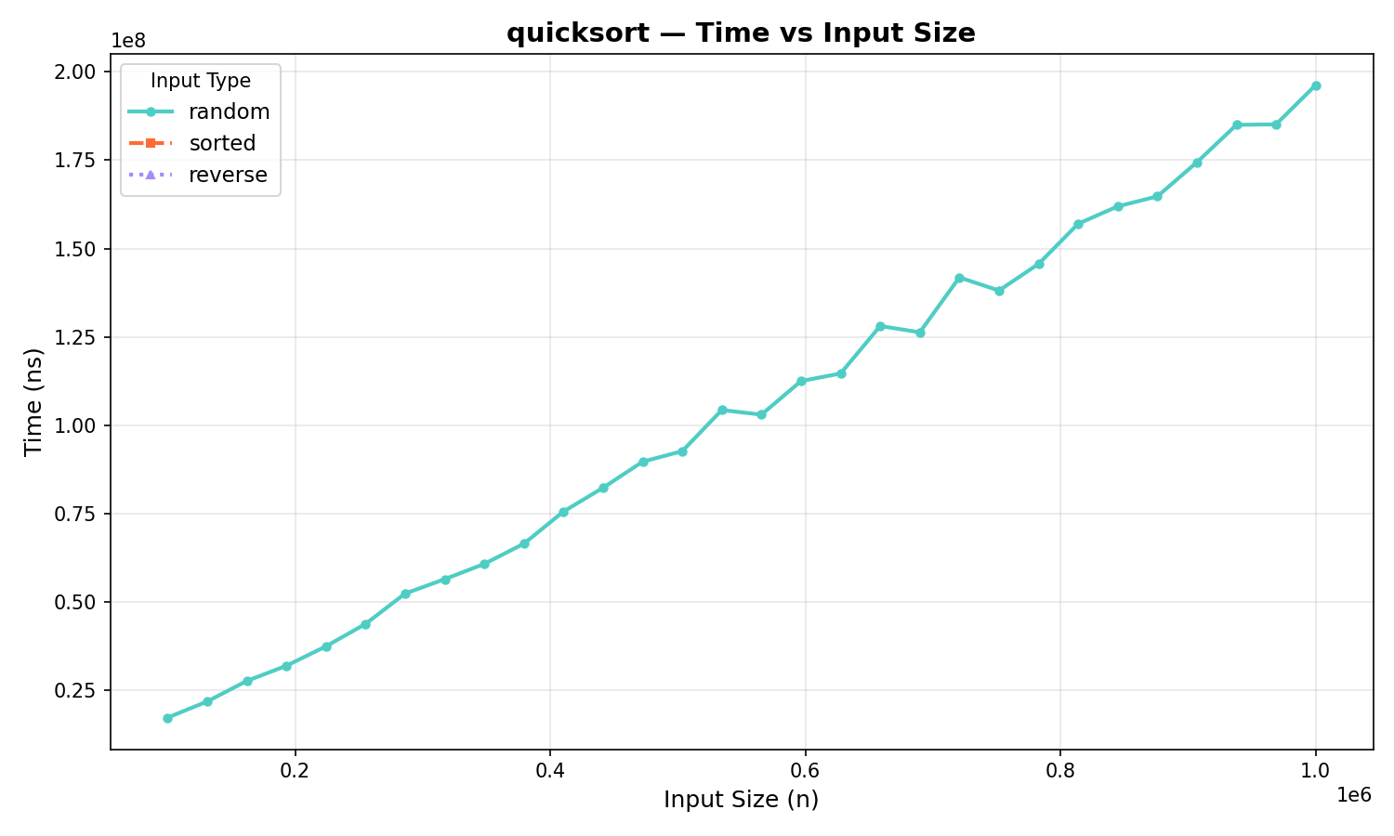
Figure 3 Naive quicksort benchmark

In Figure 3 is represented the graph of results for naive quicksort applied on all three types of arrays. As it can be seen, only the arrays with random elements could be measured, the rest of the types had an immense runtime because of the recursion depth.

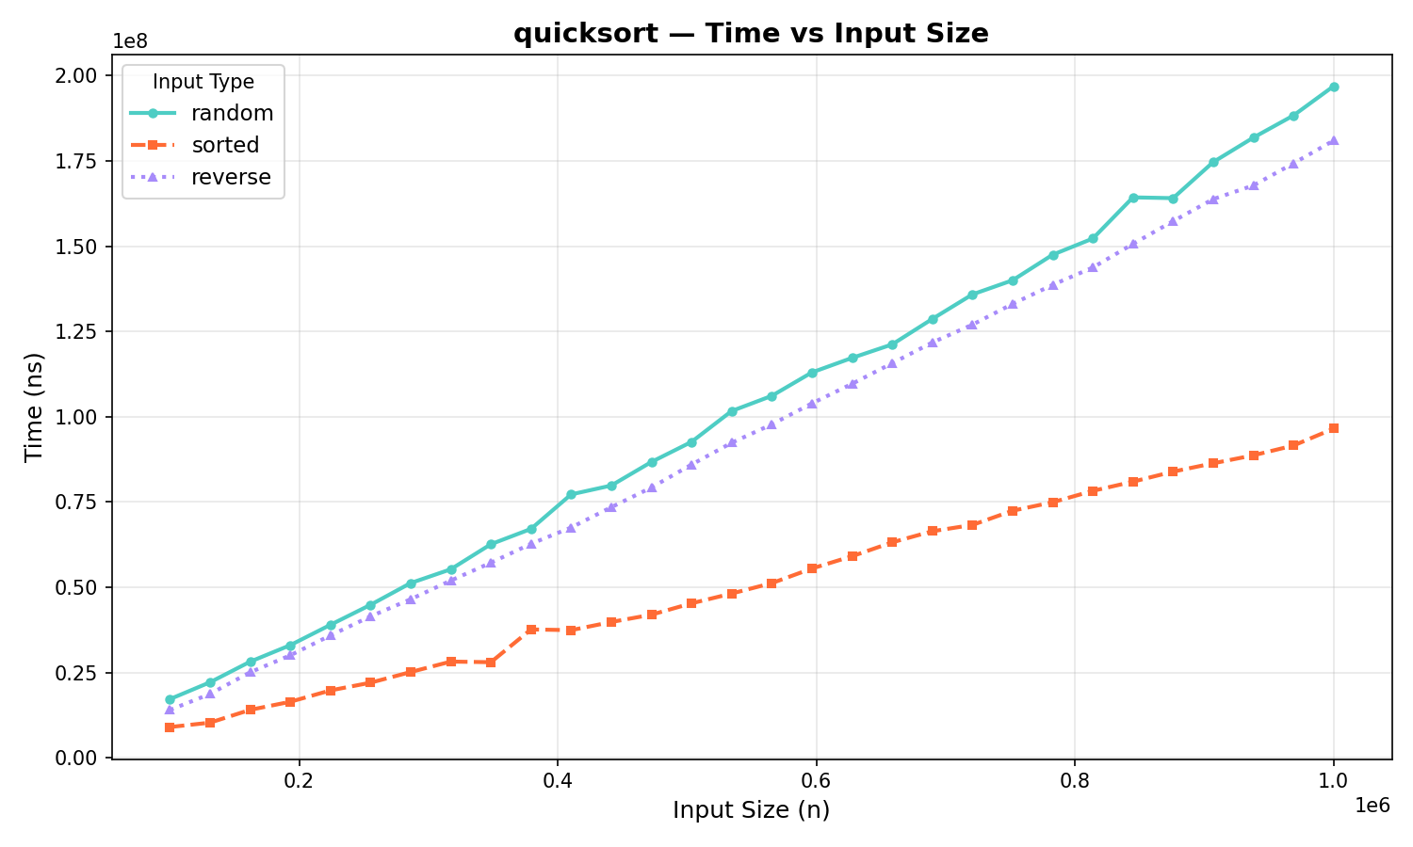
Figure 4 Improved quicksort benchmark (“median of three”)

In Figure 4 is represented the graph of results for quicksort with “median of three” strategy applied on all three types of arrays. Not only this it was possible to measure all three types of arrays but the runtime also yields a near O(n log n) time complexity.

MergeSort:

MergeSort was invented by John von Neumann in 1945. It guarantees O(n log n) time complexity in all cases — best, average, and worst — making it more predictable than QuickSort. It is also a stable sort, meaning equal elements preserve their original relative order. Its main drawback is requiring O(n) additional memory for the merge step.

Algorithm Description:
MergeSort is a divide-and-conquer algorithm that splits the array in half, recursively sorts each half, then merges the two sorted halves into one. The key steps are:
- If the array has 0 or 1 elements, return (base case)
- Split the array into two halves at the midpoint
- Recursively sort the left half
- Recursively sort the right half
- Merge the two sorted halves by repeatedly picking the smaller front element from each half into a temporary buffer, then copying back
Implementation:

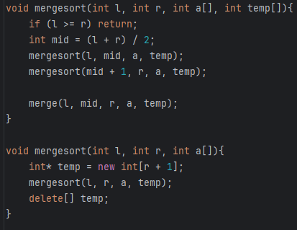
Figure 5 mergesort in C++

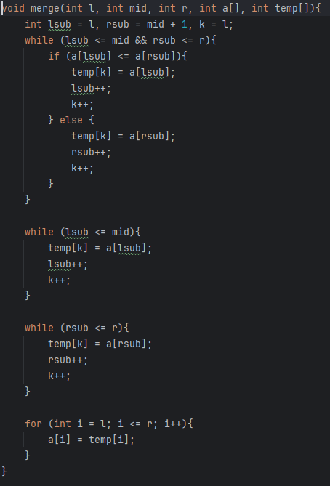
Figure 5 merging function in C++

Results: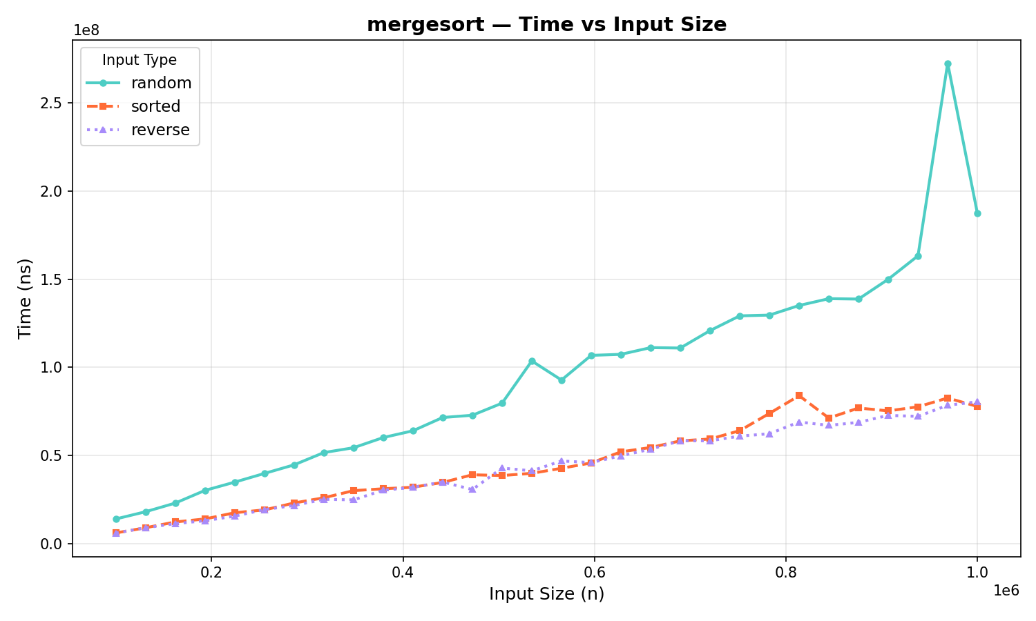
Figure 6 mergesort benchmark

In Figure 6 it can be seen that mergesort performs comparably to the quicksort algorithm. A significant difference is that mergesort yield better runtime on sorted and reversed sorted arrays, which is to be expected since mergesort has a better worst-case time complexity O(n log n).

HeapSort:

HeapSort was introduced by J. W. J. Williams in 1964. It combines the O(n log n) worst-case guarantee of MergeSort with the in-place O(1) auxiliary space of QuickSort, making it theoretically attractive. In practice however it tends to be slower than both due to poor cache locality — heap operations jump around memory non-sequentially, causing frequent cache misses.

Algorithm Description:

HeapSort uses a binary max-heap data structure — a complete binary tree where every parent is larger than its children. The algorithm operates in two phases:
- Build phase — rearrange the array into a valid max-heap in O(n) time by calling heapify on each non-leaf node from bottom to top
- Sort phase — repeatedly extract the maximum element (root of the heap) by swapping it with the last element, reducing the heap size by one, and restoring the heap property via heapify — repeated n times for O(n log n) total

Implementation:

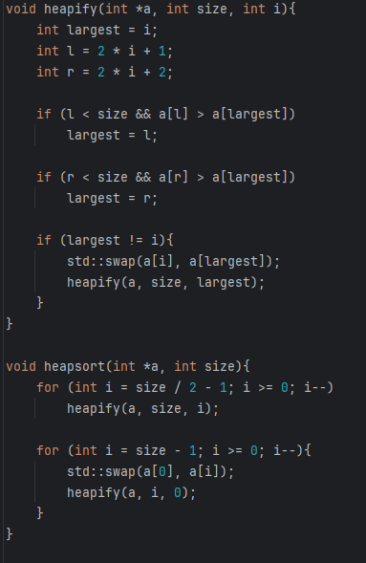
Figure 7 heapsort in C++
Results:

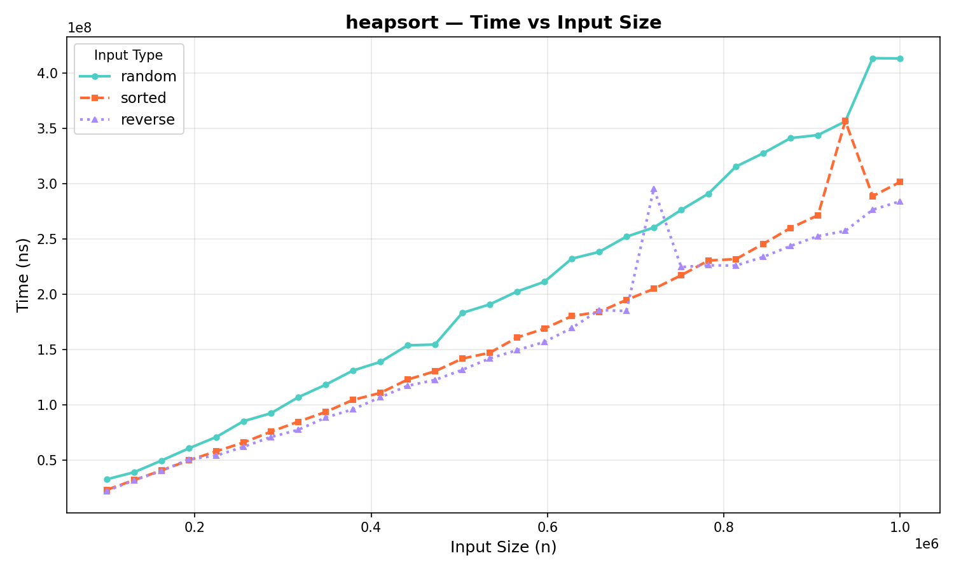
Figure 8 heapsort benchmark

In Figure 8, the graph shows a performance comparable to mergesort and quicksort. The graph certainly imitates the same shape as the previous benchmark, proving that the algorithms have similar time complexity. Although it should be noted that heapsort has weaker performance than both mergesort and quicksort.

RadixSort:

RadixSort is one of the oldest sorting algorithms, with roots tracing back to Herman Hollerith's punch card sorting machines in the 1880s. Unlike all comparison-based algorithms, RadixSort never compares two elements against each other — instead it sorts by processing individual digits or bits, one position at a time. This allows it to theoretically break the O(n log n) lower bound that limits all comparison-based sorters, achieving O(n·k) where k is the number of digits in the largest value. It is widely used in high-performance contexts such as GPU sorting, network packet processing, and database engines where keys are integers of known fixed width.

Algorithm Description:
RadixSort processes the array in k passes, one per digit position, from least significant digit (LSD) to most significant digit (MSD). At each pass it uses a stable subroutine — typically Counting Sort — to group elements by their current digit without disturbing the relative order established by previous passes. The key steps are:
- Find the maximum value in the array to determine the number of digit positions k
- For each digit position (1s, 10s, 100s, ...):
  - Count the frequency of each digit (0–9) across all elements
  - Compute cumulative counts to determine output positions
  - Place each element into its correct position in a temporary buffer
  - Copy the buffer back to the original array
- After k passes the array is fully sorted
The correctness of the algorithm relies entirely on the stability of the inner sort — because each pass preserves the ordering established by all previous passes, the final result after k passes is globally sorted.

Implementation:

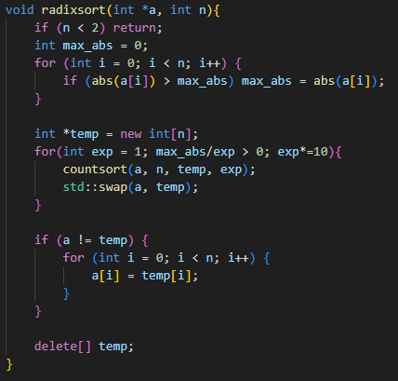

Figure 9 radixsort 10 in C++

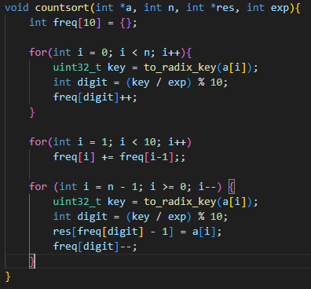

Figure 10 countsort on digits in base 10 in C++

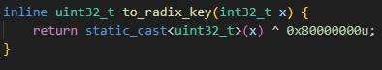

Figure 11 helper function for flipping sign bits in C++
In Figure 9 is shown the “radixsort 10” algorithm. It is called “radixsort 10” because it relies on base 10 digits. At its core, it uses countsort (Figure 10), but for digits of different significance each pass.
As mentioned, standard radixsort cannot handle negative values, for this reason, the algorithm was implement with a helper function (Figure 11), which flips the sign bits of signed integers and casts them to unsigned. In this way, the algorithm eliminates temporarily the negative values by shifting them to an unsigned domain.
Because “radixsort 10” utilizes base 10 digits for counting, it does as many iterations as there are digits in the largest element in the array. This, however, can be leveraged by using the “radixsort 256” algorithm, which instead of counting base 10 digits, utilizes byte-by-byte counting. In this way, there will be a fixed number of iterations each time, depending on the size of datatype. For int32 – 4 iterations, as it is composed of 4 bytes; for int64 – 8 iterations, as it is composed of 8 bytes.

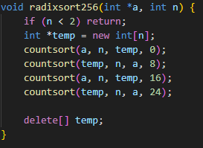

Figure 12 radixsort 10 in C++

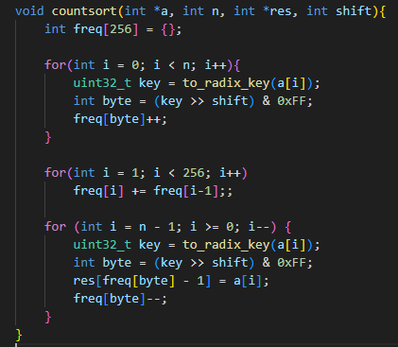

Figure 13 countsort on bytes in C++

In Figure 12 is shown the previously mentioned “radixsort 256” algorithm. The implementation benefits from the fact that the iterations happen a fixed number of times. In order to be used, the countsort function was also modified, precisely, the frequency map’s size was increased from 10 to 256, and the digit extraction was replaced with byte extraction.
Results:

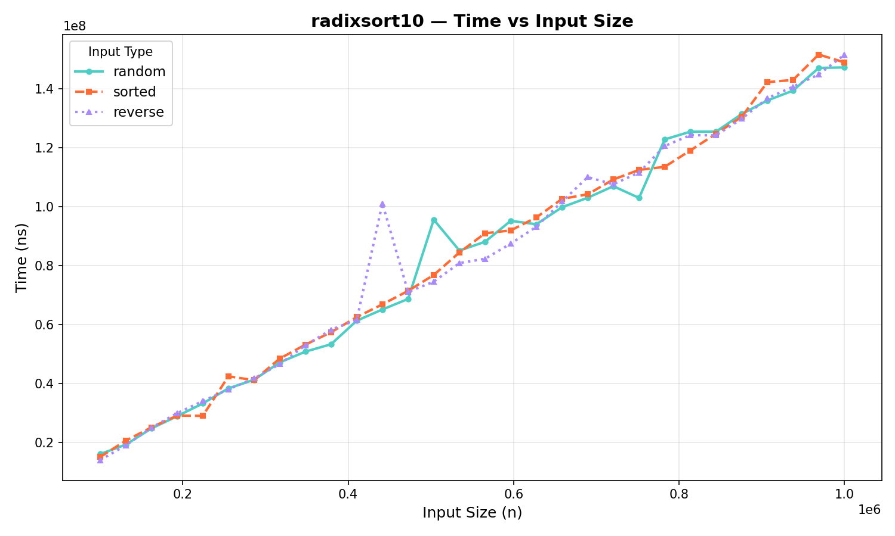
Figure 14 radixsort 10 benchmark
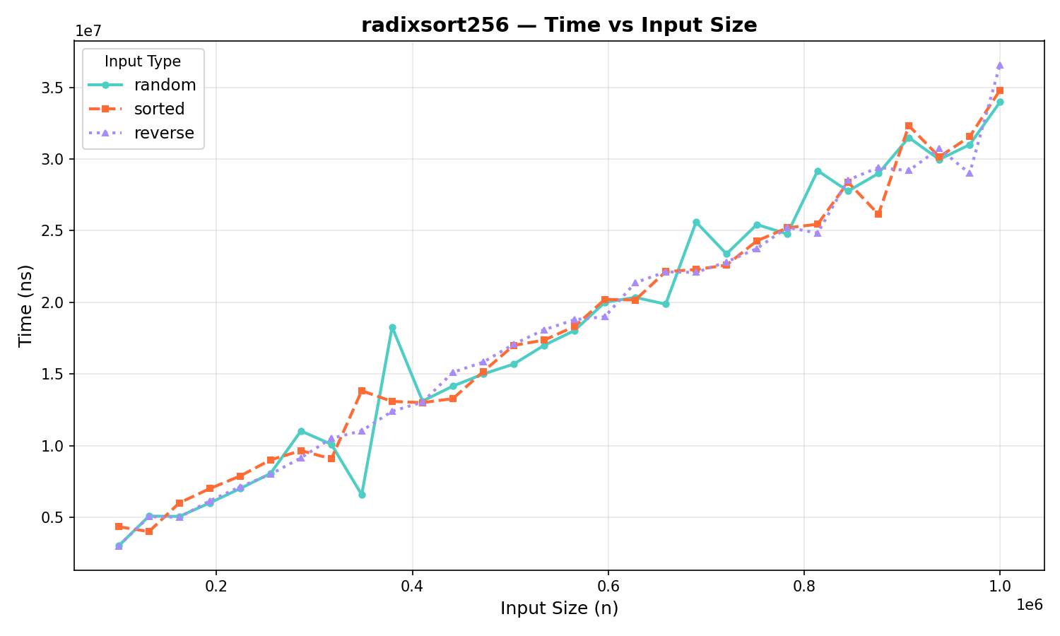
Figure 15 radixsort 256 benchmark

In Figure 15 can be seen the lower runtime of radixsort 256 compared to radixsort 10 (Figure 14). The radixsort 256 shows by far the most performant results across all algorithms analyzed. Which is to be expected, since radixsort has a time complexity of O(nk) and for large n and small k, (which in this case are
$100_000≤n≤1_000_000,k=4$), should surpass O(n log n).

CONCLUSION

This laboratory work presented an empirical analysis of four sorting algorithms — QuickSort, MergeSort, HeapSort, and RadixSort — applied across three distinct input configurations: randomly ordered, ascending sorted, and descending sorted arrays of sizes ranging from 100,000 to 1,000,000 elements.

The results confirm several theoretical expectations while also revealing important practical nuances.

QuickSort demonstrated the consequences of poor pivot selection — its naive implementation, using the leftmost element as pivot, produced O(n²) runtime on sorted and reverse sorted input, rendering it unmeasurable within practical time bounds. The median-of-three variant resolved this entirely, yielding consistent O(n log n) performance across all input types and confirming that implementation strategy has a decisive impact on real-world performance.

MergeSort proved to be the most consistent among the comparison-based algorithms, delivering stable O(n log n) performance regardless of input order. Its guaranteed worst-case complexity makes it preferable over QuickSort in scenarios where input distribution is unknown or adversarial. The cost of this predictability is the O(n) auxiliary memory requirement for the merge buffer.

HeapSort, while theoretically combining the best properties of both — O(n log n) in all cases with O(1) auxiliary space — performed the weakest among the three comparison-based algorithms in practice. This aligns with the known issue of poor cache locality inherent to heap operations, which causes frequent cache misses and degrades real-world throughput despite the favorable theoretical complexity.

RadixSort stood apart from all comparison-based algorithms entirely. Operating in O(n·k) time and bypassing element comparisons altogether, it consistently outperformed the others by a significant margin. The base-256 variant, performing exactly 4 passes for 32-bit integers regardless of data content, was the fastest algorithm tested across all input types. At n = 1,000,000 this represents approximately 4,000,000 operations versus the ~19,930,000 required by O(n log n) algorithms — a theoretical advantage of nearly 5×, which was clearly reflected in the benchmark results.

In summary, the choice of sorting algorithm is never absolute — it depends on the nature of the input, memory constraints, and implementation quality. For general-purpose use on unpredictable data, QuickSort with median-of-three is the most practical. For guaranteed worst-case performance, MergeSort is preferable. For large volumes of fixed-width integer data where raw speed is critical, RadixSort base-256 is the clear winner.

BIBLIOGRAPHY

Github repository with described implementations:

https://github.com/Makday/UTM_AA_course_2025-2026

