
MINISTRY OF EDUCATION, CULTURE AND RESEARCH
OF THE REPUBLIC OF MOLDOVA
Technical University of Moldova
Faculty of Computers, Informatics and Microelectronics
Department of Software Engineering and Automation

Cristian Bruma FAF-242
Report
Laboratory work n.5
of Operating Systems

Checked by:
Reițman Patricia, university assistant
DISA, FCIM, UTM

Chișinău – 2026
Table of Contents
1 AIM OF THE WORK 3
1.1 Purpose of practical work 3
1.2 Problem statement 3
2 THEORETICAL BACKGROUND 4
2.1 The Linux directory tree and file types 4
2.2 Inodes, hard links and symbolic links 4
2.3 Permissions, umask and special bits 4
2.4 Disks, mounting and pseudo file systems 5
3 DESCRIPTION OF EXERCISES 6
3.1 Exercise 1: The tree and the file types 6
3.2 Exercise 2: Inodes and links 7
3.3 Exercise 3: Permissions 10
3.4 Exercise 4: Disks and the kernel as files 12
CONCLUSION 14
REFERENCES 15

1 AIM OF THE WORK

1.1 Purpose of practical work
The purpose of this practical work is to examine the main concepts of a Linux file system on a real machine: the directory tree and the file types, inodes and the names that point to them, hard and symbolic links, access permissions, and the disks and kernel interfaces that stand underneath the files. Every concept is checked by running commands and by observing their output, without writing any program.

1.2 Problem statement
The work is divided into four parts. In the first part, the types of several well-known paths are determined from the output of ls -l, and the sizes of two system directories are compared. In the second part, the inode number and the link count of a file are observed, the behaviour of hard and symbolic links is compared after the original name is removed, and the difference between the size of a file and the disk space used by it is explained. In the third part, permission bits are written in numeric and symbolic form, the effect of umask is explained, the meaning of the r and x bits on directories is demonstrated, and the special bits setuid and sticky are described. In the fourth part, the layout of the disk, the usage of the root file system and the information exposed by the /proc pseudo file system are examined. All experiments are performed as a normal user, because the root user ignores most permission checks.

2 THEORETICAL BACKGROUND

2.1 The Linux directory tree and file types
Linux organises all files in a single tree that starts at the root directory /. Standard locations are defined by the file system hierarchy: /etc keeps configuration files, /dev keeps device files, /tmp keeps temporary files, /usr keeps most of the installed programs and libraries, and /var/log keeps the system logs [1]. On modern distributions /bin is no longer a separate directory but a symbolic link to usr/bin.
The kind of a file is shown by the first character of the output of ls -l [2]. The most frequent types are listed below:
- regular file, marked with -;
- directory, marked with d;
- symbolic link, marked with l;
- character device, accessed byte by byte (a terminal or /dev/null), marked with c;
- block device, accessed in blocks (a disk or a loop device), marked with b.

2.2 Inodes, hard links and symbolic links
An inode is the structure of a file system that stores everything about a file except its name: the type, the owner, the permissions, the size, the timestamps and the location of the data blocks [3]. A name in a directory is only an entry that connects a string to an inode number. The number of such entries is stored in the inode as the link count.
A hard link is one more name for the same inode. The data of the file is released only when the link count drops to zero and no process keeps the file open, so removing one name with rm does not destroy the content while another name exists. A symbolic link is a separate small file whose content is a path string. Its size is equal to the length of this path, and it breaks when the target is removed, because the path then leads nowhere [4].
Directories also have link counts. A new directory has two links: its name in the parent directory and its own . entry. Every subdirectory adds one more link through its .. entry.

2.3 Permissions, umask and special bits
Every file has an owner, a group and three sets of permission bits for the owner, the group and the others. Each set contains the read (r = 4), write (w = 2) and execute (x = 1) bits, so the mode 644 means rw-r--r-- [5]. The check is made on the process credentials, and the ownership of a file gives the right to change its mode, but it does not override the mode bits.
For a directory the bits have a different meaning: r allows listing the names stored in the directory, w allows creating and removing entries, and x allows passing through the directory to reach an entry whose name is already known. The default permissions of new files are obtained from the base mode (666 for files, 777 for directories) with the bits of umask cleared.
Three special bits exist [6]. The setuid bit makes a program run with the rights of its owner, which is shown as s in the place of the owner x. The setgid bit does the same for the group. The sticky bit, shown as t, is used on shared directories such as /tmp: everybody may create files there, but only the owner of a file may delete it.

2.4 Disks, mounting and pseudo file systems
Disks are presented to the user as block devices in /dev, for example sda, and are divided into partitions such as sda1 and sda2. A partition becomes accessible only after its file system is mounted at some directory, and the root file system is mounted at /. The file system type, such as ext4, defines how inodes and data blocks are arranged on the partition [7].
Not every file in the tree lives on a disk. The /proc directory is a pseudo file system generated by the kernel on demand, and its files expose the state of the system and of the processes, for example /proc/cpuinfo, /proc/meminfo and the directory /proc/self, which always refers to the process that is reading it [8].

3 DESCRIPTION OF EXERCISES
The exercises were performed on a Linux virtual machine as a normal user, in the working directory ~/os-lab5. The screenshots below support the answer to each question of the handout.

3.1 Exercise 1: The tree and the file types
Objective: to determine the types of files from the output of ls -l, to inspect the root of the tree and the devices, and to compare the sizes of two system directories.
Commands used: The following commands were executed:
whoami
mkdir -p ~/os-lab5 && cd ~/os-lab5
ls /
ls -ld /etc /etc/passwd /bin /dev/null /tmp
ls -l /dev | head
file /usr/bin/ls /etc/passwd /bin
du -sh /var/log 2>/dev/null ; du -sh /usr 2>/dev/null
Description: First, the command whoami was run to prove that the work is done as a normal user and not as root, as shown in figure 3.1. Then the questions of the handout were answered one by one.
Figure 3.1 – Output of whoami
For each path in the second line, what is its type according to the first letter of ls -l? The first letter of the mode string identifies the type of each path, as shown in figure 3.2 and summarised in table 3.1.
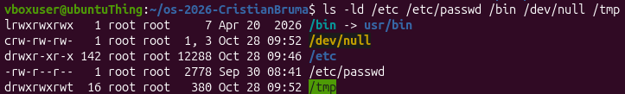
Figure 3.2 – Output of ls -ld for the selected paths
Table 3.1 – File types determined from the first letter of ls -l
String | Letter | File type
lrwxrwxrwx | l | symbolic link
crw-rw-rw- | c | character device
drwxr-xr-x | d | directory
-rw-r--r-- | - | regular file
drwxrwxrwt | d | directory
What is /bin on the system: a directory or a link, and to where? On this system /bin is not a directory but a symbolic link to usr/bin, as shown in figure 3.3.
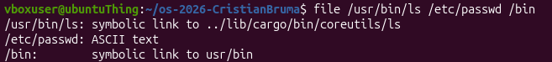
Figure 3.3 – Type of /bin determined with the file command
Which character device and which block device exist in /dev? The listing of /dev is shown in figure 3.4. The filters grep '^c' and grep '^b' select the lines that start with the letters of the character and block devices, as shown in figures 3.5 and 3.6. The character device autofs and the block device loop0 were found:
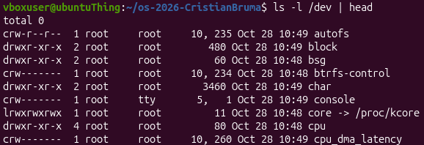
Figure 3.4 – Output of ls -l /dev
Figure 3.5 – First character device in /dev
crw-r--r-- 1 root root 10, 235 Oct 28 10:49 autofs
Figure 3.6 – First block device in /dev
brw-rw---- 1 root disk 7, 0 Oct 28 10:49 loop0
Which is bigger, /var/log or /usr, and by roughly how much? The sizes of the two directories were measured with du -sh, as shown in figure 3.7. The directory /usr is bigger than /var/log by roughly 5.3GB.
Figure 3.7 – Sizes of /var/log and /usr

3.2 Exercise 2: Inodes and links
Objective: to observe the inode number and the link count, to compare hard and symbolic links, and to explain the difference between the size of a file and the space it occupies.
Commands used: The following commands were executed:
echo hello > notes.txt
stat notes.txt
ls -li notes.txt
ln notes.txt hard.txt
ls -li notes.txt hard.txt
rm notes.txt
cat hard.txt ; ls -li hard.txt
ln -s hard.txt soft.txt
ls -li hard.txt soft.txt
cat soft.txt
rm hard.txt
cat soft.txt ; ls -l soft.txt
mkdir d ; ls -ld d
mkdir d/x d/y ; ls -ld d
echo x > one.txt ; ls -l one.txt ; du -h one.txt
truncate -s 1G big.img ; ls -lh big.img ; du -h big.img
rm big.img
Description: The answers to the questions of the handout are given below.
Which number in stat is the inode, and which tells how many names the file has? The inode number is the field Inode: 1336060, and the field Links: 1 shows how many names the file has, as shown in figure 3.8. The same inode number is printed in the first column of ls -li, as shown in figure 3.9.
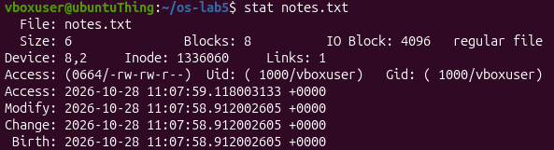
Figure 3.8 – Output of stat notes.txt
Figure 3.9 – Output of ls -li notes.txt
After rm notes.txt, why could hard.txt still be read, and what does rm really remove? The file hard.txt could still be read because rm notes.txt removed only one name of the inode and not the inode itself. The inode 1336060 stayed in place, since another name still pointed to it, as shown in figure 3.10. The command rm therefore removes a name (a directory entry) and decreases the link count, and the data is released only when the count reaches zero.
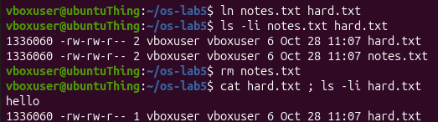
Figure 3.10 – Hard link survives the removal of the original name
Why did cat soft.txt fail, and how big is soft.txt? The command cat soft.txt failed because its target hard.txt had been removed, so the symbolic link pointed to a path that does not exist, as shown in figure 3.11. The link file itself still exists. The size of a symbolic link is the length of the path string stored in it. The target is hard.txt, which has 8 characters, so the size is 8 bytes.
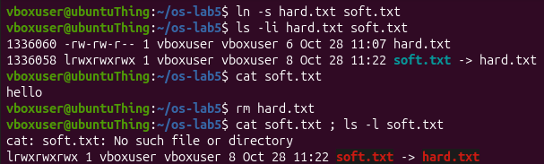
Figure 3.11 – Symbolic link after the removal of its target
Where does each link of a directory come from? The link count of a directory is the number of entries that point to its inode, as shown in figure 3.12. The empty directory d has 2 links: its name d in the parent directory and its own . entry. After d/x and d/y are created, the count is 4, because the .. entry of each subdirectory points back to d and adds one link.
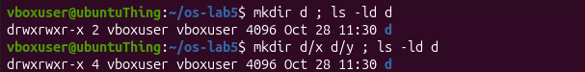
Figure 3.12 – Link count of a directory before and after creating two subdirectories
Why does a 2-byte file use 4.0K, and a 1 GB file use 0? The file one.txt occupies 4KB because this is the minimum allocation unit (block) of the file system, and a whole block is reserved even for 2 bytes. For big.img the inode records the size of 1 GB, but the blocks of zeros are never written, so the file is sparse and uses no disk space, as shown in figure 3.13.
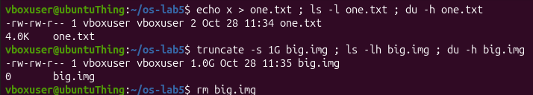
Figure 3.13 – Apparent size and disk usage of a small file and of a sparse file

3.3 Exercise 3: Permissions
Objective: to express permissions in numeric and symbolic form, to observe the role of ownership, umask and directory bits, and to explain the special bits setuid and sticky.
Commands used: The following commands were executed:
echo secret > s.txt
chmod 600 s.txt ; ls -l s.txt
chmod 000 s.txt ; cat s.txt
chmod u+r s.txt ; cat s.txt
umask ; touch new.txt ; mkdir newdir ; ls -ld new.txt newdir
mkdir box ; echo hi > box/f
chmod u=r,go= box ; ls box ; cat box/f
chmod u=x,go= box ; ls box ; cat box/f
chmod 755 box
ls -l /usr/bin/passwd ; ls -ld /tmp
cat /etc/shadow
ls -l /etc/shadow
Description: The answers to the questions of the handout are given below.
How are 600, 644, 755 and 700 written as rwx strings, and what is a real use of each? The numeric modes, their symbolic form and a typical use of each are given in table 3.2.
Table 3.2 – Numeric modes, rwx strings and typical use
Number | Means | Typical for
600 | rw- --- --- | private files: keys, passwords
644 | rw- r-- r-- | normal files: the owner edits, everyone reads
700 | rwx --- --- | private directories, ~/.ssh
755 | rwx r-x r-x | programs and directories
Why does ownership not help when the mode is 000? Ownership does not override the permission bits. With chmod 000 all three sets of bits are empty, so the owner cannot read, write or execute the file, and cat s.txt is refused, as shown in figure 3.14. The owner is still allowed to change the mode, and after chmod u+r s.txt the file can be read again.
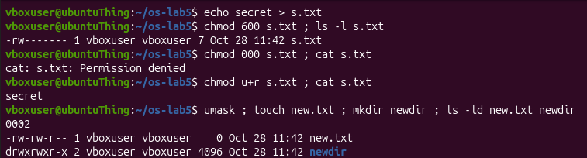
Figure 3.14 – Effect of chmod 000 and of the default umask
What is the umask, and how does it explain the permissions of new.txt and newdir? The value of umask is 0002, as shown in figure 3.14. New files start from the base mode 666, so the result is 666 - 002 = 664, which is rw-rw-r-- (new.txt). New directories start from 777, so the result is 777 - 002 = 775, which is rwxrwxr-x (newdir). In both cases only the write bit of the others is removed.
What does r allow on a directory, and what does x allow? On a directory, r allows listing the names stored in it, and x allows passing through it to reach an inode when the name is already known, as shown in figure 3.15. With only r the names can be listed but the file box/f cannot be opened. With only x the listing fails, but the file can be read by its exact name.
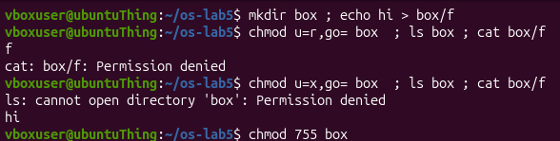
Figure 3.15 – Experiment with read-only and execute-only directory
What do the s in /usr/bin/passwd and the t in /tmp mean, and why does passwd need the s? The letter s in the place of x is the setuid bit: the program runs with the rights of its owner. The program passwd is owned by root, so it can write to /etc/shadow on behalf of a normal user who changes the password, while the user cannot read or write this file directly, as shown in figure 3.16. The letter t at the end of the mode of /tmp is the sticky bit: everyone may create files there, but only the owner of a file may delete it.
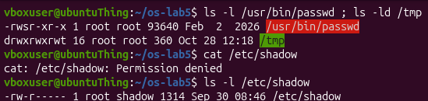
Figure 3.16 – Special bits of passwd and /tmp, and the protection of /etc/shadow

3.4 Exercise 4: Disks and the kernel as files
Objective: to examine the disk layout and the usage of the root file system, and to read system information from the /proc pseudo file system.
Commands used: The following commands were executed:
lsblk
df -h
mount | grep " / "
grep -c processor /proc/cpuinfo
head -3 /proc/meminfo
head -5 /proc/self/status
Description: The answers to the questions of the handout are given below.
What is the disk layout: disk name, partitions, the partition mounted at /, and its file system type? The disk is named sda and has two partitions, sda1 and sda2, as shown in figure 3.17. The partition /dev/sda2 is mounted at / and has the file system type ext4, as shown in figure 3.18.
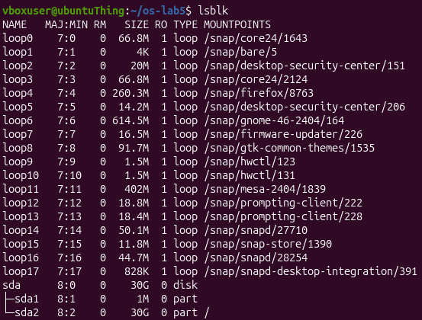
Figure 3.17 – Output of lsblk
Figure 3.18 – Mount point of the root file system
How full is the root file system? The root file system, /dev/sda2 mounted at /, has 8.7G used out of 30G, as shown in figure 3.19.
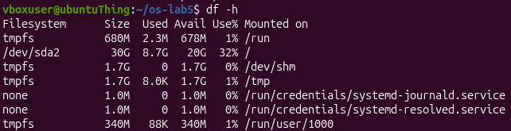
Figure 3.19 – Output of df -h
How many CPU cores and how much RAM are available according to /proc? According to /proc/cpuinfo and /proc/meminfo, the virtual machine has 2 CPU cores and about 3.4GB of RAM, as shown in figure 3.20.
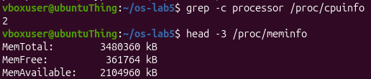
Figure 3.20 – CPU cores and memory read from /proc
Which program name did /proc/self/status show, and why that one? The file shows the name head. The path /proc/self always refers to the process that reads it, and the process that opens the file here is head, as shown in figure 3.21.
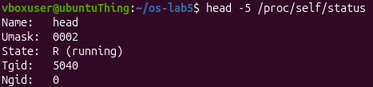
Figure 3.21 – First lines of /proc/self/status

CONCLUSION
During this work the main elements of a Linux file system were examined with ordinary commands. The types of files were read from the first letter of the output of ls -l, and it was found that /bin is a symbolic link to usr/bin, that autofs is a character device and loop0 is a block device, and that /usr is about 5.3 GB bigger than /var/log.
The experiments with inodes showed that a name is separate from the file: rm removes a name and decreases the link count, so a hard link keeps the data alive, while a symbolic link only stores a path and breaks when the target disappears. The link count of a directory was explained by the entry in the parent, the . entry and the .. entries of the subdirectories, and the difference between the apparent size and the used space was demonstrated with a small file and a sparse file.
In the part about permissions, the numeric and symbolic modes were matched, the default modes of new files and directories were explained by umask 0002, and it was confirmed that ownership does not override the mode bits. The meaning of r and x on directories, of the setuid bit of passwd and of the sticky bit of /tmp was observed in practice.
Finally, the virtual machine was found to have a disk sda with the root file system /dev/sda2 of type ext4 (8.7 GB used out of 30 GB), 2 CPU cores and about 3.4 GB of RAM, and the /proc pseudo file system was used to read this information directly from the kernel. All objectives of the practical work were achieved.

REFERENCES
1. hier(7): Description of the file system hierarchy. Linux man-pages project. Available at: https://man7.org/linux/man-pages/man7/hier.7.html
2. GNU Coreutils Manual. Free Software Foundation. Available at: https://www.gnu.org/software/coreutils/manual/coreutils.html
3. inode(7): File inode information. Linux man-pages project. Available at: https://man7.org/linux/man-pages/man7/inode.7.html
4. symlink(7): Symbolic link handling. Linux man-pages project. Available at: https://man7.org/linux/man-pages/man7/symlink.7.html
5. credentials(7): Process identifiers. Linux man-pages project. Available at: https://man7.org/linux/man-pages/man7/credentials.7.html
6. chmod(2): Change permissions of a file. Linux man-pages project. Available at: https://man7.org/linux/man-pages/man2/chmod.2.html
7. ext4 General Information. The Linux Kernel documentation. Available at: https://www.kernel.org/doc/html/latest/admin-guide/ext4.html
8. proc(5): Process information pseudo-filesystem. Linux man-pages project. Available at: https://man7.org/linux/man-pages/man5/proc.5.html

