
MINISTRY OF EDUCATION, CULTURE AND RESEARCH
OF THE REPUBLIC OF MOLDOVA
Technical University of Moldova
Faculty of Computers, Informatics and Microelectronics
Department of Software Engineering and Automation

Bruma Cristian FAF-242
Report
Laboratory work n.3
of Operating Systems

Checked by:
Reițman Patricia, university assistant
DISA, FCIM, UTM

Chișinău – 2026
Table of Contents
1 AIM OF THE WORK 3
1.1 Purpose of practical work 3
1.2 Problem statement 3
2 THEORETICAL BACKGROUND 4
2.1 Shell, built-in and external commands 4
2.2 Shell expansions and quoting 4
2.3 Redirection and command chaining 5
2.4 Pipes and text filters 5
2.5 Shell scripts 5
3 DESCRIPTION OF EXERCISES 7
3.1 Exercise 1: Move fast, find help 7
3.2 Exercise 2: What the shell does to a command line 9
3.3 Exercise 3: Redirection, chaining and jobs 11
3.4 Exercise 4: Answer questions with one-liners 14
3.5 Exercise 5: The first shell script 17
CONCLUSION 19
REFERENCES 20

1 AIM OF THE WORK

1.1 Purpose of practical work
The purpose of the practical work is to acquire the skills required for efficient work in the Bash command line interpreter on a Linux system and to understand how the shell processes a command line before executing it [1]. The work includes the following activities:
- navigation and search for help without a browser, using the built-in documentation tools;
- prediction of the transformations applied by the shell to a command line, namely expansions and quoting;
- redirection of the standard streams and chaining of commands;
- answering questions about data by means of one-line pipelines of text filters;
- creation of a first shell script.

1.2 Problem statement
The work is divided into five parts, each of them containing commands to be run and questions to be answered in the report [1]. The parts are focused on:
- the use of built-in and external commands, the PATH variable, exit codes and manual pages (part 1);
- the behaviour of the shell expansions and of the quoting on a prepared test directory (part 2);
- the redirection of the standard streams, the chaining of commands and the background jobs (part 3);
- eight questions answered with one-line pipelines applied to an artificial web access log (part 4);
- a first shell script, report.sh, which summarises the access log (part 5).
The data set for part 4 is an artificial web access log of 500 lines, generated by the commands listed below [1]. Each line of the log contains, in this order, the date, the time, the user name, the result of the request (OK or FAIL) and the requested page.
mkdir -p ~/os-lab3 && cd ~/os-lab3
for i in $(seq 1 500); do
echo "2026-10-05 10:$(printf %02d $((i % 60))) user$((i % 7)) $([ $((i % 5)) -eq 0 ] && echo FAIL || echo OK) /page$((i % 4))"
done > access.log
head -3 access.log ; wc -l access.log
The laptop was prepared in advance with the course setup script os2026-setup.sh, which installs the required packages, downloads xv6 and tests the installation [2]. All commands were run in a Linux terminal under the account vboxuser, and the deliverables of the work are the report, the script report.sh and the file oneliners.sh [1].

2 THEORETICAL BACKGROUND

2.1 Shell, built-in and external commands
The shell is a command interpreter: it reads a command line, performs the expansions on it and starts the requested program [3]. Bash is the shell used in this work.
Commands are of two kinds. A built-in command, such as cd or echo, is executed by the shell itself, while an external command, such as ls, is a program stored as a file in one of the directories listed in the PATH variable, whose entries are separated by colons [3]. The command type reveals the kind of a command, and which prints the location of an external program. The command cd must be a built-in, because the working directory is an attribute of a process: an external program would run in a child process and could change only its own directory, not the directory of the shell.
Every command returns an exit status, which is available in the special parameter $?. The value 0 means success, any other value signals a failure, and the value 127 is returned when a command is not found [4].
Help is available without a browser: man displays the manual page of a command, the option --help prints a short summary, man -k searches the manual pages by keyword, and help describes the Bash built-ins [3]. The options of ls, including the sorting by modification time, are described in the GNU Coreutils manual [5].

2.2 Shell expansions and quoting
Before a command is executed, the shell performs expansions on the command line, so the program receives only the final result [3]. The expansions relevant for this work are:
- brace expansion, which generates a sequence of words, for example {1..5};
- parameter expansion, which replaces a variable by its value, for example $HOME;
- arithmetic expansion, which evaluates an expression, for example $((7 * 6));
- command substitution, which replaces a command by its output, for example $(whoami);
- filename expansion (globbing), which replaces a pattern containing *, ? or [ ] by the list of matching file names.
Globbing is performed by the shell and not by the called program, therefore the command echo receives the already expanded list of file names. When no file matches a pattern, the pattern is passed unchanged [3]. After the expansions the shell splits the unquoted text into words at spaces, so a file name containing a space must be quoted. Three quoting mechanisms exist [3]:
- a backslash preserves the literal value of the next character;
- single quotes preserve the literal value of every character between them;
- double quotes preserve spaces and literal text, but still allow the expansion of the $ constructs.

2.3 Redirection and command chaining
Every process has three standard streams identified by file descriptors: 0 for the standard input, 1 for the standard output and 2 for the standard error [3]. The shell can redirect them with the following operators:
- the operator > writes the standard output to a file, replacing its content;
- the operator >> appends the standard output to a file;
- the operator < takes the standard input from a file;
- the operator 2> writes the standard error to a file;
- the operator 2>&1 makes the descriptor 2 a copy of the descriptor 1.
Redirections are processed from left to right, therefore their order changes the result. The special file /dev/null discards everything written to it. Several commands can be placed on one line: the operator ; runs them one after another, && runs the next command only after a success and || only after a failure [3]. A command followed by & runs in the background as a job, which can be listed with jobs and stopped with kill [3].

2.4 Pipes and text filters
The pipe operator | connects the standard output of a command to the standard input of the next one, so that small programs can be combined without temporary files [3]. The programs that read text lines and write a transformed result are called filters. The filters used in this work are:
- grep selects the lines that contain a given pattern [6];
- cut extracts fields from each line, the delimiter being set with -d and the field numbers with -f [5];
- sort orders the lines, and the option -rn produces a numeric descending order [5];
- uniq -c counts the groups of identical adjacent lines, so its input must be sorted [5];
- wc -l counts lines, while head and tail print the first and the last lines [5];
- tee copies the standard input both to a file and to the standard output [5].
The access log has five fields separated by spaces: the date, the time, the user, the result and the page. Consequently, the command cut -d' ' -f3 selects the user, cut -d' ' -f4 the result and cut -d' ' -f5 the page. The typical counting pattern is sort | uniq -c | sort -rn, which lists the values in the descending order of their frequency.

2.5 Shell scripts
A shell script is a text file containing commands. Its first line, #!/bin/bash, called shebang, names the interpreter that executes the file [3]. To be run directly, the file must have the execute permission, granted with chmod +x, and it must be called with a path, for example ./report.sh, because the current directory is usually not listed in PATH.
Inside a script the arguments are available as $1, $2 and so on, the test [ ! -f file ] checks that a file does not exist, and the for loop repeats a group of commands for each value of a list [3]. Error messages are written to the standard error with >&2, and the command exit ends the script with a chosen status; a non-zero status signals a failure to the caller [4].

3 DESCRIPTION OF EXERCISES
The exercises correspond to the five parts of the laboratory work [1]. For each exercise, the objective, the commands used and the description of the obtained results are presented; the figures are screenshots of the terminal.

3.1 Exercise 1: Move fast, find help
Objective: to determine which commands are built-in and which are external, to find the location of an executable file, to check the exit code of a missing command and to find in the manual the option of ls that sorts by modification time.
Commands used: the following commands were run in the terminal [1].
type cd ; type ls ; type echo ; which ls
echo $PATH
echo $PATH | tr ':' '\n'
nosuchprog ; echo "exit code: $?"
man ls
Description:
Which of cd, ls and echo are built-ins, and why must cd be one? The kind of each command was checked with type, as shown in figure 3.1. The result is the following:
- cd is a shell built-in;
- ls is an external command;
- echo is a shell built-in.
The command cd must be a built-in, because it changes the working directory of the shell itself.
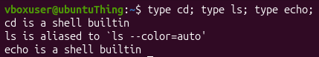
Figure 3.1 – Output of the type command for cd, ls and echo
How many directories are in PATH, and in which one is ls? According to figure 3.2, the variable PATH contains 9 directories.
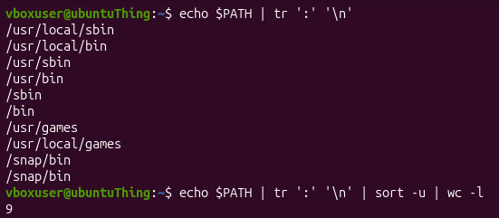
Figure 3.2 – The directories listed in the PATH variable
Figure 3.3 shows that the executable file of ls is located in /usr/bin/ls.
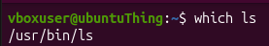
Figure 3.3 – Location of the ls executable file
What exit code does a command that is not found return? As shown in figure 3.4, the exit code of a command that is not found is 127.
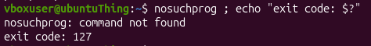
Figure 3.4 – Exit code of a command that is not found
Which option of ls sorts by modification time? According to the manual page of ls, displayed with man ls (figure 3.5), the option is -t.
Figure 3.5 – Sorting of the ls output by modification time

3.2 Exercise 2: What the shell does to a command line
Objective: to predict the transformations applied by the shell to a command line, to compare the predictions with the real output and to explain the differences.
Commands used: the test directory was created and filled with files, then the following lines were predicted and run [1].
mkdir -p ~/os-lab3/play && cd ~/os-lab3/play
touch a.c b.c file1.txt file2.txt notes.txt "alfa beta.txt"
ls
echo *.c
echo file?.txt
echo [a-b]*
echo *.xyz
ls alfa beta.txt
ls "alfa beta.txt"
echo '$HOME' "$HOME" \$HOME
echo {1..5} ; echo $((7 * 6))
echo "today is $(date +%A), I am $(whoami)"
touch log{1..3}.txt && ls log*
Description:
Predictions and real output. The files created in the directory play are shown in figure 3.6.
Figure 3.6 – Files created in the play directory
The real output of the tested command lines is presented in figure 3.7.
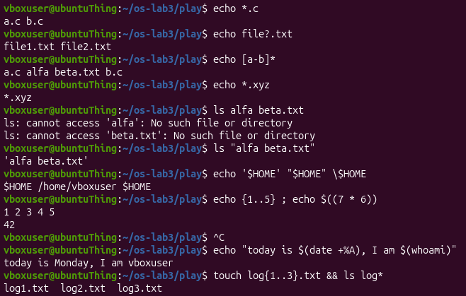
Figure 3.7 – Real output of the tested command lines
According to the data in table 3.1, the predictions were correct for six of the ten command lines, and the four differences (rows 3 to 6) are explained in the last column.
Table 3.1 – Predicted and real output of the tested command lines
Command | Prediction | Real output | Explanation (if different)
echo *.c | a.c b.c | a.c b.c | –
echo file?.txt | file1.txt file2.txt | file1.txt file2.txt | –
echo [a-b]* | a.c 'alfa beta.txt' b.c | a.c alfa beta.txt b.c | Quotes around the file name were predicted, but echo prints the name as it is.
echo *.xyz | Nothing | *.xyz | The pattern is passed unchanged when no file matches it.
ls alfa beta.txt | An error | ls: cannot access 'alfa': No such file or directory  ls: cannot access 'beta.txt': No such file or directory | The exact error message was not known in advance, but the general output was predicted correctly.
ls "alfa beta.txt" | alfa beta.txt | 'alfa beta.txt' | The command ls adds quotes around a name that contains a space.
echo '$HOME' "$HOME" \$HOME | $HOME /home/vboxuser $HOME | $HOME /home/vboxuser $HOME | –
echo {1..5} ; echo $((7 * 6)) | 1 2 3 4 5  42 | 1 2 3 4 5  42 | –
echo "today is $(date +%A), I am $(whoami)" | today is Monday, I am vboxuser | today is Monday, I am vboxuser | –
touch log{1..3}.txt && ls log* | log1.txt log2.txt log3.txt | log1.txt log2.txt log3.txt | –
Who produced the file names printed by the echo command? The names were produced by the shell, which performs globbing: the pattern *.c is replaced by the list of the matching files before echo is started (figure 3.8), so echo only prints its arguments.
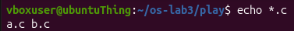
Figure 3.8 – File names produced by the shell (globbing)
Why did the command ls with the file name alfa beta.txt fail? The name of the file contains a space, so the shell split it into two arguments, alfa and beta.txt, and ls reported that neither of them exists (figure 3.9). The name can be passed as a single argument in three ways:
a) in double quotes, ls "alfa beta.txt";
b) in single quotes, ls 'alfa beta.txt';
c) with a backslash before the space, ls alfa\ beta.txt.
Variants a) and b) differ only by the type of quotes, while variant c) escapes the space character. The command ls displays the name between quotes, because GNU ls quotes the names that contain special characters when it writes to the terminal, so that the displayed name can be copied back into a command line as one argument [5].
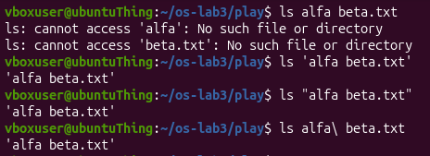
Figure 3.9 – The ls error on a name with a space and the possible fixes
What is the difference between single and double quotes? The behaviour of both types of quotes is shown in figure 3.10:
- single quotes stop every expansion, so the text is taken literally;
- double quotes keep the spaces, but the variables, for example $HOME, are still expanded.
Figure 3.10 – Single quotes, double quotes and backslash

3.3 Exercise 3: Redirection, chaining and jobs
Objective: to redirect the standard streams to files, to compare the order of redirections, to use the chaining operators and to run a background job.
Commands used: the following commands were run one by one in the terminal [1].
cd ~/os-lab3
ls /etc /nope > out.txt 2> err.txt
wc -l out.txt ; cat err.txt
ls /etc /nope > all.txt 2>&1 ; tail -2 all.txt
ls /etc /nope 2>&1 > all.txt
echo first > notes.md ; echo second >> notes.md ; cat notes.md
wc -l < access.log
ls /nope 2> /dev/null || echo "failed with code $?"
mkdir -p tmp && cd tmp && echo "I am in $(pwd)" ; cd ~/os-lab3
sleep 100 &
jobs ; kill %1 ; jobs
Description:
Which file received the error message, and which one the listing? As shown in figure 3.11, the file out.txt received the listing (standard output) and the file err.txt received the error message (standard error).
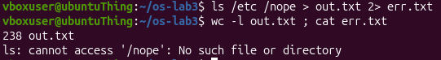
Figure 3.11 – Standard output and standard error redirected to separate files
What is the difference between > all.txt 2>&1 and 2>&1 > all.txt? Both variants were run, as shown in figure 3.12. In > all.txt 2>&1 the file descriptor 1 is first directed to all.txt and the descriptor 2 is then made a copy of it, so both streams are written to the file. In 2>&1 > all.txt the descriptor 2 is copied first, when the descriptor 1 still points to the terminal, and only afterwards the descriptor 1 is directed to the file; consequently, the error message remains on the terminal. The result differs because the redirections are processed from left to right.
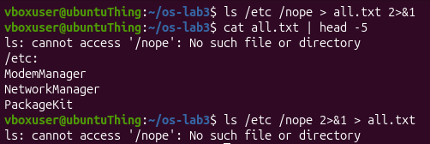
Figure 3.12 – Comparison of the order of redirections
Why does wc -l < access.log print only a number? In wc -l < access.log the shell opens access.log and connects it to the standard input of wc; since no file name is given as an argument, wc has no name to print. In wc -l access.log the program opens the file itself, knows its name and prints it after the number (figure 3.13).
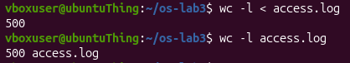
Figure 3.13 – The command wc with the file on the standard input and as an argument
What does each of the operators ; && || do? The operators were tested as shown in figure 3.14:
- the semicolon ; runs the next command regardless of the result of the previous one;
- the operator && runs the next command only if the previous one succeeded, that is, returned the exit code 0;
- the operator || runs the next command only if the previous one failed.
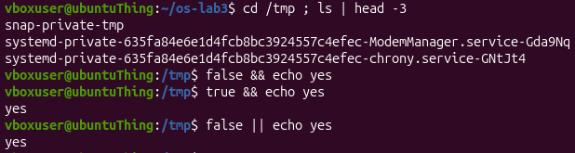
Figure 3.14 – The chaining operators ; && and ||
A background job was started with sleep 100 &, listed with jobs and stopped with kill %1, as shown in figure 3.15.
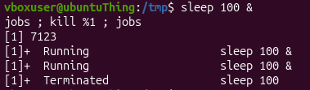
Figure 3.15 – Running a background job and stopping it

3.4 Exercise 4: Answer questions with one-liners
Objective: to answer eight questions about the file access.log and the system file /etc/passwd with one-line pipelines, each of them being saved in the file oneliners.sh under the text of the question [1].
Commands used and description: every question is answered below by one command line. All the lines are collected in the file oneliners.sh, which runs with bash oneliners.sh inside the directory ~/os-lab3.
Q1. How many requests failed? The lines that contain the word FAIL are selected by grep and counted by wc -l (figure 3.16):
grep FAIL access.log | wc -l
Figure 3.16 – Number of failed requests
The log contains 100 failed requests, which means every fifth request of the 500 generated.
Q2. How many different pages were requested, and which? The fifth field of each line is the page; the pages are sorted and counted by uniq -c, the list is shown on the screen by tee /dev/stderr, and wc -l counts the distinct pages (figure 3.17):
cut -d' ' -f5 access.log | sort | uniq -c | sort -rn | tee /dev/stderr | wc -l
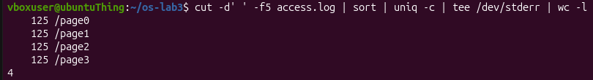
Figure 3.17 – Distinct pages and the number of requests for each page
There are 4 distinct pages: /page0, /page1, /page2 and /page3.
Q3. How many requests did each page get? The same pipeline without the final counting gives the number of requests for each page; the list is visible also in figure 3.17, because tee prints it in the previous command:
cut -d' ' -f5 access.log | sort | uniq -c | sort -rn
Each page received 125 requests, and the sum of the counts is 500, as expected.
Q4. Which user or users have the most failed requests, and how many? The failed requests are selected, the user field is cut, and the values are counted and sorted in descending order (figure 3.18):
grep FAIL access.log | cut -d' ' -f3 | sort | uniq -c | sort -rn
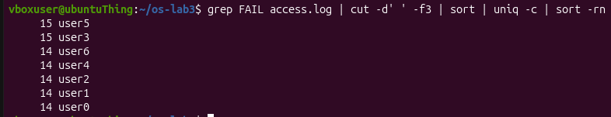
Figure 3.18 – Users with the most failed requests
The users user5 and user3 have the most failed requests, each of them with 15 failures.
Q5. How many requests did user3 make, and how many of them failed? The lines of user3 are selected, the result field is cut, and the values are counted (figure 3.19):
grep user3 access.log | cut -d' ' -f4 | sort | uniq -c
Figure 3.19 – Requests of user3 by result
The user user3 made 72 requests, distributed as follows:
- failed requests (FAIL): 15;
- successful requests (OK): 57.
Q6. Which are the last 3 failed requests, showing only the time and the user? The command tail -3 keeps the last three failed requests, and cut -d' ' -f2,3 keeps only the time and the user (figure 3.20):
grep FAIL access.log | tail -3 | cut -d' ' -f2,3
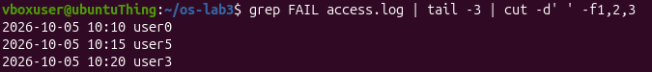
Figure 3.20 – Last three failed requests (time and user)
Q7. Which login shells appear in /etc/passwd, and how many accounts use each? The seventh field, whose separator is the colon, contains the login shell; the values are counted and sorted (figure 3.21):
cut -d: -f7 /etc/passwd | sort | uniq -c | sort -rn
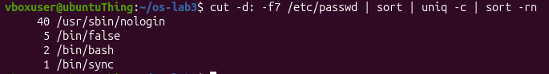
Figure 3.21 – Login shells in /etc/passwd and the number of accounts
The output lists each login shell preceded by the number of accounts that use it, in descending order.
Q8. Why do ls /etc | wc -l and ls -l /etc | wc -l differ by exactly one? The two commands are shown in figure 3.22:
ls /etc | wc -l; ls -l /etc | wc -l
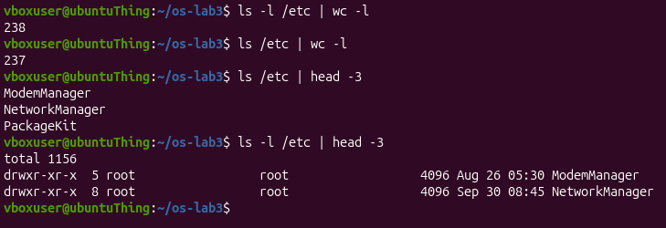
Figure 3.22 – Comparison of the line counts of ls and ls -l
The difference is caused by the long format: the command ls -l prints an additional first line, total, which gives the size of the listed files in blocks and is not a directory entry, so the second count is greater by one.

3.5 Exercise 5: The first shell script
Objective: to turn the one-liners into the script report.sh, which prints the number of requests, the number of failures and the number of failures of each user from user0 to user6, and which handles a missing log file [1].
Commands used: the script was made executable and run on the log and on a missing file.
chmod +x report.sh
./report.sh access.log
./report.sh nope.log ; echo "exit code: $?"
Description: the content of the script, including the completed loop, is listed below and shown in figure 3.23.
#!/bin/bash
# usage: ./report.sh access.log
log=$1
if [ ! -f "$log" ]; then
echo "no such file: $log" >&2
exit 1
fi
total=$(wc -l < "$log")
fails=$(grep -c FAIL "$log")
echo "$total requests, $fails failed"
for i in 0 1 2 3 4 5 6; do
n=$(grep -c " user$i FAIL " "$log")
echo "user$i: $n failures"
done
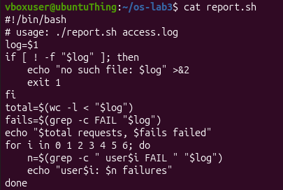
Figure 3.23 – Contents of the script report.sh
The script reads the name of the log from the first argument, $1, and ends with an error if the file does not exist. The number of lines and the number of lines with FAIL are stored in the variables total and fails. The loop for i in 0 1 2 3 4 5 6 counts, for each user, the lines that match the pattern " user$i FAIL "; the spaces around the pattern prevent partial matches.
As shown in figure 3.24, the run on access.log prints a first line with the number of requests and the number of failures, followed by one line of the form userN: X failures for each user.
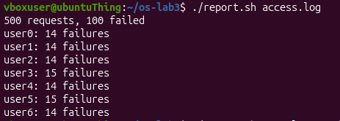
Figure 3.24 – Successful run of the script on access.log
According to figure 3.25, the run on a missing file prints the message no such file: nope.log and the exit code 1.
Figure 3.25 – Error handling for a missing log file
What does the first line #!/bin/bash do, and what happens if the script is run before chmod +x? The first line tells the system to execute the file with the interpreter /bin/bash. Without the execute permission, the attempt to run ./report.sh is refused with the message Permission denied.
Why must ./report.sh be typed and not just report.sh? The shell looks for external commands only in the directories listed in PATH, and the current directory is not among them; the prefix ./ gives the path to the file explicitly.
Why does the script write the error with >&2 and end with exit 1? The operator >&2 sends the message to the standard error, so it is separated from the regular output and can be redirected independently, while exit 1 ends the script with a non-zero status that signals the failure to the caller [3].

CONCLUSION
During the practical work the Bash command line interpreter was studied and used in five stages, and all the tasks of the laboratory handout were solved and documented with screenshots. The main results are the following:
- the commands cd and echo were identified as shell built-ins, while ls is an external program located in /usr/bin;
- the shell expands the patterns, the variables and the substitutions before the program is started, so the names printed by echo *.c are produced by the shell;
- the order of the redirections is significant, which was proved by the comparison of > all.txt 2>&1 and 2>&1 > all.txt;
- the access log of 500 requests was analysed with pipelines of filters, and the results were consistent: 4 pages with 125 requests each and 100 failed requests;
- the script report.sh summarises the log and reports a missing file through the standard error and the exit code 1.
The theoretical statements were verified against the documentation of Bash [3], the POSIX specification of the shell [4], and the manuals of GNU Coreutils [5] and GNU grep [6], which are listed in the references.

REFERENCES
1. Lab 3 – The Command Line: Shell, Pipes and Text Filters. Laboratory handout, Operating Systems, FCIM / FAF, UTM, 2026–2027, 5 October 2026 (file L3_SO.pdf).
2. Prepare Your Laptop for the Labs. Operating Systems, FCIM / FAF, UTM, 2026–2027, and the setup script os2026-setup.sh.
3. GNU Bash Reference Manual. Free Software Foundation. Available at: https://www.gnu.org/software/bash/manual/bash.html
4. The Open Group Base Specifications Issue 7 (POSIX.1-2017), Shell Command Language. Available at: https://pubs.opengroup.org/onlinepubs/9699919799/utilities/V3_chap02.html
5. GNU Coreutils Manual. Free Software Foundation. Available at: https://www.gnu.org/software/coreutils/manual/coreutils.html
6. GNU Grep Manual. Free Software Foundation. Available at: https://www.gnu.org/software/grep/manual/grep.html

