
MINISTRY OF EDUCATION, CULTURE AND RESEARCH
OF THE REPUBLIC OF MOLDOVA
Technical University of Moldova
Faculty of Computers, Informatics and Microelectronics
Department of Software Engineering and Automation

Cristian Bruma FAF-242
Report
Laboratory work n.7
of Operating Systems

Checked by:
Reițman Patricia, university assistant
DISA, FCIM, UTM

Chișinău – 2026
Table of Contents
1 AIM OF THE WORK 3
1.1 Purpose of practical work 3
1.2 Problem statement 3
2 THEORETICAL BACKGROUND 4
2.1 Process creation with fork, exec and wait 4
2.2 Zombie processes 4
2.3 File descriptors and redirection 4
2.4 Pipes 4
3 DESCRIPTION OF EXERCISES 6
3.1 Exercise 1: fork, exec and wait 6
3.2 Exercise 2: A zombie on purpose 7
3.3 Exercise 3: Redirection: ls -l > out.txt 8
3.4 Exercise 4: A pipe: ls /etc | wc -l 8
CONCLUSION 10
REFERENCES 11

1 AIM OF THE WORK

1.1 Purpose of practical work
The purpose of the practical work is to observe how a Linux process is born, where the output of a program is written and how a shell connects two commands with a pipe. Three short C programs, described in the handout [1], reproduce the work of the shell for the commands ls -l, ls -l > out.txt and ls /etc | wc -l.

1.2 Problem statement
The following tasks were set:
- to compile and run run.c, which performs the steps fork, exec and wait, and to observe its behaviour with ls, date and a nonexistent program;
- to create a zombie process with zombie.c and to find it in the process table;
- to redirect the output of ls -l into the file out.txt with redirect.c;
- to build the pipeline ls /etc | wc -l with pipeline.c and to explain why the program hangs when one descriptor is left open.

2 THEORETICAL BACKGROUND

2.1 Process creation with fork, exec and wait
A shell starts a command in three steps. First, the system call fork creates a copy of the calling process. The call returns 0 in the new process (the child) and the PID of the child in the original process (the parent) [2].
Second, the child calls a function of the exec family, for example execlp, which replaces the program of the process with another executable file. After a successful call the old code no longer exists, so the function never returns; a return happens only when the executable cannot be started, and the error is then reported with perror [3].
Third, the parent calls waitpid, which blocks until the child ends and returns its termination status. The macro WEXITSTATUS extracts the exit code from that status [4]. The value 127 used by the program after a failed exec follows the shell convention for a command that was not found.

2.2 Zombie processes
When a process ends, the kernel keeps a small entry about it in the process table until the parent reads the exit status with wait or waitpid. A child that has ended but has not been waited for is called a zombie. The command ps shows it with the state letter Z and the mark <defunct> [4].
The entry disappears when the parent calls wait, or when the parent itself ends and the orphaned entry is taken over and removed by the init process [4].

2.3 File descriptors and redirection
Every process addresses its open files with small integers called file descriptors. By convention, descriptor 0 is the standard input, 1 is the standard output and 2 is the standard error. A program such as ls writes its result to descriptor 1 without knowing what stands behind it.
The call open returns the lowest-numbered descriptor that is not currently in use [5]. Descriptors stay open across fork and exec. Therefore a shell can redirect the output of a command by closing descriptor 1 in the child, opening a file, which receives the number 1, and only then calling exec.

2.4 Pipes
The call pipe creates a one-directional channel and returns two descriptors: p[0] for reading and p[1] for writing [6]. Data written to p[1] can be read from p[0].
The call dup copies a descriptor into the lowest-numbered free number [7], exactly like open. After close(1) followed by dup(p[1]), the standard output of the process becomes the writing end of the pipe; the same technique with descriptor 0 and p[0] connects the standard input to the reading end.
A reader receives the end-of-file indication only when all descriptors that refer to the writing end of the pipe are closed, in all processes [6]. For this reason every process has to close the pipe ends that it does not use.

3 DESCRIPTION OF EXERCISES

3.1 Exercise 1: fork, exec and wait
Objective: to observe how a process is created, replaced by another program and waited for, and to see the exit status of a successful and of a failed exec
Commands used: The program was compiled and started with the following commands, and the execlp line was replaced for each variant.
gcc -Wall -Wextra -o run run.c && ./run
execlp("ls", "ls", "-l", (char *)NULL);
execlp("date", "date", (char *)NULL);
execlp("nosuchprog", "nosuchprog", (char *)NULL);
Description: The program run.c prints the PID of the parent, calls fork, lets the child become another program and waits for the child in the parent. The result with ls -l, date and nosuchprog is shown in figure 3.1, figure 3.2 and figure 3.3, respectively.
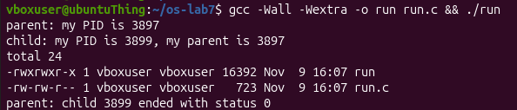
Figure 3.1 – Output of run.c with the ls command
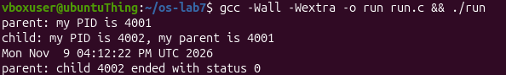
Figure 3.2 – Output of run.c with the date command
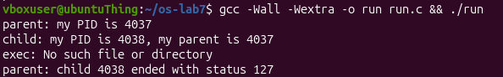
Figure 3.3 – Output of run.c with the nosuchprog command
Why is the line `perror("exec")` printed only with `nosuchprog`? On success exec never returns, because the code of the child is replaced by the new program. Any line placed after it is executed only if exec failed. With nosuchprog the executable is not found, execlp returns, and perror("exec") prints the message shown in figure 3.3.
Which number does the child print as its parent, and whose PID is it? The number printed by the child as its parent is the PID of the process that created it by fork. It is the same number that the first line of the output shows as the PID of the parent.
What status does the parent see with `ls`, and what status with `nosuchprog`? With ls the parent receives the status 0, which means that the child ended successfully, as shown in figure 3.1. With nosuchprog the child ended with the status 127, set by the explicit call exit(127) after the failed exec, as shown in figure 3.3.

3.2 Exercise 2: A zombie on purpose
Objective: to create a zombie process and to find out which call removes it
Commands used: The file zombie.c is a copy of run.c with the line sleep(20); added before waitpid. The program was started in the background and the process table was displayed twice.
gcc -Wall -Wextra -o zombie zombie.c
./zombie > /dev/null &
sleep 2; ps -o pid,ppid,stat,cmd
ps -o pid,ppid,stat,cmd
Description: During the sleep of the parent, the child ls has already ended but has not been waited for. The process table at this moment is shown in figure 3.4, and the table after the 20 seconds have passed is shown in figure 3.5.
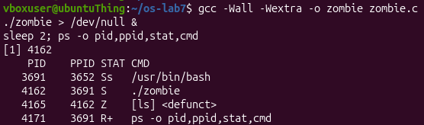
Figure 3.4 – Process table while the parent sleeps
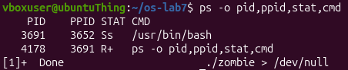
Figure 3.5 – Process table after 20 seconds
Which letter does `ls` have in the STAT column, and what does it mean? The process ls has the letter Z in the STAT column, which means that it is a zombie: it has ended, but its entry remains in the process table because the parent has not yet read its status, as shown in figure 3.4.
After 20 seconds, is the `[ls] <defunct>` line still there? Which line of `zombie.c` made it disappear? After 20 seconds the line [ls] <defunct> is no longer present, as shown in figure 3.5. The line waitpid(pid, &status, 0); made it disappear: after sleep(20) the parent waited for the child, and the kernel removed the entry of the child from the process table.

3.3 Exercise 3: Redirection: ls -l > out.txt
Objective: to redirect the standard output of ls into a file without changing ls
Commands used: The program was compiled and started, after which the first lines of the created file were displayed.
gcc -Wall -Wextra -o redirect redirect.c && ./redirect
head -3 out.txt
Description: In the child, the program redirect.c closes descriptor 1, opens out.txt and then runs ls -l. The result of the run is shown in figure 3.6.
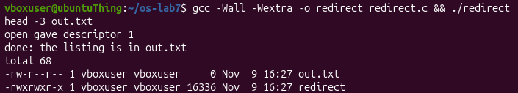
Figure 3.6 – Output of redirect.c and the beginning of out.txt
Which number did `open` give, and why exactly that one? The call open returned the descriptor 1, because the call close(1) had just freed it, and open always returns the smallest free number [5]. The message "open gave descriptor 1" is visible on the screen because it is written to the standard error, descriptor 2, which was not changed.
`ls` was not changed at all. Why does its listing not appear on the screen? The program ls writes to descriptor 1, as always, but after the redirection this descriptor points to out.txt and not to the terminal. The listing is therefore written into the file and does not appear on the screen.
To redirect the errors instead, which descriptor would be closed before `open`? Descriptor 2 has to be closed before open, so that the file receives the number 2 and the error messages are written into it, similar to the shell form 2> err.txt.

3.4 Exercise 4: A pipe: ls /etc | wc -l
Objective: to build a two-command pipeline manually with pipe, fork and dup, and to explain why an unclosed descriptor blocks the reader
Commands used: The program was compiled and its result was compared with the real shell pipeline.
gcc -Wall -Wextra -o pipeline pipeline.c && ./pipeline
ls /etc | wc -l
After that, the line close(p[1]); in the parent was turned into a comment, the program was compiled again and started, and it was stopped with Ctrl-C.
close(p[0]); /* the parent uses neither end */
/* close(p[1]); */
Description: The program pipeline.c creates one pipe and two children. In the first child descriptor 1 becomes p[1] and the process runs ls /etc; in the second child descriptor 0 becomes p[0] and the process runs wc -l. The result of the correct program and of the shell pipeline is shown in figure 3.7, and the behaviour of the modified program is shown in figure 3.8.
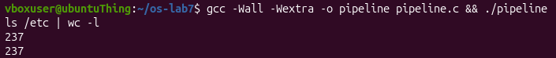
Figure 3.7 – Output of pipeline.c and of the shell pipeline
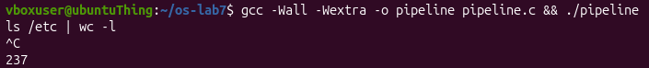
Figure 3.8 – Output of the modified pipeline.c that does not end
Did `./pipeline` and `ls /etc | wc -l` give the same number? Yes, both commands printed the same number, as shown in figure 3.7.
After the change, which of the two children never ends, `ls` or `wc`? The process wc never terminates, as shown in figure 3.8. The process ls ends normally, but the parent still holds an open copy of p[1], and the parent itself waits for wc.
Why, in one sentence: what is `wc` waiting for? The process wc is waiting for the end-of-file on the pipe, which the kernel delivers only when every descriptor that points to the writing end of the pipe, in all processes, has been closed [6].

CONCLUSION
In this practical work the programs run.c, zombie.c, redirect.c and pipeline.c were compiled, run and modified, and the results were compared with the expected behaviour of the shell [1]. The main findings are the following:
- the shell starts a command with three steps, fork, exec and wait, and a successful exec never returns [2, 3];
- a child that has ended but has not been waited for stays in the process table as a zombie with the state Z until the parent calls waitpid [4];
- the call open returns the smallest free descriptor, therefore closing descriptor 1 before open redirects the standard output of the program that is started later [5];
- the call dup works in the same way, and it allows ls and wc to be connected through a pipe without any change in these programs [6, 7];
- the reader of a pipe receives the end-of-file only when all copies of the writing end are closed, so every process has to close the pipe ends that it does not use [6].

REFERENCES
1. Technical University of Moldova, FCIM / FAF. Operating Systems 2026-2027, Lab 7: Three Small Programs: Processes, Redirection, a Pipe (Track A: the real OS, from the outside, Linux). Course handout.
2. Linux man-pages project. fork(2): create a child process. Available at: https://man7.org/linux/man-pages/man2/fork.2.html
3. Linux man-pages project. exec(3): execute a file. Available at: https://man7.org/linux/man-pages/man3/exec.3.html
4. Linux man-pages project. wait(2): wait for a process to change state. Available at: https://man7.org/linux/man-pages/man2/wait.2.html
5. Linux man-pages project. open(2): open and possibly create a file. Available at: https://man7.org/linux/man-pages/man2/open.2.html
6. Linux man-pages project. pipe(2): create a pipe. Available at: https://man7.org/linux/man-pages/man2/pipe.2.html
7. Linux man-pages project. dup(2): duplicate a file descriptor. Available at: https://man7.org/linux/man-pages/man2/dup.2.html

