
MINISTRY OF EDUCATION, CULTURE AND RESEARCH
OF THE REPUBLIC OF MOLDOVA
Technical University of Moldova
Faculty of Computers, Informatics and Microelectronics
Department of Software Engineering and Automation

Cristian Bruma FAF-242
Report
Laboratory work n.4
of Operating Systems

Checked by:
Reițman Patricia, university assistant
DISA, FCIM, UTM

Chișinău – 2026
Table of Contents
1 AIM OF THE WORK 3
1.1 Purpose of practical work 3
1.2 Problem statement 3
2 THEORETICAL BACKGROUND 4
2.1 The role of the shell 4
2.2 Expansions performed by the shell 4
2.3 The structure of the xv6 shell 4
3 DESCRIPTION OF EXERCISES 5
3.1 Exercise 1: Fix sleep for the current xv6 5
3.2 Exercise 2: bash versus the xv6 shell 6
3.3 Exercise 3: Who expands *? A program that prints its argv 10
3.4 Exercise 4: Read the shell 13
CONCLUSION 16
REFERENCES 17

1 AIM OF THE WORK

1.1 Purpose of practical work
The purpose of the work is to study the user interface of the xv6 operating system, the shell user/sh.c, by comparing it with bash on Linux and by reading its source code. The work also shows which tasks belong to the shell and which to the kernel or to the program itself, using a small program that prints the arguments it receives.
An additional purpose is to make the sleep program from Lab 2 build on the current version of xv6, where the system call sleep() was renamed to pause().

1.2 Problem statement
The problem is to determine, by experiment, which features a minimal shell must provide and which features bash adds on top of them. The following questions have to be answered:
- which features are common to both shells and which exist only in bash;
- why ls stops working after cd in xv6 and how it can still be started;
- which component expands * and removes quotes, the program, the kernel or the shell;
- which kinds of commands the xv6 shell knows and where cd is handled.
In addition, the sleep program has to be adapted to the renamed system call and tested in QEMU.

2 THEORETICAL BACKGROUND

2.1 The role of the shell
A shell is an ordinary user-level program that reads a command line, interprets it and starts the requested programs. It is not a part of the kernel: the kernel only provides system calls, while the shell uses them to create processes and to connect them with files and pipes [1].
For every external command the shell calls fork() to create a child process, the child calls exec() to replace its memory with the requested program, and the parent calls wait() until the child finishes. Redirections and pipes are set up in the child between fork() and exec() by closing and duplicating file descriptors.

2.2 Expansions performed by the shell
A full-featured shell such as bash processes the command line before any program is started. According to the manual, the main steps are brace expansion, tilde expansion, parameter and variable expansion, command substitution, filename expansion (globbing) and quote removal [1, 2].
As a result, a program never sees the characters * or $HOME. It receives only the final list of strings in argv, and the same program started from two different shells can receive different arguments for the same typed line. This is the idea tested in Exercise 3.
Features such as command history, line editing and Tab completion belong to the interactive part of the shell and have no influence on the commands that are executed.

2.3 The structure of the xv6 shell
The xv6 shell user/sh.c has about 500 lines and implements only the core of a Unix shell [3]. A command line is split into tokens, converted into a tree of command structures and executed recursively by the function runcmd().
The tokenizer separates words by white space and recognizes only the special symbols <, >, |, &, ;, ( and ). All other characters, including *, $ and quotes, are ordinary parts of a word. The command cd has to change the working directory of the shell itself, therefore it is handled directly in main() and not started as a separate program.
Programs are located without a PATH variable: the name typed by the user is passed to exec() as a path relative to the current directory. All xv6 utilities are stored in the root directory of the file system.

3 DESCRIPTION OF EXERCISES
The work consists of four parts. Each part contains the commands that were run, the screenshots and the answers to the questions from the laboratory handout.

3.1 Exercise 1: Fix sleep for the current xv6
Objective: to make the sleep program from Lab 2 build and run on the current version of xv6
Commands used:
cd ~/xv6-riscv
grep -n "pause\|sleep" user/user.h
make qemu
$ sleep 20
$ sleep
Description: In August 2025 the authors of xv6 renamed the system call sleep() to pause(), therefore the old program may not compile. The declarations in user/user.h were searched for both names, as shown in figure 3.1.
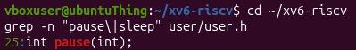
Figure 3.1 – The grep result in user.h
Since user.h declares pause, the call in user/sleep.c was replaced, as shown in figure 3.2. The entry $U/_sleep is present in UPROGS in the Makefile.
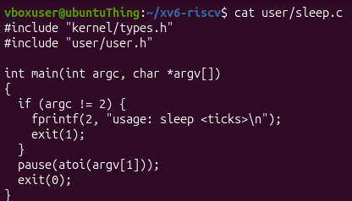
Figure 3.2 – The updated sleep.c
After rebuilding, the system was started with make qemu. The command sleep 20 pauses the shell for 20 ticks, and sleep without an argument prints the usage message, as shown in figure 3.3.
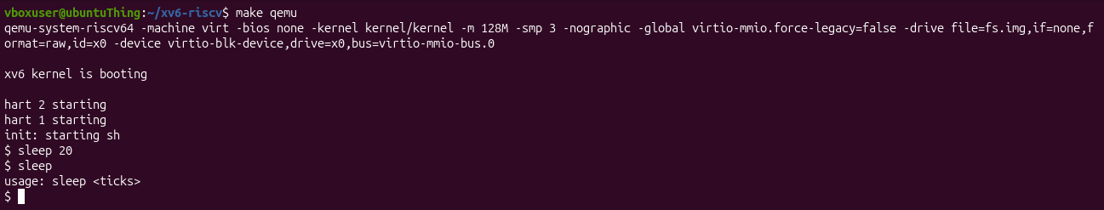
Figure 3.3 – The sleep program running in xv6, with and without an argument

3.2 Exercise 2: bash versus the xv6 shell
Objective: to compare the features of bash and the xv6 shell by running the same commands in both
Commands used:
mkdir ~/shtest && cd ~/shtest && touch README
echo hello > f ; cat < f
ls | grep READ
(echo a; echo b) | wc
echo one ; echo two
echo bg &
ls *
echo $HOME
echo "a b"
mkdir d ; cd d ; ls ..
Description: Every command was run once in bash in an empty folder containing a file named README, and once at the xv6 prompt. The results are shown in figure 3.4 and figure 3.5 and are summarized in table 3.1.
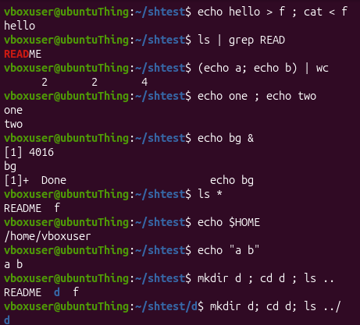
Figure 3.4 – The commands run in bash
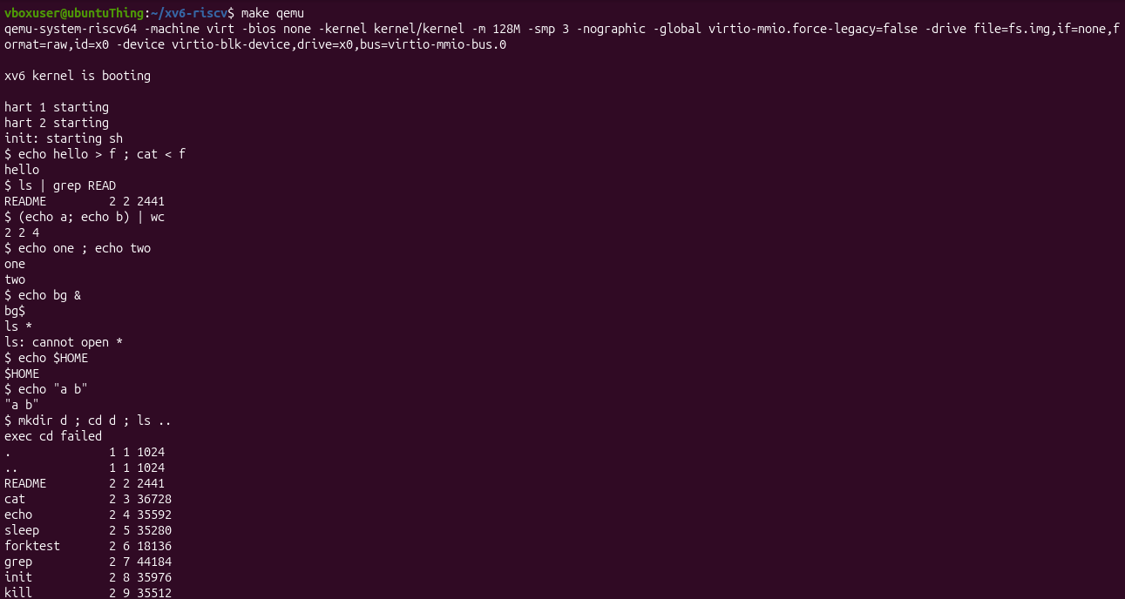
Figure 3.5 – The same commands run in xv6
Table 3.1 – Results of the commands in bash and in xv6
Command | Tests | bash | xv6 | Explanation
echo hello > f ; cat < f | redirection | hello | hello | Both shells implement < and >.
ls | grep READ | pipe | README | README 2 2 2441 | Both support pipes; the xv6 ls also prints type, inode and size.
(echo a; echo b) | wc | grouping, list | 2 2 4 | 2 2 4 | Parentheses and ; are supported in both.
echo one ; echo two | sequence | one, two | one, two | The list operator ; runs commands one after another.
echo bg & | background | runs, then [1]+ Done | runs, no job message | xv6 has no job control, so no completion message is printed.
ls * | globbing | README f | ls: cannot open * | xv6 does not expand * and passes it literally.
echo $HOME | variables | /home/vboxuser | prints $HOME | xv6 has no variables.
echo "a b" | quotes | prints a b | prints "a b" with the quotes | xv6 does not treat quotes as special.
mkdir d ; cd d ; ls .. | PATH | README d f | exec cd failed | In xv6 cd is a built-in only at the start of the line, so inside a list it is run as a program and fails.
arrow up, Tab, Ctrl+R | history, completion | works | does not work | xv6 has no line editing, history or completion.
1. Which features are common to both shells and which exist only in bash? Both shells have redirection with < and >, pipes with |, and the operators ;, & and ( ). Only bash has globbing, variables, quotes, command history, Tab completion and a PATH search.
Common features:
- redirection of input and output;
- pipes between commands;
- sequences with ;;
- background execution with &;
- grouping with parentheses.
Features only in bash:
- globbing;
- variables;
- quotes;
- command history;
- tab completion;
- search of programs through PATH.
2. Why does ls stop working after cd d, and how can it be run from inside d? The xv6 shell starts a program by passing its name to exec() as a path relative to the current directory. After cd d the file ls is no longer found, because it is stored in the root directory and not in d. The program can still be started with its absolute path /ls, as shown in figure 3.6 and figure 3.7.
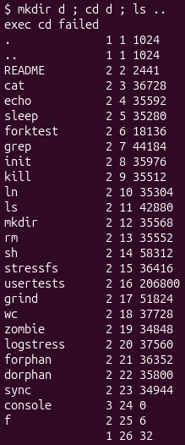
Figure 3.6 – The command ls failing after cd d
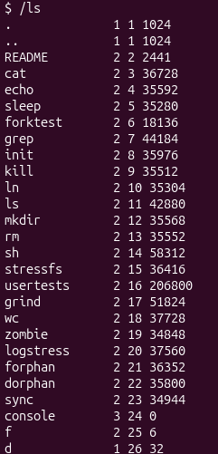
Figure 3.7 – The working alternative using the path /ls
3. Which missing feature would be missed most, and which would be easiest to add? The most missed feature in daily work would be the command history, because repeating and correcting earlier commands saves a lot of typing. The easiest feature to add is quote handling, since it requires only a small change in the tokenizer of the shell.

3.3 Exercise 3: Who expands *? A program that prints its argv
Objective: to find out which component expands * and removes quotes by writing a program that prints the arguments it receives
Commands used:
gcc -o args args_linux.c
args one two three
args *.c "x y"
args $HOME
args 'single quoted'
Description: The program args.c prints argc and every element of argv. For xv6 it uses the headers kernel/types.h and user/user.h and ends with exit(0). The Linux version args_linux.c uses <stdio.h> and return 0. The entry $U/_args was added to UPROGS, as shown in figure 3.8.
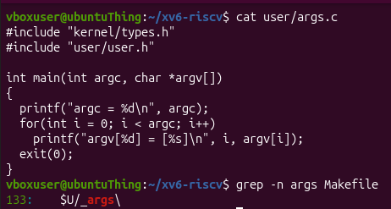
Figure 3.8 – The programs args.c and args_linux.c and the UPROGS line
The same lines were then run in both shells. The output of xv6 is shown in figure 3.9 and the output of bash in figure 3.10.
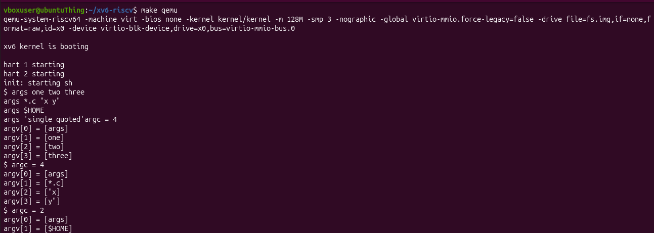
Figure 3.9 – The output of args in xv6
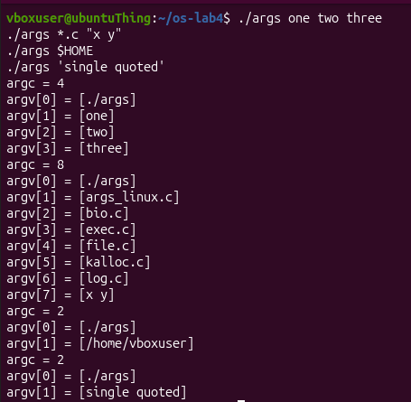
Figure 3.10 – The output of args_linux in bash
1. Paste both outputs for args *.c "x y". How many arguments did each program receive? In bash the program received 8 arguments, because *.c was replaced by the names of the matching files and the quotes around x y were removed, so the text stayed one argument. In xv6 the program received 4 arguments: *.c stayed unchanged, and "x y" was split into two arguments, "x and y", with the quote characters kept.
The output in bash:
argc = 8
argv[0] = [./args]
argv[1] = [args_linux.c]
argv[2] = [bio.c]
argv[3] = [exec.c]
argv[4] = [file.c]
argv[5] = [kalloc.c]
argv[6] = [log.c]
argv[7] = [x y]
The output in xv6:
argc = 4
argv[0] = [args]
argv[1] = [*.c]
argv[2] = ["x]
argv[3] = [y"]
2. Who turns *.c into file names and removes the quotes: the program, the kernel or the shell? The shell does both. The program only prints what it receives, and the kernel only copies the argument strings to the new process during exec(). The difference between the two outputs appears because bash expands the pattern and removes the quotes before calling exec(), while the xv6 shell does neither.
3. What happened to the extra spaces in one two three? The extra spaces were ignored. The shell splits the line into words at white space, so any number of spaces between words gives the same result: argc = 4 with the arguments one, two and three after the program name.

3.4 Exercise 4: Read the shell
Objective: to identify the kinds of commands in user/sh.c and to explain the behaviour observed in the previous parts
Commands used:
wc -l user/sh.c
grep -n "#define" user/sh.c
grep -n "case " user/sh.c
grep -n "cd" user/sh.c | head
Description: The command kinds are defined with #define constants at the beginning of sh.c, as shown in figure 3.11. The function runcmd() selects the action with a switch statement, as shown in figure 3.12.
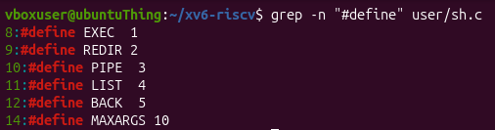
Figure 3.11 – The command kinds defined in sh.c
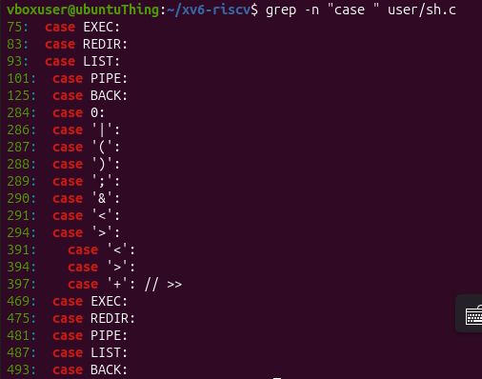
Figure 3.12 – Where each command kind is run
1. Which five kinds of command does the xv6 shell know and which character produces each? The xv6 shell knows five kinds of commands, listed in table 3.2.
Table 3.2 – Command kinds of the xv6 shell
Type | Meaning | Produced by
EXEC | a plain command with its arguments | just words, for example echo hi, without a special character
REDIR | a command with redirected input or output | <, >, >>
PIPE | the output of the left command feeds the right one | |
LIST | run one command, then the next | ;
BACK | run in the background | &
2. Where is cd handled, and why is it not run as a separate program? The only match for cd is at line 170, in main(), as shown in figure 3.13. The shell checks whether the input line starts with cd and calls chdir() itself before it forks. A failure prints cannot cd. It cannot be a separate program, because the working directory belongs to a process. A child created by fork() that executes an external cd would change only its own directory and then exit, so the directory of the shell would stay unchanged. Therefore cd has to be a built-in command executed in the shell process.
Figure 3.13 – The code that handles cd
3. What does the absence of code for * and $ in sh.c explain about Part 2? There is none. The special-character cases of the tokenizer (lines 284-294) cover only |, (, ), ;, &, < and >, and >> is handled at line 397. Nothing handles *, $ or quotes. This explains Part 2: globbing, variables and quotes do not work in xv6 because the shell passes these characters unchanged to the program.

CONCLUSION
During the work the sleep program from Lab 2 was adapted to the current xv6 by replacing sleep() with pause(), and it was tested with and without an argument.
The comparison of bash and the xv6 shell showed that the xv6 shell implements only the core of a shell: redirection, pipes, sequences, background execution and grouping. Globbing, variables, quotes, history, completion and the PATH search are available only in bash.
The program args proved that * and quotes are processed by the shell and not by the kernel or by the program: bash passed 8 arguments, while the xv6 shell passed 4 raw words. The reading of user/sh.c confirmed this, since the tokenizer has no code for *, $ or quotes, and showed that cd is a built-in command, because a working directory belongs to the process of the shell.
The work gave a practical understanding of how a shell uses fork(), exec() and wait() and of which tasks belong to the shell, the kernel and the program.

REFERENCES
1. The Open Group. POSIX.1-2017, Shell Command Language. Available at: https://pubs.opengroup.org/onlinepubs/9699919799/utilities/V3_chap02.html
2. GNU Project. GNU Bash Reference Manual. Available at: https://www.gnu.org/software/bash/manual/bash.html
3. Cox R., Kaashoek F., Morris R. xv6: a simple, Unix-like teaching operating system. MIT. Available at: https://pdos.csail.mit.edu/6.828/2023/xv6/book-riscv-rev3.pdf

