
MINISTRY OF EDUCATION, CULTURE AND RESEARCH
OF THE REPUBLIC OF MOLDOVA
Technical University of Moldova
Faculty of Computers, Informatics and Microelectronics
Department of Software Engineering and Automation

Cristian Bruma FAF-242
Report
Laboratory work n.8
of Operating Systems

Checked by:
Reițman Patricia, university assistant
DISA, FCIM, UTM

Chișinău – 2026
Table of Contents
1 AIM OF THE WORK 3
1.1 Purpose of practical work 3
1.2 Problem statement 3
2 THEORETICAL BACKGROUND 4
2.1 Process creation in xv6 4
2.2 Programs and the Makefile in xv6 4
2.3 Pipes 4
3 DESCRIPTION OF EXERCISES 5
3.1 Exercise 1: run, inside xv6 5
3.2 Exercise 2: pingpong 7
CONCLUSION 8
REFERENCES 9

1 AIM OF THE WORK

1.1 Purpose of practical work
The purpose of this practical work is to run the process-creation calls fork, exec and wait, already used on Linux in Lab 7, inside the xv6 teaching operating system, and to make two processes communicate through pipes [1].

1.2 Problem statement
The problem is to write two user programs for xv6. The first one, run, creates a child process that becomes another program (echo, ls or a program that does not exist) while the parent waits and reports the exit status. The second one, pingpong, exchanges one byte between a parent and a child through two pipes, so that the child prints the ping message first and the parent prints the pong message after it [1].

2 THEORETICAL BACKGROUND

2.1 Process creation in xv6
xv6 is a small Unix-like operating system for the RISC-V architecture, designed for teaching [2]. User programs in xv6 are linked against a minimal user library and have no glibc; the only way to use the kernel is through its system calls [3].
A new process is created with fork, which returns twice: the child receives the value 0 and the parent receives the pid of the child. The call exec replaces the memory image of the calling process with a program loaded from a file and does not return on success; if it returns, the loading failed. The call wait suspends the parent until one of its children exits and stores the exit status of the child [2, 4].
These three steps are the same ones performed by a shell when a command is typed, and they match the calls used on Linux in Lab 7 [1].

2.2 Programs and the Makefile in xv6
Each user program in xv6 is a file user/NAME.c. To be included in the file system image, the program must also be listed in the UPROGS variable of the Makefile as a line $U/_NAME\. The line starts with a tab and nothing may follow the backslash [1].

2.3 Pipes
A pipe is a unidirectional kernel buffer with one read end and one write end, created by the call pipe, which fills an array of two file descriptors [5]. Data is read in the same order in which it was written (first-in, first-out), and the pipe does not record which process wrote a given byte.
A read on an empty pipe blocks until data is written or until all write ends are closed. After fork, both processes hold both ends of the pipe, so each process closes the ends that it does not use [2]. A pair of processes that needs communication in both directions therefore uses two pipes.

3 DESCRIPTION OF EXERCISES
Two exercises were completed: running the three process-creation calls inside xv6 (run) and the bidirectional exchange of one byte through two pipes (pingpong).

3.1 Exercise 1: run, inside xv6
Objective: to run fork, exec and wait inside xv6 and to compare them with the calls used on Linux in Lab 7
Commands used: Commands used:
make qemu
$ run
Description: The file user/run.c was created, the line $U/_run\ was added to UPROGS, and the program was started in xv6. The parent prints its pid and calls fork. The child prints its pid and calls exec with the program echo, while the parent calls wait and prints the status of the child. The output of the first variant is shown in figure 3.1.
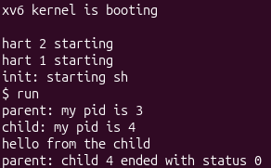
Figure 3.1 – Output of run with the child becoming echo
Who prints “hello from the child”: the code of run, or echo? The text “hello from the child” is printed by the program echo, not by the code of run. After a successful exec the memory image of the child is replaced by echo, so the lines of run that follow the call are never executed in the child.
In the second variant the arguments were changed to { "ls", 0 } and the call became exec("ls", args). The result is shown in figure 3.2.
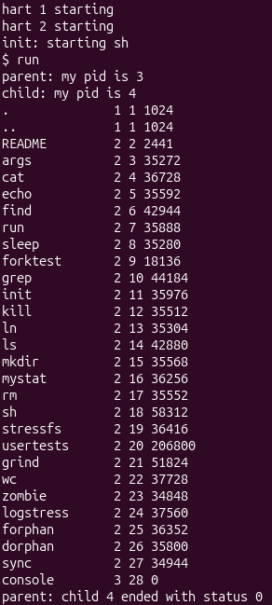
Figure 3.2 – Output of run with the child becoming ls
What is the same between the three calls in xv6 and on Linux? In xv6 (Lab 8) the calls are fork(), exec("echo", args) and wait(&status). On Linux (Lab 7) the calls were fork(), execlp("ls", "ls", "-l", NULL) and waitpid(pid, &status, 0). The three steps and the roles of the calls are identical: the parent copies itself, the child replaces its image with another program, and the parent waits for the child to finish. Only the form of the calls differs, because xv6 offers a smaller interface than glibc.
In the third variant the program name was replaced with nosuchprog, which does not exist. The call exec fails, the child prints “exec failed” and ends with exit(1), as shown in figure 3.3.
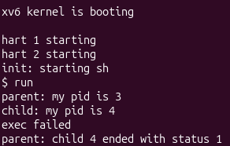
Figure 3.3 – Output of run when exec fails
Why is the status 1 here and 127 on Linux? The status is 1 because the two programs call exit with different numbers after a failed exec: the xv6 program uses exit(1), while the Linux program of Lab 7 used 127. The parent does not interpret the value and only reports the number given by the child.

3.2 Exercise 2: pingpong
Objective: to make a parent and a child process exchange one byte through two pipes
Commands used: Commands used:
make qemu
$ pingpong
Description: The file user/pingpong.c was written and the line $U/_pingpong\ was added to UPROGS. Two pipes are created before fork: p2c for the direction from parent to child and c2p for the opposite direction. Each process closes the pipe ends that it does not use. The parent writes the byte 'x' into p2c[1], the child reads it, prints its message, writes the byte into c2p[1] and exits, and the parent reads the byte, prints its message and calls wait. The result is shown in figure 3.4.
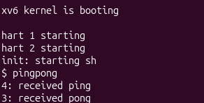
Figure 3.4 – Output of pingpong
Why are two pipes needed, and not one for both directions? A pipe is one buffer with one reading end and one writing end, and it is first-in, first-out. It has no notion of who wrote a byte, so any process holding the read end can take any byte out of it. If the parent and the child shared a single pipe, the parent would write the ping and then immediately call read on the same pipe, and it could take back its own ping before the child had read it. The child would then block forever, and the pong could not be told apart from the ping. Two pipes give each direction its own buffer, so every byte has a single reader.
Which call makes the parent wait for the reply of the child? The call read(c2p[0], &b, 1) in the parent makes it wait. The pipe c2p is empty until the child writes into it, so read blocks the parent until the byte arrives. This blocking behaviour of read also guarantees the order of the messages: the ping is always printed before the pong.

CONCLUSION
In this practical work the programs run and pingpong were written, built and executed inside xv6. The results can be summarised as follows:
- the calls fork, exec and wait have the same roles in xv6 as on Linux, and only the form of the calls differs [2, 4];
- after a successful exec the output belongs to the new program, so the text “hello from the child” is printed by echo;
- a failed exec returns to the caller, and the status seen by the parent is the number passed to exit by the child;
- two pipes are required for communication in both directions, because a pipe is a single first-in, first-out buffer without information about the writer [5];
- a blocking read on an empty pipe is enough to synchronise the parent with the child, without any explicit wait for the reply.
These results show that the same small set of system calls is sufficient for both program execution and inter-process communication, which prepares the construction of further parts of the operating system.

REFERENCES
1. OS 2026 – Lab 8 – The Same Calls, Inside Your Own OS (xv6). Operating Systems, FCIM / FAF, Technical University of Moldova, 2026–2027.
2. Cox R., Kaashoek F., Morris R. xv6: a simple, Unix-like teaching operating system (RISC-V edition). MIT. Available at: https://pdos.csail.mit.edu/6.828/2023/xv6/book-riscv-rev3.pdf
3. xv6-riscv source code repository. MIT PDOS. Available at: https://github.com/mit-pdos/xv6-riscv
4. fork(2) – Linux manual page. Available at: https://man7.org/linux/man-pages/man2/fork.2.html
5. pipe(2) – Linux manual page. Available at: https://man7.org/linux/man-pages/man2/pipe.2.html

