
MINISTRY OF EDUCATION, CULTURE AND RESEARCH
OF THE REPUBLIC OF MOLDOVA
Technical University of Moldova
Faculty of Computers, Informatics and Microelectronics
Department of Software Engineering and Automation
Bruma Cristian FAF-242
Report
Practical Works No. 1 and No. 2
Operating Systems
Topic: The OS as a Resource Manager (Track A, Linux); Meet the OS You Will Build (Track B, xv6)
Checked by:
Reițman Patricia, university assistant
FCIM, UTM
Chișinău – 2026
TABLE OF CONTENTS
1 FILES AND DIRECTORIES 3
1.1 Findings 3
1.2 Ownership of the created files 3
1.3 Meaning of the permission string 3
1.4 Directories under the root 4
2 PROCESSES 5
2.1 Findings 5
2.2 Process number 1 5
2.3 Number of running processes 6
2.4 State of a sleeping process 6
3 MEMORY 7
3.1 Findings 7
3.2 Total and free RAM 7
3.3 Swap memory 7
3.4 Resident memory of a sleeping process 7
4 DEVICES AND STORAGE 8
4.1 Findings 8
4.2 Device of the root filesystem 8
4.3 Entries in the device directory 8
4.4 Meaning of “everything is a file” 8
5 BUILDING AND USING XV6 9
5.1 Building and booting xv6 9
5.2 Programs shipped with xv6 9
5.3 Features required by a pipe 10
5.4 Comparison with the Linux shell 10
6 READING THE XV6 SOURCE CODE 11
6.1 System calls used by a user program 11
6.2 Implementation of a system call 12
6.3 Kernel code and user code 12
7 FIRST XV6 PROGRAM 13
7.1 Task description 13
7.2 Source code of the program 13
7.3 Integration into the build system 13
CONCLUSION 14

1 FILES AND DIRECTORIES

1.1 Findings
According to figure 1.1, the filesystem of the Linux operating system (OS) is organised as one unified tree, whose top is the root directory /. This is interesting, because Windows, unlike Linux, uses letter drives, e.g., (C:) and (D:).
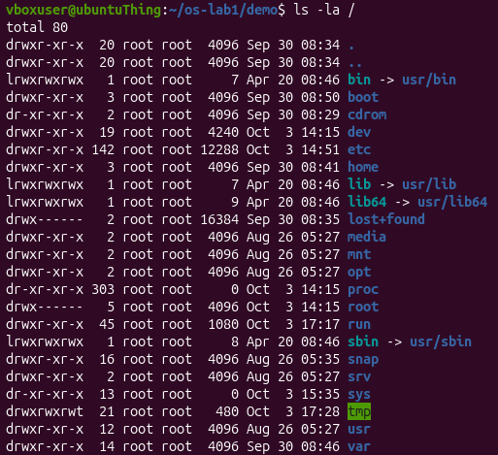
Figure 1.1 – Listing of the root directory

1.2 Ownership of the created files
The first question concerns the owner and the group of the files created during the practical work.
According to figure 1.2, the file note.txt is owned by the user that created it, vboxuser, which is also the group assigned to it. The group is named the same as the user because, by default, the primary group is assigned, which is the private group created for each user.
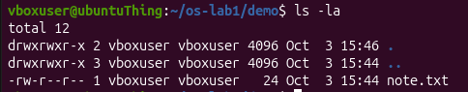
Figure 1.2 – Owner and group of the created file

1.3 Meaning of the permission string
The second question concerns the meaning of the ten characters at the beginning of the ls -l output for note.txt after the command chmod 600.
The string -rw------- shown in figure 1.3 is a permission string. Here it means that the file can be read and written to only by the user owning it, while no one else can read, write, or execute the file.
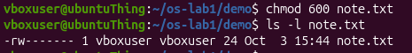
Figure 1.3 – Permissions of the file after changing the mode to 600

1.4 Directories under the root
The third question concerns two directories located directly under the root and the content of each of them.
Linux organises files as a single unified tree. At the top there is the root /, holding everything inside of itself, as shown in figure 1.1. In particular, it holds directories such as:
- the /home directory, which is the space designed for the user;
- the /etc directory, which holds various configurations for the system and services.

2 PROCESSES

2.1 Findings
It is fascinating that processes on Linux can be expressed through files in /proc/, as shown in figure 2.1 for a background sleep process. This illustrates the UNIX philosophy of “Everything is a file”.
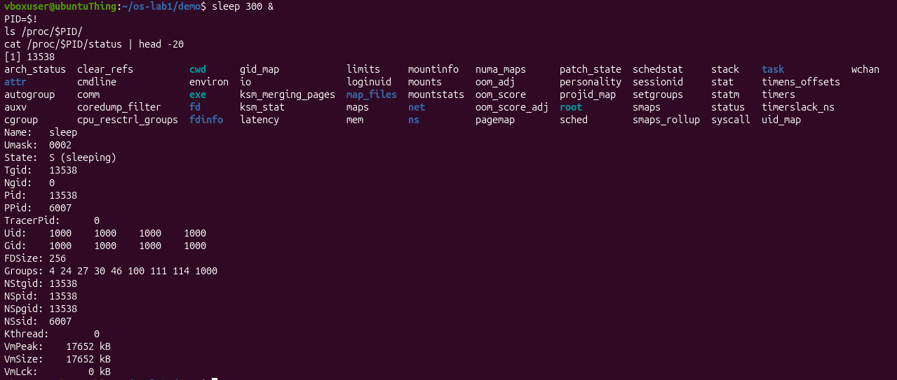
Figure 2.1 – Information about a background process exposed by the kernel

2.2 Process number 1
The first question concerns the process identifier (PID) of process number 1 and the nature of this process.
The question admits two readings. If it asks for the PID of the first process, the answer is 1. Otherwise, it can be interpreted as asking what the process with PID 1 is. In this case, the answer is systemd, as shown in figure 2.2 and figure 2.3. It is the first process instantiated in user mode, and every following user-space process is its descendant. It is started by the kernel.
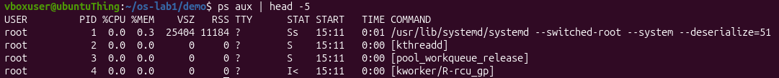
Figure 2.2 – First lines of the process list
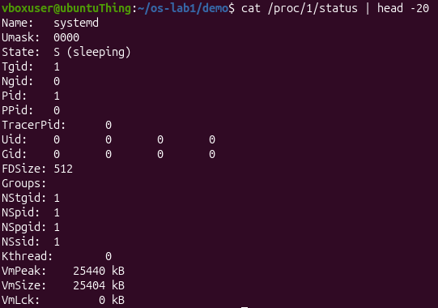
Figure 2.3 – Status of the process with PID 1

2.3 Number of running processes
The second question concerns the approximate number of processes running on the idle virtual machine (VM).
According to figure 2.4, 236 processes were counted. One line was excluded, because it is the header with the information columns.
Figure 2.4 – Number of lines in the process list

2.4 State of a sleeping process
The third question concerns the content of the State: line from the status file of the sleeping process.
According to figure 2.5, the State: line of the sleeping process says S (sleeping).
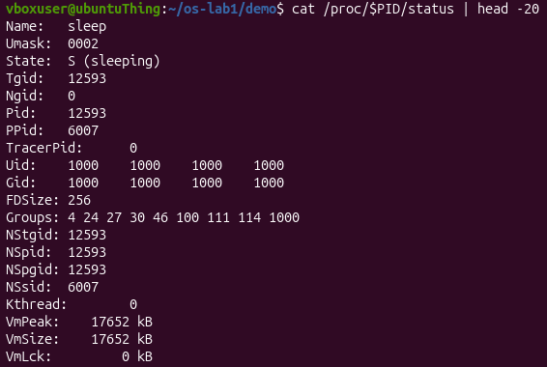
Figure 2.5 – Status of the sleeping process

3 MEMORY

3.1 Findings
It was interesting to discover the concept of swap memory, namely that disk space can act as RAM in certain circumstances. The memory and swap totals of the system are presented in figure 3.1.
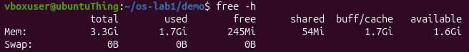
Figure 3.1 – Memory and swap totals reported by the system

3.2 Total and free RAM
The first question concerns the total amount of RAM of the VM and the amount of free RAM.
According to the output of free -h in figure 3.1, the VM has 3.3 GiB in total, with 245 MiB absolutely free and 1.6 GiB available for use.

3.3 Swap memory
The second question concerns the definition of swap and the amount of swap configured.
Swap memory is disk space that the OS uses as an extension of RAM, and it acts as a very slow safety net for processes. According to figure 3.1, the amount of swap memory configured is 0 B.

3.4 Resident memory of a sleeping process
The third question concerns the amount of resident memory (VmRSS) used by a bare sleep process and whether this amount is surprising.
As shown in figure 3.2, the sleep 300 process uses 8 MB of VmRSS. This value is surprising, because it seems excessive for a simple sleeping process. A possible explanation is that the system counts the memory of some elements additional to sleep, thus not displaying the true memory usage.
Figure 3.2 – Resident memory of the sleeping process

4 DEVICES AND STORAGE

4.1 Findings
The fact that the system can communicate with devices via files in /dev/, as shown in figure 4.1, solidifies the concept of “everything is a file”, since it allows a standard way of interacting with devices.
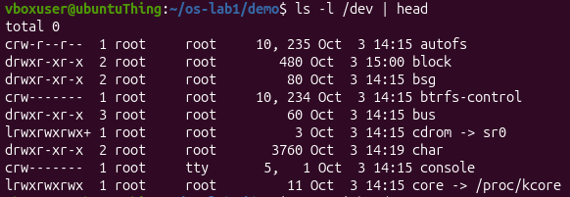
Figure 4.1 – Devices presented as files

4.2 Device of the root filesystem
The first question concerns the device on which the root filesystem / is mounted.
According to figure 4.2, the root filesystem / is mounted on /dev/sda2.
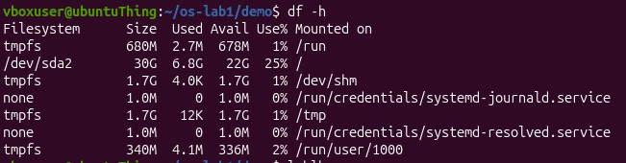
Figure 4.2 – Mounted filesystems and free space

4.3 Entries in the device directory
The second question concerns one entry from /dev and the real thing that this entry stands for.
The entry /dev/bus/, visible in figure 4.1, represents the direct access to hardware buses. It can be used for gaining access to USB via /dev/bus/usb/.

4.4 Meaning of “everything is a file”
The third question concerns the meaning of “everything is a file”, based on the observations made.
“Everything is a file” is the philosophy of the OS according to which not only plain data, but also the hardware (files in /dev/) and even the processes (files in /proc/) are expressed as files, for simplicity.

5 BUILDING AND USING XV6

5.1 Building and booting xv6
xv6 is a small teaching operating system, a modern re-implementation of Unix Version 6 written in about 9,000 lines of C, which runs on the RISC-V architecture under the QEMU emulator. The first step of the practical work is to build it from source and to boot it. For this purpose, the command make qemu is run in the directory ~/xv6-riscv, which compiles the kernel together with the user programs and launches the emulator.
After the boot, the kernel starts the init process, which launches the shell and displays the prompt $. All the commands presented in this chapter are typed at this prompt. Since xv6 runs inside QEMU, the emulator is left by pressing Ctrl-A, releasing it, and then pressing X.

5.2 Programs shipped with xv6
The second step is to use xv6 as the Unix system it is, by running its built-in programs at the shell prompt. The first question concerns three programs that xv6 ships with.
The command ls, whose output is presented in figure 5.1, lists the entries of the root directory of the xv6 file system. Among them there are the programs ls, cat and grep, which answer the question. The listing contains many other programs as well, such as echo, wc, sh, mkdir and rm, as well as the text file README and the special file console, which is marked with the type 3, i.e. a device file.
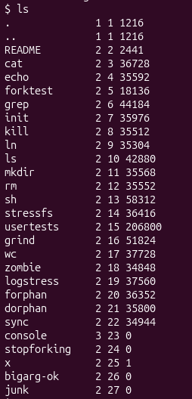
Figure 5.1 – Programs and files listed by ls in xv6
The program cat is used in figure 5.2 to print the file README. The text states that xv6 is a re-implementation of Unix Version 6 for a modern RISC-V multiprocessor, written in ANSI C.
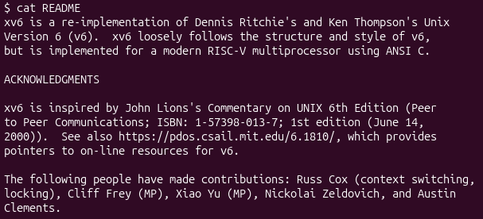
Figure 5.2 – Content of the README file displayed by cat

5.3 Features required by a pipe
The second question concerns the two features of the OS that must exist for a pipe to work.
In figure 5.3, the output of ls is passed through a pipe to grep, which keeps only the entries containing the letter c. For this to work, the OS must have process management, since it creates two separate processes, ls and grep, and schedules them at the same time. It must also have file-like input and output, based on the philosophy of “everything is a file”: the OS exposes the pipe as a file-like channel. The program ls writes its output into one end of the pipe as if it were a file, and grep reads from the other end as if it were a file, so the output of one process becomes the input of the other.
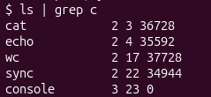
Figure 5.3 – Pipe between ls and grep in xv6

5.4 Comparison with the Linux shell
The third question concerns the comparison of the xv6 shell with the Linux shell from the first practical work.
The xv6 shell seems to be a minimal version of the Linux one, because it provides the same basic mechanisms, such as running programs and pipes, but lacks a number of additional tools.

6 READING THE XV6 SOURCE CODE

6.1 System calls used by a user program
After leaving the emulator, the source code of xv6 is studied. The first question concerns the system calls used by the user program user/cat.c, whose main part is displayed in figure 6.1.
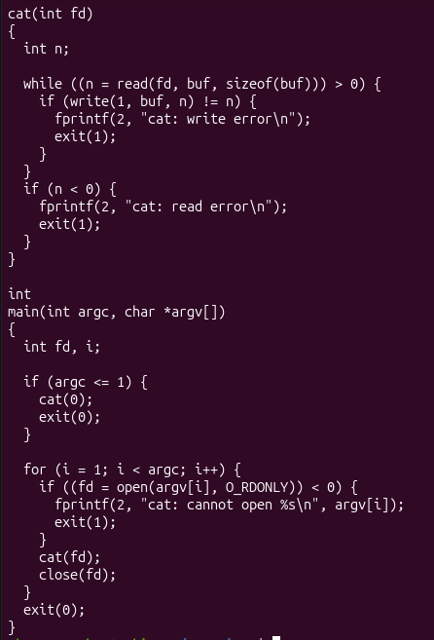
Figure 6.1 – Source code of the user program cat
The function cat reads the data of an open file in blocks into a buffer and writes each block to the file descriptor 1, which is the standard output. The function main opens every file named in the arguments for reading, passes it to cat, and closes it afterwards; if no arguments are given, cat reads from the file descriptor 0, which is the standard input. The errors are reported on the file descriptor 2, which is the standard error. The program uses the following system calls:
- open() asks the kernel to open a file and to return a file descriptor;
- read() asks the kernel to read bytes from a file;
- write() asks the kernel to write bytes to a file;
- close() asks the kernel to release the file descriptor;
- exit() asks the kernel to terminate the program.

6.2 Implementation of a system call
The second question concerns the kernel file and the line in which sys_read is implemented. The functions read() and write() used by cat are not ordinary functions, but requests into the directory kernel/. The system calls available to programs are listed in user/user.h, while their handlers are searched in the kernel with the command grep -n "sys_read\|sys_write" kernel/sysfile.c | head, whose output is presented in figure 6.2.
According to figure 6.2, sys_read is implemented in the file kernel/sysfile.c on line 69. The handler of the opposite operation, sys_write, is located in the same file on line 83.
Figure 6.2 – Location of sys_read and sys_write in the kernel

6.3 Kernel code and user code
The third question concerns the difference between the code in kernel/ and the code in user/. The whole OS splits into these two directories, and this split is the core of how an operating system is organised. The directory kernel/ is the operating system itself and contains, among others, the scheduler, the memory management, the file system and the handlers of system calls. The directory user/ holds the ordinary programs that run on top of it, such as ls, cat, echo and the shell.
The difference is that the code in kernel/ runs in privileged mode, while the code in user/ runs in user mode. For this reason, a user program cannot perform privileged operations itself, and has to ask the kernel for them through system calls, as cat does with read() and write(). Unlike on Linux, where programs can be seen only from the outside, in xv6 both sides can be read: the program that asks, in user/, and the kernel code that answers, in kernel/.

7 FIRST XV6 PROGRAM

7.1 Task description
The last step of the practical work is to write the first program for xv6. The new user program sleep has to pause for a number of clock ticks, given as a command-line argument, by calling a system call that already exists in the kernel. A tick is a unit of time defined by the kernel, namely the interval between two timer interrupts. The program is placed in the file user/sleep.c.

7.2 Source code of the program
The source code of the program is presented below:
#include "kernel/types.h"
#include "user/user.h"

int main(int argc, char *argv[])
{
if (argc != 2) {
fprintf(2, "usage: sleep <ticks>\n");
exit(1);
}
pause(atoi(argv[1]));
exit(0);
}
The program starts by including two header files: kernel/types.h, which defines the basic data types, and user/user.h, which declares the system calls and the library functions available to user programs. The function main receives the number of command-line arguments argc and the array of arguments argv, where argv[0] is the name of the program. Therefore, a correct call, such as sleep 10, gives argc equal to 2.
If the number of arguments is different from 2, the program prints the usage message usage: sleep <ticks> to the file descriptor 2, which is the standard error, and terminates with the status 1, which signals an error. Otherwise, the argument is converted from a string to an integer with atoi, and the system call pause is invoked with this value, asking the kernel to suspend the process for the given number of ticks. In this version of xv6, pause is the user-level name of the system call that suspends a process. When the pause ends, the program terminates with the status 0, which signals success.

7.3 Integration into the build system
To make the build system compile the new program and add it to the xv6 file system, the line $U/_sleep\ is added to the UPROGS list in the Makefile, next to the entries of the other programs. The line must be indented with a tab, exactly as the neighbouring ones, and must end with a backslash.
After rebuilding with make qemu, the program can be launched from the xv6 shell. The call sleep 10 makes the process pause for ten ticks and then return the prompt, while the call sleep without an argument prints the usage message. In this way, a program written by the author runs on top of a kernel compiled from source, and reaches this kernel through a system call.

CONCLUSION
The first practical work showed that the OS manages files, processes, memory and devices. More precisely, this fact can be confirmed by the following commands:
- managing files: ls -l;
- managing processes: top;
- managing memory: free -h;
- managing devices: ls -l /dev | head.
The second practical work introduced xv6, a small Unix-like operating system, which was built, booted and used from its shell. It was observed that xv6 ships with programs such as ls, cat and grep, and that a pipe between two programs requires both process management and file-like input and output. The study of the source code showed that the OS is split into kernel/, which runs in privileged mode, and user/, which runs in user mode, and that user programs, such as cat, ask the kernel for services through system calls like open(), read(), write(), close() and exit(). Finally, the user program sleep was written, which checks its arguments and uses a system call to suspend the process for a given number of clock ticks.
In conclusion, an operating system encapsulates tedious tasks and critical decisions in order to provide a simplified and comfortable usage of the computer to the user, while the small size of xv6 makes it possible to examine both the programs that ask for services and the kernel code that provides them.

