
MINISTRY OF EDUCATION, CULTURE AND RESEARCH
OF THE REPUBLIC OF MOLDOVA
Technical University of Moldova
Faculty of Computers, Informatics and Microelectronics
Department of Software Engineering and Automation

Cristian Bruma FAF-242
Report
Laboratory work n.6
of Operating Systems

Checked by:
Reițman Patricia, university assistant
DISA, FCIM, UTM

Chișinău – 2026
Table of Contents
1 AIM OF THE WORK 3
1.1 Purpose of practical work 3
1.2 Problem statement 3
2 THEORETICAL BACKGROUND 4
2.1 Inodes and the on-disk layout of xv6 4
2.2 Directories and hard links 4
2.3 Limits of the xv6 file system 4
2.4 Recursive traversal of the directory tree 4
3 DESCRIPTION OF EXERCISES 6
3.1 Exercise 1: Read what xv6 shows 6
3.2 Exercise 2: Write mystat 7
3.3 Exercise 3: Measure the limits 10
3.4 Exercise 4: Write find 12
3.5 Exercise 5: Stretch: inode numbers in find 14
CONCLUSION 16
REFERENCES 17

1 AIM OF THE WORK

1.1 Purpose of practical work
The purpose of this work is to study the structure of the xv6 file system, which implements the main ideas of production file systems such as ext4 (inodes, directories stored as tables, hard links and a journal) in a few hundred lines of readable code [1, 2]. The work combines reading the information exposed by xv6, writing two user-space programs, and measuring the limits defined in the kernel sources.

1.2 Problem statement
The following tasks were set in the handout [1]:
- to decode the output of ls and the type codes defined in kernel/stat.h;
- to write the mystat program, which prints the type, inode number, link count and size of a file, and to use it for observing hard links;
- to measure the limits written in kernel/fs.h (directory entry name length, maximum file size, disk layout);
- to write the find program, which walks the directory tree recursively;
- to add an optional -n argument to find that prints the inode number of each match.

2 THEORETICAL BACKGROUND

2.1 Inodes and the on-disk layout of xv6
The xv6 file system is stored on a disk divided into blocks of BSIZE bytes. The disk is organized as a boot block, a superblock, the log area used for crash recovery, the inode blocks, the free-block bitmap and finally the data blocks [2].
Every file, directory and device is described by an inode. The on-disk form is struct dinode from kernel/fs.h, which stores the type, the device numbers (major and minor, used by devices only), the link count nlink, the size in bytes and the array addrs with the block addresses [3]. The inode does not contain the file name, and xv6 inodes have neither permission bits nor a symbolic link type. The type of an inode is one of the constants T_DIR, T_FILE and T_DEVICE from kernel/stat.h [3].
The information of an inode is returned to user programs by the stat system call in struct stat (fields dev, ino, type, nlink and size) [1, 3].

2.2 Directories and hard links
A directory in xv6 is a file of type T_DIR whose content is a sequence of fixed-size records struct dirent. Each record holds an inode number inum and a name of at most DIRSIZ characters. A record with inum equal to zero is a free slot [2, 3]. Every directory contains the entries . (the directory itself) and .. (the parent directory); in the root directory both refer to the root itself.
A hard link is an additional directory entry that refers to an already existing inode. The inode counts these entries in nlink. The unlink system call removes one entry and decrements nlink; the inode and its data blocks are released only when no entry and no open file refer to it any more, which is performed by iput in kernel/fs.c [2, 3].

2.3 Limits of the xv6 file system
Because a directory entry has a fixed size, the length of a name is limited by DIRSIZ, and longer names are truncated. The size of a file is limited by the structure of the inode: NDIRECT direct block addresses plus one indirect block that contains NINDIRECT further addresses, so that the maximum number of data blocks is NDIRECT + NINDIRECT [3].
The layout of the whole image is computed by the mkfs tool, which prints the nmeta line with the number of metadata blocks (boot, superblock, log, inodes and bitmap) and the number of data blocks [1, 3].

2.4 Recursive traversal of the directory tree
A directory tree is traversed by opening a directory, reading its struct dirent records one by one, building the full path of each entry in a buffer and calling the traversal again for every sub-directory. The entries . and .. must be skipped, otherwise the recursion never terminates, and free slots (inum equal to zero) must be ignored. Each opened descriptor must be closed, since a xv6 process can keep only a limited number of files open [1, 4]. The program user/ls.c shows the required system calls (open, fstat, read, close) [3].

3 DESCRIPTION OF EXERCISES
All commands were executed in the xv6 shell running under QEMU. The source files of the programs are user/mystat.c and user/find.c, and the corresponding lines $U/_mystat and $U/_find were added to UPROGS in the Makefile, as required by the handout [1].

3.1 Exercise 1: Read what xv6 shows
Objective: to decode the output of ls and to identify the types, the inode numbers and the sizes of directory entries
Commands used: ls, mkdir a, ls a and the inspection of kernel/stat.h.
Description: The listing of the root directory was obtained with ls, then the directory a was created and listed. Each output line contains the name, the type, the inode number and the size in bytes, as shown in figure 3.1.
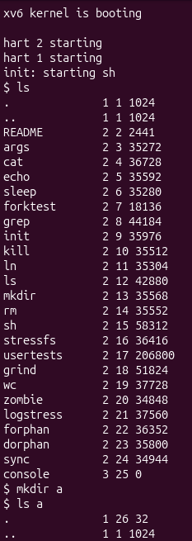
Figure 3.1 – Output of `ls`, `mkdir a` and `ls a` in xv6
What do types 1, 2 and 3 mean? The type codes are defined in kernel/stat.h, shown in figure 3.2 and summarized in table 3.1. Type 1 denotes a directory, type 2 a regular file and type 3 a device.
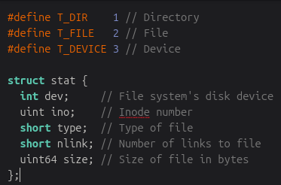
Figure 3.2 – Type constants in `kernel/stat.h`
Table 3.1 – Type codes of xv6 inodes
Value | Constant | Meaning
1 | T_DIR | Directory
2 | T_FILE | Regular file
3 | T_DEVICE | Device
Which inode number does the root directory have, and why are `.` and `..` the same there? The root directory has inode number 1. The entries . and .. are identical there because the root has no parent directory, so .. refers back to the root itself.
How big is one directory entry, and which entries does the empty directory `a` contain? One directory entry occupies 16 bytes: struct dirent consists of a two-byte inode number and a name of DIRSIZ (14) bytes. The size of 32 bytes of the empty directory a therefore corresponds to two entries, . (the directory a itself) and .. (its parent, the root directory).

3.2 Exercise 2: Write mystat
Objective: to write a program that prints the metadata of a file and to observe the behavior of hard links
Commands used: The following commands were run after mystat was compiled:
mystat README . console
ln README r2
mystat README r2
rm README
mystat r2
cat r2 | wc
Description: The program mystat calls stat for every argument, prints an error message to the standard error (descriptor 2) and continues when the call fails, and otherwise prints the name, the type, the inode number, the link count and the size. The type is converted to text by the function typename. The complete source code is given below.
#include "kernel/types.h"
#include "kernel/stat.h"
#include "user/user.h"
char *
typename(int t)
{
switch(t) {
case T_DIR: return "directory";
case T_FILE: return "file";
case T_DEVICE: return "device";
default: return "?";
}
}
int
main(int argc, char *argv[])
{
struct stat st;
for(int i = 1; i < argc; i++){
if(stat(argv[i], &st) < 0) {
fprintf(2, "mystat: error for %s\n", argv[i]);
continue;
}
printf("%s: %s, inode %d, links %d, size %d bytes\n",
argv[i], typename(st.type), st.ino, st.nlink, (int)st.size);
}
exit(0);
}
What changed and what did not after `ln` and after `rm`? The compilation and the execution of the commands are shown in figure 3.3, and the outputs are listed below. After ln both names report inode 2 and a link count of 2. After rm only r2 remains, with the same inode and size but a link count of 1, and the content is still readable (cat r2 | wc reports 2441 bytes). Consequently, the link count changed, whereas the inode number, the size and the data did not, because README and r2 were two names of the same inode.
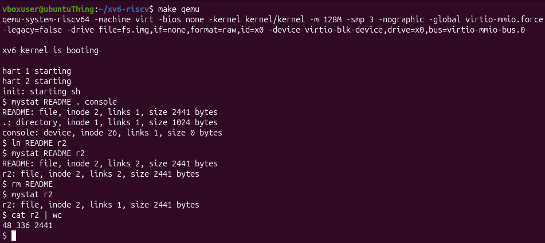
Figure 3.3 – Compilation and execution of `mystat` with `ln` and `rm`
$ mystat README . console
README: file, inode 2, links 1, size 2441 bytes
.: directory, inode 1, links 1, size 1024 bytes
console: device, inode 26, links 1, size 0 bytes
$ ln README r2
$ mystat README r2
README: file, inode 2, links 2, size 2441 bytes
r2: file, inode 2, links 2, size 2441 bytes
$ rm README
$ mystat r2
r2: file, inode 2, links 1, size 2441 bytes
$ cat r2 | wc
48 336 2441
Which line decrements the link count, and when are the data blocks freed? The link count is decremented in sys_unlink in kernel/sysfile.c, as shown in figure 3.4. The three relevant statements are given below. The data blocks are not freed by sys_unlink itself: according to the comments in kernel/fs.c (figure 3.5), iput releases the inode and its data once the reference count and the link count both reach zero.
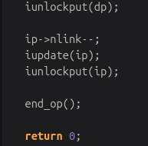
Figure 3.4 – Function `sys_unlink` in `kernel/sysfile.c`
ip->nlink--;
iupdate(ip);
iunlockput(ip);
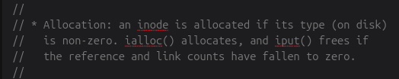
Figure 3.5 – Comments about `iput` in `kernel/fs.c`
Which fields does an xv6 inode have? The structure struct dinode, shown in figure 3.6, defines the fields listed below. The inode contains no owner, permission bits or timestamps, and no file name.
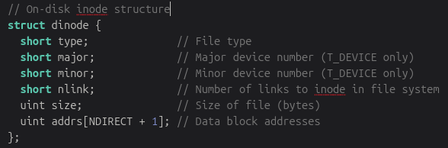
Figure 3.6 – Structure `struct dinode` in `kernel/fs.h`
short type; // File type
short major; // Major device number (T_DEVICE only)
short minor; // Minor device number (T_DEVICE only)
short nlink; // Number of links to inode in file system
uint size; // Size of file (bytes)
uint addrs[NDIRECT + 1]; // Data block addresses

3.3 Exercise 3: Measure the limits
Objective: to determine the constants of the file system, the maximum file size and the layout of the disk image
Commands used: The constants and the disk layout were obtained with the commands below, and the directory averyveryverylongname was created and listed in the xv6 shell.
grep -n "define BSIZE\|define NDIRECT\|define NINDIRECT\|define DIRSIZ" kernel/fs.h
make clean ; make fs.img 2>&1 | grep nmeta
mkdir averyveryverylongname
ls
Description: The constants of kernel/fs.h are shown in figure 3.7: BSIZE is 1024, NDIRECT is 12, NINDIRECT is 256 and DIRSIZ is 14.
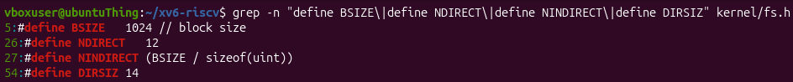
Figure 3.7 – Constants `BSIZE`, `NDIRECT`, `NINDIRECT` and `DIRSIZ` in `kernel/fs.h`
What does `ls` show for `averyveryverylongname`, and which constant explains it? The result of ls is shown in figure 3.8. The name was truncated to 14 characters, which is the value of DIRSIZ, and the line has the form given below: type 1 (directory), inode 27 and size 32 bytes (two directory entries).
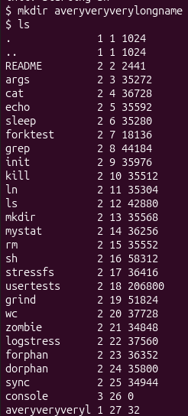
Figure 3.8 – Output of `ls` for a directory with a long name
averyveryveryl 1 27 32
What is the largest file xv6 can hold? A file consists of NDIRECT direct blocks and one indirect block, which holds NINDIRECT block numbers of 4 bytes each. The calculation is given below. The limit refers to the data blocks only: the inode and the indirect block are metadata and do not change the maximum size of the content, so the limit is exactly 274432 bytes.
NINDIRECT = BSIZE / sizeof(uint) = 1024 / 4 = 256
MAX_BLOCKS = NDIRECT + NINDIRECT = 12 + 256 = 268
MAX_FILE_SIZE = MAX_BLOCKS * BSIZE = 268 * 1024 = 274432 bytes = 268 KB
How many blocks does the disk have, and how many are used for the log, the inodes and the data? The nmeta line printed during the build is shown in figure 3.9, and the distribution of the blocks is summarized in table 3.2. The disk has 2000 blocks in total: 31 for the log, 13 for the inodes and 1953 for the data. The remaining three blocks are the boot block, the superblock and the free-block bitmap.
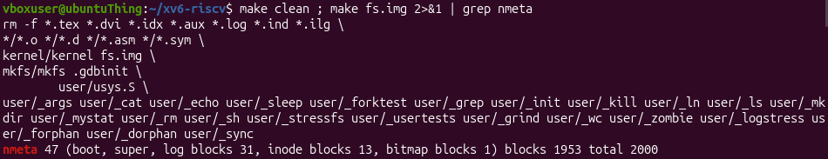
Figure 3.9 – The `nmeta` line printed by `make fs.img`
Table 3.2 – Distribution of the blocks of the disk image
Region | Blocks
Log | 31
Inodes | 13
Data | 1953
Boot block, superblock and bitmap | 3
Total | 2000

3.4 Exercise 4: Write find
Objective: to write a program that recursively walks a directory tree and prints every path whose last component equals a given name
Commands used: The program was started as find <dir> <name>, for example find . r2, on a fresh disk after make clean ; make qemu.
Description: The program find was written starting from the structure of user/ls.c. The function find performs the following actions:
- it opens the path and obtains its metadata with fstat;
- it prints the path when its last component, extracted by last_component, equals the requested name;
- it checks that the path buffer is large enough for one more entry;
- it reads the struct dirent records of a directory, skips free slots with inum equal to zero and the entries . and .., and calls itself for every other entry;
- it closes every descriptor before returning, because only 16 files can be open in a process.
The names are compared with strcmp. The recursive function is given below, and the test performed on a fresh disk is shown in figure 3.10.
void
find(char *path, char *name, int print_inode)
{
char buf[512], *p;
int fd;
struct dirent de;
struct stat st;
if ((fd = open(path, O_RDONLY)) < 0) {
fprintf(2, "find: cannot open %s\n", path);
return;
}
if (fstat(fd, &st) < 0) {
fprintf(2, "find: cannot stat %s\n", path);
close(fd);
return;
}
if (strcmp(last_component(path), name) == 0) {
if (print_inode)
printf("%s %d\n", path, st.ino);
else
printf("%s\n", path);
}
if (st.type == T_DIR) {
if (strlen(path) + 1 + DIRSIZ + 1 > sizeof buf) {
fprintf(2, "find: path too long\n");
close(fd);
return;
}
strcpy(buf, path);
p = buf + strlen(buf);
*p++ = '/';
while (read(fd, &de, sizeof(de)) == sizeof(de)) {
if (de.inum == 0)
continue;
if (strcmp(de.name, ".") == 0 || strcmp(de.name, "..") == 0)
continue;
memmove(p, de.name, DIRSIZ);
p[DIRSIZ] = 0;
find(buf, name, print_inode);
}
}
close(fd);
}
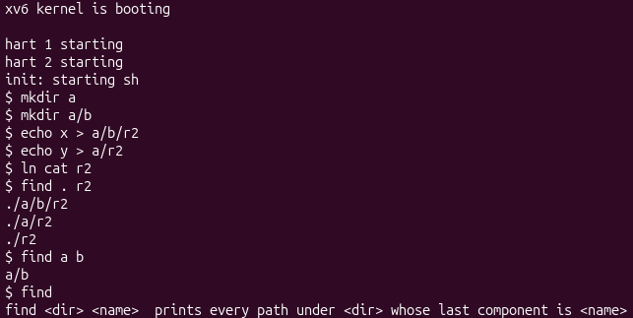
Figure 3.10 – Implementation and test of `find`

3.5 Exercise 5: Stretch: inode numbers in find
Objective: to extend find with the -n argument and to identify which files are hard links of the same inode
Commands used: ln cat r2, find . r2 -n and a comparison with the inode number of cat.
Description: When the third argument is -n, the function find receives the flag print_inode and prints the inode number st.ino next to each matching path. The result of find . r2 -n is shown in figure 3.11, and the comparison with the inode number of cat is shown in figure 3.12.
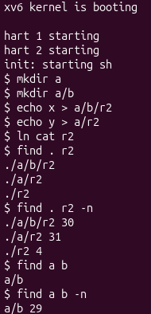
Figure 3.11 – Output of `find . r2 -n`
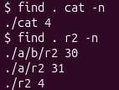
Figure 3.12 – Comparison of the inode numbers of `cat` and `r2`
Which of the three `r2` files is the same file as `cat`? The file r2 located in the root directory has the same inode number as cat, since it was created with ln cat r2. Therefore both names refer to the same file, whereas the other two r2 files, created with echo, are separate files with their own inodes.

CONCLUSION
In this work the xv6 file system was studied through the information shown by the system, two user programs were written, and the limits of the file system were measured [1]. The main findings are the following:
- the types 1, 2 and 3 correspond to a directory, a regular file and a device, the root directory has inode 1, and a directory entry occupies 16 bytes;
- a hard link is a second name of the same inode, and rm only decrements the link count, so the data remain available until the last link and the last reference disappear [2];
- the xv6 inode contains only the type, the device numbers, the link count, the size and the block addresses, without permissions and without the file name;
- names are limited to DIRSIZ (14) characters, and the maximum file size is 268 blocks, which equals 274432 bytes with BSIZE equal to 1024;
- the disk image has 2000 blocks, of which 31 belong to the log, 13 to the inodes and 1953 to the data;
- the program find traverses the tree recursively and, with the -n argument, shows that cat and one of the r2 files share an inode [4].
The programs mystat and find were implemented and tested successfully, and the exercises confirmed that the main concepts of ext4-like file systems can be observed directly in a compact implementation [3].

REFERENCES
1. Operating Systems, FCIM / FAF, UTM, 2026-2027. Lab 6: Inside the xv6 File System. Course handout.
2. Cox R., Kaashoek F., Morris R. xv6: a simple, Unix-like teaching operating system (RISC-V edition). MIT. Available at: https://pdos.csail.mit.edu/6.828/2023/xv6/book-riscv-rev3.pdf
3. xv6-riscv source code repository. MIT PDOS. Available at: https://github.com/mit-pdos/xv6-riscv
4. MIT 6.1810 Operating System Engineering. Lab: Xv6 and Unix utilities. Available at: https://pdos.csail.mit.edu/6.828/2023/labs/util.html

