
MINISTRY OF EDUCATION, CULTURE AND RESEARCH
OF THE REPUBLIC OF MOLDOVA
Technical University of Moldova
Faculty of Computers, Informatics and Microelectronics
Department of Software Engineering and Automation
Bruma Cristian FAF-242
Report
Practical Work No. 1
Operating Systems
Topic: The OS as a Resource Manager (Track A, Linux)
Checked by:
Reițman Patricia, university assistant
FCIM, UTM
Chișinău – 2026
TABLE OF CONTENTS
1 FILES AND DIRECTORIES 3
1.1 Findings 3
1.2 Ownership of the created files 3
1.3 Meaning of the permission string 3
1.4 Directories under the root 4
2 PROCESSES 5
2.1 Findings 5
2.2 Process number 1 5
2.3 Number of running processes 6
2.4 State of a sleeping process 6
3 MEMORY 7
3.1 Findings 7
3.2 Total and free RAM 7
3.3 Swap memory 7
3.4 Resident memory of a sleeping process 7
4 DEVICES AND STORAGE 8
4.1 Findings 8
4.2 Device of the root filesystem 8
4.3 Entries in the device directory 8
4.4 Meaning of “everything is a file” 8
CONCLUSION 9

1 FILES AND DIRECTORIES

1.1 Findings
According to figure 1.1, the filesystem of the Linux operating system (OS) is organised as one unified tree, whose top is the root directory /. This is interesting, because Windows, unlike Linux, uses letter drives, e.g., (C:) and (D:).
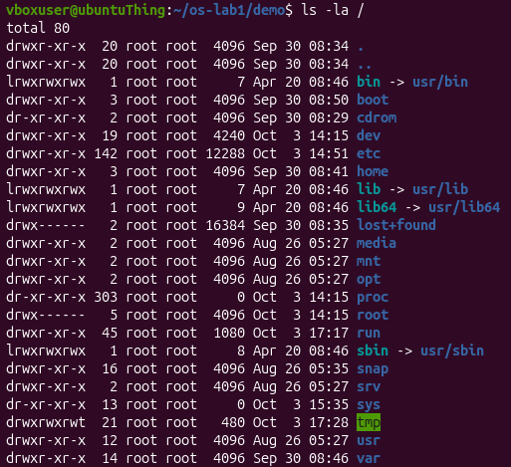
Figure 1.1 – Listing of the root directory

1.2 Ownership of the created files
The first question concerns the owner and the group of the files created during the practical work.
According to figure 1.2, the file note.txt is owned by the user that created it, vboxuser, which is also the group assigned to it. The group is named the same as the user because, by default, the primary group is assigned, which is the private group created for each user.
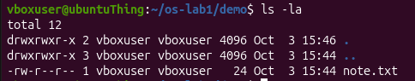
Figure 1.2 – Owner and group of the created file

1.3 Meaning of the permission string
The second question concerns the meaning of the ten characters at the beginning of the ls -l output for note.txt after the command chmod 600.
The string -rw------- shown in figure 1.3 is a permission string. Here it means that the file can be read and written to only by the user owning it, while no one else can read, write, or execute the file.
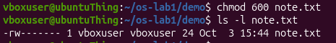
Figure 1.3 – Permissions of the file after changing the mode to 600

1.4 Directories under the root
The third question concerns two directories located directly under the root and the content of each of them.
Linux organises files as a single unified tree. At the top there is the root /, holding everything inside of itself, as shown in figure 1.1. In particular, it holds directories such as:
- the /home directory, which is the space designed for the user;
- the /etc directory, which holds various configurations for the system and services.

2 PROCESSES

2.1 Findings
It is fascinating that processes on Linux can be expressed through files in /proc/, as shown in figure 2.1 for a background sleep process. This illustrates the UNIX philosophy of “Everything is a file”.
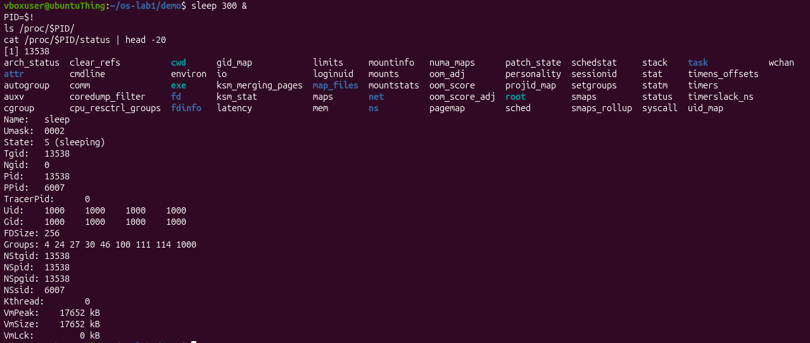
Figure 2.1 – Information about a background process exposed by the kernel

2.2 Process number 1
The first question concerns the process identifier (PID) of process number 1 and the nature of this process.
The question admits two readings. If it asks for the PID of the first process, the answer is 1. Otherwise, it can be interpreted as asking what the process with PID 1 is. In this case, the answer is systemd, as shown in figure 2.2 and figure 2.3. It is the first process instantiated in user mode, and every following user-space process is its descendant. It is started by the kernel.
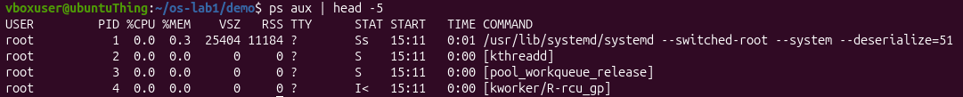
Figure 2.2 – First lines of the process list
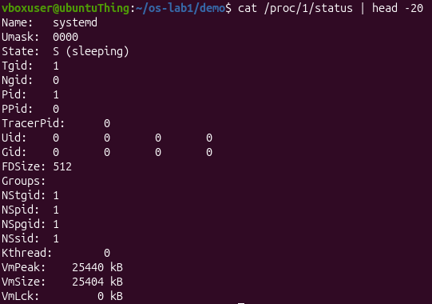
Figure 2.3 – Status of the process with PID 1

2.3 Number of running processes
The second question concerns the approximate number of processes running on the idle virtual machine (VM).
According to figure 2.4, 236 processes were counted. One line was excluded, because it is the header with the information columns.
Figure 2.4 – Number of lines in the process list

2.4 State of a sleeping process
The third question concerns the content of the State: line from the status file of the sleeping process.
According to figure 2.5, the State: line of the sleeping process says S (sleeping).
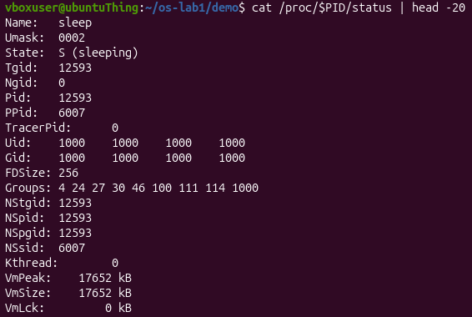
Figure 2.5 – Status of the sleeping process

3 MEMORY

3.1 Findings
It was interesting to discover the concept of swap memory, namely that disk space can act as RAM in certain circumstances. The memory and swap totals of the system are presented in figure 3.1.
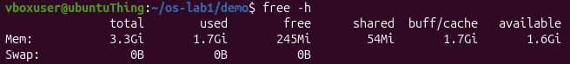
Figure 3.1 – Memory and swap totals reported by the system

3.2 Total and free RAM
The first question concerns the total amount of RAM of the VM and the amount of free RAM.
According to the output of free -h in figure 3.1, the VM has 3.3 GiB in total, with 245 MiB absolutely free and 1.6 GiB available for use.

3.3 Swap memory
The second question concerns the definition of swap and the amount of swap configured.
Swap memory is disk space that the OS uses as an extension of RAM, and it acts as a very slow safety net for processes. According to figure 3.1, the amount of swap memory configured is 0 B.

3.4 Resident memory of a sleeping process
The third question concerns the amount of resident memory (VmRSS) used by a bare sleep process and whether this amount is surprising.
As shown in figure 3.2, the sleep 300 process uses 8 MB of VmRSS. This value is surprising, because it seems excessive for a simple sleeping process. A possible explanation is that the system counts the memory of some elements additional to sleep, thus not displaying the true memory usage.
Figure 3.2 – Resident memory of the sleeping process

4 DEVICES AND STORAGE

4.1 Findings
The fact that the system can communicate with devices via files in /dev/, as shown in figure 4.1, solidifies the concept of “everything is a file”, since it allows a standard way of interacting with devices.
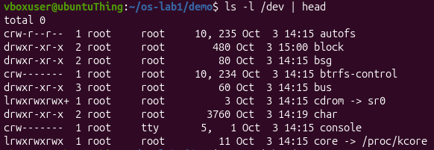
Figure 4.1 – Devices presented as files

4.2 Device of the root filesystem
The first question concerns the device on which the root filesystem / is mounted.
According to figure 4.2, the root filesystem / is mounted on /dev/sda2.
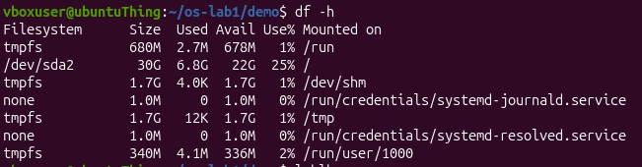
Figure 4.2 – Mounted filesystems and free space

4.3 Entries in the device directory
The second question concerns one entry from /dev and the real thing that this entry stands for.
The entry /dev/bus/, visible in figure 4.1, represents the direct access to hardware buses. It can be used for gaining access to USB via /dev/bus/usb/.

4.4 Meaning of “everything is a file”
The third question concerns the meaning of “everything is a file”, based on the observations made.
“Everything is a file” is the philosophy of the OS according to which not only plain data, but also the hardware (files in /dev/) and even the processes (files in /proc/) are expressed as files, for simplicity.

CONCLUSION
The OS manages files, processes, memory and devices. More precisely, this fact can be confirmed by the following commands:
- managing files: ls -l;
- managing processes: top;
- managing memory: free -h;
- managing devices: ls -l /dev | head.
In conclusion, an operating system encapsulates tedious tasks and critical decisions in order to provide a simplified and comfortable usage of the computer to the user.

