HOW TO COMPILE SOURCE CODE OF MBLOCK USING FLASH BUILDER
1， Install flash builder 4.7 premium:
1， Install flash builder 4.7 premium:
https://creative.adobe.com/products/download/flash-builder
2， Download AIR-SDK
http://www.adobe.com/devnet/air/air-sdk-download.html
3, Download mblock Source Code:
https://github.com/Makeblock-official/mBlock/tree/master/source
4, Download Adobe AIRinstaller for run time compiler http://download.macromedia.com/air/win/download/21.0/AdobeAIRInstaller.zip
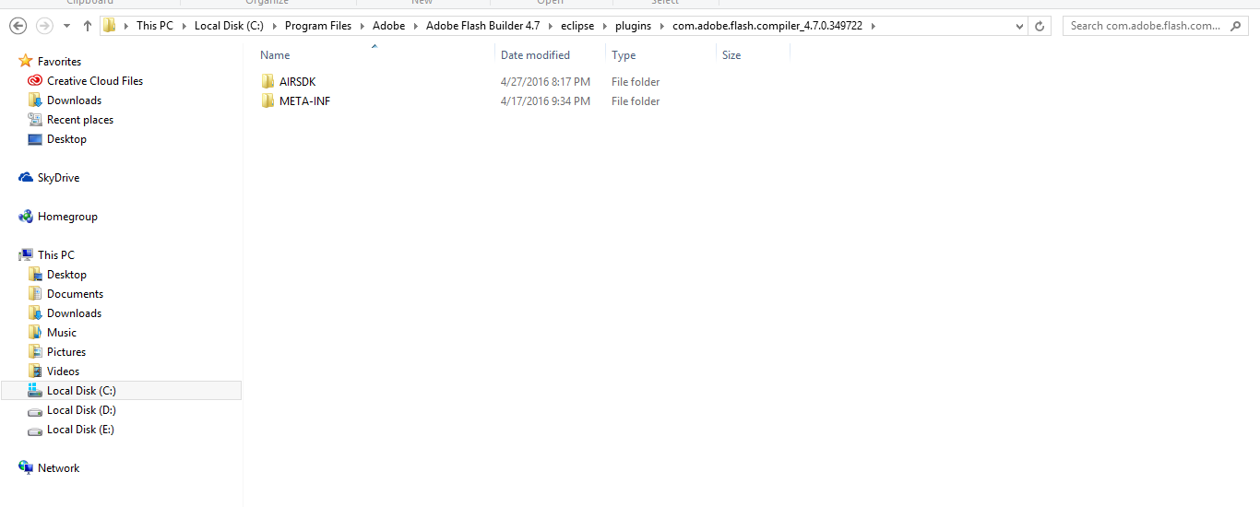
5, Unzip AIRSDK and Copy to： C:\Program Files\Adobe\Adobe Flash Builder 4.7 (64 Bit)\eclipse\plugins\com.adobe.flash.compiler_4.7.0.349722\AIRSDK
(Replace your downloaded AIRSDK with this)

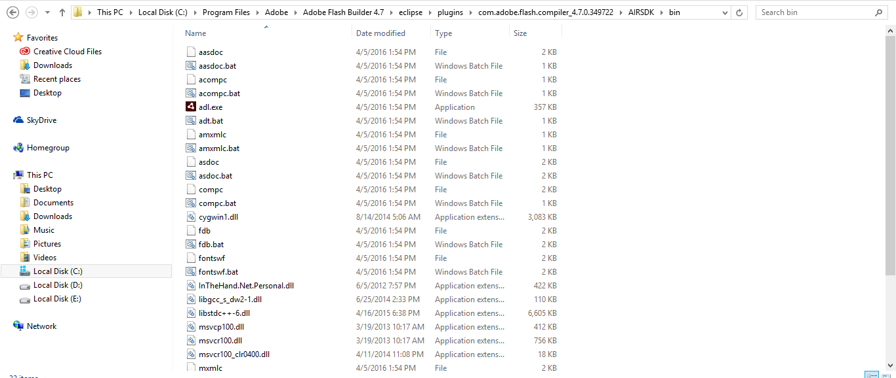
6, Copy DLL files( avoid a flash builder's bug ) to : C:\Program Files\Adobe\Adobe Flash Builder 4.7 (64 Bit)\eclipse\plugins\com.adobe.flash.compiler_4.7.0.349722\AIRSDK\bin
download qt-dll.zip (2.1 MB) msvc-dll.zip (547.5 KB) cygwin1.dll.zip (1.0 MB) bluetooth-dll.zip (173.1 KB)
(Extract all the dll files and into the bin)
7, Launch Flash builder 4.7
Create New ActionScript Project named "MBlock" and click on Desktop application

8, Import Source Code：Replace your Project src with MBlock src
mblock\source\src instead the src folder of new project
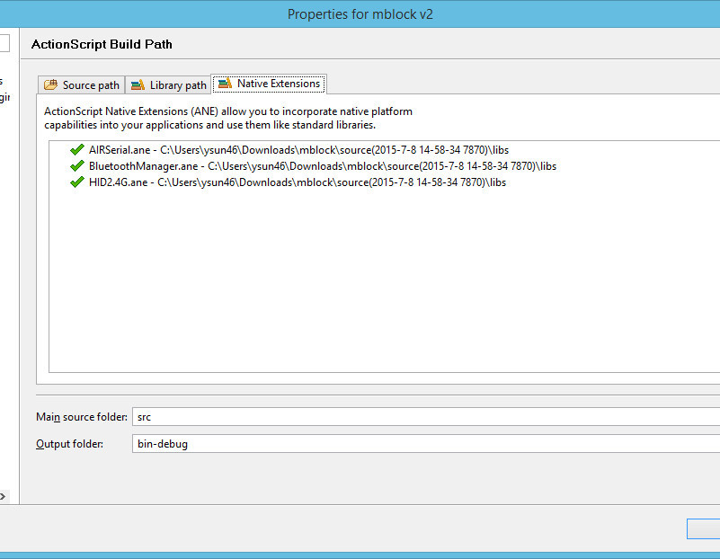
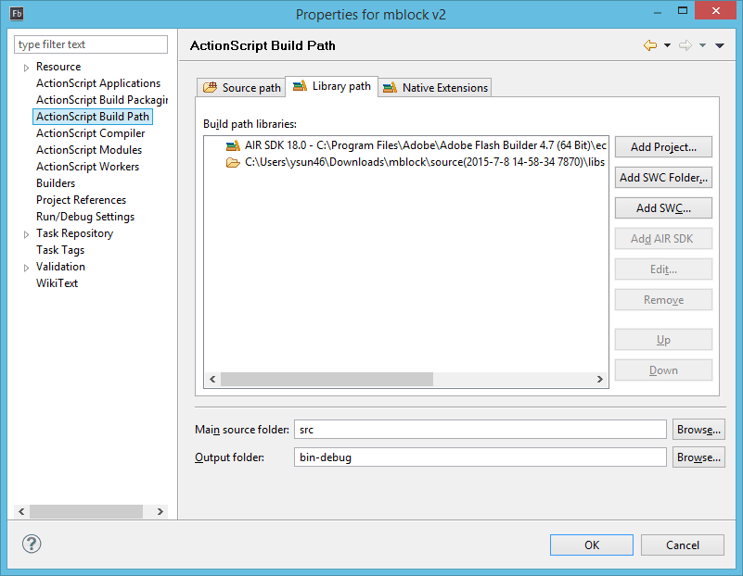
9, Open Project's Property in Flash Builder IDE：
add Libraries Folder： mblock\source\libs
add ANE： mblock\source\libs*.ane

10, Modify Mblock-app.xml，Use your AIR SDK Version below：
<application xmlns="http://ns.adobe.com/air/application/18.0">

11, Ready to Compile

