**Arduino Based Keypad Door Lock System**

Made By:

Abdul Rehman

Amir

Acknowledgement:

<http://www.instructables.com/id/Keypad-Door-Lock/>

Parts Used:

Arduino UNO

Keypad 4x4

Relay (SRD-5VDC-SL-C)

Red Led x1

Green Led x1

Buzzer

DC Motor

Breadboard

Explanation:

This is a door lock system which can replace traditional lock with digital passwords. It will check right password is entered then it opens door for 5 seconds then closes it automatically.

In this version we have dc motor to open door. And lock will have backup power source too, so that it can be used at time of power failure.

Arduino code is available on: https://github.com/Makeistan/Arduino-Keypad-Door-Lock-

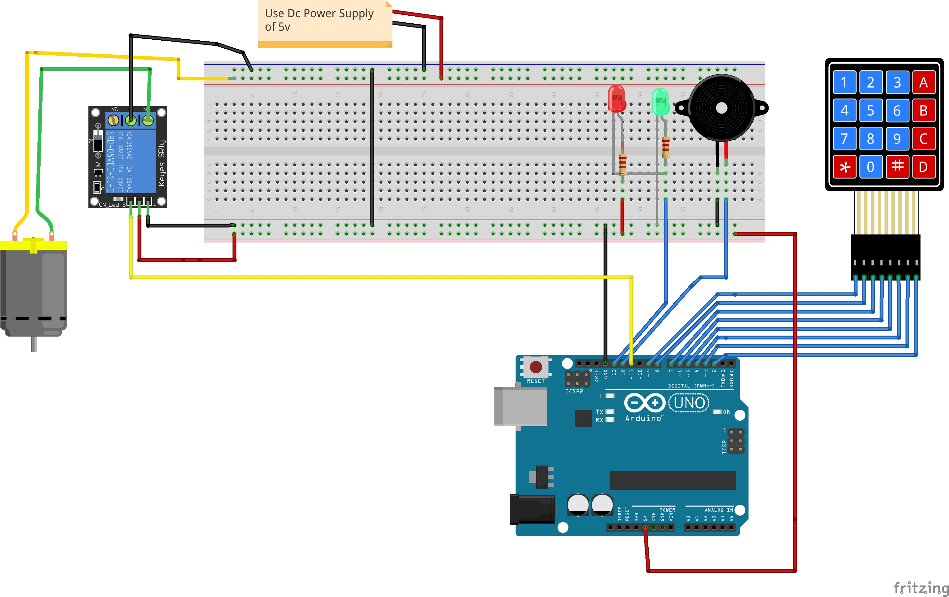Schematics: