Nigran

Environment Parameters Recording and Communication System using Arduino & Sensors

Made in

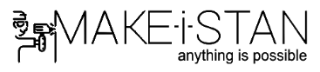

Introduction

Nigran, an invigilator by name is a tool for updating data on a server. This setup uses one way communication for sending data to a website, which updates the dataset maintained on a server.

Reference:

1. Cover Image by Anton Rusetsky [<https://unsplash.com/photos/PTiNuIxdKrk>]
2. Previously deployed Heroku App: [<http://damp-crag-29984.herokuapp.com>]