Database Report #2

8/1/19

## Completed this week

* Updated database tables for better data storage
* 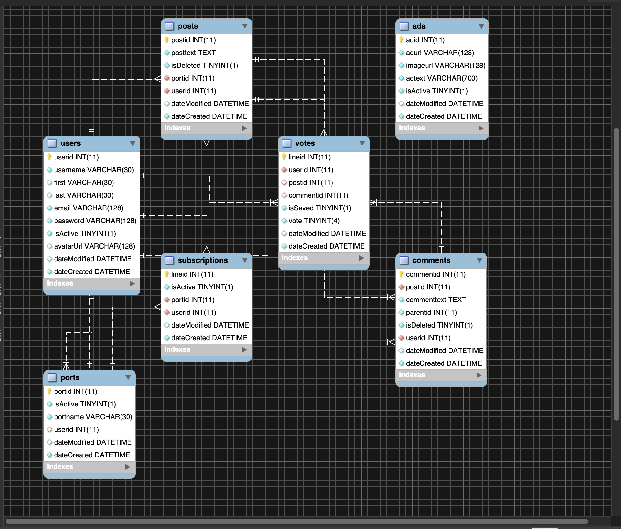
* Added database table ‘votes’ as per front-end request

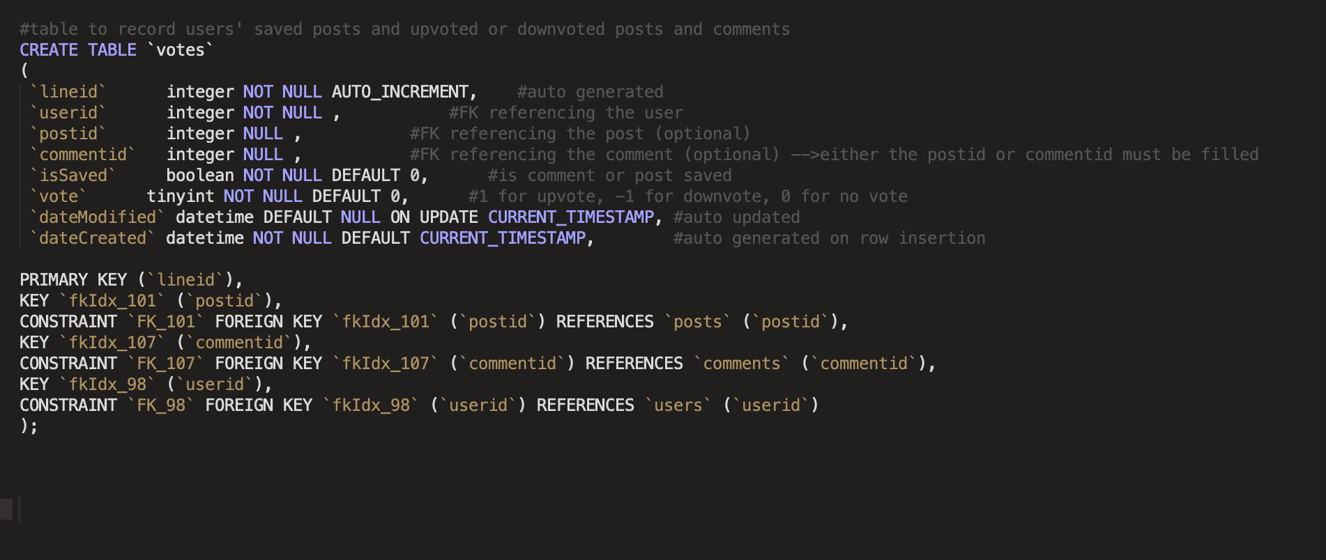

* Created two additional test functions for the back-end to implement

Seen in dbmodule.py and testable via url requests shown in dbroutes.py

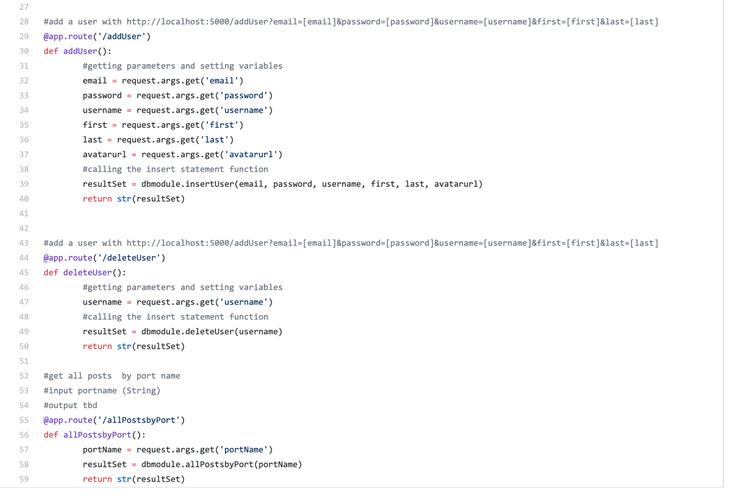

* Created many queries in sql that will be integrated into functions
* Created [sample data](../Downloads/Database_proj.sql) for the database to assist with testing and have content available for implementation – will be pushed to github later in the weekend!

## Coming Up...

* Adding further function to the database module, including more queries and inserts, etc
* Working further with the backend team to make sure all the necessary queries, updates, and inserts are going into the code
* Working with backend and QC teams to assure data integrity and reduce errors