**Bill Daugherty II**

08

**The TV Meta Data Finder**

**Indexing Your TV Media**

**Bill Daugherty II**

# General Overview

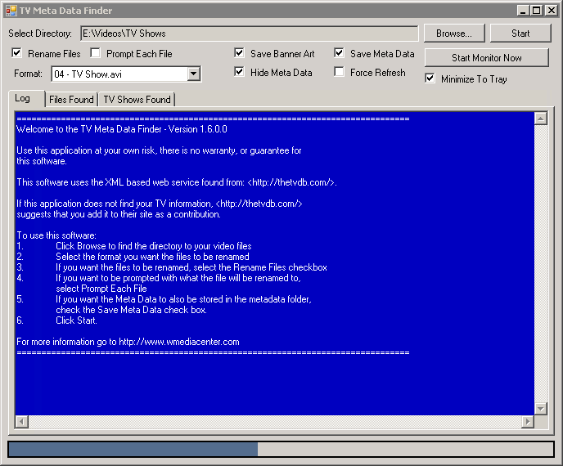

* Select Directory – Read only field, shows the directory last picked
* Browse – Allows you to pick a directory to scan for TV Shows
* Start – Starts the process with the given options
* Rename Files – Renames the files as it finds them
* Prompt Each File – If a file is found and it would like to rename it, it will prompt you first
* Save Banner Art – Saves the banner art that is found (if any) to your folder structure
* Save Meta Data – Saves the meta data in a “metadata” folder in the format of XML
* Format Dropdown – When renaming the files, it will rename it to the format of the drop down value that is selected
* Hide Meta Data – If banner art and/or meta data is found, it will hide folder, and root images
* Force Refresh – Regardless if the metadata is found for a given file, it will override the file with a refreshed version of the meta data, otherwise it will just skip writing metadata for that file. It is good to do once in a while as errors are fixed in the database server
* Start Monitor Now – Starts listening for new files in the selected directory, you can now minimize this and keep it running, and as you move videos to the monitored location, it will detect it and start the process on that directory
* Minimize To Tray – When minimized, the application will hide from the task list and move to the system tray instead
* Log Tab – Will keep a short list of all the actions that were taken
* Files Found – When files are found, it will show up here (not very useful for a lot
* TV Shows Found – Will show a listing of all the shows that were found

# Directory Structure

The application requires you to have the directory format of the following:

E:\Vidoes\TV Shows\Show Series Name\Season 1\01 – Episode Title.avi

E:\Vidoes\TV Shows\Show Series Name\Season 1\02 – Episode Title.avi

E:\Vidoes\TV Shows\Show Series Name\Season 1\03 – Episode Title.avi

The highlighted yellow and red text MUST be present, and some identification of the episode number. Anything before and after in gray is optional.

The TV Show file names may also contain most strings such as: 01x02 or 01e02, etc… for season 1, episode 2, it will rename it to your selected naming format.

In a version to come, I plan to change both the required directory structure, and the fixed set of filenames.

Version 2.0 I am planning on a completely new design and build. I will use some of the same source code, however I will redesign it from ground up.