Fusion 360

Install PostProcessor
- Start Fusion 360.
- Navigate to the Manufacture Workspace.
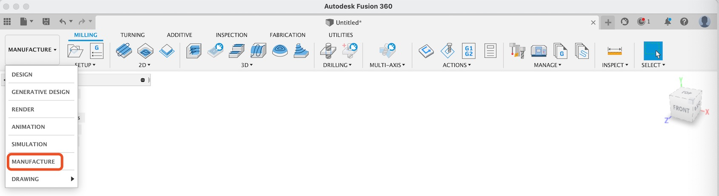
- Under the Manage group, select the Post Library button.
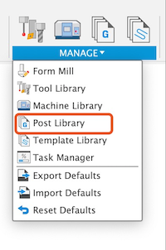
- Navigate to the "My Posts->Local" folder.

- Click the "Import" button.
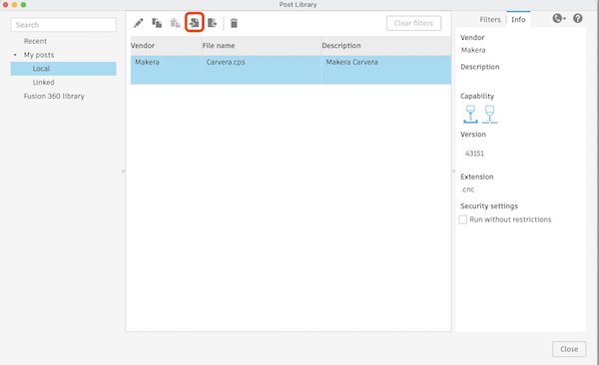
- Select the "Carvera.cps" file and finish the importing.

Install Machine
- Under the Manage group, select the Machine Library button.
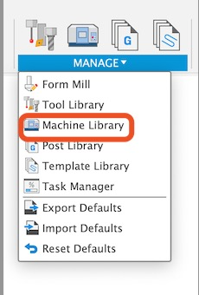
- Navigate to the "My Machines->Local" folder.

- Click the "Import" button.
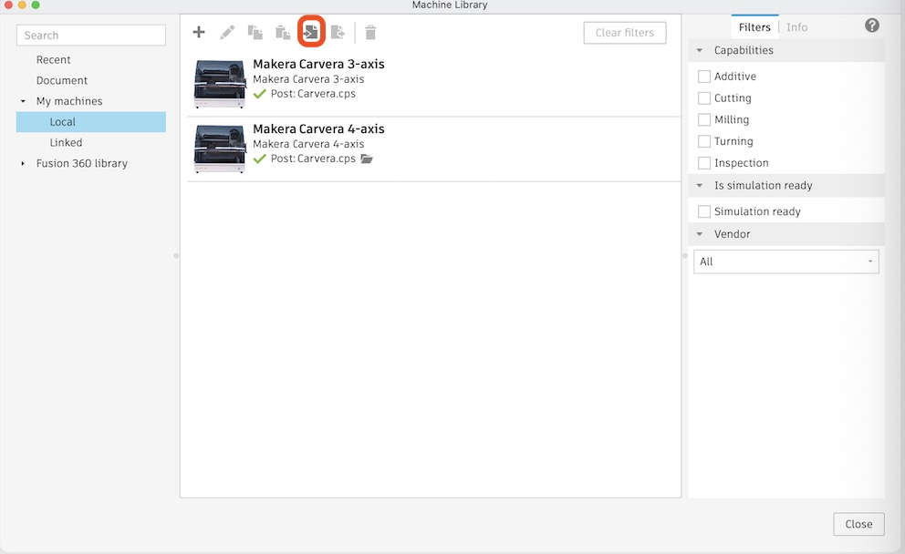
- Import the machine definition .f3d files from CAM_Post_Processors/Fusion360-profiles/. They are labeled by machine and features

Install Tool Library
- Under the Manage group, select the Tool Library button.
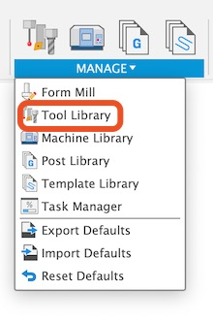
- Navigate to "All->Local".
- Right click the "Local" folder and click the "New folder" button, create a new folder named "Carvera Tools".
- Right click the new folder and then click the "Import libraries" button.
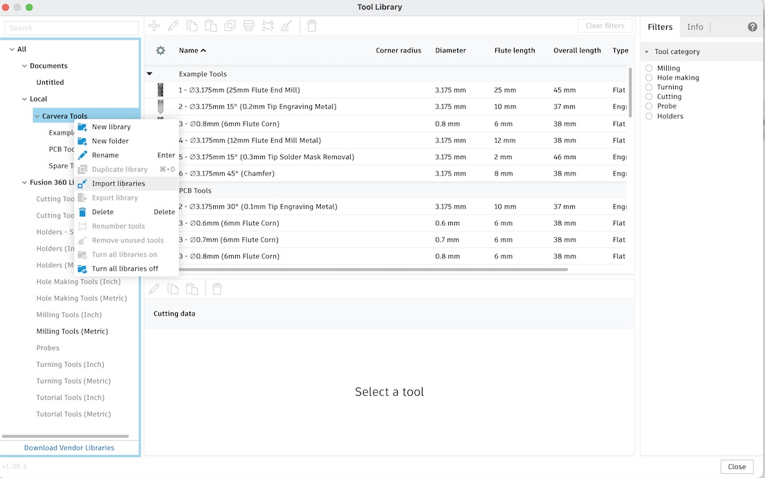
- Import the .tools files from CAM_Post_Processors/Fusion360-profiles/Tool Files/ (for example: Makera Ball Endmills.tools, Makera Drill Bits.tools, Makera Engraving Bits.tools, Makera O Flute Bits.tools, Makera Corn Bits.tools, Makera Thread Mills.tools, Makera Other Tools.tools, and Makera ToolHolders.tools).

Using Fusion360 Profiles
- When creating setups, select the imported Makera Carvera machine profile that matches your hardware (for example 3-axis, 4-axis, Air, or Harmonic).
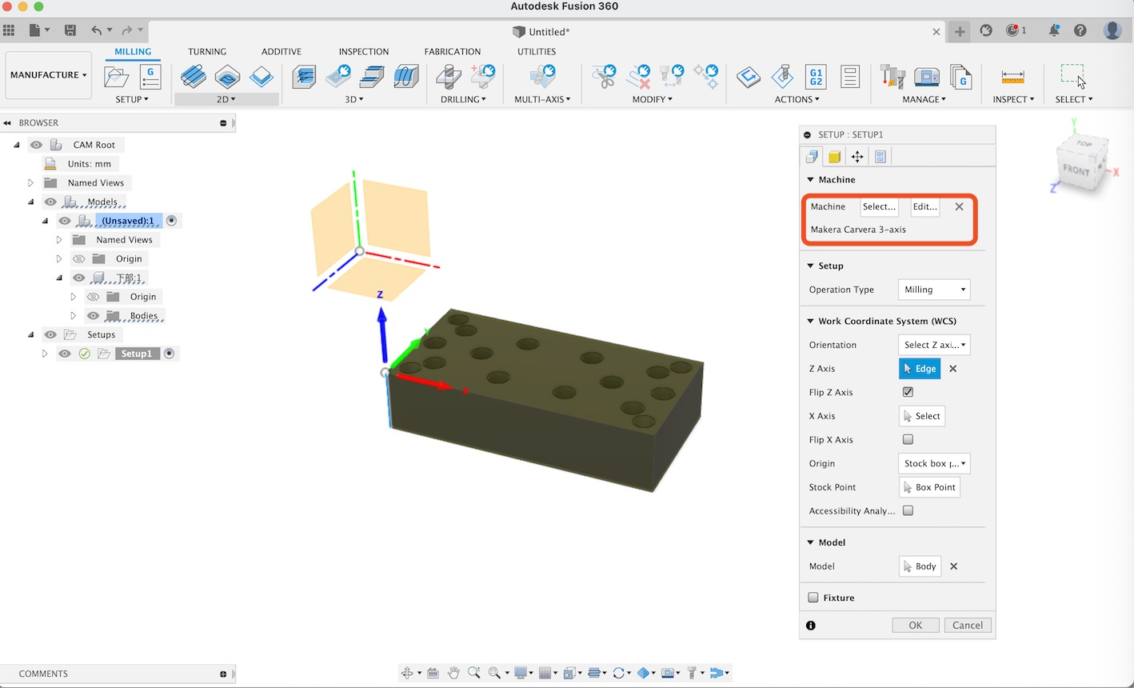
- When doing post process, select the Makera Carvera machine and the Carvera.cps post file.
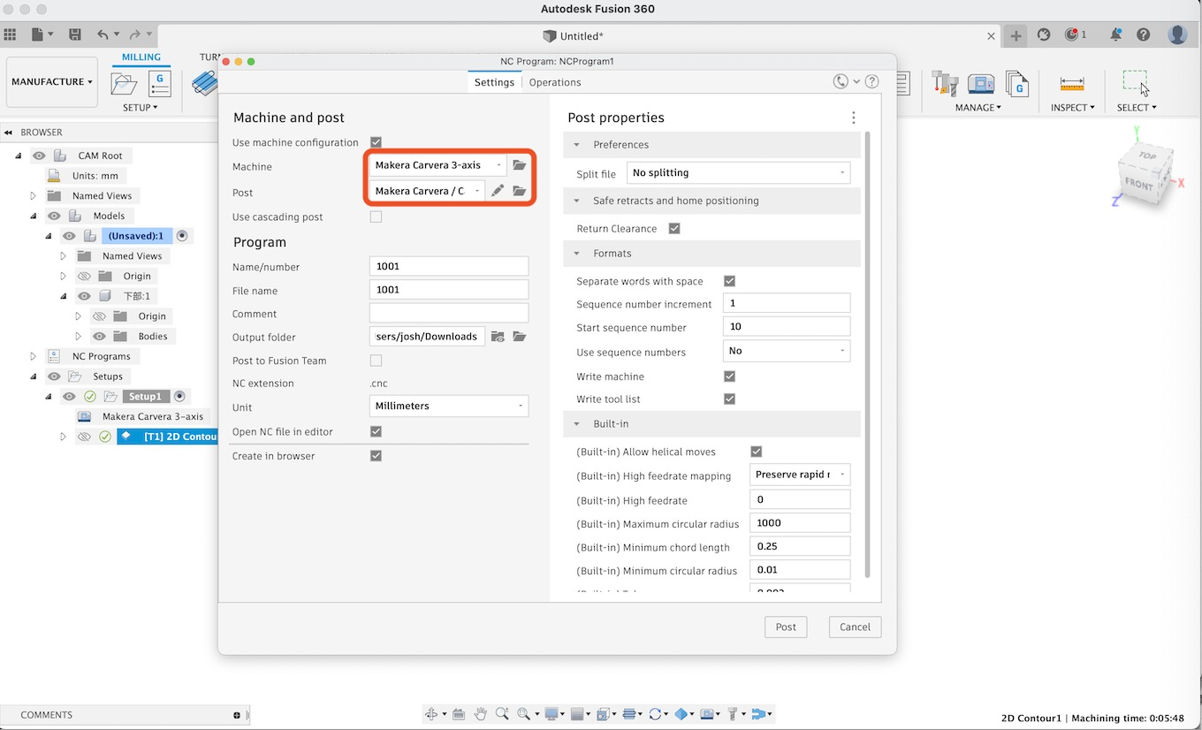

- the post properties page now looks like this:
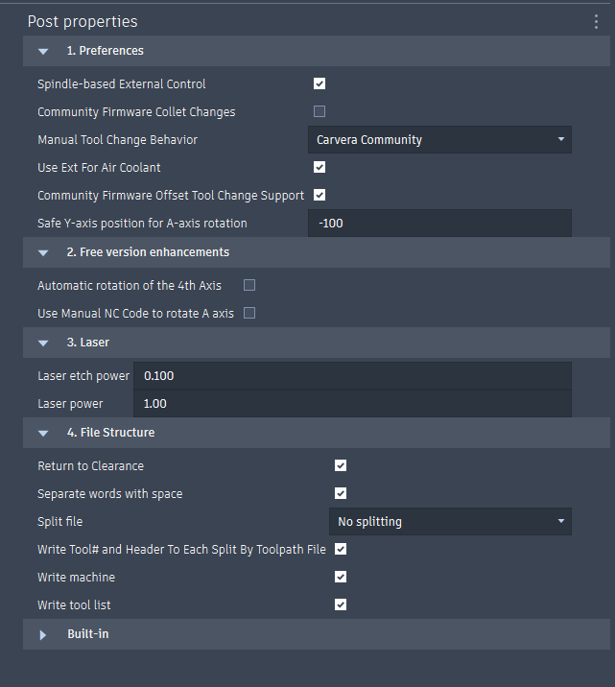

You want to select the machine you are using in the manual tool change behavior.
Spindle based external control turns on the ext port whenever the spindle is turned on
Ext for air coolant turns on the ext port whenever the coolant type is set to mist
All of the community options are expanded upon in the community gitbook: Gitbook - View
The laser module only works with one set of etch and engraving values. It can be set up in the following way:
Using the laser:
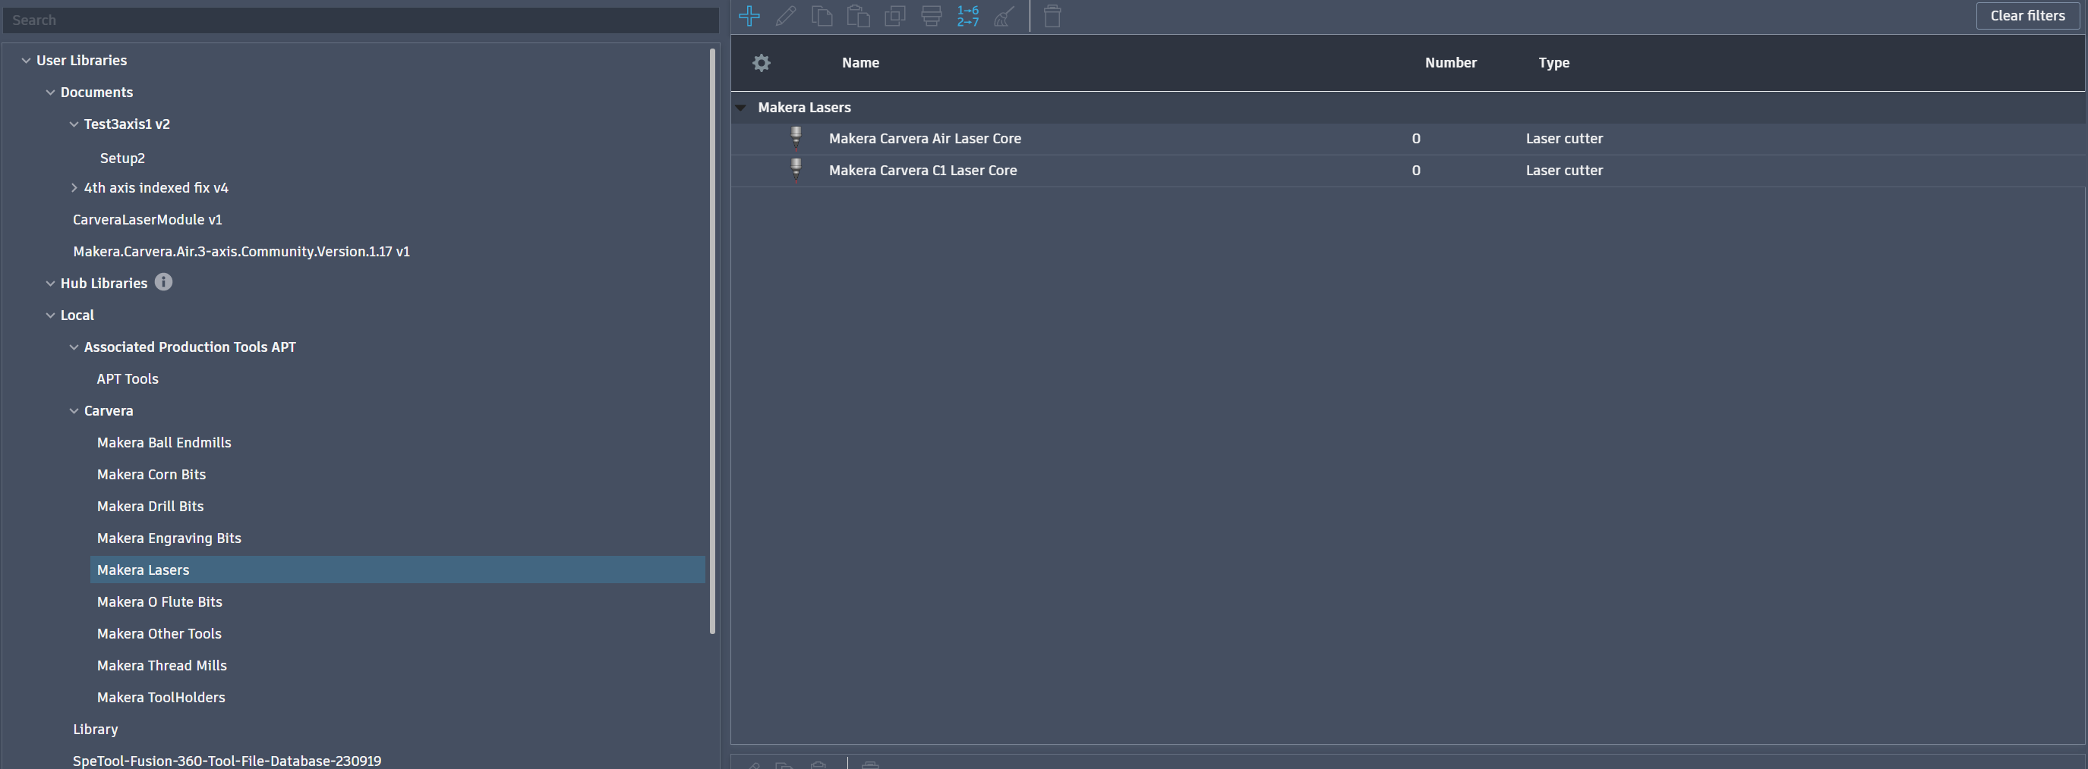
- in the fabrication manufacturing tab, select the laser cutting feature
2. Select the carvera or carvera air laser from the tools pack attached to this github
3. use through-auto or etch cutting method 4. when posting the file set the power you want the laser to use, laser power is for through cutting
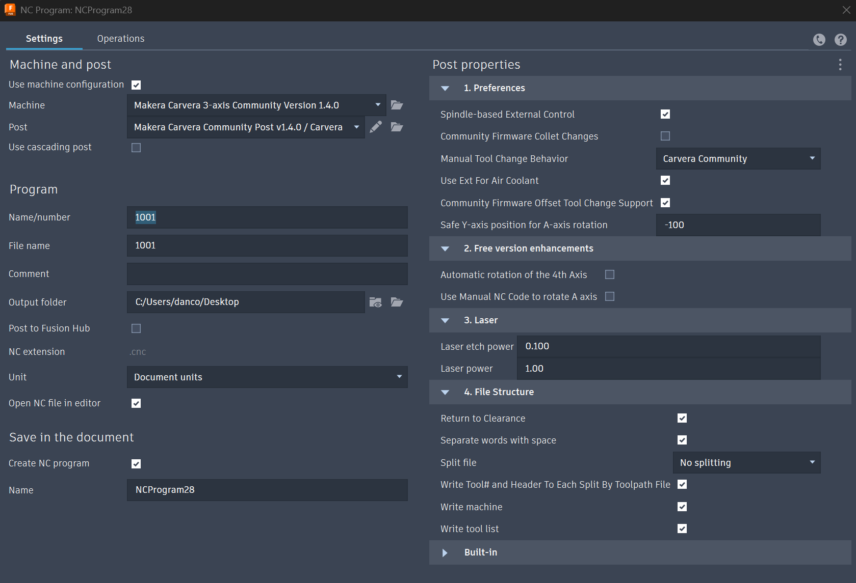

Manual NC dropdown commands:
Dwell -pause for x seconds
Stop -pause and wait for input from tne user
Comment -write a comment into the file
Measure Tool -run a tool length offset calibration on the current tool
Tool Break Control -run a tool break test. Requires the community firmware
Pass Through -send the contents of the input box directly to the machine
Useful Pass Through Commands
M98.1 "nameOfFile" -open subprogam by name
M98 P2002 -open subprogram by number, this command would open and run /macros/2002.cnc before returning to the main program
The following ACTION commands are supported by this post.
RapidA:# -rapids the a axis to degree position
SaferA:# -Moves the z axis up to its clearance poition then moves the a axis
SafeZ -Go to a safe z height (same height as the clearance position)
SpindleOff -turns the spindle off
Clearance -goes to carvea clearance position
ClearAutoLevel -clears the auto level data from the machine
ResetFeedOverride -resets the spindle override value to 100%
FeedOverride:# -sets the feed override to a given percent. Useful for vetting new programs as well as speeding up an entire set of operations quickly
AirOn -Turns the compressed air on
AirOff -Turns the compressed air off
VacOn -Turns on the vacuum
VacOff -Turns off the vacuum
AutoVacOn -turns on auto vacuum
AutoVacOff -turns off auto vacuum
LightOn -turns on the light
LightOff -turns off the light
ShrinkA -Shrinks the A axis with offset 0, so A365 will turn into A5

