Software Usage
- Open and connect to the host computer
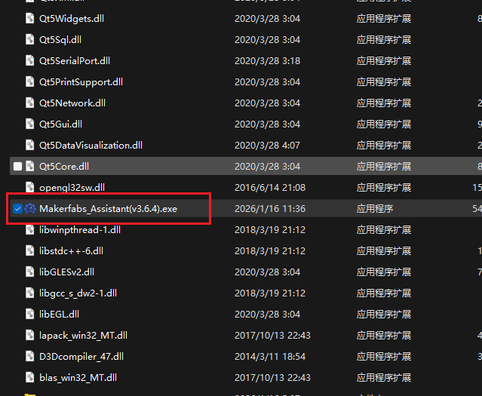
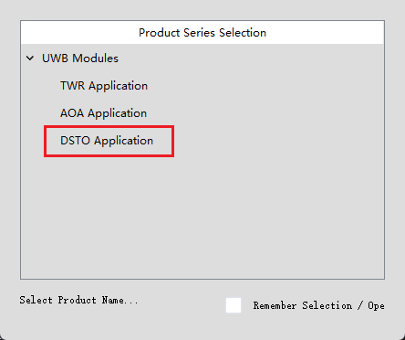
Note: When data is transmitted, garbled characters may appear in the [Serial Port/Network Assistant]. This data is not actually garbled, but rather hexadecimal data.
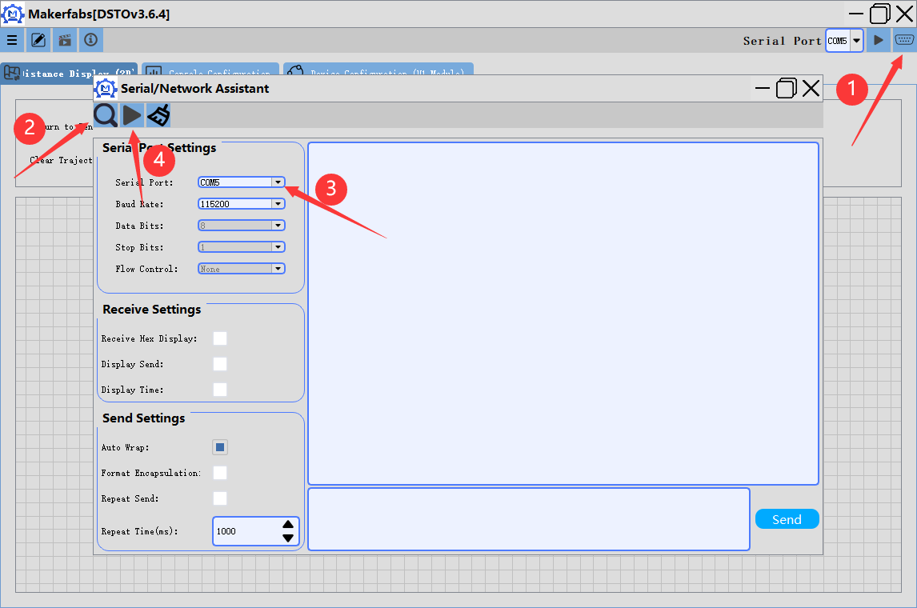
- Distance display interface
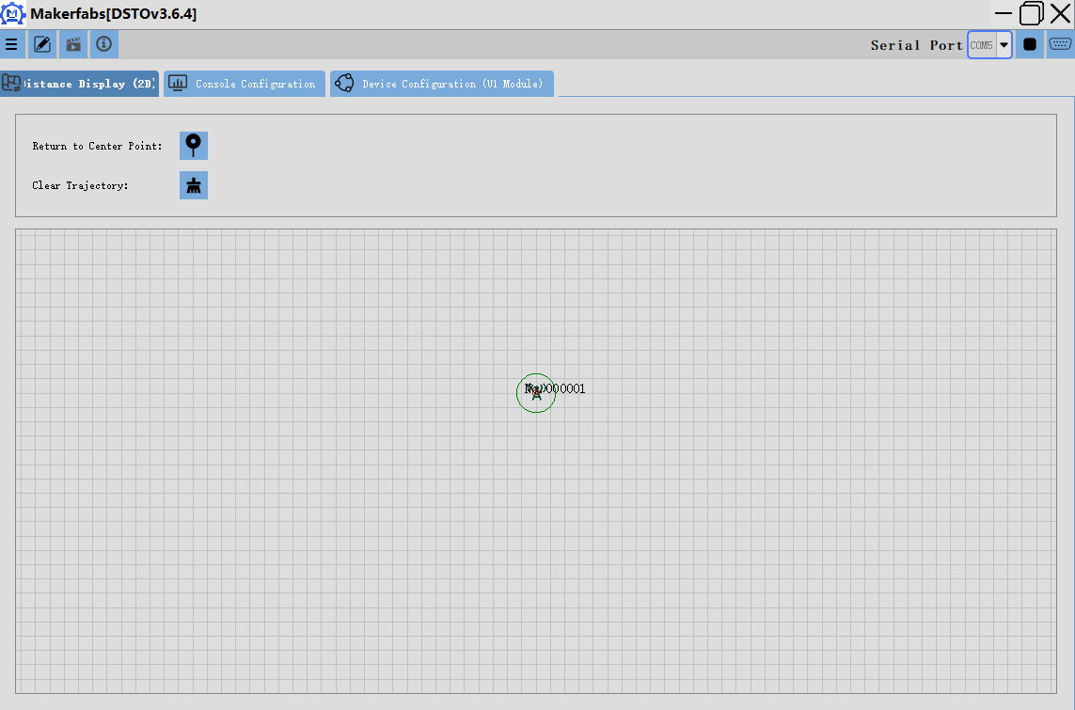
- Console configuration interface
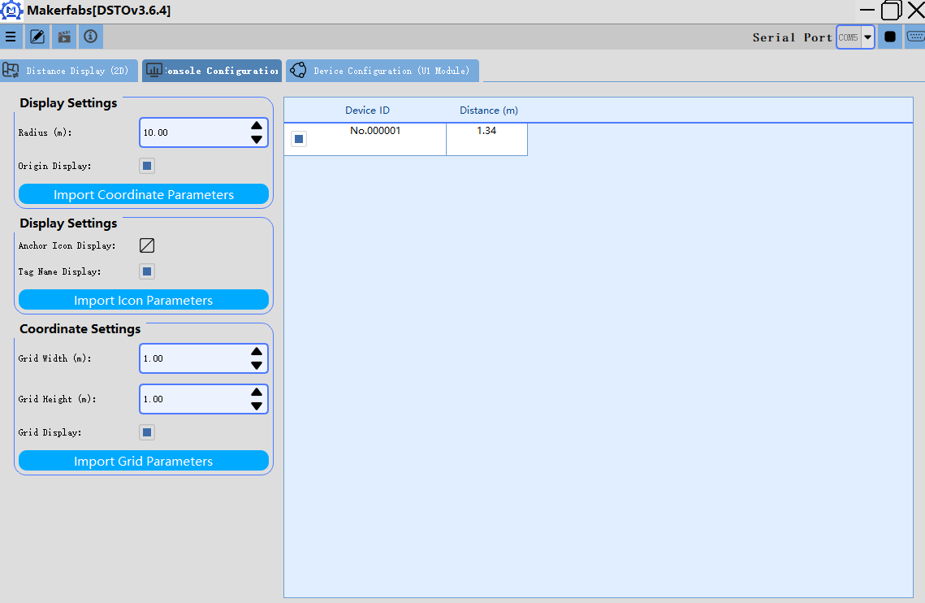
[Table Parameters]
Device ID: devID of other devices (user-defined)
Device Distance: Distance from other devices to this device
Device Capacity: Type of other devices
Device Network: Operating mode of other devices
Device Power: Voltage of other devices
Device PA Enabled: Charging status of other devices

- Device configuration interface
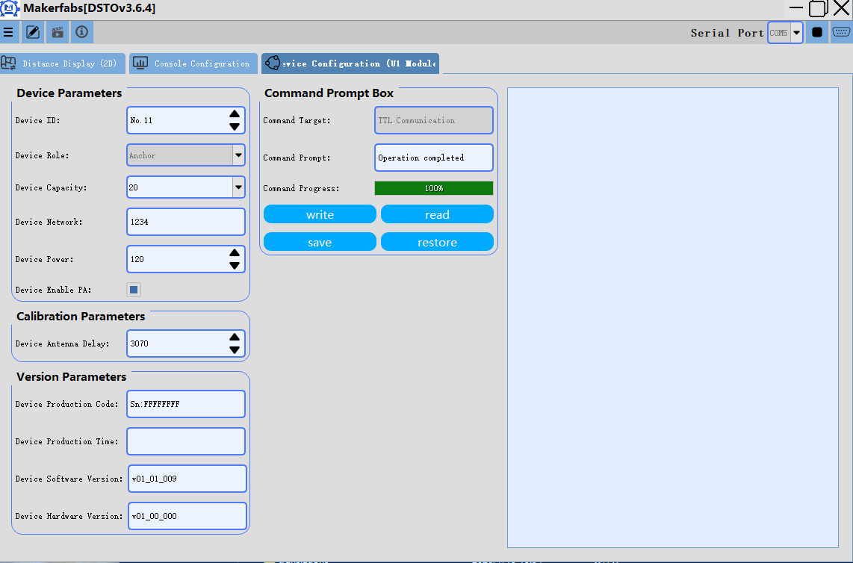
Parameter Description:
【Device Parameters】
Device ID: Device ID, no upper limit 0-100000 (upper computer range, actually an int type)
Device Role: Default
Device Capacity: Default setting is 20, if you have specific capacity requirements, please contact our company for modification.
Device Network: Devices with the same network ID can measure distances to each other; different networks are not allowed to measure distances.
Device Power: Device power setting (0-120)
Device PA Enable: Power amplifier setting (0: Off 1: On)
【Calibration Parameters】
Device Antenna Delay: Adjusts the error in distance measurement during module ranging (default is sufficient)
【Version Parameters】
Device Production Code: The unique MAC address of the device at the time of manufacture
Device Production Time: The manufacturing date of the device
Software/Hardware Version: Base station software version number

Reading Parameters Instructions:
Step 1: Click [Read]

Writing Parameters Instructions:
Step 1: Click [Read]
Step 2: Modify the parameters
Step 3: Click [write]
Step 4: Click [save]

