UWB DSTO Data Sheet
version: 1.0
by: Lin
目录
UWB DSTO Data Sheet 1
1. System Introduction 1
1.1 System Introduction 1
1.2 System Features 2
1.3 Application objects 2
1.4 System application schematic diagram 3
2. Module Hardware Specifications 4
2.1 Module Hardware Pin Definitions 4
2.2 Module hardware packaging dimensions 5
3. Communication Protocol Description 6
3.1 Distributed Ranging Frame 6
3.2 Node configuration frame 7
3.3 OTA upgrade frame 7

System Introduction

System Introduction
Makerfabs Electronics' DSTO series distributed ranging system is a high-performance,secure ranging system independently developed based on UWB (Ultra-Wideband)technology. This system boasts excellent ranging accuracy down to 10 centimetersand provides real-time distance information at a refresh rate of up to 500Hz, achieving millisecond-level ultra-fast response. lts distributed architecture theoretically allows for unlimited system node capacity and enables data packet output via standard serial ports, significantly reducing intergration complexity.

Distributed ranging: UWB-DSTO moudle
Product Images | 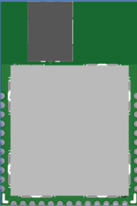
Coverage | Open view with visibility up to 200 meters
External dimensions | 28mm*19mm*3mm
Power supply method | DC3.3v
Antenna design | Built-in antenna
Operating temperature | -20℃~60℃
Operating frequency | CH9 band 8987.2MHz
Refresh rate | 500Hz
System capacity | System capacity is unlimited / Capacity in the same area is 20(Contact for capacity adjustments)

System Features
- Flexible network, unlimited capacity: The distributed architecture supports unlimited node expansion, allowing system capacity to grow on demand and easily handle future business upgrades.
- Ultra-fast response, imperceptible latency: A 500Hz refresh rate ensures instantaneous data feedback within 2 milliseconds, meeting the most demanding real-time control and safety application requirements.
- Intelligent Networking, Plug and Play: Nodes possess autonomous discovery and networking capabilities, enabling rapid deployment and system self-healing, greatly simplifying operation and maintenance.
- Exceptional Accuracy, Reliable Foundation: High-precision ranging with 10-centimeter accuracy and stable performance, providing reliable distance information even in multipath interference environments.
- Ultra-Long Ranging, Unrestricted Operation: A maximum open-space visual range of 200 meters, perfectly suited for large indoor and outdoor scenarios, providing ample operating space.

Application objects
- Drone formation applications
- Forklift anti-collision applications
- AGV/AMR cluster scheduling and anti-collision applications
- Robot collision-free collaborative applications
- Mining truck anti-collision and collaborative applications

System application schematic diagram
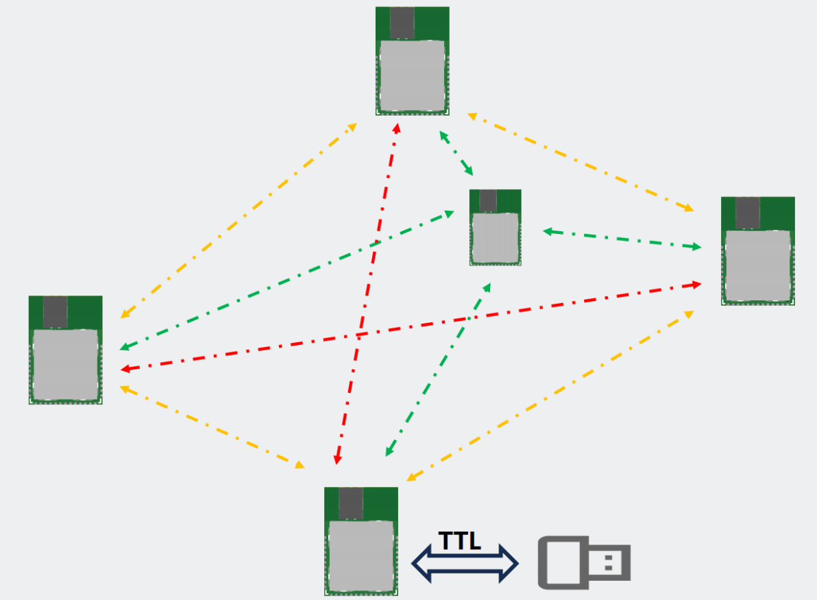
Schematic diagram of distributed distance measurement.

Module Hardware Specifications

Module Hardware Pin Definitions
Module Pinout Description 1
Module Pinout Description 2
Pin | Function
1/2/10/11/19/20/24/34/35 | GND
3 | UART_Rx Pin speed 115200
4 | Download CLK
5 | Download DIO
6/12/13/14/15/16/21/23/  25/26/27/28/29/30/31/32 | NC must be suspended
7 | UART_Tx Pin speed 115200
8、9、22 | 3V3 power supply
17 | Output pins(status indicator lights)  Configured: Fast flash(10hz)  Not configured: Show flash(1hz)
18 | -
33 | Output pin (Networking indicator LED)  Networked: Slow flashing (1Hz)  Not networked: Off (Low level)

Module hardware packaging dimensions
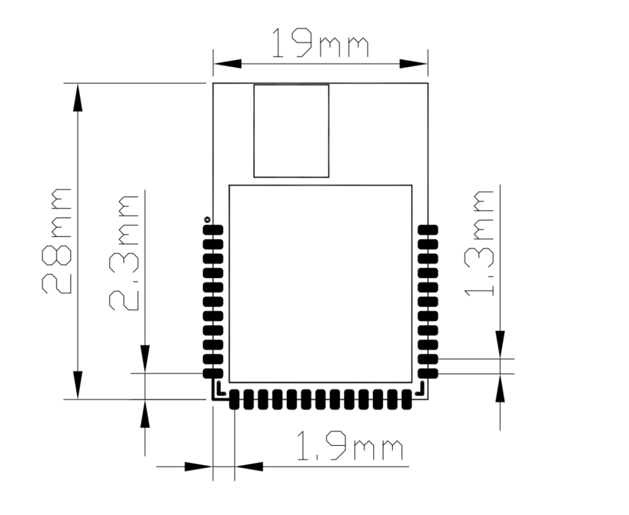
Module size specifications

Communication Protocol Description

Distributed Ranging Frame
Field name | Byte type | Length (Byte) | Index subscript | Function Description
head | uint8_t | 1 | 0 | Fixed header 0x2A
cmd_len | uint16_t | 2 | 1 | Data frame length (length of the fields: cmd_saddr saddr-reserve)
cmd_saddr | uint64_t | 8 | 3 | Self-assigned long address (8 bytes reserved)
cmd_daddr | uint64_t | 8 | 11 | Recipient's full address (8 bytes reserved)
cmd_type | uint8_t | 1 | 19 | Command frame types (0x02: Node configuration frame, 0x10: OTA upgrade frame, 0x71: Distributed ranging frame)
cmd_direct | uint8_t | 1 | 20 | Command frame direction (1: Engine request, 2: Device response, 3: Device request, 4: Engine response, 5: Engine report, 6: Device report)
dev_time | uint32_t | 4 | 21 | Device communication time
dev_devID | uint32_t | 4 | 25 | Device unique ID
dev_role | uint16_t | 2 | 29 | Device roles
dev_capacity | uint8_t | 1 | 31 | Device capacity
dev_sn | uint32_t | 4 | 32 | Device reporting serial number (sn)
dev_onlineCnt | uint8_t | 1 | 36 | Number of devices currently online
other(1..20) para | uint64_t | 8 | 37, 47, ... | Basic information about other devices; this is a bit structure.
other(1..20) dist | uint16_t | 2 | 45, 55, ... | The distance parameters for other devices are in centimeters (cm).
check | uint8_t | 1 | * | Checksum (Field: Checksum before cmd_saddr-check)[Note 2: Checksum calculation program]
foot | uint8_t | 1 | * | Fixed trailer byte: 0x23

Node configuration frame
Field name | Byte type | Length (Byte) | Index subscript | Function Description
head | uint8_t | 1 | 0 | Fixed header 0x2A
cmd_len | uint16_t | 2 | 1 | Data frame length (length of the fields: cmd_saddr saddr-reserve)
cmd_saddr | uint64_t | 8 | 3 | Self-assigned long address (8 bytes reserved)
cmd_daddr | uint64_t | 8 | 11 | Recipient's full address (8 bytes reserved)
cmd_type | uint8_t | 1 | 19 | Command frame types (0x02: Node configuration frame, 0x10: OTA upgrade frame, 0x71: Distributed ranging frame)
cmd_direct | uint8_t | 1 | 20 | Command frame direction (1: Engine request, 2: Device response, 3: Device request, 4: Engine response, 5: Engine report, 6: Device report)
config_cmd | uint8_t* | * | * | Configuration command set [Note 3: Base station configuration command set]
check | uint8_t | 1 | * | Checksum (Field: checksum of cmd_ saddr-config_cmd) [Note 2: Checksum calculation program]
foot | uint8_t | 1 | * | Fixed trailer byte: 0x23

OTA upgrade frame
Field name | Byte type | Length (Byte) | Index subscript | Function Description
head | uint8_t | 1 | 0 | Fixed header 0x2A
cmd_len | uint16_t | 2 | 1 | Data frame length (length of the fields: cmd and saddr-reserve)
cmd_saddr | uint64_t | 8 | 3 | Self-assigned long address (8 bytes reserved)
cmd_daddr | uint64_t | 8 | 11 | Recipient's full address (8 bytes reserved)
cmd_type | uint8_t | 1 | 19 | Command frame types (0x02: Node configuration frame, 0x10: OTA upgrade frame, 0x71: Distributed ranging frame)
cmd_direct | uint8_t | 1 | 20 | Command frame direction (1: Engine request, 2: Device response, 3: Device request, 4: Engine response, 5: Engine report, 6: Device report)
OTA_cmd | uint8_t* | * | * | OTA commands (developers can ignore this)
check | uint8_t | 1 | * | Checksum (Field: checksum of cmd_ saddr-OTA_cmd) [Note 2: Checksum calculation program]
foot | uint8_t | 1 | * | Fixed trailer byte: 0x23

[Note 1: Bit structure]
typedef struct {
uint64 t dev_mode:2; // Device Mode
uint64_t dev_id:32; // devID
uint64_t dev_type:3; // Device Type
uint64 t done:1; // ignore
uint64 t inNet:1, // Is networking enabled?
uint64 t reserve:25;}devPara t; // Reserved
} devPara_t;
[Note 2: Verification calculation program]
Static uint8_t get_Xor_CRC(uint8_t *bytes, int offset, int len)
{
uint8_t xor_crc = 0;
Int i;
for (i = 0l i < len; i++) {
xor_crc ^= bytes[offset + i];
}
return xor_crc;
}
[Note 3: Node Configuration Command Set]
Command | Meaning | Examples
restart | Reset | Reset
restore | Restore to factory settings | Restore to factory settings
save | Save | Save settings
getver | Get the version
setcfg (x1) (x2) (x3) (x4) (x5) (x6) | Set up configuration | setcfg 0 0 50 1122 0 1f  x1: 0-10000  x2: Device role (-1: not set, 0: tag, 1: base station. Default: -1 not set)  x3: Device capacity (20 devices in the same area)  x4: Device Network  x5: Device PA function (0: Off, 1: On. Default: 0 Off)  x6: Device power setting (0-120)
getcfg | Get configuration
setAntD(x1) | Set antenna delay | setAntD 3454  x1: Antenna delay parameter (default: 3454)
getAntD | Get antenna delay

