MaUWB AOA Anchor Data Sheet
version: 1.0
by: Leobo
目录
MaUWB AOA Anchor Data Sheet 1
1. Product Introduction 1
1.1 Product Introduction 1
1.2 Product Features 2
1.3 Application objects 3
2. Module Hardware Specifications 3
2.1 Module Hardware Pin Definitions 4
2.2 Module hardware packaging dimensions 4
3. Communication Protocol Description 5
3.1 Base Station Positioning Frame 5
3.2 Base station positioning frame RSSI 6
3.3 Base station configuration frame 8
3.4 OTA upgrade frame 9

Product Introduction

Product Introduction
Makerfabs Electronics' MaUWB-AOA-U is an ultra-small patch-type AOA base station module specially developed for the MaUWB-AOA positioning system, working cooperatively with MaUWB-AOA-T tags. Equipped with a built-in mini antenna array and metal shielding cover for anti-interference performance, the module receives UWB signals transmitted by wearable tags, calculates the real-time relative distance and incident angle of the target, and outputs filtered positioning data via TTL serial port to vehicle main controllers to realize automatic following for luggage trolleys, AGVs, service robots, balance cars and unmanned aerial vehicles. The bare-board ultra-compact form factor allows customers to embed it tightly inside compact devices for secondary integration and customized development.

Follow-up base station: MaUWB-AOA-U module
Product Images | 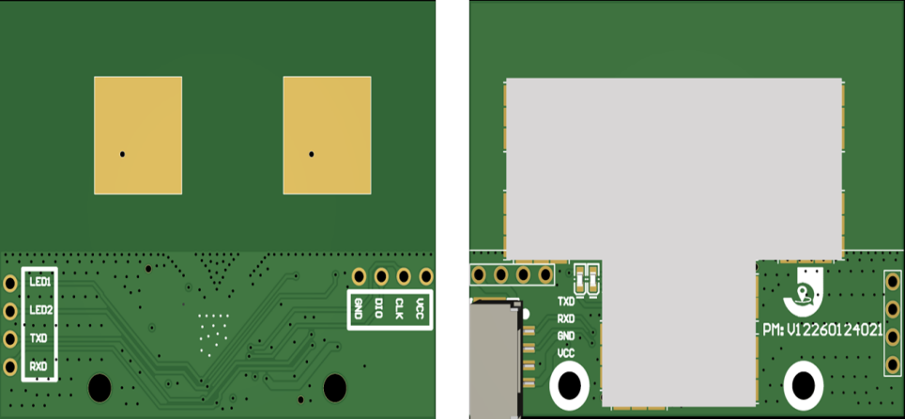
External Dimensions | 39mm*30mm*5mm
Product Weight | 4 g
Positioning Angle | 150° in front of the base station
Coverage radius | 50 meters - Wide open viewable area
Communication Methods | UART-TTL
Power Supply Method | 5V Power Supply
Installation Methods | M2 Fixed-Hole Installation
Frequency Range | CH9 (7987.2 MHz) (Complies with MIIT requirements)
Distance Measurement Error | <10CM
Angle Error | <5°
Operating Temperature | -20℃~+65℃
Use Cases | Follow scene application (use in conjunction with tags)
Features | The frequency band complies with MIIT regulations; ultra-compact size of 3.9 × 3 cm; compatible with the URAT protocol; and features a shielded housing to resist interference.

Product Features
- High-Precision Distance and Angle Detection: This module uses a miniature antenna array and ultra-wideband (UWB) radio technology to accurately measure the distance and angle between wearable tags and anchor points. It provides reliable positioning data for automatic tracking and control.
- Wide coverage and large detection field of view: It features a 150°front detection angle with an open-sight coverage radius exceeding 50 meters, offering ample moving space for various following devices and effectively avoiding tag signal loss.
- High resistance to interference; unaffected by ambient light: Equipped with a shielding cover, it is unaffected by changes in lighting and provides stable,reliable data in complex real-world environments.
- Simultaneous multi-target tracking to prevent tracking confusion:Avoid interference among multiple sets through the network ID. Support the simultaneous operation of multiple tracking devices.
- Easy to integrate with standard serial communication: Users can connect a TTL-to-USB adapter to view positioning data in real time using PC software, significantly reducing the complexity of secondary development.

Application objects
- Following applications of balance scooters and following robots
- Application of service robots
- Specialized robots and unmanned aerial vehicle applications

Module Hardware Specifications
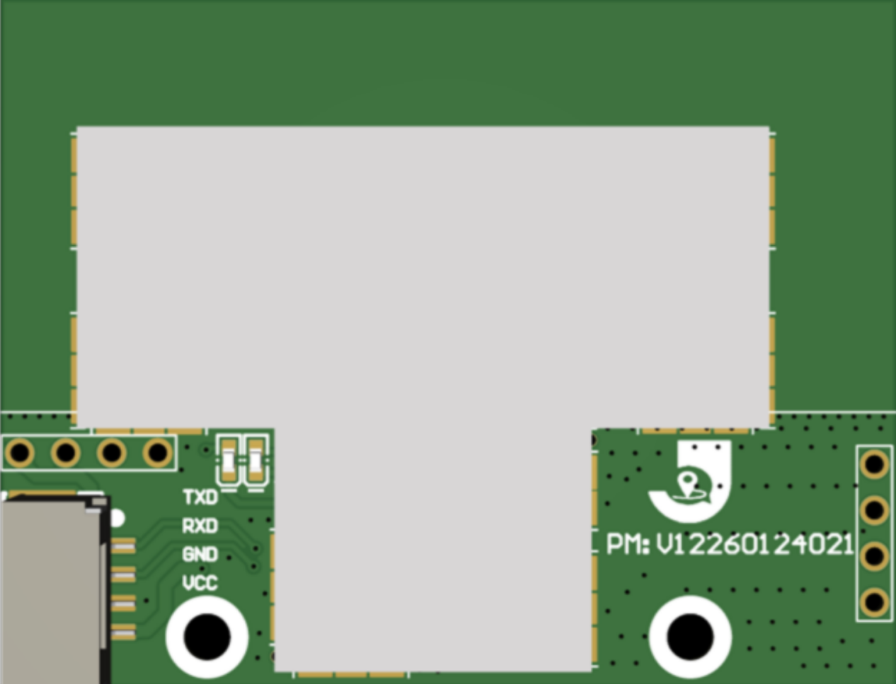

Module Hardware Pin Definitions
Lable | Function
TXD(1) | UART_Tx Pin speed 115200
RXD(3) | UART_Rx Pin speed 115200
GND(4) | GND
VCC(5) | Positive power supply terminal is powered by 5V

Module hardware packaging dimensions
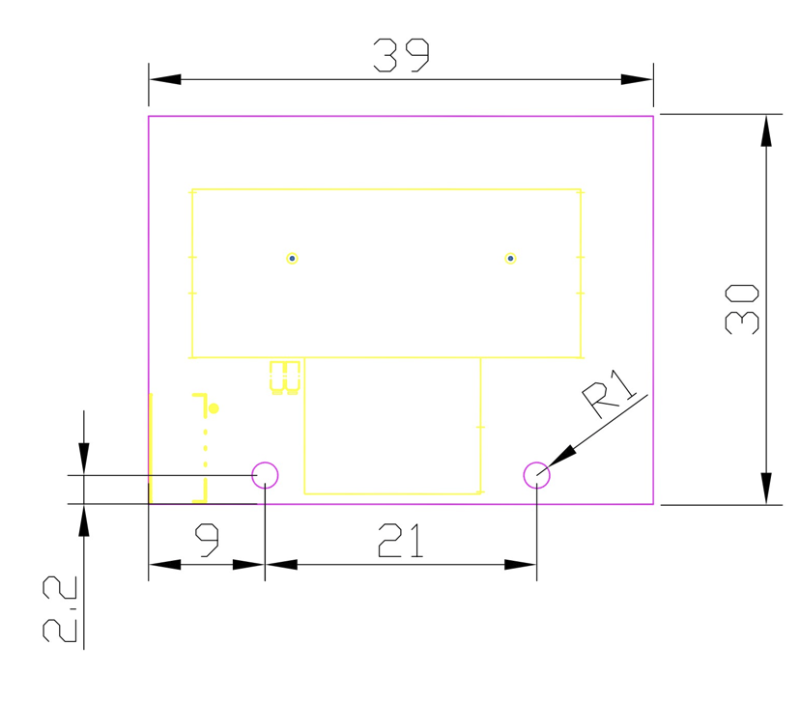
Module size specifications

Communication Protocol Description

Base Station Positioning Frame
Field name | Byte type | Length (Byte) | Index subscript | Function Description
head | uint8_t | 1 | 0 | Fixed header 0x2A
cmd_len | uint16_t | 2 | 1 | Data frame length (length of the fields: cmd_saddr-reserve)
cmd_saddr | uint64_t | 8 | 3 | Self-assigned long address (8 bytes reserved)
cmd_daddr | uint64_t | 8 | 11 | Recipient's full address (8 bytes reserved)
cmd_type | uint8_t | 1 | 19 | Command frame types (1: Base station positioning frame 2: Base station configuration frame 3: Tag configuration frame 4: OTA upgrade frame 5: Whole machine configuration frame 0x64: Base station positioning frame RSSI)
cmd_direct | uint8_t | 1 | 20 | Command frame direction (1: Engine request, 2: Device response, 3: Device request, 4: Engine response, 5: Engine report, 6: Device report)
tag_time | uint32_t | 4 | 21 | Tag communication time
anc_addr16 | Uint16_t | 2 | 25 | The short address of the base station
tag_addr16 | uint16_t | 2 | 27 | The short address of the tag
tag_sn | uint8_t | 1 | 29 | Tag communication sn
tag_mask | uint8_t | 1 | 30 | Tag communication is effective.
tag_a0_filter_angle | int16_t | 2 | 31 | Base station 0 filtering angle (°)
tag_a0_filter_range | uint16_t | 2 | 33 | Base station 0 filtering distance (cm)
tag_a1_filter_angle | int16_t | 2 | 35 | Base station 1 filtering angle (°)
tag_a1_filter_range | uint16_t | 2 | 37 | Base station 1 filtering distance (cm)
tag_a2_filter_angle | int16_t | 2 | 39 | Base station 2 filtering angle (°)
tag_a2_filter_range | uint16_t | 2 | 41 | Base station 2 filtering distance (cm)
tag_a3_filter_angle | int16_t | 2 | 43 | Base station 3 filtering angle (°)
tag_a3_filter_range | uint16_t | 2 | 45 | Base station 3 filtering distance (cm)
tag_detail_para | uint32_t | 4 | 47 | Tag data (tag type / battery power / charging status / remote control status) [Note 1: bit structure]
tag_acc_x | uint16_t | 2 | 51 | Tag acceleration along the x-axis
tag_acc_y | uint16_t | 2 | 53 | Tagged acceleration along the y-axis
tag_acc_z | uint16_t | 2 | 55 | Tagged acceleration along the z-axis
tag_gcc_x | uint16_t | 2 | 57 | Taggy Gyroscope X-axis
tag_gcc_y | uint16_t | 2 | 59 | Taggy Gyroscope Y-axis
tag_gcc_z | uint16_t | 2 | 61 | Taggy Gyroscope Z-axis
self_raw_angle | int16_t | 2 | 63 | The original measurement angle of the object (unfiltered)
self_raw_range | uint16_t | 2 | 65 | The original measurement distance of the object (unfiltered)
self_raw_degree | int32_t | 4 | 67 | Original angle of the tag (used during calibration of the base station)
angle_360 | uint16_t | 2 | 71 | 360° angle (used in conjunction with the entire machine)
angle_dir | uint8_t | 1 | 73 | 360° angle approximate direction (for use with the entire machine)
reserve | uint8_t* | 5 | 74 | Reserve 5 bytes
check | uint8_t | 1 | 79 | Check bit (field: checksum of cmd_saddr-reserve)[Note 2: Checksum calculation program]
foot | uint8_t | 1 | 80 | Fixed trailer byte: 0x23

Base station positioning frame RSSI
Field name | Byte type | Length (Byte) | Index subscript | Function Description
head | uint8_t | 1 | 0 | Fixed header 0x2A
cmd_len | uint16_t | 2 | 1 | Data frame length (length of the fields: cmd_saddr saddr-reserve)
cmd_saddr | uint64_t | 8 | 3 | Self-assigned long address (8 bytes reserved)
cmd_daddr | uint64_t | 8 | 11 | Recipient's full address (8 bytes reserved)
cmd_type | uint8_t | 1 | 19 | Command frame type (1: Base station positioning frame 2: Base station configuration frame 3: Tag configuration frame 4: OTA upgrade frame 5: Whole machine configuration frame 0x64: Base station positioning frame RSSI)
cmd_direct | uint8_t | 1 | 20 | Command frame direction (1: Engine request, 2: Device response, 3: Device request, 4: Engine response, 5: Engine report, 6: Device report)
tag_time | uint32_t | 4 | 21 | Tag communication time
anc_addr16 | Uint16_t | 2 | 25 | The short address of the base station
tag_addr16 | uint16_t | 2 | 27 | The short address of the tag
tag_sn | uint8_t | 1 | 29 | Tag communication sn
tag_mask | uint8_t | 1 | 30 | Tag communication is effective
tag_a0_filter_angle | int16_t | 2 | 31 | Base station 0 filtering angle (°)
tag_a0_filter_range | uint16_t | 2 | 33 | Base station 0 filtering distance (cm)
tag_a0_rssl | int16_t | 2 | 35 | Base station 0 signal strength
tag_a1_filter_angle | int16_t | 2 | 37 | Base station 1 filtering angle (°)
tag_a1_filter_range | uint16_t | 2 | 39 | Base station 1 filtering distance (cm)
tag_a1_rssl | int16_t | 2 | 41 | Base station 1 signal strength
tag_a2_filter_angle | int16_t | 2 | 43 | Base station 2 filtering angle (°)
tag_a2_filter_range | uint16_t | 2 | 45 | Base station 2 filtering distance (cm)
tag_a2_rssl | int16_t | 2 | 47 | Base station 2 signal strength
tag_a3_filter_angle | int16_t | 2 | 49 | Base station 3 filtering angle (°)
tag_a3_filter_range | uint16_t | 2 | 51 | Base station 3 filtering distance (cm)
tag_a3_rssl | int16_t | 2 | 53 | Base station 3 signal strength
tag_detail_para | uint32_t | 4 | 55 | Tag data (tag type / battery power / charging status / remote control status) [Note 1: bit structure]
tag_acc_x | uint16_t | 2 | 59 | Tag acceleration along the x-axis
tag_acc_y | uint16_t | 2 | 61 | Tagged acceleration along the y-axis
tag_acc_z | uint16_t | 2 | 63 | Tagged acceleration along the z-axis
tag_gcc_x | uint16_t | 2 | 65 | Taggy Gyroscope X-axis
tag_gcc_y | uint16_t | 2 | 67 | Taggy Gyroscope Y-axis
tag_gcc_z | uint16_t | 2 | 69 | Taggy Gyroscope Z-axis
self_raw_angle | int16_t | 2 | 71 | The original measurement angle of the object (unfiltered)
self_raw_range | uint16_t | 2 | 73 | The original measurement distance of the object (unfiltered)
self_raw_degree | int32_t | 4 | 75 | Original angle of the tag (used during calibration of the base station)
angle_360 | uint16_t | 2 | 79 | 360° angle (used in conjunction with the entire machine)
angle_dir | uint8_t | 1 | 81 | 360° angle approximate direction (for use with the entire machine)
reserve | uint8_t* | 5 | 82 | Reserve 5 bytes
check | uint8_t | 1 | 87 | Check bit (field: checksum of cmd_saddr-reserve)[Note 2: Checksum calculation program]
foot | uint8_t | 1 | 88 | Fixed trailer byte: 0x23

Base station configuration frame
Field name | Byte type | Length (Byte) | Index subscript | Function Description
head | uint8_t | 1 | 0 | Fixed header 0x2A
cmd_len | uint16_t | 2 | 1 | Data frame length (length of the fields: cmd_saddr-reserve)
cmd_saddr | uint64_t | 8 | 3 | Self-assigned long address (8 bytes reserved)
cmd_daddr | uint64_t | 8 | 11 | Recipient's full address (8 bytes reserved)
cmd_type | uint8_t | 1 | 19 | Command frame type (1: Base station positioning frame 2: Base station configuration frame 3: Tag configuration frame 4: OTA upgrade frame 5: Whole machine configuration frame 0x64: Base station positioning frame RSSI)
cmd_direct | uint8_t | 1 | 20 | Command frame direction (1: Engine request, 2: Device response, 3: Device request, 4: Engine response, 5: Engine report, 6: Device report)
config_cmd | uint8_t* | * | * | Configuration command set [Note 3: Base station configuration command set]
check | uint8_t | 1 | * | Check bit (Field: cmd_saddr - checksum of config_cmd) [Note 2: Checksum calculation program]
foot | uint8_t | 1 | * | Fixed trailer byte: 0x23

OTA upgrade frame
Field name | Byte type | Length (Byte) | Index subscript | Function Description
head | uint8_t | 1 | 0 | Fixed header 0x2A
cmd_len | uint16_t | 2 | 1 | Data frame length (length of the fields: cmd and saddr-reserve)
cmd_saddr | uint64_t | 8 | 3 | Self-assigned long address (8 bytes reserved)
cmd_daddr | uint64_t | 8 | 11 | Recipient's full address (8 bytes reserved)
cmd_type | uint8_t | 1 | 19 | Command frame type (1: Base station positioning frame 2: Base station configuration frame 3: Tag configuration frame 4: OTA upgrade frame 5: Whole machine configuration frame 0x64: Base station positioning frame RSSI)
cmd_direct | uint8_t | 1 | 20 | Command frame direction (1: Engine request, 2: Device response, 3: Device request, 4: Engine response, 5: Engine report, 6: Device report)
OTA_cmd | uint8_t* | * | * | OTA commands (developers can ignore this)
check | uint8_t | 1 | * | Checksum (Field: checksum of cmd_ saddr-OTA_cmd) [Note 2: Checksum calculation program]
foot | uint8_t | 1 | * | Fixed trailer byte: 0x23

[Note 1: Bit structure]
【Alarm Status: No/(Remote Control Dedicated) Mode: No/】
0x041A0002 (Hexadecimal) = 0x02001A04 (High-low bit conversion) = 00000010000000000001101000000100 (Binary)
【Alarm Status: Yes/(Remote Control Dedicated) Mode: No/】
0x061A0002 (in hexadecimal) = 0x02001A06 (High-low bit conversion) = 00000010000000000001101000000110 (in binary)
【Alarm status: No / Remote control dedicated mode: Yes / 】
0x241A1002 (in hexadecimal) = 0x02101A24 (High-low bit conversion) = 00000010000100000001101000000110 (in binary)
typedefstruct
{
uint32_tis_lowbattery:1; //Is there a low battery alarm?
uint32_tis_alarm:1; //Is there an alarm?
uint32_tis_chrg:1; //Is charging required?
uint32_tis_tdby:1; //Is it fully charged?
uint32_tbattery_val:10; //Battery voltage 350 = 3.50V
uint32_tis_offset_range_zero_bit:1; //Distance correction position
uint32_tis_offset_pdoa_zero_bit:1; //Angle correction position
uint32_tturn_up:1; //(For remote control use) Forward
uint32_tturn_down:1; //(For remote control use) Backward
uint32_tturn_left:1; //(For remote control use) Left
uint32_tturn_right:1; //(For remote control use) Right
uint32_tmode:3; //(For remote control use) Mode
uint32_trecal:1; //(For remote control use) Recall
uint32_tlock:1; //(For remote control use) Locked
uint32_tdev_type:3; //Device type (0: Learning board 1: Bracelet 2: Remote control)
uint32_treserve:4; //Reserved
}tag_detail_para_t;

[Note 2: Verification calculation program]
Static uint8_t get_Xor_CRC(uint8_t *bytes, int offset, int len)
{
uint8_t xor_crc = 0;
int i;
for (i = 0;i < len; i++) {
xor_crc ^= bytes[offset + i];
}
return xor_crc;
}

[Note 3: Base Station Configuration Command Set]
Command | Meaning | Examples
reset | Reset | Reset
rtoken | Restore to factory settings | Restore to factory settings
save | Save | Save settings
saver | Save & Reset
setcfg (x1) (x2) (x3) (x4) (x5) (x6)(x7) | Set up configuration | setcfg 1 1 1111 1 100 1 0  x1: Number of discovered tags (1)  x2: Number of bound tags (1)  x3: Personal network ID (0 - 0xfffe)  x4: Base station ID (0 - 3)  x5: Refresh rate (deprecated)  x6: Filtering settings (deprecated)  x7: Reporting format (0: General format / 1: Json format / 2: Car-following format / 3: Car positioning format, 4: General format (RSSI))
getcfg | Get configuration
setslot(x1) | Set the time slot cycle (related to the refresh rate) | setslot 10  x1: A single time period is 10 milliseconds (Note: If one time slot is 10 milliseconds, the refresh rate is 100Hz)
getslot | Obtain the time slot period (related to the refresh rate)
setfilter(x1)(x2) | Set the hardware filtering parameters | setfilter 1 30  x1: Whether to enable hardware filtering  x2: Hardware filtering coefficient (2 - 50)
getfilter | Obtain the hardware filtering parameters
addtag(x1)(x2)(x3)(x4)(x5) | Binding tag | addtag 10205FA01000154F 154F 0001 000A 00  x1: Long address of the tag (64 bits)  x2: Short address of the tag  x3: Fast refresh rate of the tag (deprecated)  x4: Slow refresh rate of the tag (deprecated)  x5: Tag mode (deprecated)
deltag | Delete the tag | deltag 10205FA01000154F  x1: Label long address 64 bits
getklist | Obtain the list of already paired tags
getdlist | Obtain the list of tags that the request is to join.

