**Covid-19 Prescription**

☐ Budesonide 800 mcg inhaled twice daily

if unavailable, please substitute with   
 Beclomethasone 400 mcg twice daily  
 Ciclesonide 400 mcg twice daily  
 Fluticasone 500 mcg twice daily  
 Mometasone 400mcg twice daily

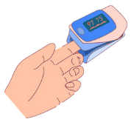☐ Pulse Oximeter – Check your levels twice daily. Come to   
 hospital if levels are below 94% or if you are feeling   
 increasingly short of breath  
  
☐ Aspirin 81mg daily for 21 days  
  
☐ Vitamin D 1000 units daily

_________________________ ______________________  
Name Date  
License Number: