EXPLORATORY DATA ANALYSIS
Job Acceptance Prediction System
Data-driven insights from 50,000 candidates | HR Job Placement Dataset

1. Interview score vs job acceptance
Does a higher interview score mean a better chance of getting placed?

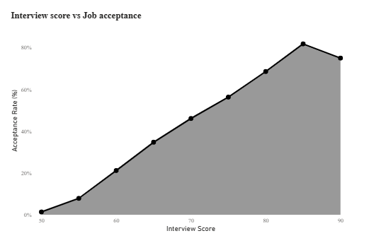
INTERVIEW SCORE Acceptance goes up steadily as the interview score goes up. Candidates scoring around 50 are almost never placed (about 1%), compared with about 21% at 60, 46% at 70 and 69% at 80. Every extra 10 points on the interview adds roughly 20 to 25 percentage points to the acceptance rate.
THE DIP AT 90 The curve peaks at 85 (about 82%) and then dips at 90. This dip is not a real drop, because very few candidates score that high (only 37 candidates score 85 or above), so those last points are not reliable.
WHAT DRIVES IT The technical score does most of the work. Placed candidates average 75 on technical against 65 for those not placed, while aptitude (64.6 vs 63.7) and communication (67.6 vs 65.5) are almost the same for both groups. Also, no candidate with a technical score below 60 was placed (12,571 candidates).

2. Skills match percentage vs job acceptance
Does a better match between a candidate's skills and the job improve their chances?

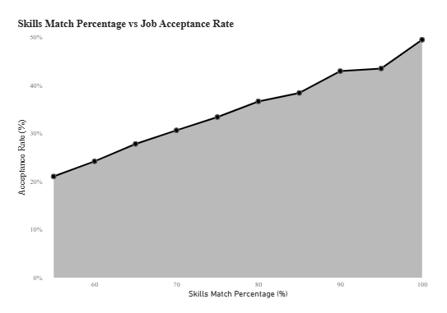
SKILLS MATCH A better skills match means a better chance of acceptance. The rate climbs from about 21% at a 55% match to about 49% at a 100% match, which is more than double.
STEADY, NOT STEEP The rise is gradual and consistent, with each extra 5 points of match adding only about 3 percentage points. This is a gentler slope than the interview score. Even a perfect match is no guarantee: at 100%, about half of the candidates (51%) are still not placed.
THE FLOOR The chart starts at 55% because of a hard cut-off in the data: no candidate with a skills match below 55% was placed (2,944 candidates). A match of about 55% looks like the minimum needed to be considered at all.

3. Company tier vs job acceptance rate
Do candidates have a better chance of acceptance at some company tiers than at others?

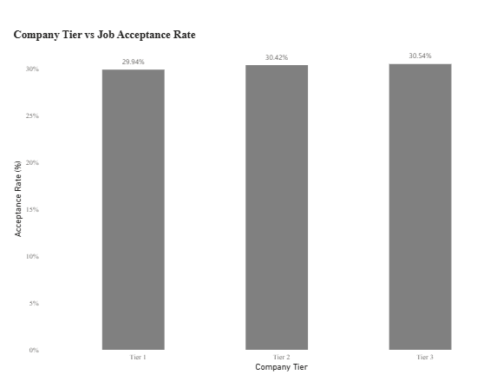
COMPANY TIER The company tier makes almost no difference. Tier 1 is at 29.94%, Tier 2 at 30.42% and Tier 3 at 30.54%, so the gap between the highest and lowest is under 0.6 percentage points.
WHAT IT MEANS Candidates are not more or less likely to be accepted by a big-name company. Tier 1 receives the most candidates (19,305 vs 12,212 for Tier 3), but the rate is the same. So tier is not a useful predictor on its own, and the candidate profile (scores, skills, experience) matters far more.

4. Experience vs placement rate
Do more experienced candidates get accepted more often?

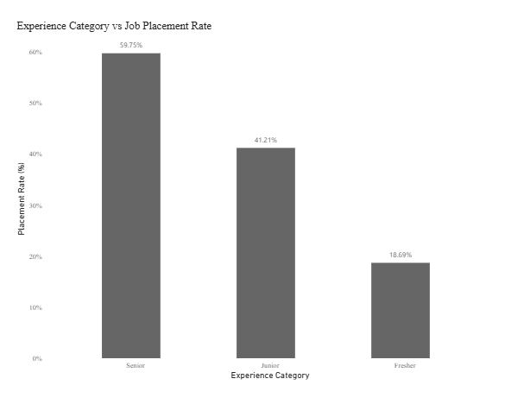
EXPERIENCE Experience is one of the strongest factors. Senior candidates are placed 59.75% of the time, Juniors 41.21% and Freshers only 18.69%. A Senior is about 3 times as likely to be placed as a Fresher, and each step up adds roughly 20 percentage points.
FRESHERS Freshers are the biggest group (28,460, or 57% of all candidates) and have the lowest rate, so they make up about two thirds of all candidates who were not placed. This is where training and internships can help the most.
YEAR BY YEAR Looking at single years, the rate goes from 13.8% at 0 years to 64.6% at 5 years, which is about 10 percentage points for every extra year of experience.

5. Competition level vs job acceptance rate
Does a more competitive job market lower a candidate's chances?

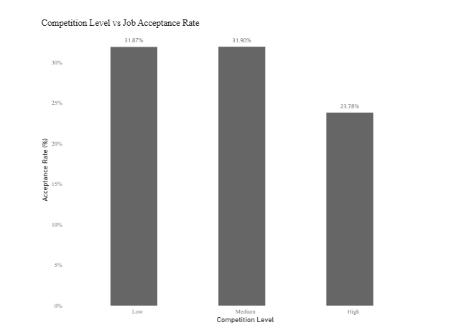
COMPETITION Only high competition hurts. Low and medium competition have the same acceptance rate (31.87% and 31.90%), while high competition drops to 23.78%, about 8 percentage points lower.
A THRESHOLD, NOT A SLOPE Going from low to medium competition changes nothing, but high competition cuts the acceptance rate by about a quarter. About 20% of candidates (10,045) are applying in high-competition situations, so this affects a good share of the pool.

6. Correlation among numeric features
Which numeric features move together, and which are linked to placement?

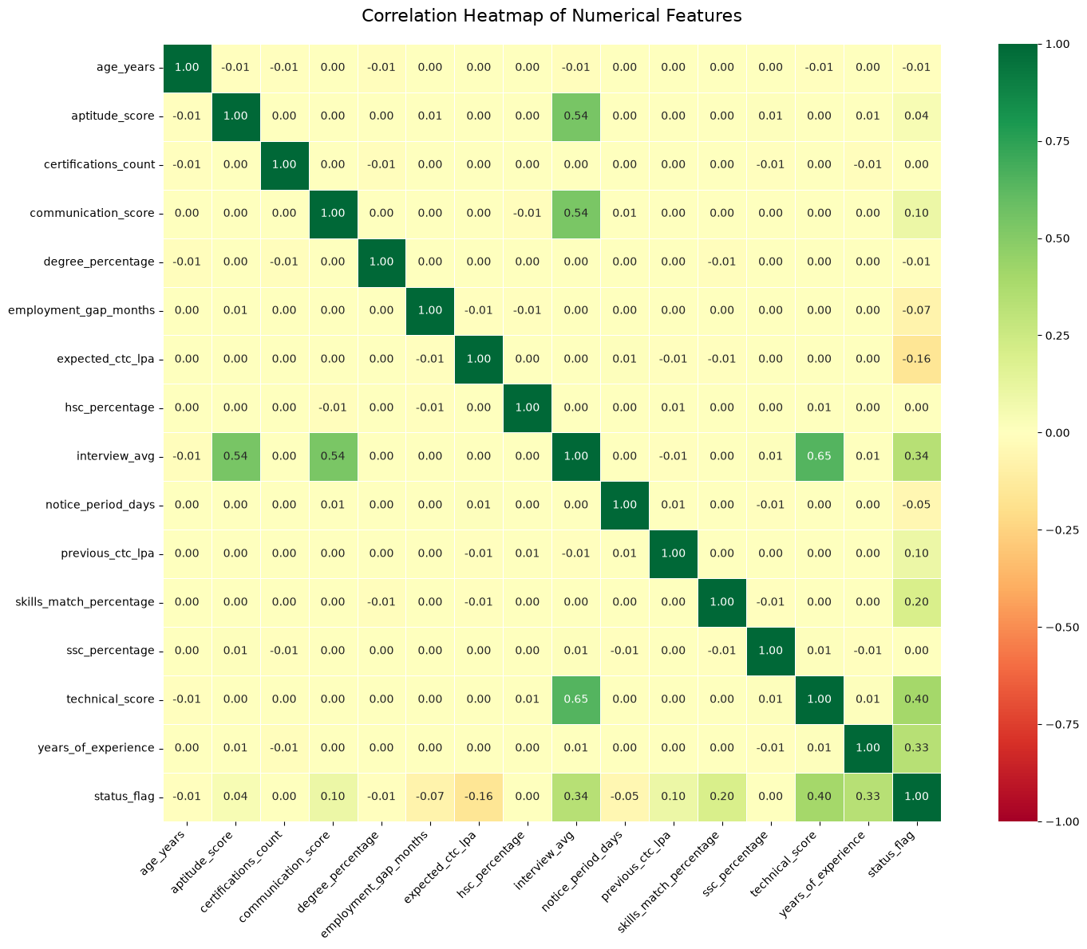
PLACEMENT The strongest links with placement are technical score (0.40), interview average (0.34) and years of experience (0.33), followed by skills match (0.20). The only meaningful negative link is expected CTC (-0.16): the more a candidate asks for, the less likely they are to be placed. Communication score, previous CTC, employment gap and notice period have only a weak link (0.10 to -0.07).
NO LINK Age, certifications count and the SSC, HSC and degree percentages are all at about 0.00. Academic marks and certificates do not separate placed candidates from the rest.
BETWEEN FEATURES The features are almost completely independent of each other (nearly every pair is 0.00 or ±0.01). The only strong links are interview average with its own three scores (technical 0.65, aptitude 0.54, communication 0.54), which is expected because it is their average.

