EXPLORATORY DATA ANALYSIS
Online Food Delivery Analysis
Data-driven business insights from 71,541 orders | January to December 2024

Key findings
- Order value clusters at Rs 1,197 (33% of orders); the average is higher at Rs 1,784.
- Delivery takes 125 minutes on average. Only 27% of orders arrive within an hour, and 33% take more than 2 hours.
- Hyderabad and Indian cuisine each account for about 34% of orders, roughly double any other city or cuisine.
- Demand is the same on weekdays and weekends: 196 vs 197 orders per day.
- Distance does not affect delivery time: 125 min for short trips vs 124 min for the longest.
- 15% of orders are cancelled; 40% of those have no recorded reason and the rest split evenly at about 20% each.
- Numeric features barely move together, apart from Order Value and Final Amount (r = 1.00), which is expected.

1. Distribution of order values and delivery time

How much do customers spend per order, and how long does delivery take?

Figure 1: Distribution of order value (left) and delivery time (right)
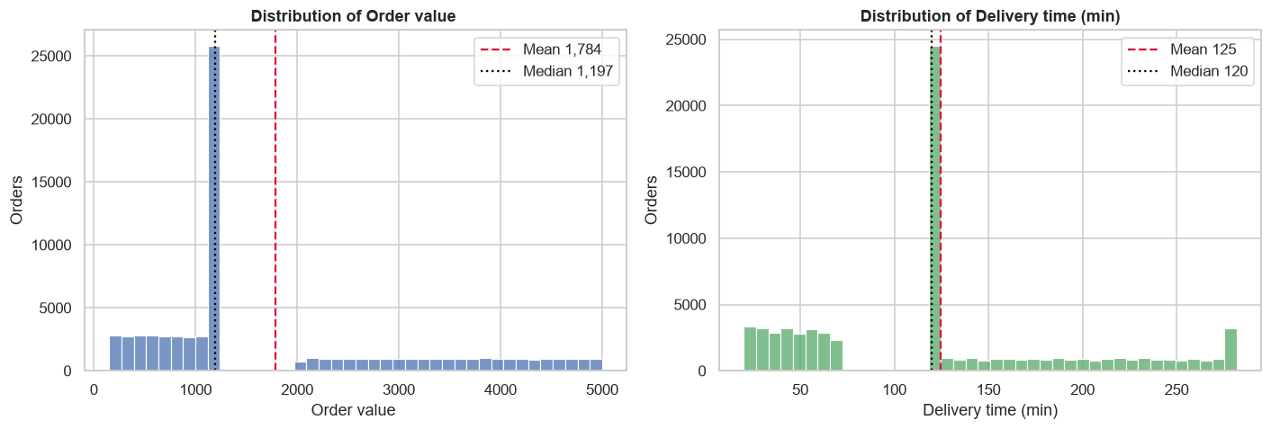

ORDER VALUE Most orders are around Rs 1,200. Half of all orders land between Rs 933 and Rs 2,734. The average looks higher at Rs 1,784 because a good number of bigger orders (Rs 2,000 to Rs 5,000) pull it up. And here is something odd: 1 in 3 orders (33%) is for exactly Rs 1,197.
DELIVERY TIME Food takes about 2 hours to show up on average, which is pretty slow. Only 27% of orders (roughly 1 in 4) arrive within an hour, while 33% (1 in 3) take more than 2 hours. And the unluckiest 5% of customers wait over 4.5 hours.

2. City-wise and cuisine-wise orders
Which cities and cuisines drive the most orders and revenue?
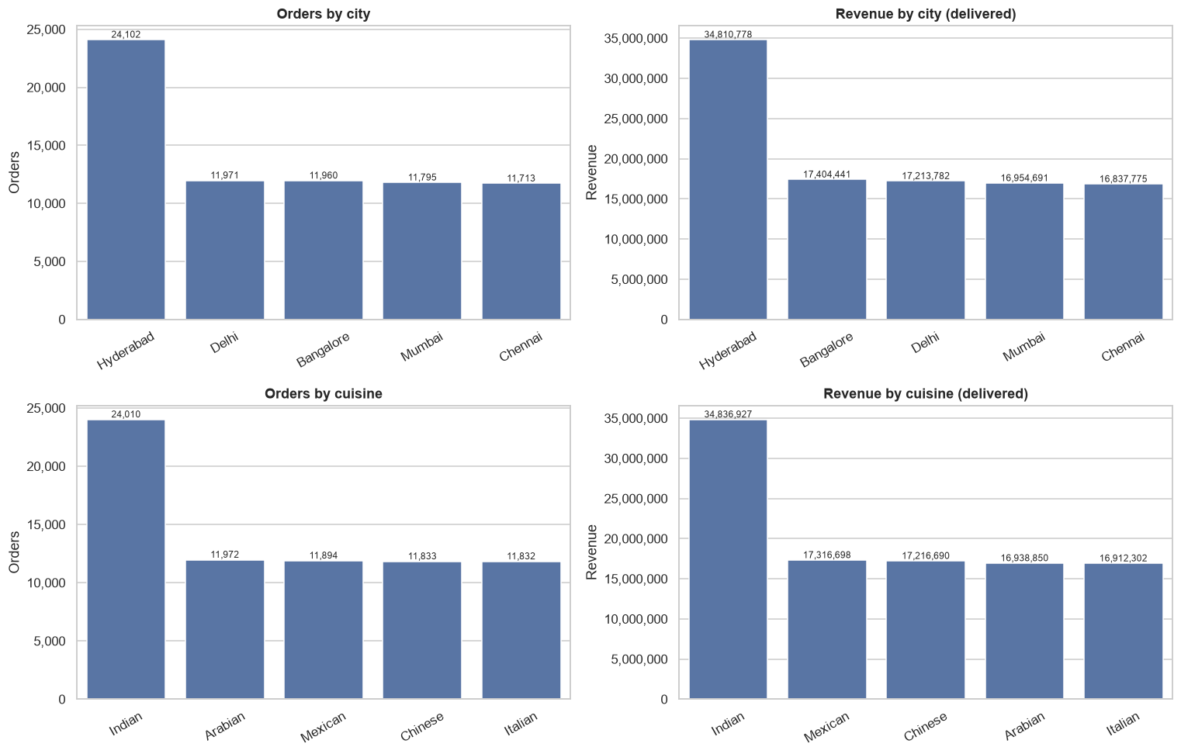
Figure 2: Orders and delivered revenue by city (top) and by cuisine (bottom)
CITY & CUISINE Hyderabad is the clear favourite, with about 34% of all orders (24,102). That is roughly double what each of the other four cities gets, since they sit at about 11,700 to 12,000 each. Cuisine is the same story: Indian food leads with about 34% of orders (24,010), well ahead of Arabian at 17% (11,972).
REVENUE Revenue follows orders. Hyderabad brings in about Rs 34.8 million and Indian cuisine about Rs 34.8 million, roughly twice what any other city or cuisine earns.

3. Weekend vs weekday demand
Do people order more on weekdays or on weekends?
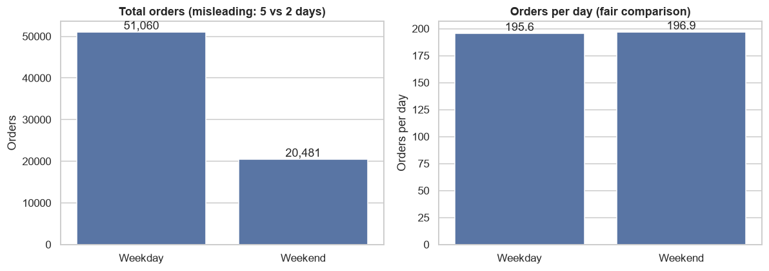
Figure 3: Total orders (left) and orders per day (right) for weekdays and weekends
WEEKDAY VS WEEKEND Weekdays have 71% of all orders (51,060 vs 20,481), but that is only because there are 5 weekdays for every 2 weekend days. Per day, it is basically a tie: 196 orders on a weekday vs 197 on a weekend. So people order just as much on a Saturday as on a Tuesday.

4. Distance vs delivery delay
Does a longer distance mean a longer delivery?
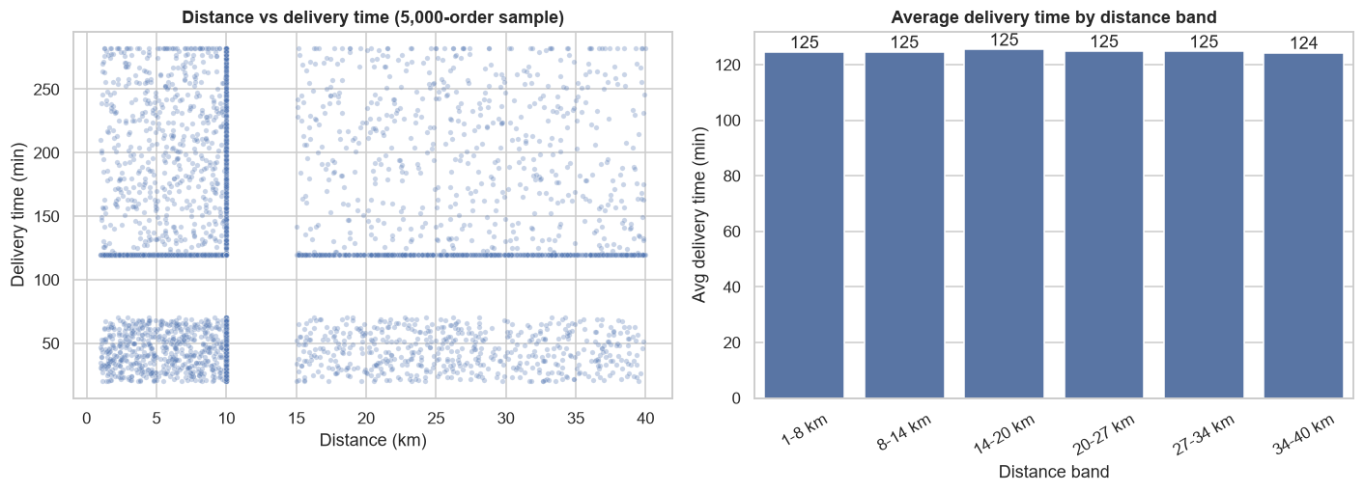
Figure 4: Distance vs delivery time (left) and average delivery time by distance band (right)
DISTANCE Surprisingly, how far the food travels barely changes how long it takes. A short trip (1 to 8 km) takes about 125 min, and the longest trips (34 to 40 km) take about 124 min. The correlation is essentially zero (r = 0.00), so distance is not the reason for late deliveries. The delays are coming from something else, like restaurant prep time or rider availability.

5. Cancellation reasons
How many orders get cancelled, and why?
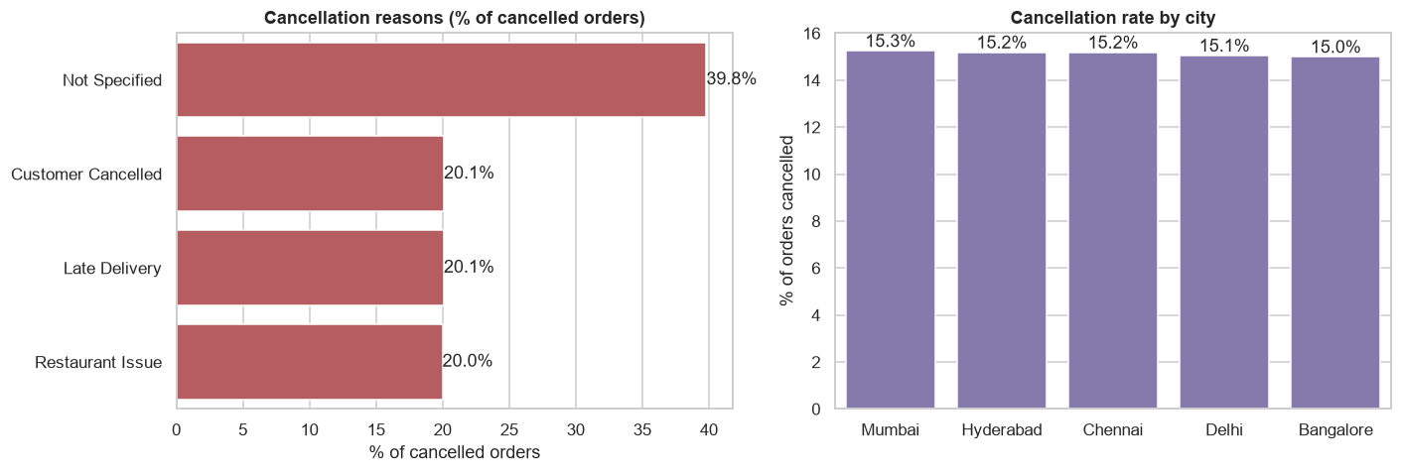
Figure 5: Cancellation reasons (left) and cancellation rate by city (right)
CANCELLATIONS About 15% of orders, roughly 1 in 7, get cancelled, and it is the same everywhere: every city sits between 15.0% and 15.3%. In 40% of cancellations nobody recorded why, which is the biggest gap in the data. The reasons that were recorded are all about equal (around 20% each), so there is no single villain. Fixing one reason will not fix cancellations.

6. Correlation among numeric features
Which numeric features move together?
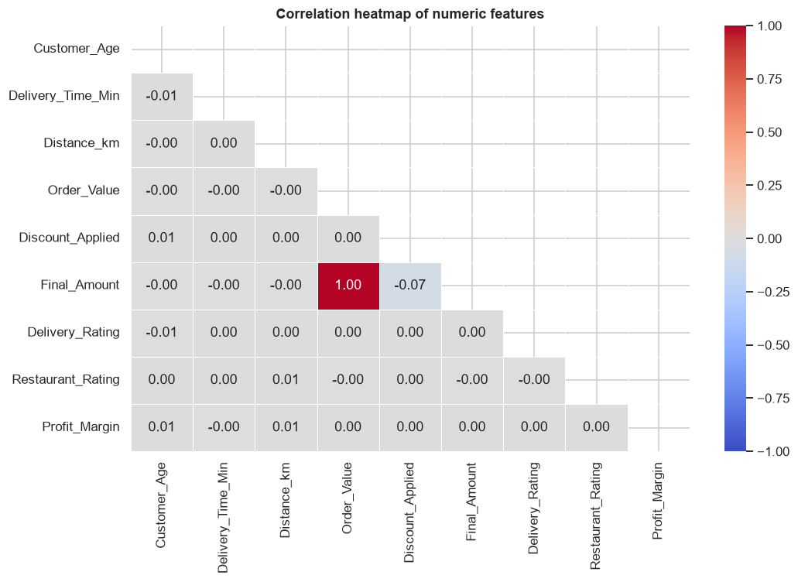
Figure 6: Correlation heatmap of numeric features
CORRELATION Most of the numbers here do not move together. The only strong link is Order Value and Final Amount (r = 1.00), which is expected since the final amount is just the order value minus the discount. Beyond that, the strongest pair is Discount Applied and Final Amount (r = -0.07), which is still very weak. So things like age, ratings and distance do not predict much about each other.

