EXPLORATORY DATA ANALYSIS
Online Food Delivery Analysis
71,541 orders | January to December 2024

71,541  Orders | 103.2M  Revenue | 125 min  Average delivery time | 15.1%  Orders cancelled

Summary
Topic | What we found
1. Customer & Order Analysis | Spending is the same across age groups and across weekdays and weekends. The top 10 customers are only 0.3% of revenue.
2. Revenue & Profit Analysis | Revenue is steady (8.3M to 8.9M a month) and profit margin stays at about 25% at every discount level. Hyderabad and Indian food each bring in about a third of revenue.
3. Delivery Performance | Delivery takes about 125 minutes everywhere. City, distance and customer rating make no difference, and a third of deliveries take over 2 hours.
4. Restaurant Performance | Restaurants and cuisines are rated almost the same, but a few cancel far more than average (up to 23.7% vs 15.1%). Delivery is rated about 3.0, restaurants about 4.2.
5. Operational Insights | Card is the top payment mode (40%). 40% of cancellations have no reason recorded, and late delivery and restaurant issues cause another 2 in 5.

- Period and size: 71,541 orders from 1 January to 30 December 2024, across five cities and five cuisines.
- Delivered vs all orders: revenue, delivery time and rating figures use the 60,706 delivered orders. Cancellation figures use all orders.
- Delayed delivery: an order that took more than 120 minutes. Quick is 60 minutes or less.
- Profit margin: the cleaned data excludes orders with a negative profit margin, so margin figures describe profitable orders only.
- Peak status: about a third of orders have no peak or off-peak flag, so peak-hour findings should be read with care.

1. Customer & Order Analysis

What this section is for. It shows who your customers are and how they order: who spends the most, whether age changes spending, and whether weekends are busier than weekdays. It tells you who to target and when.
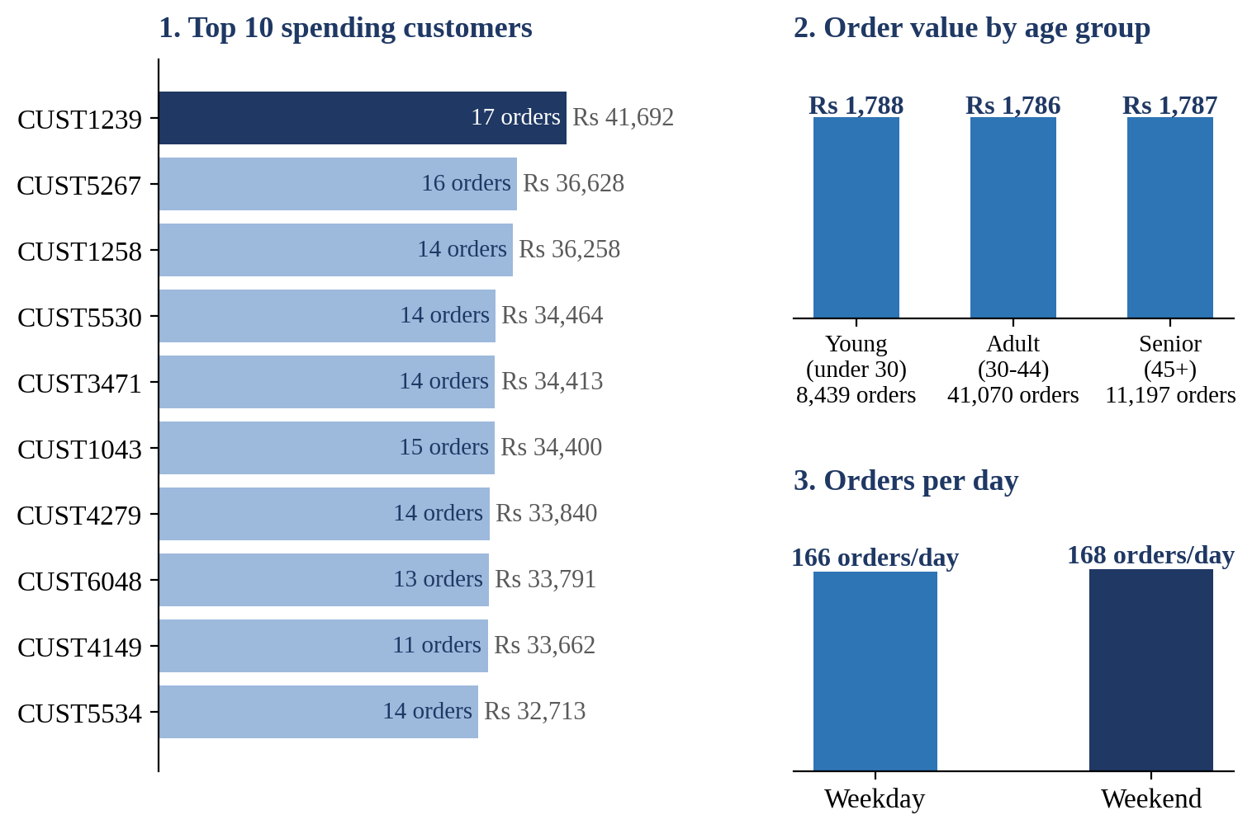

TOP SPENDERS Your top spender is CUST1239 with Rs 41,692 over 17 orders, and the rest of the top 10 are close behind (Rs 32.7K to Rs 36.6K). They are frequent buyers (11 to 17 orders each), but together they make up just 0.3% of revenue, so you don’t rely on a few big spenders.
AGE GROUP Age doesn’t change what people spend: about Rs 1,787 per order in every group, a gap of only Rs 2. Adults place most of the orders (68%), so they are your main audience.
WEEKDAY VS WEEKEND Weekdays have more orders in total (43,270 vs 17,436), but only because there are more weekdays. Per day it’s a tie: about 166 orders on a weekday and 168 on a weekend.
TAKEAWAY Customers behave alike across age and day. A loyalty offer for your frequent buyers will work better than targeting by age or day.

2. Revenue & Profit Analysis

What this section is for. It tracks the money: how revenue moves through the year, whether discounts eat into profit, and which cities and cuisines earn the most. It tells you where revenue comes from and whether it is stable.
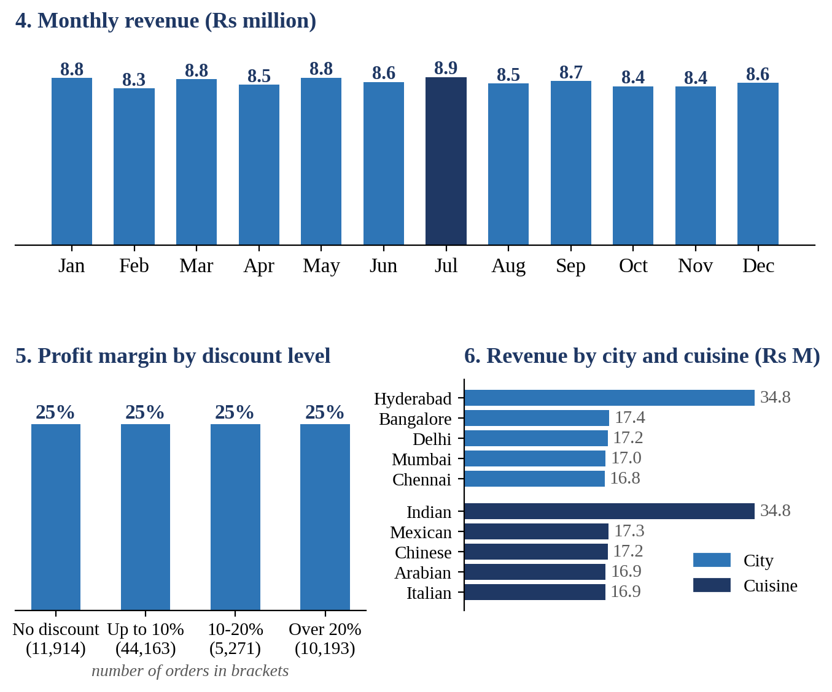

MONTHLY REVENUE Revenue is steady all year, between Rs 8.27M (February) and Rs 8.88M (July), about Rs 8.6M a month. The best and weakest months are only about 7% apart, so there is no busy season to plan around.
DISCOUNTS Discounts don’t dent your margin. Profit margin is about 25% with no discount and with a discount above 20%. Most orders carry a discount (83%), and 62% of all orders get one of up to 10%.
CITY & CUISINE Hyderabad earns Rs 34.8M, a third of all revenue (34%), and Indian food earns Rs 34.8M (also 34%). Every other city and cuisine earns between Rs 16.8M and Rs 17.4M.
TAKEAWAY Revenue is stable and discounts are not hurting margin. Revenue is concentrated in one city and one cuisine, while the other four of each perform alike.

3. Delivery Performance

What this section is for. It checks how fast food reaches customers and what, if anything, explains slow deliveries: city, distance or customer rating. It tells you where to look when fixing delivery times.
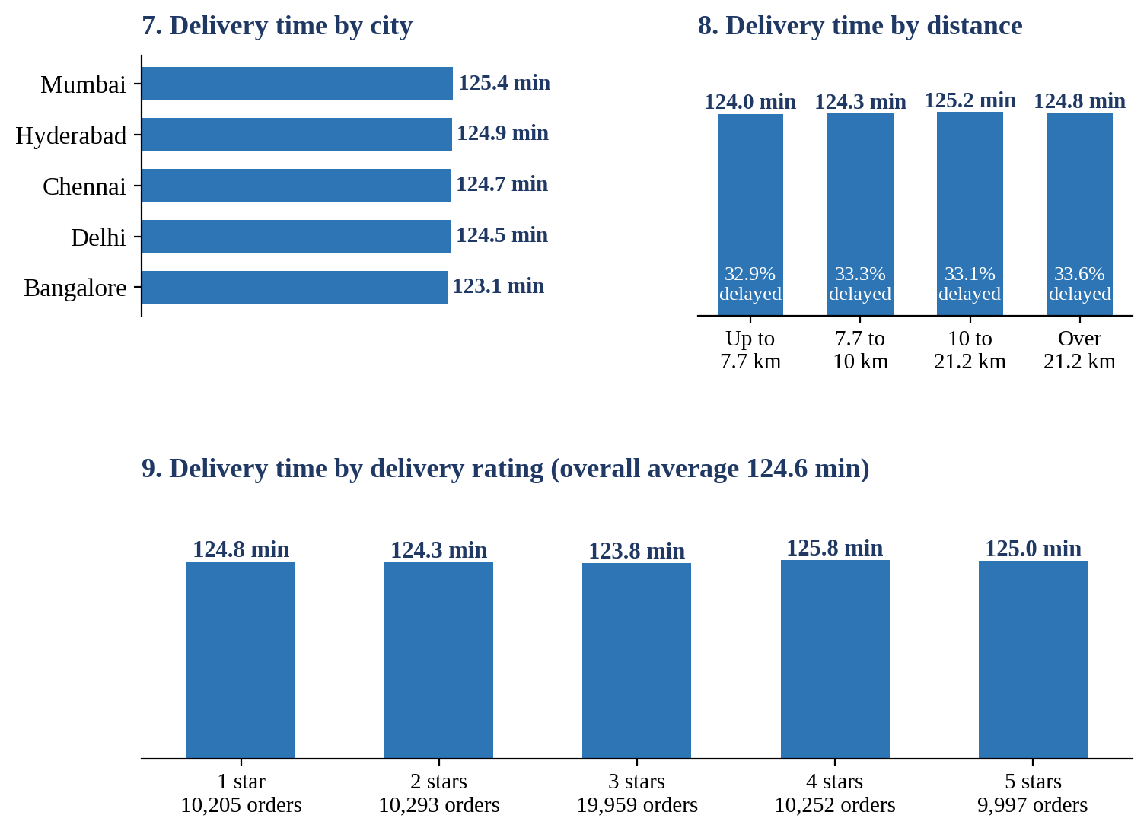

BY CITY Delivery takes about 125 minutes in every city. Bangalore is quickest (123.1) and Mumbai slowest (125.4), a gap of just 2 minutes.
BY DISTANCE Distance doesn’t matter. The nearest quarter of orders (up to 7.7 km) takes 124.0 min and the farthest (over 21.2 km) takes 124.8 min. About a third of orders are delayed (over 120 min) in every distance group (32.9% to 33.6%).
BY RATING Waiting time doesn’t explain ratings either. Customers who gave 1 star waited 124.8 min on average, the same as those who gave 5 stars (125.0). A third of deliveries (33%) are rated 3 stars.
TAKEAWAY Slow deliveries aren’t caused by the city or the distance, so the cause lies elsewhere, for example restaurant preparation time or rider allocation, which this data doesn’t cover.

4. Restaurant Performance

What this section is for. It looks at the restaurants: who is rated highest, who cancels the most, and how the five cuisines compare. It tells you which partners to reward and which to review.
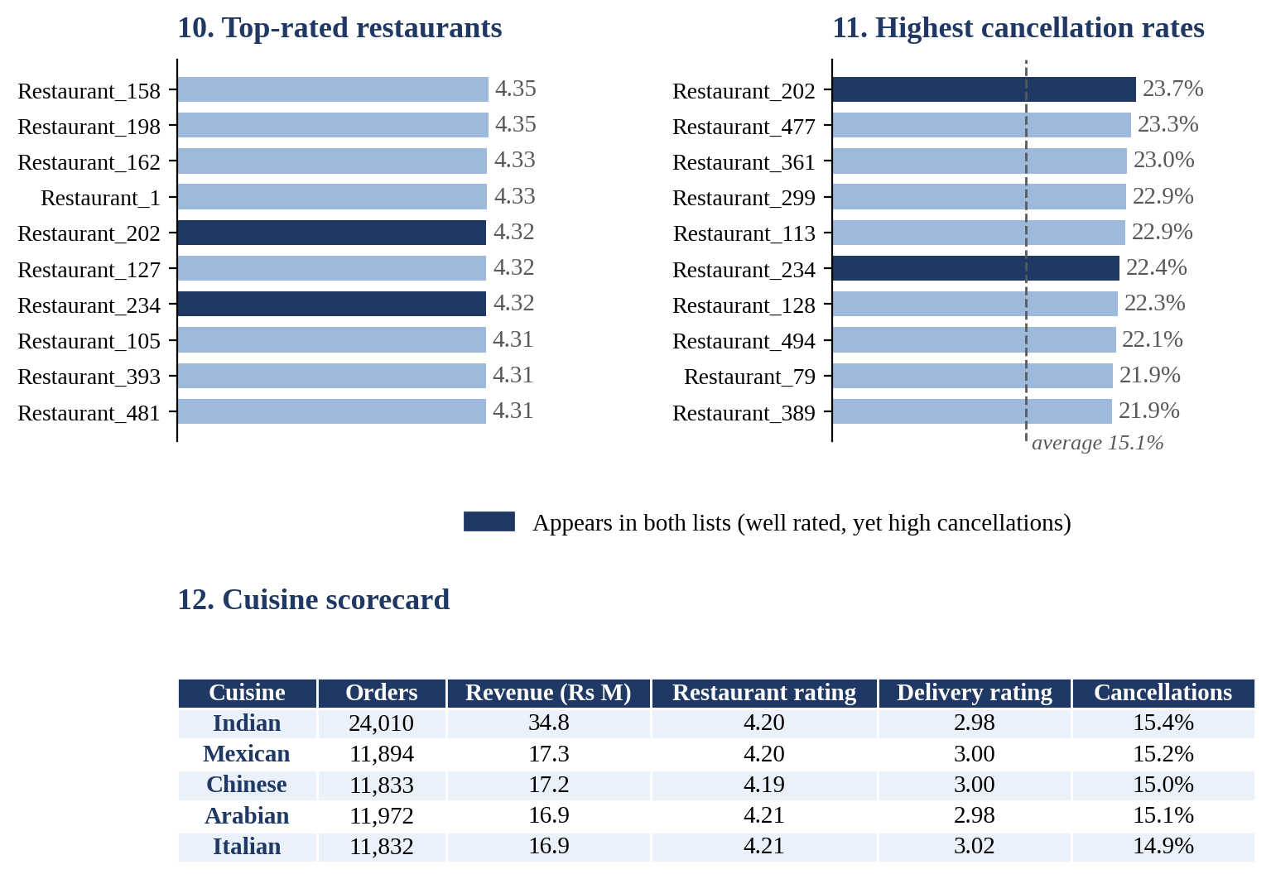

TOP-RATED The ten best-rated restaurants are tightly bunched, between 4.31 and 4.35. Restaurant_158 and Restaurant_198 lead at 4.35.
CANCELLATIONS Restaurant_202 cancels the most: 23.7% of its orders (37 of 156), about 1.6 times the platform average of 15.1%. The top ten range from 21.9% to 23.7%. Two of them, Restaurant_202 and Restaurant_234, are also among the best rated, so a high rating doesn’t mean a reliable restaurant.
CUISINES The five cuisines look almost identical: restaurant ratings 4.19 to 4.21 and cancellation rates 14.9% to 15.4%. Indian leads only on volume (24,010 orders, twice any other cuisine). Customers rate restaurants about 4.2 but delivery only about 3.0.
TAKEAWAY Restaurant quality is consistent, but a handful of restaurants cancel far more than the rest. Delivery is the weaker part of the customer experience.

5. Operational Insights
.
What this section is for. It covers the day-to-day operation: when orders come in, how customers pay and why orders get cancelled. It tells you what to improve in checkout and operations.
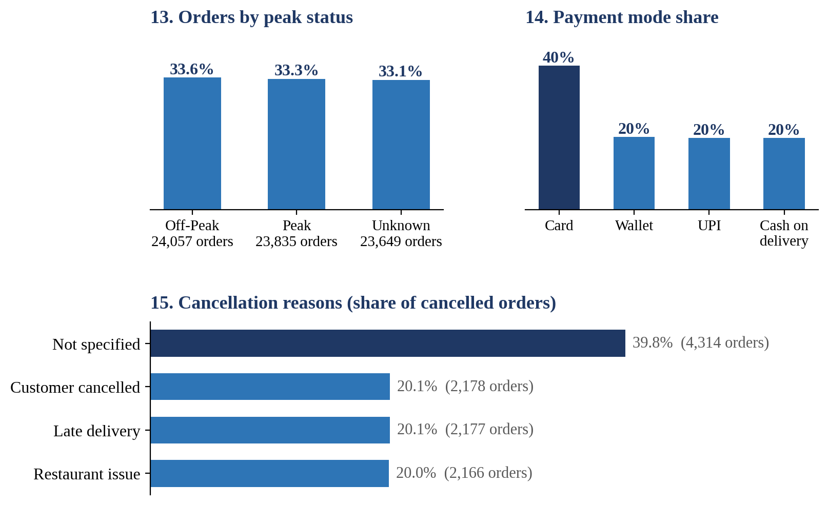

PEAK HOURS Orders split evenly: off-peak 33.6%, peak 33.3% and unknown 33.1%. Order value (about Rs 1,783) and delivery time (about 125 min) are the same in each group, so busy periods don’t slow delivery. A third of orders have no peak flag, so read this one with care.
PAYMENTS Card is the most used payment mode with 40% of orders. Wallet, UPI and cash on delivery are about 20% each.
CANCELLATIONS 40% of cancellations (4,314 of 10,835) have no reason recorded. Customer cancellations (20.1%), late delivery (20.1%) and restaurant issues (20.0%) are almost equal, so 2 in 5 cancellations come from late delivery or restaurant problems that you can act on.
TAKEAWAY Make the cancellation reason mandatory, and work on late deliveries and restaurant issues, which together cause 2 in 5 cancellations.

Recommended actions

S.NO | What the data shows | What to do
1 |  | Make the reason mandatory when an order is cancelled.
  Missing cancellation reasons
2 | Long delivery times and low delivery ratings | Improve restaurant preparation and rider allocation.
3 | High cancellation rates at certain restaurants | Review underperforming restaurants
4 | Similar spending across age groups and days | Introduce loyalty offers for repeat customers.
5 | Revenue concentrated in Hyderabad and Indian cuisine | Test growth campaigns in other cities and cuisines.

