Assignment-1

Connect and disconnect with login Access

* What happens when you login a non-existent users or username?

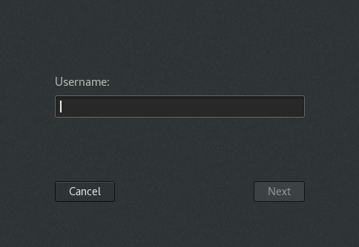

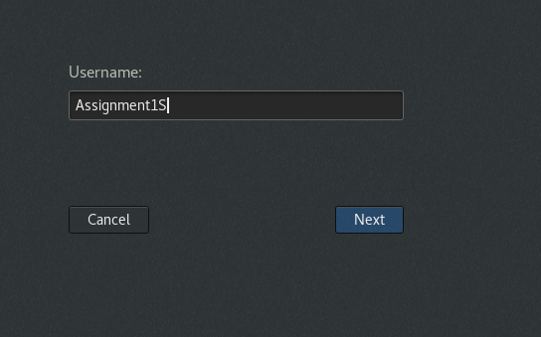

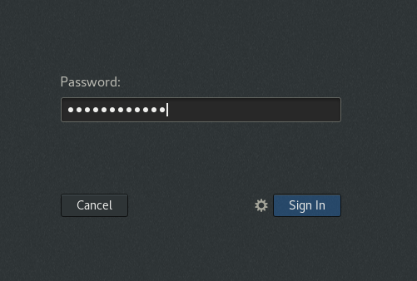

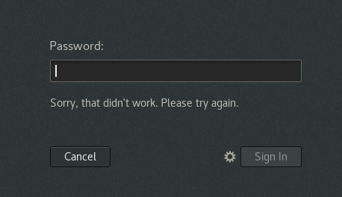

Valid user :

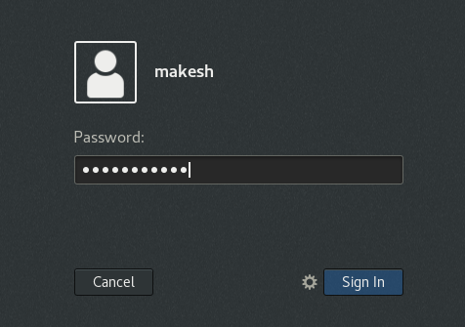

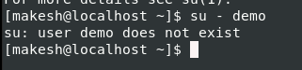

**Explanation:**

1. When a user tries to login with any new user credentials, he or she cant be logged in. When we try to switch to other user which is not existing, it will also throw a warning message.

**Assignment-2**

Password changing

* Login into your account and then change password?
  + Change your password into ***IneuR0n#42*** and hit the **Enter** key

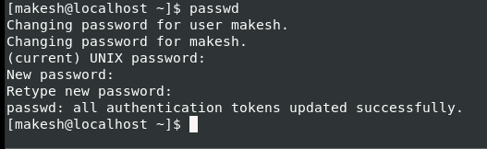

When I logout and tries to login with old pwd:

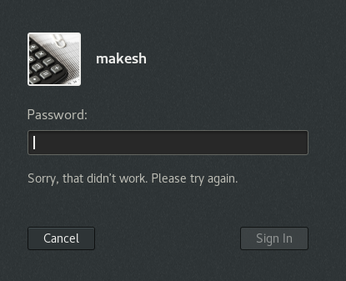

Trying to login with new pwd: 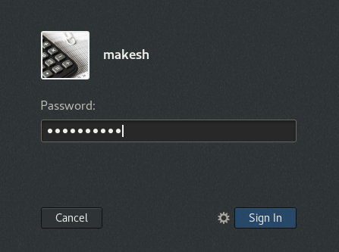

When I entered the right password it displayed the count of wrong attempts made and Successfully logged in:

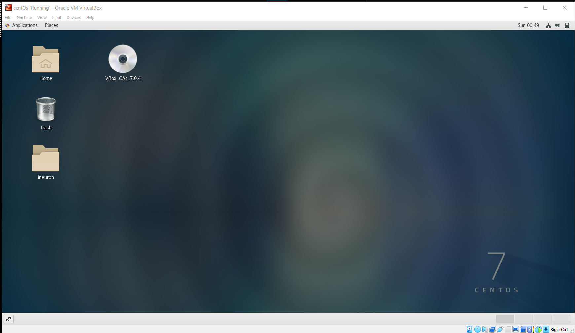

* + Try again to change password but use like password ***1234*** or ***abcd***

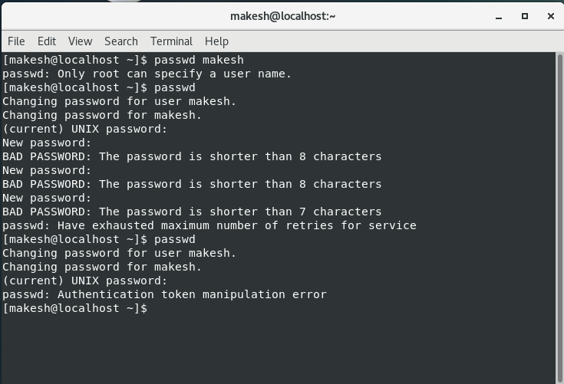

Displayed error message : ***Getting*** authentication token manipulation error. So user needs to enter a strong password and when we enter password with length less than 8, error message is displayed.

* + Try again to change password but now don’t use any password just hit **Enter** key
  + Answer: Got Authentication token manipulation error

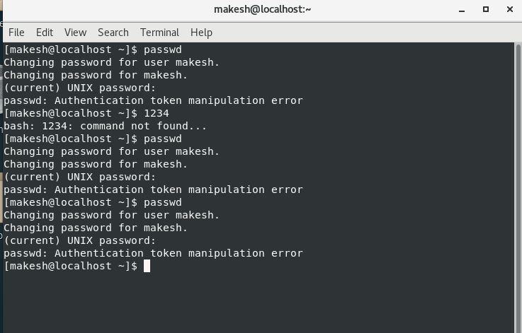

Assignment-3

Working with Directories

* Enter the command **cd /** and then **ls** and then hit **Enter** key

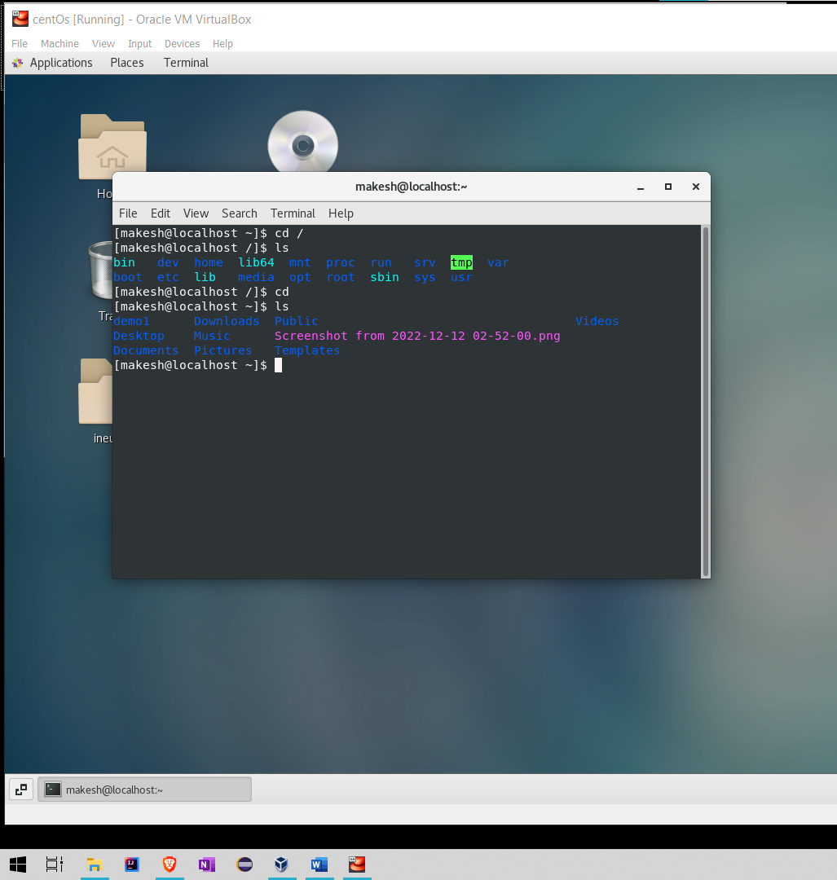

Cd / - move to the root directory

Ls – gives the list of files in that current root directory

* Enter the command now **cd /home** and then hit **Enter** key
  + Do **ls,** provide screenshot and explain what is **/home** directory used for?

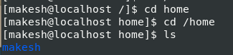

**Explanation:** List the home directory name

* Enter **cd ..** and hit **Enter** key [ *Note: here we have space after cd then use double dot*]

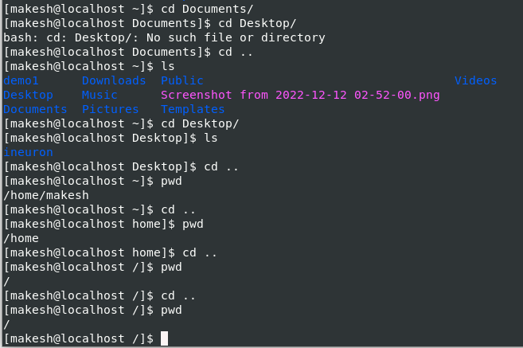

**Explanation: To move back to the parent directory.**

* Now enter **cd /var/www/html** and then type **cd** and hit **Enter** key

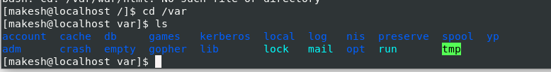



* Since we don’t have www folder inside, it was throwing error.
* Now type **cd /root** and then hit **Enter** key:

Answer: As a normal user, we don’t have access to the root folder. Hence throwing error.

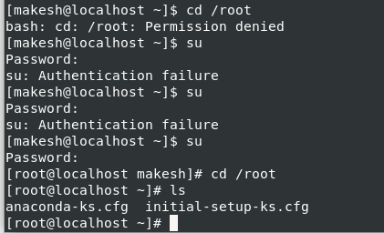

Assignment-4

Working with File Listing

* Go to **cd /etc** and type **ls**

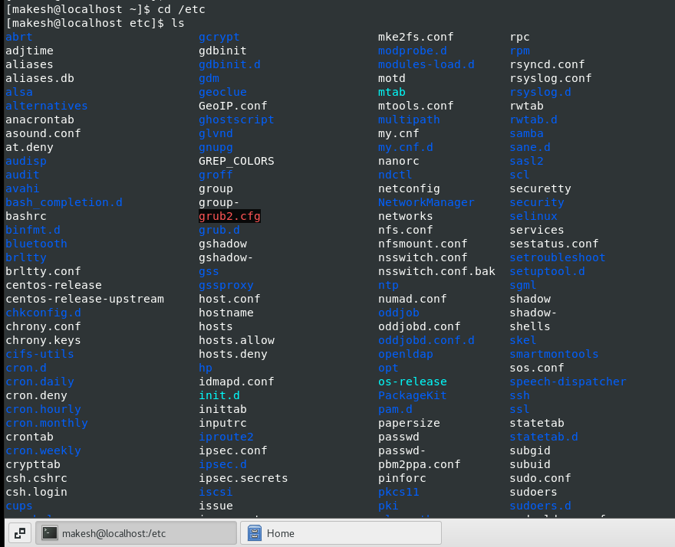

Explanation:

* + All the configuration files are located and this can be treated as nerve centre of your Linux/Unix machine and contains system configuration information. It contains configuration files, executable files required to boot system and log files. These files are needed for the storage system to operate
  + Take screenshot and explain what different output you found compare to previous command you used?.

**Explanation:** In all the previous commands we are able to see only the files or folders which are present inside the particular directory. But we wont be able to see the config files of the OS,

* Then type **ls -al** and hit **Enter** key
  + Take screenshot and explain what new file or directory you found?

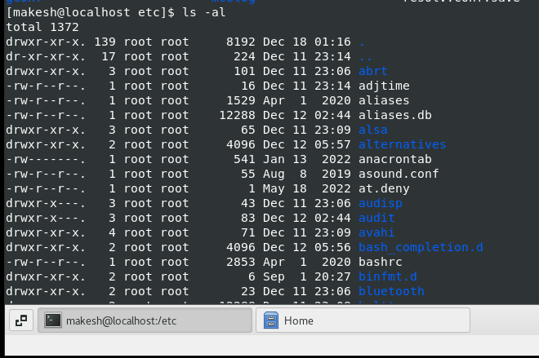

User is able to see the hidden files like . and .. which cant be seen in ls command. So -a is added along with ls command and l provides the permission info of the directory and file.

* Then use **ls -i** and hit **Enter** key

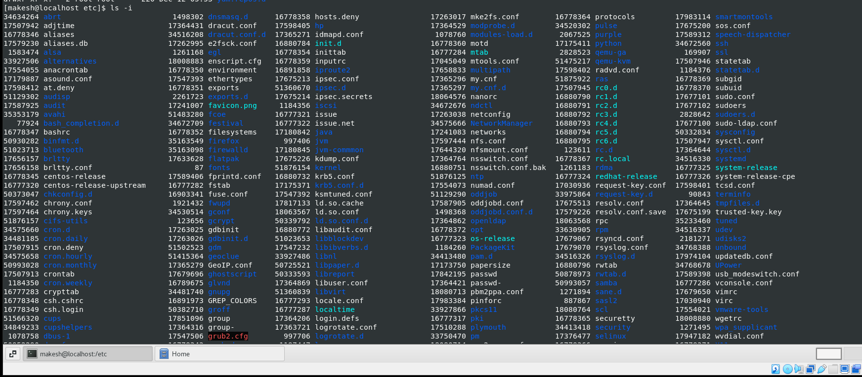

Explanation:

Displays the reference number or node for each file and directory

* Then use **ls –help** and see other options about **ls** command

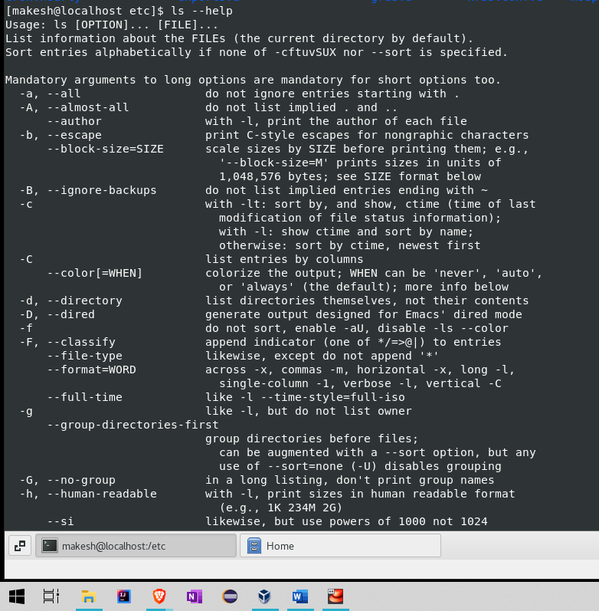

* + Explore it and try with other attribute we can use with **ls** command

Assignment-5

Know where you are and where you working

*Here we use* ***pwd, cd and ls*** *as combine task to understand where you working on terminal and how you can switch from one directory to another one.*

* Open terminal after restart the linux
  + Check which location you working, type **pwd** and take screenshot

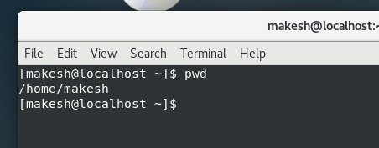

* Now use **cd /var** and hit **Enter** key
  + Do **ls,** and see what output comes, give screenshot?

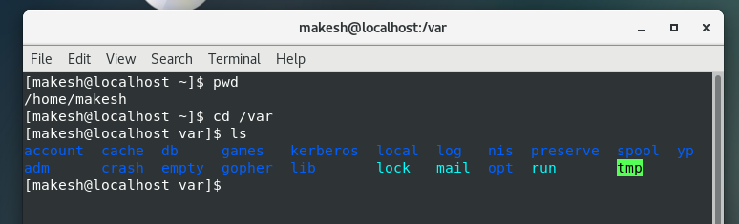

Other Assignment given during class:

Assignment -1 : Install all the dependencies to make centOS fullscreen

Command used: sudo – to move to root user

1. Sudo yum -y install gcc
   1. Install gcc package and 4 other dependent package (cpp, glibe-devel, glibe-headers, kernel-headers)

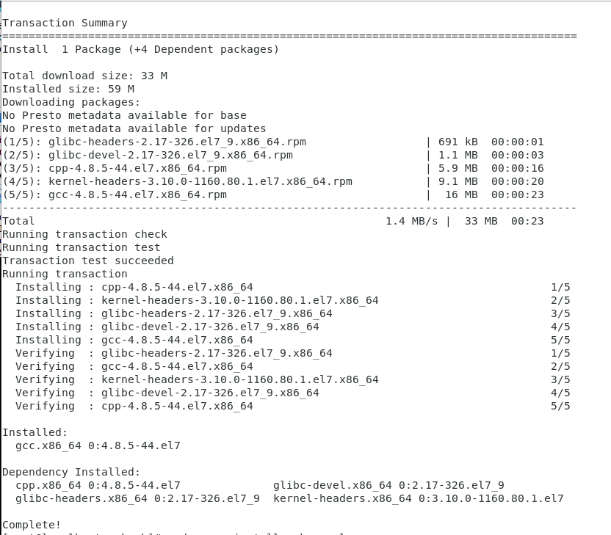

1. Sudo yum install make perl
   1. Package 1:make already installed and latest version
   2. Package 4:perl already installed and latest version

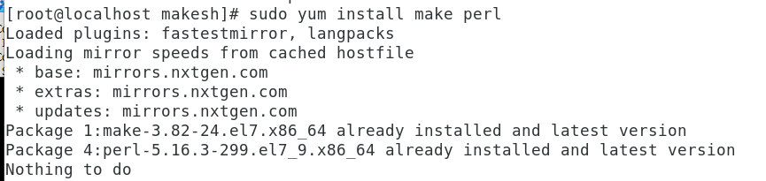

1. Installing package kernel-devel:
   1. Installing the package kernel-devel

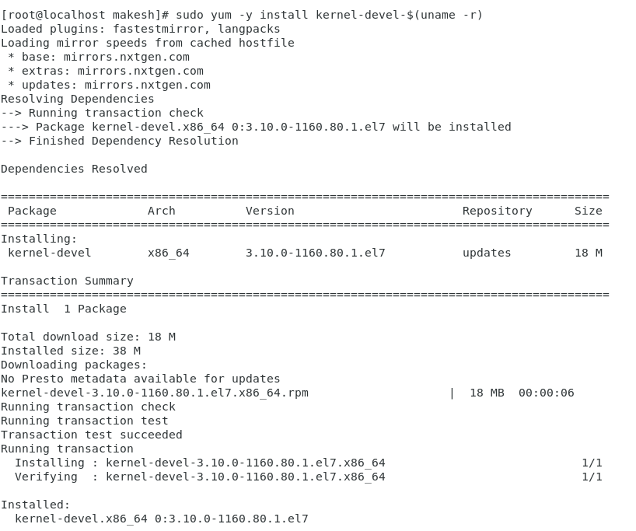

1. Sudo yum install elfutils-libelf-devel:
   1. Installing the package elfutils-libelf-devel and it’s dependent package: zlib-debel
   2. Enter y when prompted

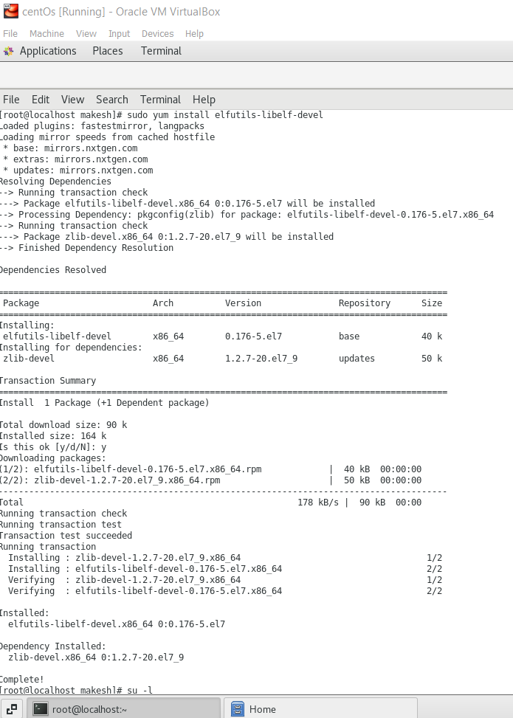

Go to home and remove the disk edition

Click on devices -> Insert Guest additions CD image

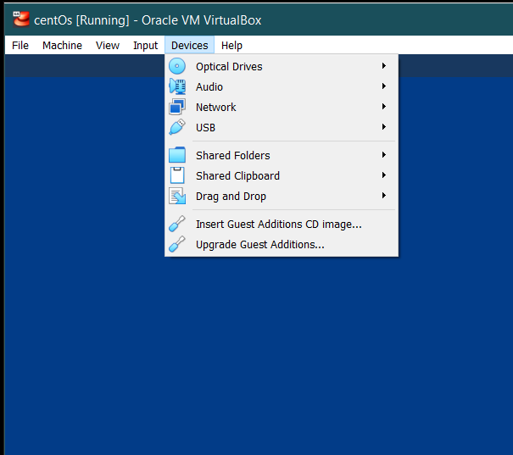

You will see a cd in the home page. Now click view from the menu bar and select full screen mode or click right ctrl+F button. The centOS will be in full screen mode…!

Note: Sometimes it may display as error. Check if the wired connection is connected.

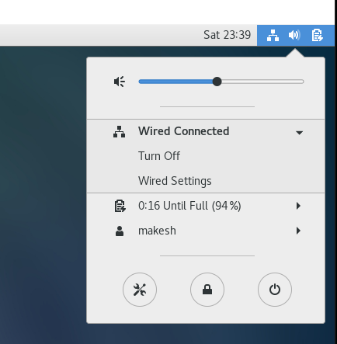

Assignment -2 : Update centOS machine

Move to the root user. This can be identified using # symbol

Command:

su - : to move to root user i.e) switch user

sudo yum -y update : to update and -y signifies yes i.e) to disable the confirmation prompt

Why yum?

Yum is the primary command to get, install, delete, querying packages from the repositories

Why sudo?

Super User DO – command used to execute commands either as root user or another user

Let’s assume two users, who is admin and makesh. If I have logged in as Makesh and if I need to switch to admin,

sudo su – [username] : to switch from one user to another user

sudo - : used to switch to root user