
Applied Software Project Report

By

Makesh Balasubramaniam

A Master’s Project Report submitted to Scaler Neovarsity - Woolf in partial fulfillment of the requirements for the degree of Master of Science in Computer Science

May, 2026>

Scaler Mentee Email ID : makeshb@ymail.com
Thesis Supervisor : Naman Bhalla
Date of Submission : DD/MM/YYYY <Date of Submission>

Certification

I confirm that I have overseen / reviewed this applied project and, in my judgment, it adheres to the appropriate standards of academic presentation. I believe it satisfactorily meets the criteria, in terms of both quality and breadth, to serve as an applied project report for the attainment of Master of Science in Computer Science degree. This applied project report has been submitted to Woolf and is deemed sufficient to fulfill the prerequisites for the Master of Science in Computer Science degree.

Naman Bhalla
…………………
Project Guide / Supervisor

DECLARATION

I confirm that this project report, submitted to fulfill the requirements for the Master of Science in Computer Science degree, completed by me from < Project Module start date > to < Module end date >, is the result of my own individual endeavor. The Project has been made on my own under the guidance of my supervisor with proper acknowledgement and without plagiarism. Any contributions from external sources or individuals, including the use of AI tools, are appropriately acknowledged through citation. By making this declaration, I acknowledge that any violation of this statement constitutes academic misconduct. I understand that such misconduct may lead to expulsion from the program and/or disqualification from receiving the degree.

Makesh Balasubramaniam

<Signature of the Candidate> Date: XX Month 20XX

ACKNOWLEDGMENT

<Insert a Paragraph within this Page to express gratitude to your family, Scaler instructors and everyone who helped, inspired or motivated you to complete the program and earn the Master’s degree>

Table of Contents

List of Tables 6
List of Figures 7
Applied Software Project 8
Abstract 8
Project Description 8
Requirement Gathering 9
Class Diagrams 9
Database Schema Design 9
Feature Development Process 11
Deployment Flow 12
Technologies Used 12
Conclusion 13
References 14

List of Tables
(To be written sequentially as they appear in the text)

Table No. | Title | Page No.
1
2

List of Figures
(List of Images, Graphs, Charts sequentially as they appear in the text)

Figure No. | Title | Page No.
1
2

Applied Software Project

Abstract
This project presents a comprehensive digital banking platform designed to revolutionize banking accessibility for retail customers through a secure, 24/7 online portal. The system addresses the growing demand for seamless digital financial services by enabling end-to-end account creation, verification, and transaction management without physical branch visits.

The platform implements a robust online registration and Know Your Customer (KYC) verification process leveraging India's national identity infrastructure—PAN (Permanent Account Number) and Aadhaar—ensuring regulatory compliance with Reserve Bank of India (RBI) guidelines while maintaining stringent security standards. Employees from partner organizations benefit from streamlined onboarding procedures, facilitating faster financial inclusion and banking access.
Key functionalities include comprehensive Transaction management, enabling users to register and verify payees for secure fund transfers. The system supports both domestic payments through NEFT, RTGS, and IMPS integration with the National Payments Corporation of India (NPCI), as well as international remittances through SWIFT corridors. Real-time transaction processing ensures immediate fund availability and confirmation, enhancing user experience and operational efficiency.
Built on a secure, scalable architecture with multi-layer authentication and encryption protocols, the platform operates continuously across geographical regions, providing uninterrupted banking services. This accessibility eliminates traditional banking hour constraints and geographical barriers, particularly benefiting working professionals, rural populations, and users requiring after-hours banking services.

The application demonstrates significant potential for financial institutions seeking digital transformation, reducing operational costs associated with physical infrastructure while expanding customer reach. By automating account opening, KYC verification, and payment processing workflows, the platform exemplifies how modern software solutions can democratize banking services, improve transaction efficiency, and align with India's vision of a digitally empowered financial ecosystem.
.

Project Description

This project delivers a secure, scalable, and always-available digital banking platform tailored for retail customers. It enables seamless online account creation, KYC verification, and transaction management, eliminating the need for physical branch visits. The platform leverages India’s national identity infrastructure (PAN and Aadhaar) for regulatory compliance and robust security, aligning with RBI guidelines. It supports both domestic and international payments, real-time transaction processing, and multi-layer authentication, making banking accessible to all user segments, including rural and working professionals.

This Project has 3 microservices

notifications-service
payments-service
useraccounts-service

Considering the Project scope and timeline I limited the functionality only to a Minimum Viable Product (MVP) which supports the users need to user Registration, Account generation,
Payment initiation and send notification, As this project grows and goes through multiple users feedback , we keep adding new features in future ,like processing the payment in real time and
Integrating notification service to cloud service like AWS SNS.

System Architecture & Key Components

- Client (C): The end-user interface (web/mobile app) for registration, authentication, and banking operations.
- UserAccounts-Service (UAS): Handles user authentication, registration, KYC, and account management.
- Payments-Service (PS): Manages payment initiation, processing, and transaction records.
- Notifications-Service (NS): Sends notifications for registration, status updates, and payments.
- Databases: Each service has a dedicated database (UASDB, PSDB, NSDB) for secure data storage.

API Details & Flow:

1. User Registration (Authentication)
- Endpoint: POST /auth/register
- Request: { userId, pwd, roles }
- Flow:
  - Client sends registration details.
  - UAS stores credentials and roles in UASDB.
  - Success response sent to client.
2. User Login & Token Generation
- Endpoint: POST /auth/login
- Request: { userId, pwd }
- Flow:
  - Client submits credentials.
  - UAS validates against UASDB.
  - On success, returns JWT token for session authentication.
3. Authenticated User Registration (KYC & Account Creation)
- Endpoint: POST ap1/v1/users/register
- Headers: Authorization: Bearer <JWT Token>
- Request: { Personal Details, Contact Details, KYC Details (PAN, Aadhaar) }
- Flow:
  - JWT token validated.
  - UAS creates customer profile, CIF, and account with status PENDING in UASDB.
  - Sends registration notification via NS.
  - Returns customer number to client.
4. Registration Status Inquiry
- Endpoint: GET ap1/v1/users/pending/{customerNumber}
- Headers: Authorization: Bearer <JWT Token>
- Flow:
  - JWT token validated.
  - UAS fetches registration status from UASDB.
  - Returns status to client.
5. Admin Status Update (Account Activation)
- Endpoint: PUT ap1/v1/users/update
- Headers: Authorization: Bearer <JWT Token>
- Request: { customerNumber, status: "ACTIVE" }
- Flow:
  - JWT token validated.
  - UAS updates customer status in UASDB.
  - Sends status update notification via NS.
  - Returns update success response.
6. Payment Initiation & Processing
- Endpoint: POST ap1/v1/payments/createPayment
- Headers: Authorization: Bearer <JWT Token>
- Request: { FromAccount, ToAccount, Amount }
- Flow:
  - JWT token validated.
  - PS processes payment and stores transaction in PSDB.
  - Sends payment notification via NS.
  - Returns payment success response.

Sequence Flow Summary
- User Registration: Client registers and receives credentials.
- Login: Client logs in and receives JWT token.
- KYC & Account Creation: Authenticated client submits KYC; account is created with pending status.
- Status Inquiry: Client checks registration/account status.
- Admin Activation: Admin updates account status to active; notification sent.
- Payments: Authenticated client initiates payments; processed and notified in real-time.

Security & Compliance
- Authentication: JWT-based, multi-layered.
- KYC: PAN and Aadhaar integration for regulatory compliance.
- Encryption: All sensitive data and communications are encrypted.
- Notifications: All critical actions trigger notifications for transparency.

Key Benefits
- 24/7 Accessibility: No branch or time constraints.
- Regulatory Compliance: Adheres to RBI and national KYC norms.
- Operational Efficiency: Reduces manual intervention and physical infrastructure costs.
- Scalability: Modular microservices architecture supports growth and new features.
- Financial Inclusion: Empowers rural and working populations with digital banking.

Describe the project, Outline the objectives and explain its relevance.
Use Pictures, flow diagrams to illustrate the project well

Architect Diagram:

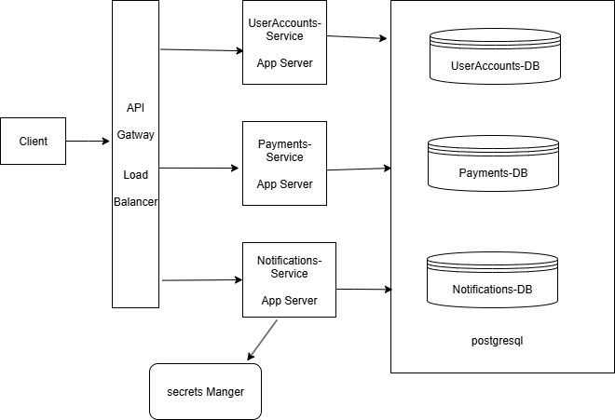

Use the below format as reference when including a picture

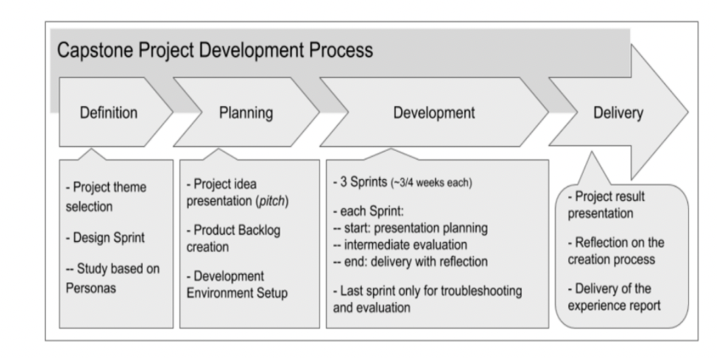
Figure 1.1: Project Development Process (Figure captions go below figures.)

Requirement Gathering

- Describe the requirements - Functional, Non-Functional Requirements
- Describe the Users and Use Cases
  - Include detailed Use Case Diagram / Images to illustrate
- List and detail out the Feature set -
  - Use Tables to list out the feature set

Use the below format as reference when including a table

Table 1.1: < Table caption > (Table captions go above tables.)

User Registration Service:

Accounts

Specifications:

- id
- created_at
- created_by
- del_flg
- updated_at
- updated_by
- account_type
- balance
- branch_code
- currency
- ifsc_code
- opening_date
- status
- cif_id
- Primary Key(id)

Schema:

create table accounts (
id bigint generated by default as identity,
created_at timestamp(6) not null,
created_by varchar(255),
del_flg boolean,
updated_at timestamp(6),
updated_by varchar(255),
account_type varchar(255) not null,
balance numeric(38,2) not null,
branch_code varchar(10),
currency varchar(3),
ifsc_code varchar(11),
opening_date date,
status varchar(255),
cif_id bigint not null,
primary key (id)
)

Addresses:
Specifications:

- id
- created_at
- created_by
- del_flg
- updated_at
- updated_by
- address_line1
- address_line2
- address_type
- city
- country
- is_communication_address
- landmark
- postal_code
- state
- customer_id
- Primary Key(id)

Schema:

create table addresses (
id bigint generated by default as identity,
created_at timestamp(6) not null,
created_by varchar(255),
del_flg boolean,
updated_at timestamp(6),
updated_by varchar(255),
address_line1 varchar(255),
address_line2 varchar(255),
address_type varchar(255) check (address_type in ('PERMANENT','TEMPORARY','OFFICE')),
city varchar(255),
country varchar(255),
is_communication_address boolean,
landmark varchar(255),
postal_code varchar(255),
state varchar(255),
customer_id bigint,
primary key (id)
)

CIF:

Specfications:
- id
- created_at
- created_by
- del_flg
- updated_at
- updated_by
- activation_date
- approved_by
- approved_date
- cif_status
- closure_date
- customer_number
- customer_type
- last_review_date
- next_review_date
- remarks
- risk_category
- customer_id
- Primary Key(id)

Schema:

create table cif (
id bigint generated by default as identity,
created_at timestamp(6) not null,
created_by varchar(255),
del_flg boolean,
updated_at timestamp(6),
updated_by varchar(255),
activation_date date,
approved_by varchar(255),
approved_date date,
cif_status varchar(255) check (cif_status in ('PENDING','ACTIVE','INACTIVE','SUSPENDED','CLOSED','REJECTED')),
closure_date date,
customer_number bigint not null,
customer_type varchar(255) check (customer_type in ('INDIVIDUAL','CORPORATE','PARTNERSHIP','TRUST','GOVERNMENT')),
last_review_date date,
next_review_date date,
remarks varchar(500),
risk_category varchar(255),
customer_id bigint,
primary key (id)
)

Customers:

Specfications:

- id
- created_at
- created_by
- del_flg
- updated_at
- updated_by
- aadhar_number
- address_line1
- address_line2
- alternate_phone
- annual_income
- city
- country
- date_of_birth
- email
- first_name
- gender
- last_name
- middle_name
- nationality
- occupation
- pan_number
- phone_number
- pincode
- state
- status
- Primary Key(id)

Schema:

create table customers (
id bigint generated by default as identity,
created_at timestamp(6) not null,
created_by varchar(255),
del_flg boolean,
updated_at timestamp(6),
updated_by varchar(255),
aadhar_number varchar(12),
address_line1 varchar(255),
address_line2 varchar(255),
alternate_phone varchar(255),
annual_income float(53),
city varchar(255),
country varchar(255),
date_of_birth date,
email varchar(255),
first_name varchar(255) not null,
gender varchar(255) check (gender in ('MALE','FEMALE','OTHER')),
last_name varchar(255) not null,
middle_name varchar(255),
nationality varchar(255),
occupation varchar(255),
pan_number varchar(10),
phone_number varchar(255) not null,
pincode varchar(6),
state varchar(255),
status varchar(255) check (status in ('PENDING','ACTIVE','INACTIVE','SUSPENDED','BLOCKED','REJECTED','CLOSED')),
primary key (id)
)

Class Diagrams

Describe the Low Level Design of the Project…

Provide class diagrams - Provide proper captions and follow the proper format for including diagrams / figures / images

Tip - Make images using draw.io and paste here following the guidelines for adding images / figures

Database Schema Design

Explain the Low Level Design of the Project in more detail by providing the database schema
design description

Provide the schema design textually as well as diagrammatically

Sample Schema Design described textually –

This Notification Micro service is used to accept the notification of type SMS and EMAIL for payment, user creation and user Approval and store it in notification DB.

Assumption:
External messaging system will pull this and publish the notification to user

Notification service:
Tables:

Notifications:

- id
- created_by
- creation_time
- del_flg
- modification_time
- modified_by
- updation_time
- message
- notification_id
- recipient
- sent
- sent_time
- subject
- type
- user_id
- Primary Key(id)

create table notifications (
id bigint generated by default as identity,
created_by varchar(100) not null,
creation_time timestamp(6) not null,
del_flg boolean not null,
modification_time timestamp(6),
modified_by varchar(100),
updation_time timestamp(6),
message TEXT not null,
notification_id bigint,
recipient varchar(255) not null,
sent boolean not null,
sent_time timestamp(6),
subject varchar(500),
type varchar(10) not null check (type in ('EMAIL','SMS')),
user_id bigint not null,
primary key (id)
)

Batches
  - Batch_id
  - Name
  - Start_month
  - Current_instructor
  - Batch_type_id
  - Primary Key(Batch_id)
Students
  - student_id
  - name
  - graduation_year
  - University_name
  - email
  - Phone_number
  - batch_id
  - Buddy_id
  - Primary Key(student_id)
Classes
- Class_id
- Name
- Date
- Time
- Instructor
- Primary Key(Class_id)
Mentors
  - Mentor_id
  - Name
  - Current_company
  - Primary Key(Mentor_id)

Mentor_Sessions
- mentor_session_id
- time
- Duration
- Student_id
- Mentor_id
- Student_rating
- Mentor_rating
  - Primary Key(mentor_session_id)

Batches_Classes
  - Batch_id
  - Class_id
  - Primary Key(Batch_id, Class_id)

Student_batch_history
  - student_id
  - batch_id
  - Shift_date
  - Primary Key(student_id, batch_id)

Batch_type
  - Batch_type_id
  - Batch_type
  - Primary Key(Batch_type_id)

Foreign Keys:

- Batches(batch_type_id) refers Batch_type(batch_type_id)
- Students(batch_id) refers Batches(batch_id)
- Mentor_Sessions(Student_id) refers Students(Student_id)
- Mentor_Sessions(Mentor_id) refers Mentors(Mentor_id)
- Batches_Classes(Batch_id) refers Batches(batch_id)
- Batches_Classes(student_id) refers Students(Student_id)
- Student_batch_history(student_id) refers Students(Student_id)
- Student_batch_history(batch_id) refers Batches(batch_id)

Cardinality of Relations:
- Between Batches and Batch_type -> m:1
- Between Students and Batches -> m:1
- Between Batches and Classes -> m:m
“”

Feature Development Process

Pick One key feature - Talk about its development process, implementation and performance optimisation / metric optimisation achieved…

For example, ‘Book a seat’ feature in developing ‘BookMyShow’ app

Elaborate the request flow to backend
  - API Request Payload
  - Service which picks the request
  - Flow of MVC architecture

Explain the performance improvement / metric optimization achieved.

For example,
- Used Cache to reduce API Response time by X seconds…
- Optimized Query Response time by using Indexing…

Benchmarking of response time without the optimisation and post the optimisation

Deployment Flow

Explain how the deployment will work via AWS (Describe the below) -
- EC2
- VPC
- Security Groups
- RDS
- Cache
- Managed Infra / Elastic Beanstalk

Use diagrams, images to explain better

Technologies Used
Kafka, MySQL, Springboot, Cloud etc…
- For each key technology used in building the project,
  - Detail and describe each of them
  - Elaborate how they can be used in real life
  - Provide example of real-life applications using them

Use diagrams, images to explain better

Tip - Use the internet to improve your project but DO NOT PLAGIARIZE - Include proper references if you are quoting articles from the internet

Conclusion
The Conclusion should include some key points as elaborated below -

- Key Takeaways: Highlight the important concepts and technologies learned from doing the Project
- Practical Applications : Significance of technologies with their real-world applications
- Limitations : Limitations of the technologies, cost implications and suggestions for improvement

References

Include the websites or works or the list of works referred to in a text or consulted by you for writing this report

- Name of the Website, Date and time of referring to the Website, Name of the Author, Title/Topic
- Author Name, Title / Topic, Research Paper Name / Book Name, Year of Publication

Format Guidelines

- Detailed and Elaborate report of 40 pages at least is expected
- Margins - Every page of your document must meet the margin requirements of 1.25 inches on the left and right, and 1 inch on the top and bottom.
- Font:
  - Style: Times New Roman,
  - Font Size:14 (For Headings), 12 (For body text) in black colored text.
  - All text must be the same justification, like left justified or fully justified.
- Line Spacing:
  - Body of the text: 1.5
  - List of Tables/graphs/charts/bibliography: single line.
- Alignment:
  - Title page: Centre
  - Chapter Heading: Centre
  - Subheading: Left
  - Body of the text: Justify
- Titles: All titles and subtitles should be in bold. All tables/graphs/charts/figures should have appropriate titles.
- Numbering of the tables, charts, graphs should be in the following fashion: Second table/graph/chart in the second chapter should be numbered as Table/graph/chart no. 2.02; where the first digit stands for chapter no. and digits after (.) stands for number of table/graph/charts in that chapter. Same numbering should be followed for all other chapters.

