**Actors and Goals**

|  |  |  |
| --- | --- | --- |
| **ACTOR** | **ACTOR’S GOALS** | **USE CASE NAME** |
| Client | To create an Account | UC-1 SignUp |
| Client | To SignIn to the system | UC-2 SignIn |
| Client | To change password | UC-3 ChangePassword |
| Client | To be able to de-activate the Account | UC-4 DeActivate |
| Client | To search for salons by Name | UC-5 SearchBySalonName |
| Client | To search for salons by location | UC-6 SearchByLocation |
| Client | To search a salon by price range and get results of all salons in that price range. | UC-7 SearchSalonByPrice |
| Client | To search for a salon by distance to the salon and get results of all salons within the specified distance. | UC-8  SearchSalonByProximity |
| Client | To be able to see where salon is situated on Google maps. | UC-9 ViewSalonOnMap |
| Client | To be able to get route from where the client is to the salon on Google maps. | UC-10 GetSalonRoute |
| Client | To be able to get salon address on Google maps salon position. | UC-11 GetSalonAddress |

**Use Cases**

1. **Casual Descriptions**

**UC-1 Sign Up**

The client want to sign up and create an account so that she can have access to some other functionalities of the system.

**UC-2 Sign In**

The client signs in to the system.

**UC-3 Change Password**

The clients can change their password.

**UC-4 DeActivate**

The client can de-activate their accounts.

**UC-5 Search By Salon Name**

The client can search Salons by salon’s names.

**UC-6 Search By Location**

The client can search for salons by their location.

**UC-10 Get Salon Route**

The client can get the route from its current location to the salon on Google maps.

**UC-11 Get Salon Address**

The client willbe able to get salon address on Google maps salon position.

1. **Use Case Diagram**

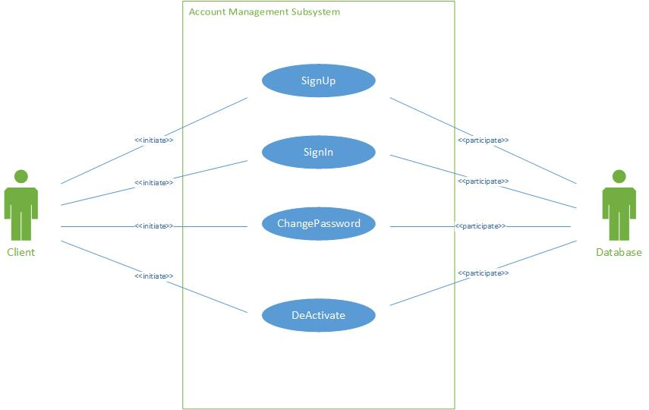

Figure 1 Use Case Diagram for Account Management Subsystem

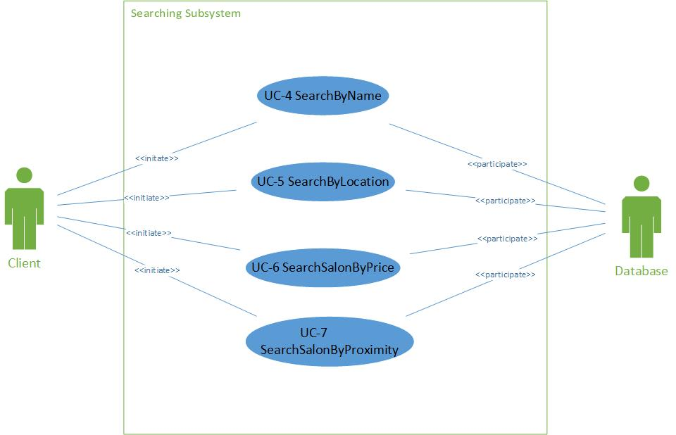

Figure 2 Use Case Diagram for Searching Subsystem

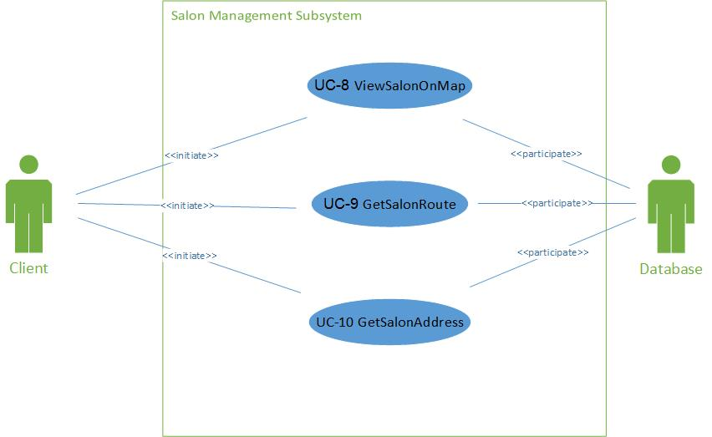

Figure 3 Use Case Diagram for Salon Management Subsystem

1. **Fully Dressed Descriptions:**

|  |  |
| --- | --- |
| Use Case UC-1 |  |
| Related Requirements: | Req1 |
| Initiating Actor: | Client |
| Actor’s Goal: | To create an account |
| Participating Actors: | Database |
| Preconditions: | None worth mentioning |
| Post conditions: | A new client is added into the database. |
| Flow of Events for Main Success Scenario:  1. Client goes to home page, clicks on the hyperlink “Sign Up”.  2. System prompts the client to enter their details.  3. The client enters required details and then submits.  4. The System records the new data into the database and signals completion. | |

|  |  |
| --- | --- |
| Use Case UC-2 |  |
| Related Requirements: | Req2 |
| Initiating Actor: | Client |
| Actor’s Goal: | To sign in to the system |
| Participating Actors: | Database |
| Preconditions: | None worth mentioning |
| Post conditions: | A Client is signed in to the system. |
| Flow of Events for Main Success Scenario:  1. Client goes to home page, clicks on the hyperlink “Sign in”.  2. System prompts the client to enter their details.  3. The client enters required details and then submits.  4. System prepares a database query to verify whether the details provided are valid. | |

|  |  |
| --- | --- |
| Use Case UC-2 | ChangePassword |
| Related Requirements: | Req 3 |
| Initiating Actor: | Client |
| Actor’s Goal: | To change password |
| Participating Actors: | Database |
| Preconditions: | None worth mentioning |
| Postconditions: | System successfully updates the client’s password. |
| Flow of Events for Main Success Scenario:  1. The client clicks on sign in hyperlink.  2. The system displays the sign in form.  3. The client clicks on “Forgot Password” hyperlink.  4. System prepares a database query to verify whether the email address provided is in the database. If the email address is found in the database, then an email will be sent to the client with a link that when clicked will direct the client to a page where they can register a new password.  5. System prepares another database query to update the password.  6. Client will then login using the email address and the updated password. | |

|  |  |
| --- | --- |
| Use Case UC-5 | SearchByLocation |
| Related Requirements: | Req12 |
| Initiating Actor: | Any Client |
| Actor’s Goal: | To search for salons by Location |
| Participating Actors: | Google Maps |
| Preconditions: | • The sets of salons and their locations are stored in the system database.  • The system displays the menu of available functions at the home page of the system, “search by hairstyle”, “search by location”, “search by price range” and “search by name”. |
| Postconditions: | A page with all salons in the location searched will be generated |
| Flow of Events for Main Success Scenario:  1. Client goes to home page search drop down menu, chooses option “search by Location”.  2. System allows client to enter the location.  3. System prepares a database query to search the database and returns all the salons in the location searched.  4. Clients can then select the salons of their choice. | |

|  |  |
| --- | --- |
| Use Case UC-6 | SearchSalonByPrice |
| Related Requirements: | Req15 |
| Initiating Actor: | Any client |
| Actor’s Goal: | To search for a salon by price range. |
| Participating Actors: | Database |
| Preconditions: | • The set of salons and price ranges stored in the system database.  • The system displays the menu of available functions at the home page of the system, “search by hairstyle”, “search by location”, “search by price range”. |
| Postconditions: | Drop down menu of all salons in that price range. |
| Flow of Events for Main Success Scenario:  1. Client goes to home page search drop down menu, chooses option “search by price range”.  2. System allows client to enter price range.  3. System shows results of salons by price range. | |

|  |  |
| --- | --- |
| Use Case UC-7 | SearchSalonByProximity |
| Related Requirements: | Req17 |
| Initiating Actor: | Any client |
| Actor’s Goal: | To search a salon by distance to the salon and get results of all salons within the specified distance. |
| Participating Actors: | Database |
| Preconditions: | • The set of salons stored in the system database.  • The system displays the menu of available functions at the home page of the system, “search by hairstyle”, “search by location”, “search by price range”. |
| Postconditions: | Drop down menu of all salons within the specified distance. |
| Flow of Events for Main Success Scenario:  1. Client goes to home page search drop down menu, chooses option “search by proximity”.  2. System allows client to enter distance.  3. System shows results of salons in distance specified. | |

|  |  |
| --- | --- |
| Use Case U-8 | ViewSalonOnMap |
| Related Requirements: | Req26 |
| Initiating Actor: | Any client |
| Actor’s Goal: | To be able to see where salon is situated on Google maps. |
| Participating Actors: | Google Maps |
| Preconditions: | • The set of salons and IP addresses stored in the system database.  • The system displays available options at the salon page, one of which is view salon on map. |
| Postconditions: | Google map shows position of salon. |
| Flow of Events for Main Success Scenario:  1. Client goes to home page search drop down menu, chooses one of the options “search by hairstyle”, “search by location”, “search by price range”.  2. System allows client to enter distance, or price, or hairstyle.  3. System shows results of salons with specified information. | |

|  |  |
| --- | --- |
| Use Case UC-9 | GetSalonRoute |
| Related Requirements: | Req27 |
| Initiating Actor: | Any client |
| Actor’s Goal: | To be able to get route from where the client is to the salon on Google maps. |
| Participating Actors: | Google Maps |
| Preconditions: | • The set of salons and IP addresses stored in the system database.  • The system displays available options at the salon page, one of which is get route. |
| Postconditions: | Google maps calculates route from current position to salon position and shows route on map. |
| Flow of Events for Main Success Scenario:  1. Client goes to home page search drop down menu, chooses one of the options “search by hairstyle”, “search by location”, “search by price range”.  2. System allows client to enter distance, or price, or hairstyle.  3. System shows results of salons with specified information. | |

|  |  |
| --- | --- |
| Use Case UC-10 | GetSalonAddress |
| Related Requirements: | Req29 |
| Initiating Actor: | Any client |
| Actor’s Goal: | To be able to get salon address on Google maps salon position. |
| Participating Actors: | Google Maps |
| Preconditions: | • The set of salons and IP addresses stored in the system database.  • The system displays available options at the salon page, one of which is view salon on map. |
| Postconditions: | Google map shows position of salon. |
| Flow of Events for Main Success Scenario:  1. Client goes to home page search drop down menu, chooses one of the options “search by hairstyle”, “search by location”, “search by price range”.  2. System allows client to select the salon searched for.  3. System displays the salon address. | |

**System Sequence Diagrams:**

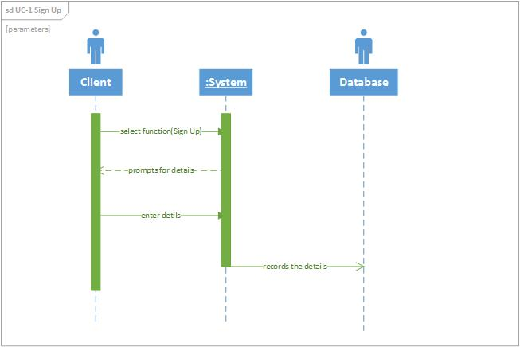

Figure 1 Sequence Diagram of Use Case 1

Figure 4-1 shows the sequence diagram of Use Case 1 which is “Sign Up”. It is used to create new client’s accounts. First the client clicks the “Sign Up” hyperlink. Next, the system prompts the client to enter their details. Then the client enters the required details. After that the system records the data into the database.

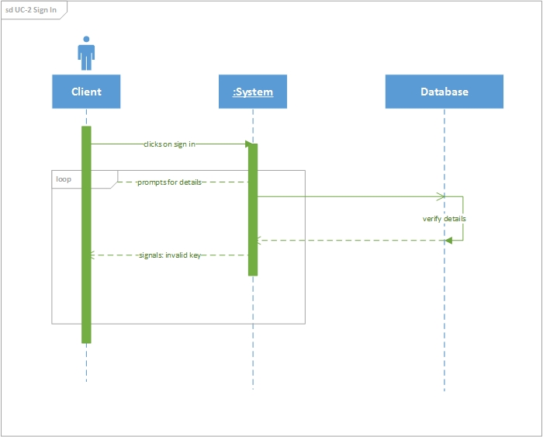

Figure 2 Sequence Diagram for Use Case 2

Figure 2 shows the sequence diagram of Use Case 2 which is “Sign In”. It is used to sign in clients. First the client clicks the “Sign In” hyperlink. Next, the system prompts the client to enter their details. Then the client enters the required details. After that the

System prepares a database query to verify whether the details provided are valid.

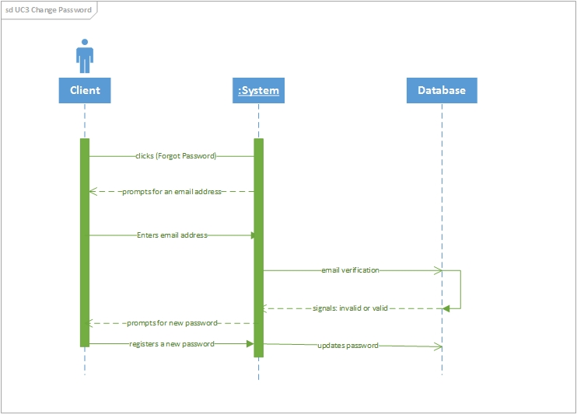

Figure 3 Sequence Diagram for Use Case 3

Figure 3 shows the sequence diagram of Use Case 3 which is “Sign In”. It is used to change a client’s password. First, the clients clicks the “Forgot Password” hyperlink and the system will prompt the client to enter a registered password. The system prepares a database query to verify whether the email address provided is in the database. If the email address is found in the database, then an email will be sent to the client with a link that when clicked will direct the client to a page where they can register a new password. Then after that the system will prepare another database query to update the old password.

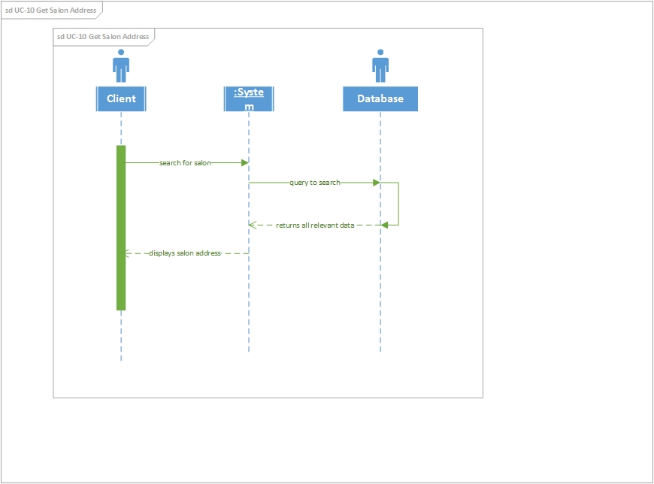

Figure 4 Sequence Diagram for Use Case 10

Figure 4 shows the sequence diagram of Use Case 10 which is “Get Salon Address”. It is used to get salon’s addresses. First, the clients searches for the salon either by hair-style, location or by price range. Then after that the system will allow the client to select the salon of their choice. Then the system will display the salon address.