EaZZy-Travels Data Schema
Entity relationship diagram covering login, employee, customer, provider, subscription, booking and payment records.
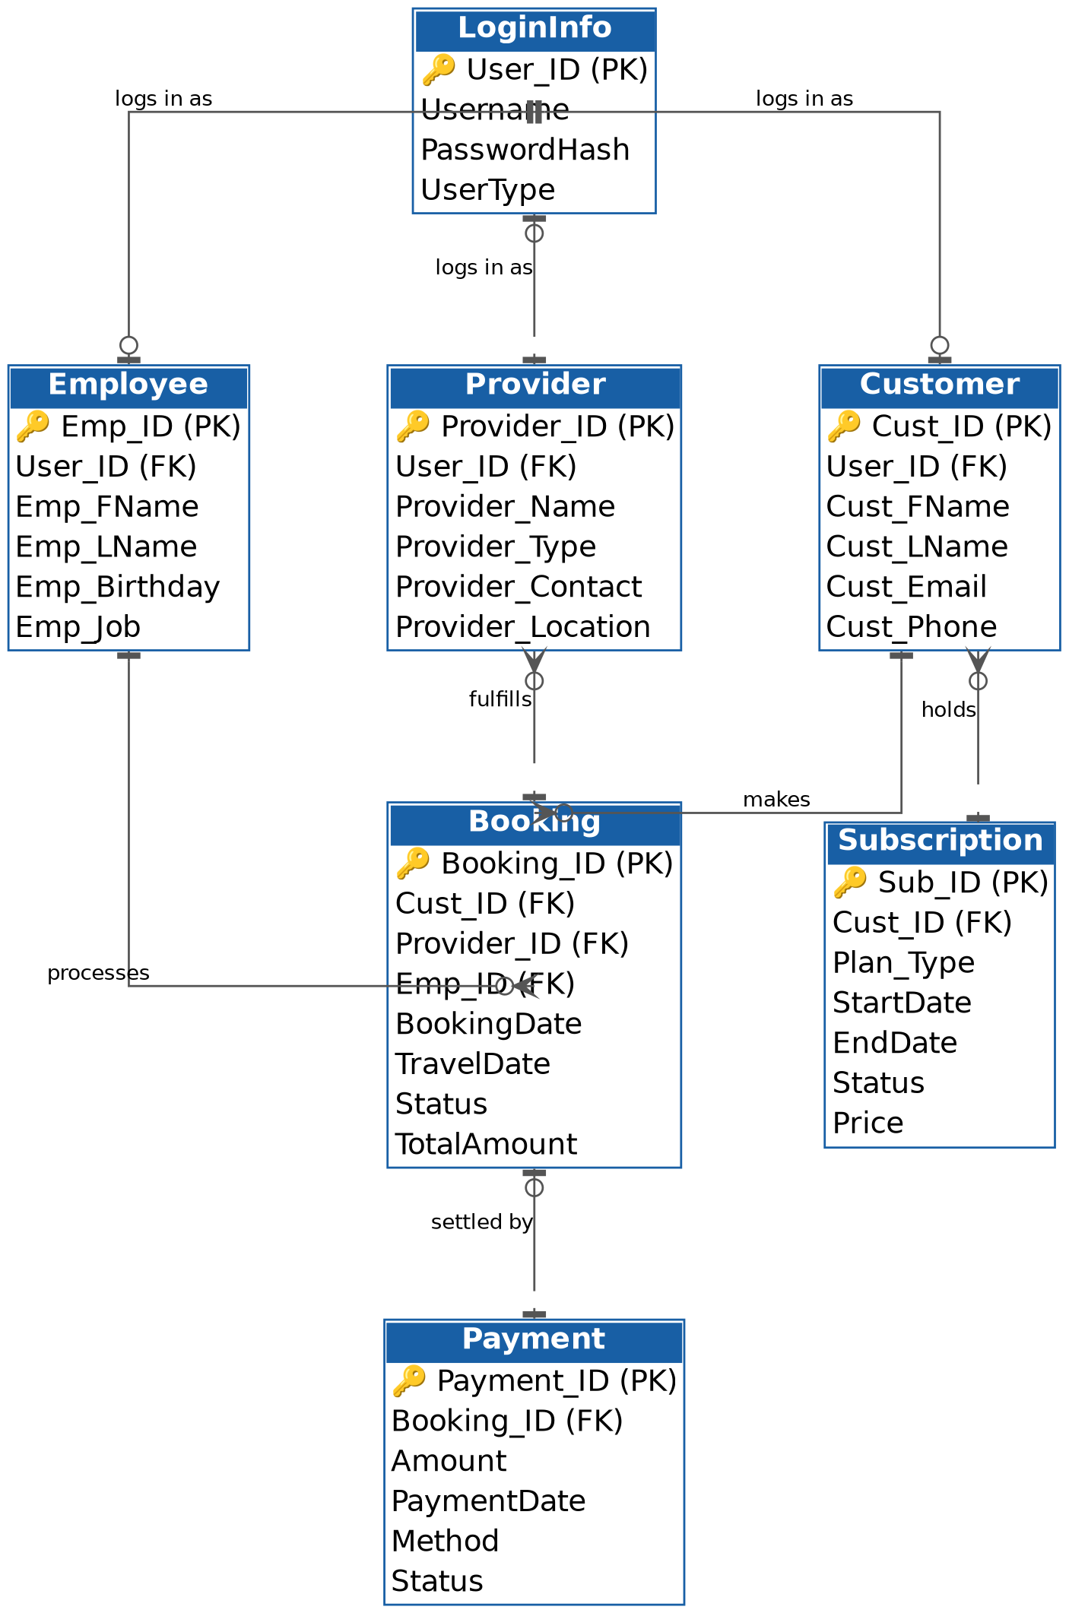

Key relationships
- LoginInfo holds one shared login per Employee, Customer, or Provider (UserType distinguishes them).
- A Customer can hold many Subscriptions and make many Bookings.
- A Booking links one Customer, one Provider, and the Employee who processed it.
- Each Booking is settled by exactly one Payment.

